IEEE P802.11  
Wireless LANs

|  |  |  |  |  |
| --- | --- | --- | --- | --- |
| Resolution to CID20718 | | | | |
| Date: 2019-07-14 | | | | |
| Author(s): | | | | |
| Name | Affiliation | Address | Phone | email |
| Yujin Noh | Newracom |  |  | yujin.noh at newracom.com |
|  |  |  |  |  |

Abstract

This submission shows

* Resolution for comments received from TGax comment collection (11ax D4.0)
* The proposed changes are based on 11ax D4.1.
* The submission provides resolutions to 1 CID: 20718

Revisions:

* Rev 0: Initial version of the document.

|  |  |  |  |  |
| --- | --- | --- | --- | --- |
| **CID** | **P.L** | **Comment** | **Proposed Change** | **Resolution** |
| 20718 |  | Re CID 16008: "a" is a terrible name for the pre-FEC padding factor because it cannot be searched for. The spec is so large that the only realistic way to process it is to search for terms; so "a" does do harm | Change all uses of "a" as the pre-FEC padding factor to "PFPF" | Revised.  Agreed in principle  However, assuming many readers already get used to “*a*” for last years, *aPFPF* (**P**re-**F**EC **P**adding **F**actor) is not-that-surprised update and it is a terminergy to be searched      TGax Editor: make changes according to this document 11-19-0973-00-00m Resolution to CID20718 |

***Discussion***

The corresponding terms are *a*, *ainit*, *ainit,u*, *aRX* and *aRX,u* that replaced with *aPFPF*, *aPFPF,init*, *aPFPF,init,u*, *aPFPF,RX* and *aPFPF,RX,u*, respectively in 27.3.11.2 (Pre-FEC padding process), 27.3.11.5.1 (BCC coding and puncturing), 27.3.11.5.2 (LDPC coding), 27.3.11.5.4 (Encoding process for an HE MU PPDU), 27.3.11.5.5 (Encoding process for an HE TB PPDU), 27.3.12 (Packet extension) and 27.4.3 (TXTIME and PSDU_LENGTH calculation).

***To TGax Editor:*** ***P26L11*** *replace the current text (e.g. a ) with the proposed changes (aPFPF ) below.*

***------------- Begin Text Changes ---------------***

Figure 27-36—HE PPDU padding process in the last OFDM symbol (non-STBC) if *~~a~~aPFPF* = 1...................... 584

***------------- End Text Changes -----------------------***

***To TGax Editor:*** ***P583L44*** *replace the current text (e.g. a and ainit ) with the proposed changes (aPFPF and aPFPF,init ) below.*

***------------- Begin Text Changes ---------------***

Figure 27-36 (HE PPDU padding process in the last OFDM symbol (non-STBC) if *~~a~~aPFPF* = 1) illustrates these four possible symbol segments in the last OFDM symbol of a non-STBC case, and the general padding process assuming the desired pre-FEC padding boundary, represented by the pre-FEC padding factor, is 1. In the case of STBC, the FEC output bits and post-FEC padding bits are modulated into the last two OFDM symbols by STBC encoding, each with the same pre-FEC padding boundary.

|  |
| --- |
|  |
| * HE PPDU padding process in the last OFDM symbol (non-STBC) if *~~a~~aPFPF* = 1 |

**…**

Based on *NExcess*, compute the initial number of symbol segments in the last OFDM symbol(s), initial pre-FEC padding factor value or *~~a~~~~init~~ aPFPF,init*, as shown in Equation (27-60).

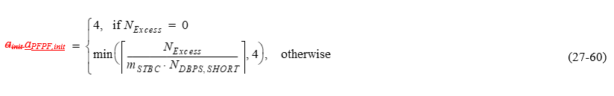

where

, in which *R* is the coding rate, and

;

**…**

Given the *~~a~~~~init~~ aPFPF,init* values, the initial number of data bits per symbol and the initial number of coded bits per symbol in the last OFDM symbol(s) are defined in Equation (27-61).

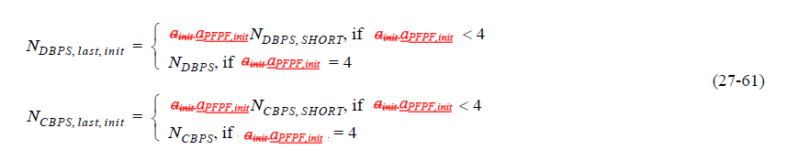

***…***

Among the pre-FEC padding bits, the MAC delivers a PSDU that fills the available octets in the Data field of the HE PPDU (see A-MPDU padding for HE PPDUs in 26.6.2.2 (A-MPDU padding in an HE SU PPDU, HE ER SU PPDU and HE MU PPDU) and 26.6.3 (A-MPDU padding in an HE TB PPDU)), toward the desired initial pre-FEC padding boundary, represented by *~~a~~~~init~~ aPFPF,init* value, in the last OFDM symbol(s). The number of pre-FEC pad bits added by MAC will always be a multiple of 8. The PHY then determines the number of remaining pad bits to add and appends them to the PSDU. The number of pre-FEC pad bits added by PHY will always be 0 to 7. The procedure is defined in Equation (27-64).

***------------- End Text Changes -----------------------***

***To TGx Editor:*** ***P587L15*** *replace the current text (e.g. a and ainit ) with the proposed changes (aPFPF and aPFPF,init ) below.*

***------------- Begin Text Changes ---------------***

For an HE SU PPDU with BCC encoding,

*NSYM* = *NSYM,init* (27-65)

and

*~~a~~aPFPF* = *~~a~~~~init~~ aPFPF,init* (27-66)

where *NSYM,init* is defined in Equation (27-63), *~~a~~~~init~~ aPFPF,init* is defined in Equation (27-60) and *~~a~~aPFPF* is the pre-FEC padding factor.

The number of data bits per symbol in the last OFDM symbol(s) of an HE SU PPDU or HE ER SU PPDU is *NDBPS,last* = *NDBPS,last,init*, where *NDBPS,last,init* is defined in Equation (27-61).

The number of coded bits per symbol in the last OFDM symbol(s) of an HE SU PPDU or HE ER SU PPDU is given by Equation (27-67).

**

***------------- End Text Changes -----------------------***

***To TGax Editor:*** ***P588L10*** *replace the current text (e.g. a and ainit ) with the proposed changes (aPFPF and aPFPF,init ) below.*

***------------- Begin Text Changes ---------------***

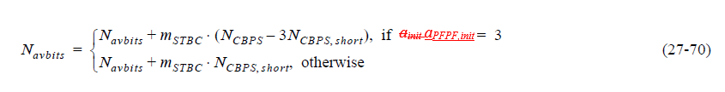

and then compute the pre-FEC padding factor *a* and *NSYM* using Equation (27-71):



If in step d) of LDPC encoding process as described in 19.3.11.7.5 (LDPC PPDU encoding process), the above mentioned condition is not met, then the LDPC Extra Symbol Segment field in HE-SIG-A shall be set to 0, and



Using the pre-FEC padding factor *~~a~~aPFPF*, compute the *NCBPS* of the last symbol as:



The number of data bits of the last symbol is calculated as *NDBPS,last* = *NDBPS,last,init*.

***------------- End Text Changes -----------------------***

***To TGax Editor:*** ***P589L01*** *replace the current text (e.g. a, ainit and ainit,u ) with the proposed changes (aPFPF , aPFPF,init and aPFPF,init,u ) below.,*

***------------- Begin Text Changes ---------------***

First compute initial pre-FEC padding factor value, *~~a~~~~init,u~~ aPFPF,init,u*, for each user *u* using Equation (27-60), and the initial number of OFDM symbols, *NSYM,init,u*, for each user *u* using Equation (27-63). Among all the users, derive the user index with the longest encoded packet duration, as in Equation (27-75).



where



*mSTBC* is the common STBC setting among all the users, as described in 27.3.11.7 (Segment parser).

Then the common *~~a~~~~init~~ aPFPF,init* and *NSYM,init* values among all the users are derived by Equation (27-76):



Calculate each user’s initial number of coded bits in its last symbol as below:

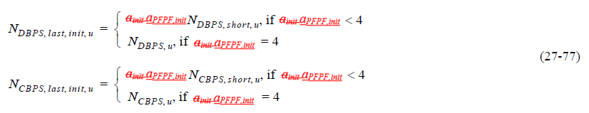

…

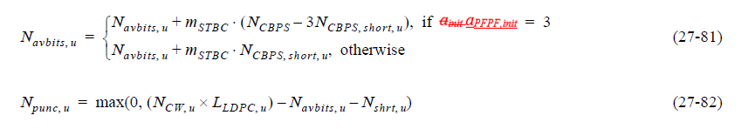

Update the common pre-FEC padding factor and *NSYM* values for all users by the following equation:



….



For the users with LDPC encoding, *NDBPS,last,u* = *NDBPS,last,init,u*.

For the users with BCC encoding, update the *NDBPS* of the last symbol as



For each user with either LDPC or BCC encoding, update the *NCBPS* of the last symbol as

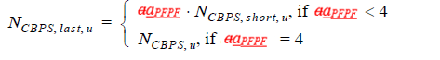

…

Among the pre-FEC padding bits, the MAC delivers a PSDU that fills the available octets in the Data field of the HE PPDU, toward the desired initial pre-FEC padding boundary represented by *~~a~~~~init~~aPFPF,init* for users encoded by LDPC and the pre-FEC padding boundary represented by *~~a~~aPFPF* for users encoded by BCC, in the last OFDM symbol(s). The PHY then determines the number of pad bits to add and appends them to the PSDU. The number of pre-FEC pad bits added by PHY will always be 0 to 7. The procedure is defined in Equation (27-88) and Equation (27-89).

***------------- End Text Changes -----------------------***

***To TGax Editor:*** ***P591L19*** *replace the current text (e.g. a and ainit ) with the proposed changes (aPFPF and aPFPF,init ) below.*

***------------- Begin Text Changes ---------------***

For an HE TB PPDU with BCC encoding, follow the HE SU PPDU padding and encoding process as introduced in 27.3.11.2 (Pre-FEC padding process), 27.3.11.5.1 (BCC coding(#20693) and puncturing), and 27.3.11.5.3 (Post-FEC padding) with initial parameters as follows:

* If the TXVECTOR parameter TRIGGER_METHOD is TRIGGER_FRAME, the initial parameters are *NSYM,init* = *NSYM*, and *~~a~~~~init~~aPFPF,init* = *~~a~~aPFPF*, where *~~a~~aPFPF* is the pre-FEC padding factor indicated in the UL Packet Extension subfield of the Common Info field in the Trigger frame and *NSYM* is the common number of data OFDM symbols derived from the UL Length, Number Of HE-LTF Symbols And Midamble Periodicity, and Doppler subfields of the Common Info field in the Trigger frame
* If the TXVECTOR parameter TRIGGER_METHOD is TRS, the initial parameters are *NSYM,init* = *NSYM*, and *~~a~~~~init~~aPFPF,init* = *~~a~~aPFPF* where *~~a~~aPFPF* is the pre-FEC padding factor set to 4 and *NSYM* is set to *FVAL* + 1, where *FVAL* is the value of the UL Data Symbols subfield of the TRS Control subfield

For an HE TB PPDU with LDPC encoding, follow the HE SU PPDU padding and encoding process as introduced in 27.3.11.2 (Pre-FEC padding process), 27.3.11.5.2 (LDPC coding), and 27.3.11.5.3 (Post-FEC padding), with the following exceptions:

* If the TXVECTOR parameter TRIGGER_METHOD is TRIGGER_FRAME and the LDPC Extra Symbol Segment field in the Trigger frame is 1, set the initial parameters following Equation (27-90).



where *mSTBC* is 2 if the Trigger frame indicates STBC and 1 otherwise. Then continue with the LDPC encoding process as in 19.3.11.7.5 (LDPC PPDU encoding process), during which in step d) of 19.3.11.7.5 (LDPC PPDU encoding process), always increment *Navbits* as in Equation (27-70), and always recompute *Npunc* as in Equation (19-40).

* If the TXVECTOR parameter TRIGGER_METHOD is TRIGGER_FRAME and the LDPC Extra Symbol Segment field in the Trigger frame is 0, set initial parameters to *NSYM,init* = *NSYM*, and *~~a~~~~init~~aPFPF,init* = *~~a~~aPFPF*. Then continue with the LDPC encoding process as in 19.3.11.7.5 (LDPC PPDU encoding process), during which in step d) of 19.3.11.7.5 (LDPC PPDU encoding process), *Navbits* and *Npunc* are not changed, and *~~a~~aPFPF*= *~~a~~~~init~~* *aPFPF,init*.
* If the TXVECTOR parameter TRIGGER_METHOD is TRS then the parameter LDPC_EXTRA_SYMBOL is 1 and initial parameters set to *NSYM,init* = *NSYM*, and *~~a~~~~init~~aPFPF,init* = *~~a~~aPFPF* – 1, where *~~a~~aPFPF* is the pre-FEC padding factor set to 4 and *NSYM* is set to *FVAL* + 1, where *FVAL* is the value of the UL Data Symbols subfield of the TRS Control subfield. Then continue with the LDPC encoding process as in 19.3.11.7.5 (LDPC PPDU encoding process), during which in step d) of 19.3.11.7.5 (LDPC PPDU encoding process), always increment *Navbits* as in Equation (27-70), and always recompute *Npunc* as in Equation (19-40).

***------------- End Text Changes -----------------------***

***To TGax Editor:*** ***P608L06*** *replace the current text (e.g. a and ainit ) with the proposed changes (aPFPF and aPFPF,init ) below.*

***------------- Begin Text Changes ---------------***

For an HE SU or HE ER SU PPDU, the nominal *TPE* value (*TPE,nominal*) is given by Table 27-44 (Nominal TPE values). In this case, *~~a~~aPFPF* in Table 27-44 (Nominal TPE values) is given by Equation (27-71) or Equation (27-72).

For an HE MU PPDU, the nominal *TPE* value (*TPE,nominal*) is given by Equation (27-113).

*TPE,nominal* = max*u* *TPE,nominal,u* (27-113)

where

*TPE,nominal,u* is the nominal *TPE* value for user *u* and is also given by Table 27-44 (Nominal TPE values)

max*u* *f*(*u*) is the maximum value of *f*(*u*) over all values of *u*

In this case, *~~a~~aPFPF* in Table 27-44 (Nominal TPE values) is given by Equation (27-83) or Equation (27-84).

|  |  |  |  |
| --- | --- | --- | --- |
| * Nominal *TPE* values | | | |
| *~~a~~aPFPF* | TXVECTOR parameter NOMINAL_PACKET_PADDING (HE SU PPDU or HE ER SU PPDU) or NOMINAL_PACKET_PADDING[*u*] (HE MU PPDU) | | |
| 0 µs | 8 µs | 16 µs |
| 1 | 0 µs | 0 µs | 4 µs |
| 2 | 0 µs | 0 µs | 8 µs |
| 3 | 0 µs | 4 µs | 12 µs |
| 4 | 0 µs | 8 µs | 16 µs |

…

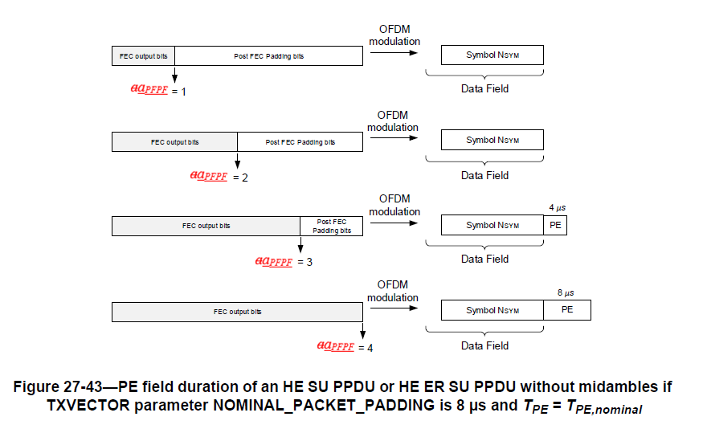

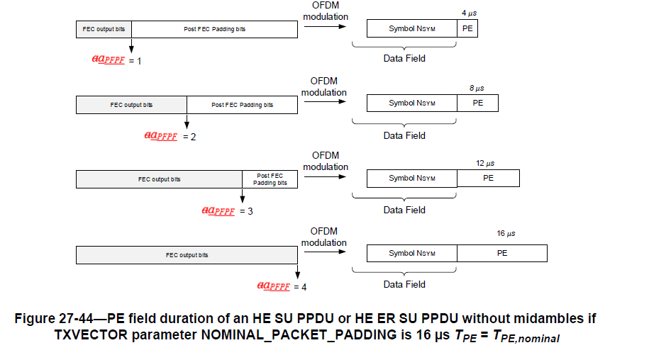

***------------- End Text Changes -----------------------***

***To TGax Editor:*** ***P656L01*** *replace the current text (e.g. a, aRX and aRX,u ) with the proposed changes (aPFPF, aPFPF,RX and aPFPF,RX,u ) below.*

***------------- Begin Text Changes ---------------***

where

*NSYM* is given by Equation (27-119)



where

*~~a~~~~RX~~ aPFPF,RX* is given by Equation (27-142)

*NSD,short* is defined in Table 27-31 (NSD,short values)

*NSS*, *NBPSCS*, *R* are defined in Table 27-15 (Frequently used parameters)

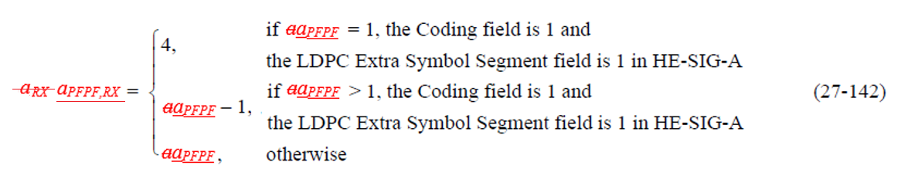

where

*~~a~~aPFPF* is the pre-FEC padding factor (ranging from 1 to 4) indicated in HE-SIG-A

***…***

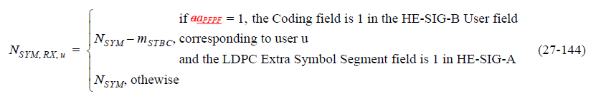

where

*NSYM* is given by Equation (27-119)

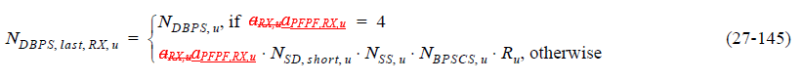

where

*~~a~~~~RX,u~~aPFPF,RX,u* is given by Equation (27-146)

*NSD,short,u* is *NSD,short* defined in Table 27-31 (NSD,short values) for user *u*

*NSS,u*, *NBPSCS,u*, *Ru* are defined in Table 27-15 (Frequently used parameters)

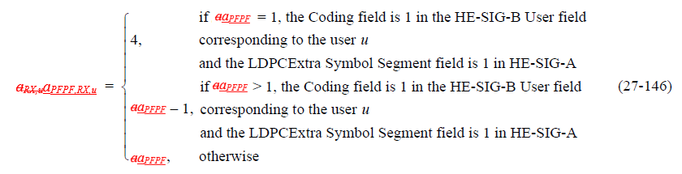

where

*~~a~~aPFPF* is the pre-FEC padding factor (ranging from 1 to 4) indicated in HE-SIG-A

***------------- End Text Changes -----------------------***