IEEE P802.11
Wireless LANs
PHY CR in Clause 10
Date: 2019-5-15
Author(s):
Name | Affiliation | Address | Phone | email
Youhan Kim | Qualcomm |  |  | youhank@qti.qualcomm.com

Abstract
This submission proposes resolutions for the following comments from the letter ballot on P802.11ax D4.0:

20507, 20953, 20882

NOTE – Set the Track Changes Viewing Option in the MS Word to “All Markup” to clearly see the proposed text edits.

Revision History:

R0: Initial version.

CID 20507

CID | Clause | Page.Line | Comment | Proposed Change
20507 | 10.6.1 | 239.26 | PLME-TXTIME requires TXTIME to be integer, but HE TXTIME can be non-integer -- might this cause problems? | Clarify

Background

Comment is made on 10.6.1.

D4.1 P242-243:
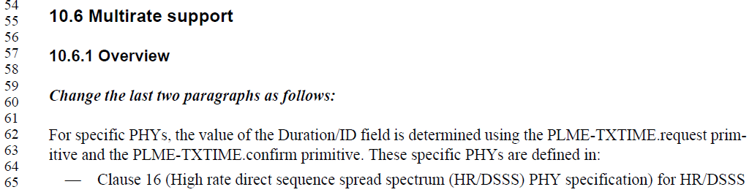
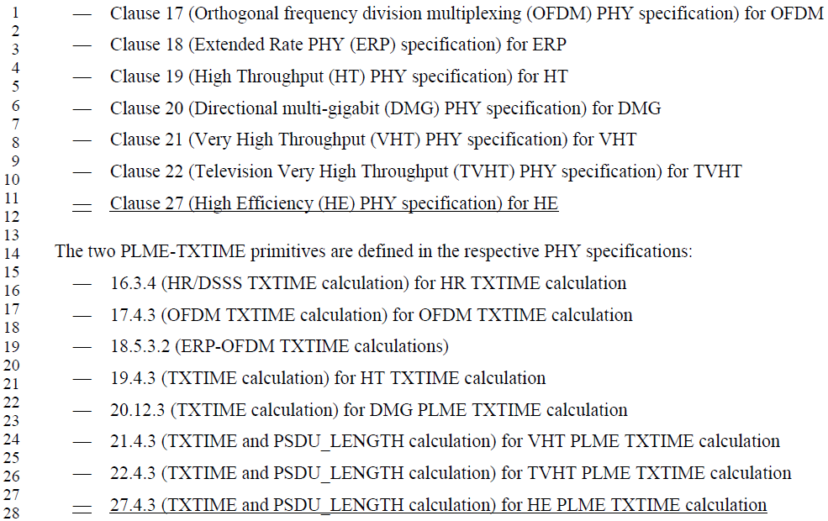

Note that 10.6.1 does not state that TXTIME has to be an integer value.

Looking into PLME-TXTIME.confirm in REVmd,

REVmd D2.2 P751:
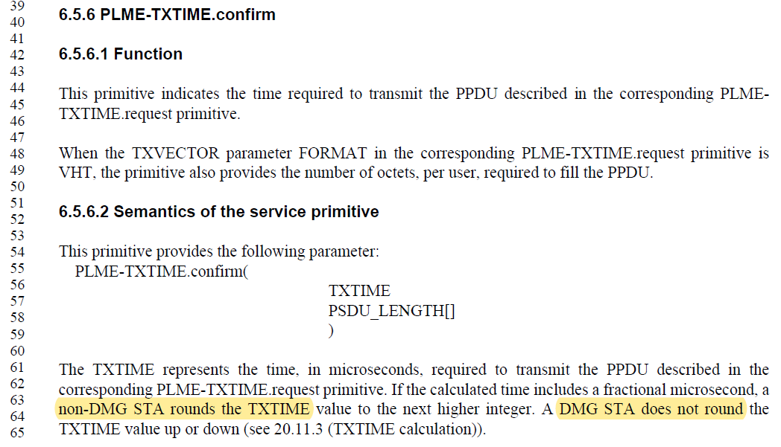

Proposed Resolution: CID 20507
Revised.
The reviewer could not find any requirement that TXTIME has to be an integer value. Furthermore, PHY has equations using TXTIME (e.g. Equation (27-11), (27-118)). Changing the TXTIME at this point will require reviewing the impact to various PHY equations and PHY assumptions. Hence, the proposed text update in 11-19/0858 clarifies that TXTIME is not rounded up for HE PPDUs.

Instruction to Editor: Implement the text updates for CID 20507 in 11-19/0858r0.

Proposed Text Updates: CID 20507

TGax Editor: Add clause 6.5.6 at D4.1 P65L35 as shown below.
6.5.6 PLME-TXTIME.confirm
Change the second paragraph as follows:

The TXTIME represents the time, in microseconds, required to transmit the PPDU described in the corresponding PLME-TXTIME.request primitive. If the calculated time includes a fractional microsecond and the TXVECTOR parameter FORMAT in the corresponding PLME-TXTIME.request primitive is not HE_SU, HE_MU, HE_TB or HE_ER_SU, a non-DMG STA rounds the TXTIME value to the next higher integer. A non-DMG STA does not round the TXTIME value up or down if the TXVECTOR parameter FORMAT in the corresponding PLME-TXTIME.request primitive is HE_SU, HE_MU, HE_TB or HE_ER_SU. A DMG STA does not round the TXTIME value up or down (see 20.11.3 (TXTIME calculation)).

CID 20953

CID | Clause | Page.Line | Comment | Proposed Change
20953 |  |  | Re CID 16191: locations where the baseline needs to be extended to allow for signal extension in HE are, in md/D2.1: 10.3.8 and maybe 10.28.4 | Refer to HE PPDU formats too, at the referenced locations

Discussion

For reference, following is CID16191 from LB on D3.0:
CID | Clause | Page.Line | Comment | Proposed Change | Resolution
16191 |  |  | Need to be clearer the packet extension is completely distinct and independent from the signal extension (also need to make sure the HE PHY is mentioned wherever the ERP/HT PHYs are currently mentioned for signal extension, in the baseline) | As it says in the comment | Commenter has not provided specific location on where the packet extension is not clearly different from signal extension. The comment resolution group feels the two are disambiguously different.  11-18/2034r0 updated 10.3.8 to add HE PPDUs to the list of PPDUs using signal extension.  Instruction to Editor: Implement the text updates for CID 16191 in 11-18/2034r0

Note that 10.3.8 has already been updated in D4.1 to include HE PPDUs.

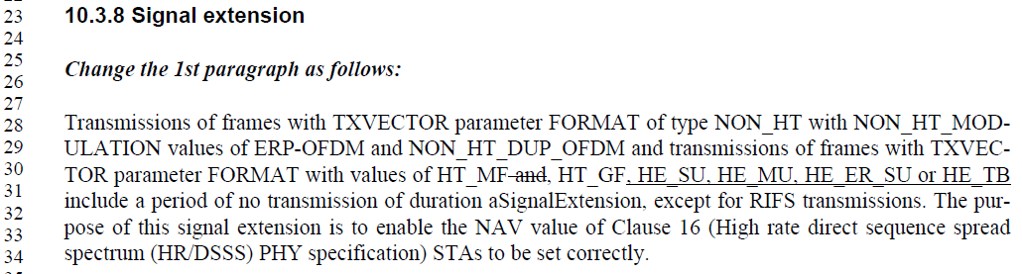

As for 10.28.4, it is about how to compute the L_LENGTH for HT_MF PPDUs. It is not related to HE PPDUs.
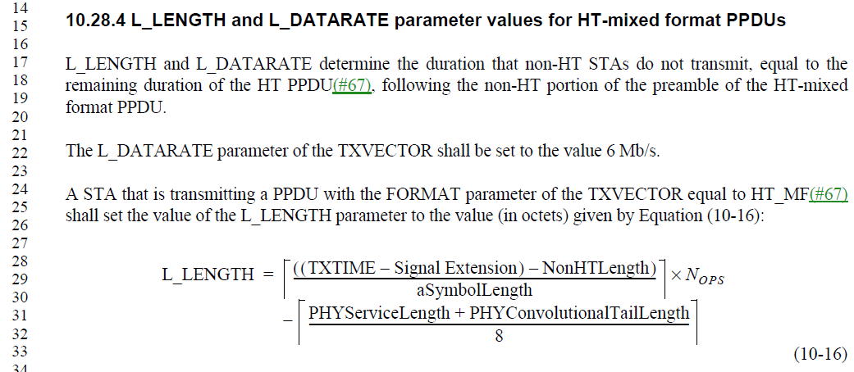

Proposed Resolution: CID 20953
Revised.
Change proposed by the commenter for 10.3.8 has already been made in D4.1. Change potentially proposed by the commenter for 10.28.4 is not applicable because 10.28.4 is not related to HE PPDUs.

Note to Editor: There is no additional text update needed for CID 20953.

CID 20882

CID | Clause | Page.Line | Comment | Proposed Change
20882 |  |  | Re CID 16005: "packet extension value" is not defined | Change "packet extension  value" to "PE field duration" throughout 26.12 and "Post FEC Padding and Packet Extension value" to "PE field duration" throughout C.3

Background

For reference, following is CID16005 from LB on D3.0:
CID | Clause | Page.Line | Comment | Proposed Change | Resolution
16005 |  |  | In some places (PE) is PPDU extension (e.g. 99.52), in some packet extension (e.g. 168.38); also it is missing from the glossary | Use PE as meaning packet extension, NPE as meaning nominal packet extension (not PPE), change PPET to NPET, change T_PE,nominal to T_PE,minimum | REVISED (EDITOR: 2018-10-11 22:06:41Z) - The field is called the PE field. Fields should have a single name. If it is an abbreviated name (PE field) so be it. No need to call a field something and then abbreviate it.

Proposed Resolution: CID 20882
Revised.
PPE Threshold field in HE Capabilities element signals PPE Threhold (PPET), which is used to compute the nominal packet padding. Then, given the specific pre-FEC padding factor for each PPDU, the PE (Packet Extension) field duration can be computed. The commenter is asking to use the ‘correct’ terminology in various places in the draft. Proposed text update in 11-19/0858 makes such changes.

Instruction to Editor: Implement the text updates for CID 20882 in 11-19/0858r0.

Proposed Text Updates: CID 20882

TGax Editor: Update D4.1 P414L44 as shown below.

The nominal packet padding is used in computing the PE field duration (see 27.3.12 (Packet extension)).

TGax Editor: Update D4.1 P415L32 as shown below.
In Table 26-12, "RU Allocation index = (b + DCM)" means the following. With the exception of a 2×996-tone RU, if DCM is applied in a given RU, the nominal packet padding value is based on the next larger RU size (RU index + 1). For example, if DCM is applied to a 242-tone RU then the nominal packet padding value for a 484-tone RU is used. If DCM is applied to 106-tone RU then the nominal packet padding value for a 242-tone RU is used. If DCM is applied to a 2×996-tone RU then the nominal packet padding value for a 2×996-tone RU is used.

TGax Editor: Update D4.1 P415L57 as shown below.

A STA transmitting an HE PPDU to a receiving STA shall include post-FEC padding determined by the pre- FEC padding factor (see 27.3.11 (Data field)) and after including the post-FEC padding, the transmitting STA shall include a PE field as specified in 27.3.12 (Packet extension) based on the TXVECTOR parameter NOMINAL_ PACKET_PADDING.

TGax Editor: Update D4.1 P510L1 as shown below.

e) Post-FEC padding: Append the post-FEC pad bits and PE field as described in 27.3.11 (Data field).

TGax Editor: Update D4.1 P510L43 as shown below.

e) Post-FEC padding: Append the post-FEC pad bits and PE field as described in 27.3.11 (Data field).

TGax Editor: Update D4.1 P513L57 (Table 27-12) as shown below.

T_{PE} | 0, 4 µs, 8 µs, 12 µs or 16 µs depending on the actual extension duration used | Duration of the PE field

TGax Editor: Update D4.1 P614L50 as shown below.

within ±0.4 μs + 16 μs from the end, at the STA’s antenna connector, of the last OFDM symbol of the triggering PPDU (if it contains no PE field) or of the PE field of the triggering PPDU (if the PE field is present).

TGax Editor: Update D4.1 P616L49 as shown below.

The HE sounding NDP has the following properties:
— Uses the HE SU PPDU format but without the Data field
— Has a PE field that is 4 µs in duration

TGax Editor: Update D4.1 P647L53 as shown below.

Except in an HE sounding NDP and HE TB feedback NDP, a Data field follows the HE-STF and HE-LTF fields. The number of symbols in the Data field and the PE field duration are computed from Equation (27-119) and Equation (27-120), respectively.

TGax Editor: Update D4.1 P647L53 as shown below.

NOTE—This is the maximum length in octets for an HE SU PPDU with a bandwidth of 160 MHz or 80+80 MHz using 2×996 RU, HE-MCS 11, 8 spatial streams, 0.8 μs GI duration, 1x HE-LTF, LDPC coding, 0 μs duration of the PE field, pre-FEC padding factor value of 4, and limited by 398 possible Data field OFDM symbols(#20692) in aPPDUMaxTime.

TGax Editor: Update D4.1 P711L52 as shown below.

dot11PPEThresholdsRequired OBJECT-TYPE
SYNTAX TruthValue
MAX-ACCESS read-only
STATUS current
DESCRIPTION
"This is a capability variable.
Its value is determined by device capabilities.
This attribute, when true, indicates that PPE Thresholds exist and are provided in dot11PPEThresholdsTable."
DEFVAL { false }
::= { dot11HEStationConfigEntry 11}

TGax Editor: Update D4.1 P718L11 as shown below.

dot11PPEThresholdsMappingPPET8 OBJECT-TYPE
SYNTAX TruthValue
MAX-ACCESS read-create
STATUS current
DESCRIPTION
"An index that determines a constellation value at or above which a nominal packet padding value of at least 8 microseconds is required for the given NSS/RU pair corresponding to the row of the entry. The index values are mapped as follows: 0 is BPSK, 1 is QPSK, 2 is 16-QAM, 3 is 64-QAM, 4 is 256-QAM, 5 is 1024-QAM, 6 is reserved, 7 is the special value of NONE."
::= { dot11PPEThresholdsMappingsEntry 4 }

dot11PPEThresholdsMappingPPET16 OBJECT-TYPE
SYNTAX TruthValue
MAX-ACCESS read-create
STATUS current
DESCRIPTION
"An index that determines a constellation value at or above which a nominal packet padding value of 16 microseconds is required for the given NSS/RU pair corresponding to the row of the entry. The index values are mapped as follows: 0 is BPSK, 1 is QPSK, 2 is 16-QAM, 3 is 64-QAM, 4 is 256-QAM, 5 is 1024-QAM, 6 is reserved, 7 is the special value of NONE."
::= { dot11PPEThresholdsMappingsEntry 5 }

[End of File]

