IEEE P802.11
Wireless LANs
LB236 PHY CR
Date: 2019-05-12
Author(s):
Name | Affiliation | Address | Phone | email
Youhan Kim | Qualcomm |  |  | youhank@qti.qualcomm.com

Abstract
This submission proposes resolutions for the following comments from the letter ballot on P802.11-REVmd D2.0:

2177, 2712

NOTE – Set the Track Changes Viewing Option in the MS Word to “All Markup” to clearly see the proposed text edits.

Revision History:

R0: Initial version.

CID 2177

CID | Clause | Page.Line | Comment | Proposed Change
2177 | 17.2.3.1 | 2893.00 | The RXVECTOR parameter RSSI has an upper limit of "RSSI maximum" but there is no definition of RSSI maximum in the document. There are 7 instances of "RSSI maximum" in the document. | Define RSSI maximum

Discussion
Following are the locations in which the valid range of RSSI is mentioned in D2.2.

D2.2 P495:

…

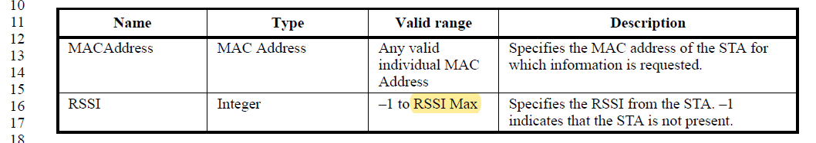

D2.2 P2847:
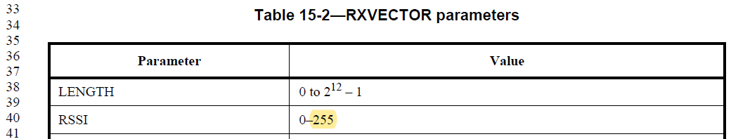

D2.2 P2887:
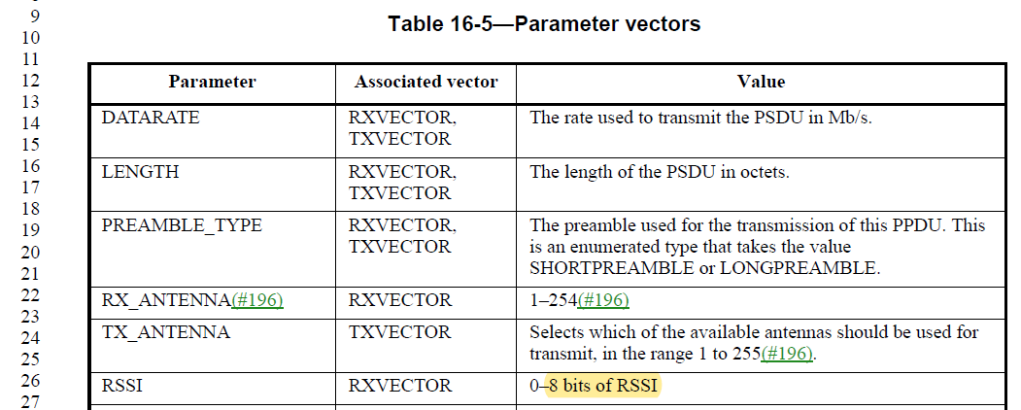

D2.2 P2903:
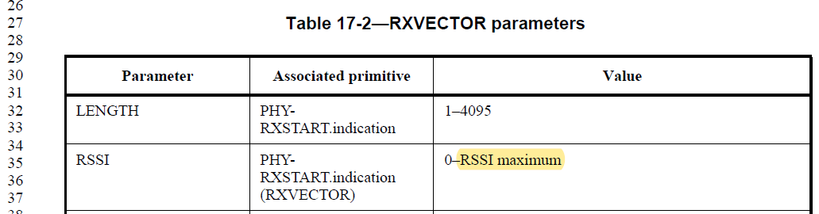

D2.2 P2904:
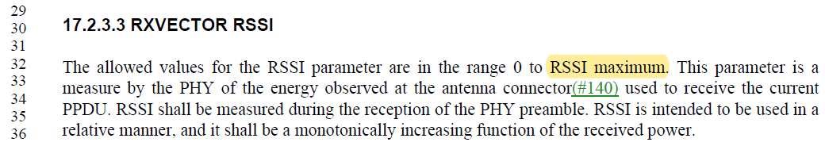

D2.2 P2949:
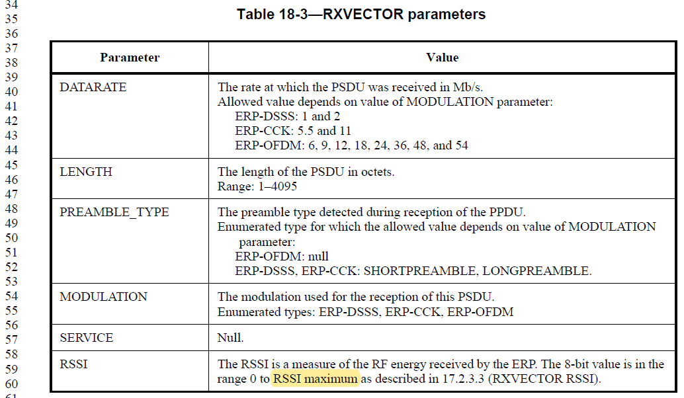

D2.2 P2962:
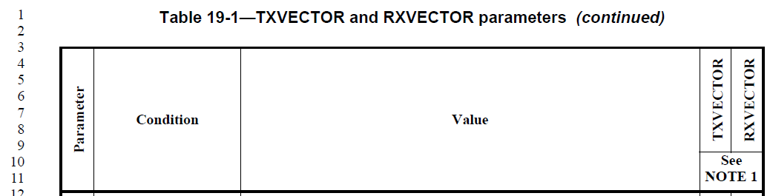
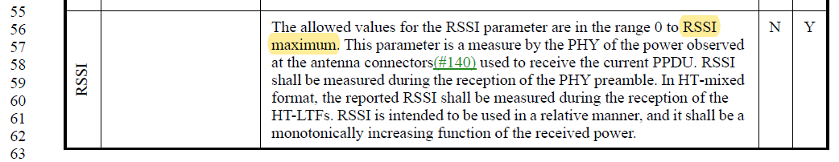

D2.2 P3068:
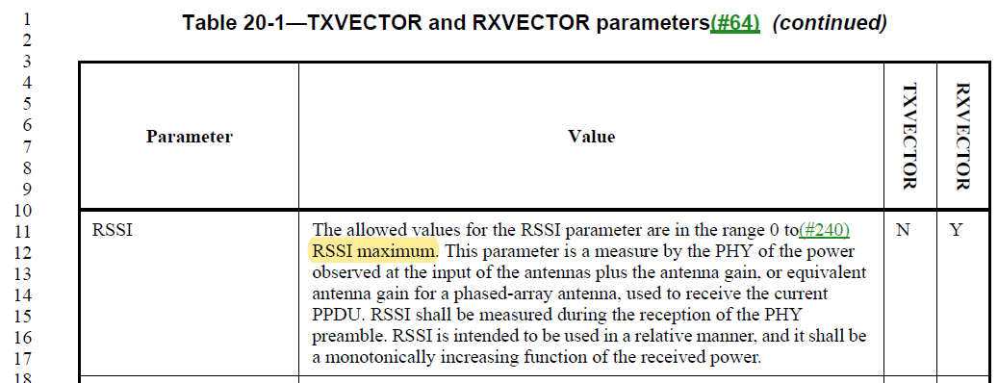

D2.2 P3121:
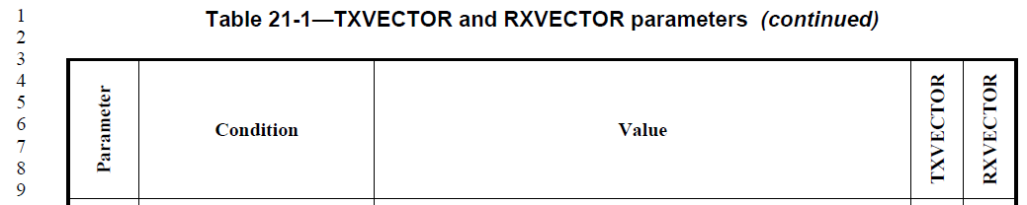
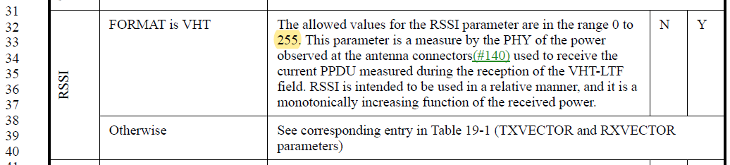

D2.2 P3255:
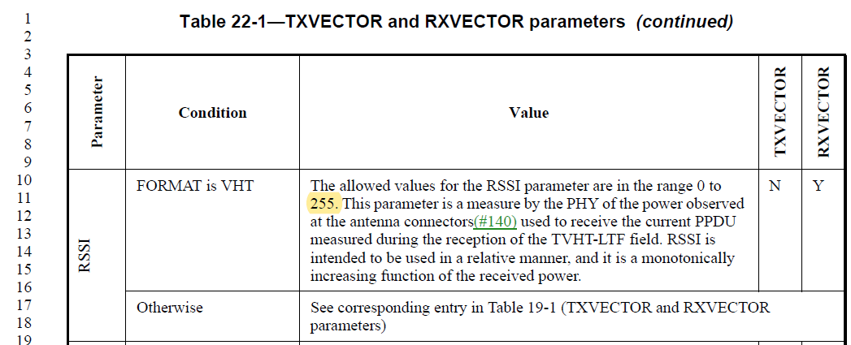

D2.2 P3308:
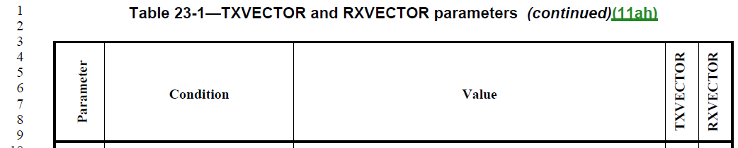
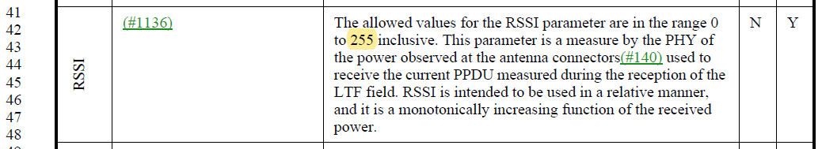

D2.2 P3432:
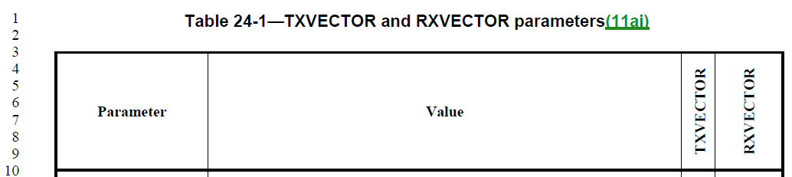
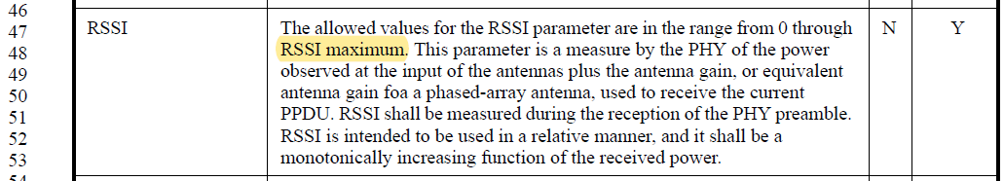

D2.2 P3461:
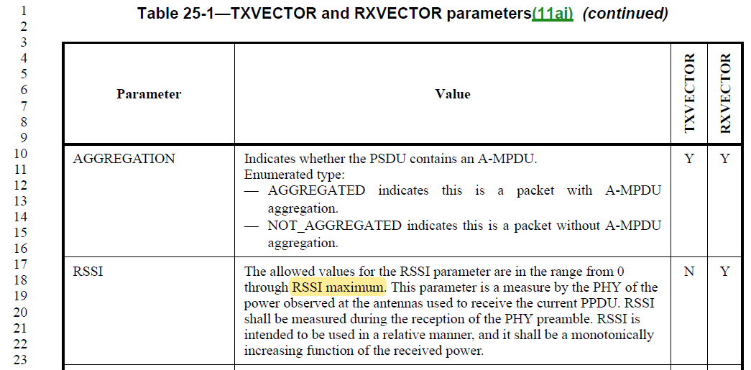

In summary:
Maximum RSSI value | Location in D2.2
RSSI max, RSSI maximum | MLME-TDLSPOTENTIALPEERSTA.confirm  Clause 17 (OFDM – a.k.a. 11a) RXVECTOR  Clause 18 (ERP – a.k.a. 11g) RXVECTOR  Clause 19 (HT) RXVECTOR  Clause 20 (DMG) RXVECTOR  Clause 24 (CDMG) RXVECTOR  Clause 25 (CMMG) RXVECTOR
255 | Clause 15 (DSSS) RXVECTOR  Clause 21 (VHT) RXVECTOR  Clause 22 (TVHT) RXVECTOR  Clause 23 (S1G) RXVECTOR
8 bits | Clause 16 (HR/DSSS – a.k.a. CCK) RXVECTOR

While there is no specific reason why RSSI should be “8 bits” integer (max. 255), it is already used in almost half the places in the draft. And given that the RX dynamic range of typical receivers do not exceed 100 dB, 256 levels seems sufficient for the purpose of RSSI. Hence, the suggestion is to replace “RSSI maximum”, “RSSI max” and “8 bits” with “255” throughout the draft.

Proposed Resolution: CID 2177
Revised.
There are multiple places in the draft which uses the value “255” as the maximum RSSI value. Hence, propose to replace “RSSI maximum”, “RSSI max” and “8 bits” with “255”.

Instruction to Editor (all PageLine locations are based on D2.2):
Change “RSSI Max” to “255” at P495L16.
Change “8 bits of RSSI” to “255” at P2887L26.
Change “RSSI maximum” to “255” at P2903L35, P2904L32, P2949L60, P2962L56, P3068L12, P3432L48, P3461L18.

CID 2712

CID | Clause | Page.Line | Comment | Proposed Change
2712 | 19.3.9.3.3 | 2977.00 | Looking at P2977L42, it says that the L-STF is identical to the Clause 17 (Orthogonal frequency division multiplexing (OFDM) PHY specification) short training symbol. The non-HT short training OFDM symbol in the 20 MHz channel width is shown in Equation (19-8). However, there seems to be inconsistency between 11a STF sequence related Equations (17-6), (17-7) and L-STF sequence related Equations (19-8), (19-10). It presents different power scaling factors on two different clauses. Clause 19 (and later clauses) absorbs the part of scaling factor in the Equation (19-8) and also adds per antenna CSD. | Option 1) At P2977L42, corresponding description deleted such as "The L-STF in the 20 MHz channel width is shown in Equation (19-8). However if we want to point out that there is no L-STF change between clause 17 and clause 19 (excluding CSD and scaling factors), Option 2) might be desirable.  Option 2) change Equation (17-6) to use the scaling factor of sqrt (1/2) and update Equation (17-7) to include another factor of N_L_STF to be consistent with later clauses.

Discussion

11a L-STF (P2.2 P3147)
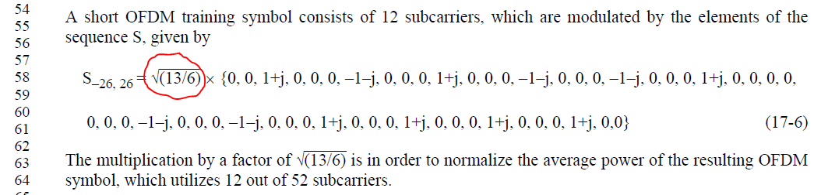
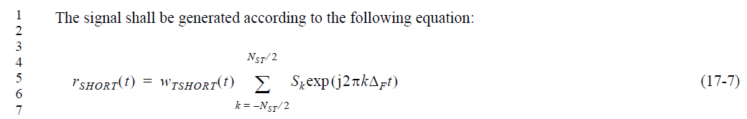

11a has the same number of modulated tones (52 tones) between L-LTF, L-SIG and Data fields. Only the L-STF field has different # of modulated tones (12 tones). Hence, 11a put the normalization factor solely in the L-STF field – specifically on the frequency domain modulated “constellations”.

In case of HT-mixed format, however, has different number of modulated tones between L-STF/HT-STF (12 tones for 20 MHz, 24 tones for 40 MHz), L-LTF/L-SIG/HT-SIG (52 tones for 20 MHz, 104 tones for 40 MHz) and HT-LTF/Data (56 tones for 20 MHz, 114 tones for 40 MHz). And the normalization factors to maintain consistent power between different fields were put in the equation representing the time domain waveform equation (Equation (19-10)).

HT-mixed format L-STF (D2.2 P2987)
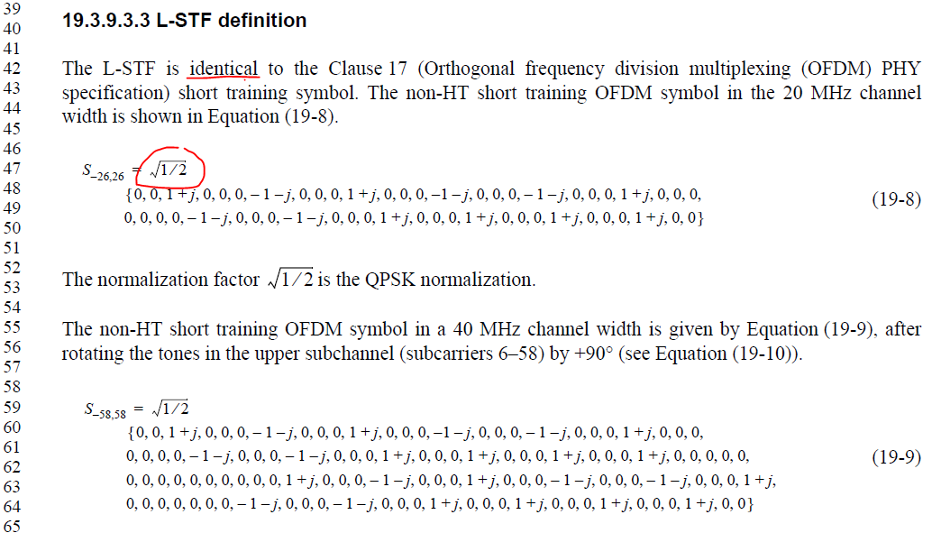

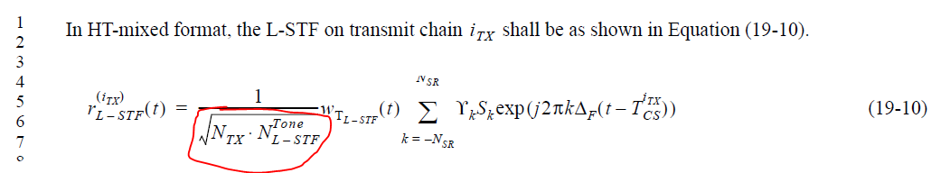

Issue pointed out by the commenter is that due to this difference in ‘representation’, it is not correct to sat that the Equations (17-6) and (19-8) are identical.

Option 2 suggested by the commenter is to update the equations in Clause 17 such that the normalization terms are in the time domain waveform generation, just like Clause 19. While that could be done, updating mathematical equations of existing PHY clauses should be done with caution.

Lastly, L-STF is also used in VHT and TVHT PPDUs. Fortunately, both VHT and TVHT do not use the phrase that the L-STF is “identical to” that of 11a. Hence, no changes are needed there.

VHT L-STF (D2.2 P3160)
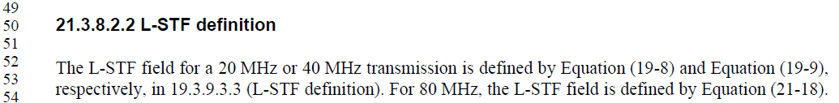

TVHT L-STF (D2.2 P3275)
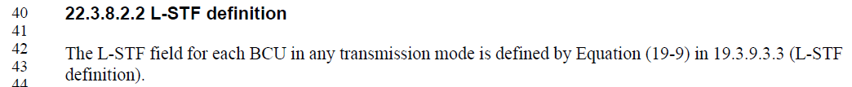

Proposed Resolution: CID 2712
Revised.
The commenter is correct that Equations (17-6) and (19-8) are not identical. While commenter’s option 2 is a valid approach, updating mathematical equations for PHY should be done with caution and should be avoided if possible. Note that 19.3.10.3.3 has all the necessary information to clearly define the L-STF waveform on its own. Hence, the proposal is delete the sentence with the phrase “identical”, and instead add a NOTE to inform readers that L-STF sequence of HT-mixed format is essentially the same as that of 11a, except for the scaling difference.

Instruction to Editor: Implement the text updates for CID 2712 in 11-19/0857r0.

Proposed Text Updates: CID 2712

TGmd Editor: Update Table 9-321b in D4.1 as shown below.

19.3.9.3.3 L-STF definition
TThe non-HT short training OFDM symbol in the 20 MHz channel width is shown in Equation (19-8).

NOTE – Other than the scaling difference, Equation (19-8) represents the same BPSK constellations per subcarrier as those represented in Equation (17-8).

[End of File]

