IEEE P802.11
Wireless LANs
CR on HE Capabilities
Date: 2019-5-12
Author(s):
Name | Affiliation | Address | Phone | email
Youhan Kim | Qualcomm |  |  | youhank@qti.qualcomm.com

Abstract
This submission proposes resolutions for the following comments from the letter ballot on P802.11ax D4.0:

20798, 21368, 21369, 20828, 20605, 20515, 20778, 20993, 20666

NOTE – Set the Track Changes Viewing Option in the MS Word to “All Markup” to clearly see the proposed text edits.

Revision History:

R0: Initial version.

CID 20798

CID | Clause | Page.Line | Comment | Proposed Change
20798 | 9.4.2.242.3 | 174.28 | "If a non-AP STA operates with 20 MHz channel width and 20 MHz In 160/80+80 MHz HE PPDU subfield is  set to 0, then B5 indicates support of 242-tone RUs in a 40 MHz and 80 MHz HE MU PPDU in the 5 GHz band or 6 GHz band. If a non-AP STA operates with 20 MHz channel width and 20 MHz In 160/80+80 MHz HE PPDU subfield is set to 1, then B5 indicates support of 242-tone RUs in a 40 MHz, 80 MHz, 160 MHz, and 80+80 MHz HE MU PPDU in the 5 GHz band. "  -- shoudl also apply in the 6G band if the 20Min160/80+80 is set to 1. Also missing articles | Change to  "If a non-AP STA operates with 20 MHz channel width and the 20 MHz In 160/80+80 MHz HE PPDU subfield is set to 0, then B5 indicates support of 242-tone RUs in a 40 MHz and 80 MHz HE MU PPDU in the 5 GHz band or 6 GHz band. If a non-AP STA operates with the 20 MHz channel width and 20 MHz In 160/80+80 MHz HE PPDU subfield is set to 1, then B5 indicates support of 242-tone RUs in a 40 MHz, 80 MHz, 160 MHz, and 80+80 MHz HE MU PPDU in the 5 GHz band or 6 GHz band. ".  In the previous para change "and 20 MHz In 40 MHz HE PPDU In 2.4 GHz subfield " to "and the 20 MHz In 40 MHz HE PPDU In 2.4 GHz subfield "
20295 | 9.4.2.242.3 | 174.37 | "If a non-AP STA operates with 20 MHz channel width and 20 MHz In 160/80+80 MHz HE PPDU subfield is set to 1, then B5 indicates support of 242-tone RUs in a 40 MHz, 80 MHz, 160 MHz, and 80+80 MHz HE MU PPDU in the 5 GHz band". It should also apply to 6GHz band. | Change "in the 5GHz band" to "in the 5GHz and 6GHz band"

Discussion

Following is the suggested edits by CID 20798, which seems reasonable.

- Subfields of the HE PHY Capabilities Information field
Subfield | Definition | Encoding
Supported Channel Width Set | B0 indicates support for a 40 MHz channel width in the 2.4 GHz band.  B1 indicates support for a 40 MHz and 80 MHz channel width in the 5 GHz band or 6 GHz band.  B2 indicates support for a 160 MHz channel width in the 5 GHz band or 6 GHz band.  B3 indicates support for a 160/80+80 MHz channel width in the 5 GHz band or 6 GHz band.  If a non-AP STA operates with 20 MHz channel width and the 20 MHz In 40 MHz HE PPDU In 2.4 GHz subfield is 1, then B4 indicates support of 242-tone RUs in a 40 MHz HE MU PPDU in the 2.4 GHz band. Otherwise, B4 is reserved.  If a non-AP STA operates with 20 MHz channel width and the 20 MHz In 160/80+80 MHz HE PPDU subfield is set to 0, then B5 indicates support of 242-tone RUs in a 40 MHz and 80 MHz HE MU PPDU in the 5 GHz band or 6 GHz band. If a non-AP STA operates with 20 MHz channel width and 20 MHz In 160/80+80 MHz HE PPDU subfield is set to 1, then B5 indicates support of 242-tone RUs in a 40 MHz, 80 MHz, 160 MHz, and 80+80 MHz HE MU PPDU in the 5 GHz or 6 GHz band. Otherwise, B5 is reserved.  B0 and B4 are applicable to 2.4 GHz band operation and reserved for 5 GHz band or 6 GHz band operation.  B1, B2, B3 and B5 are applicable to 5 GHz band and 6 GHz band operation and reserved for 2.4 GHz band operation. | B0 is set to 0 if not supported. B0 set to 1 if supported.  B1 is set to 0 if not supported, i.e., it indicates a 20 MHz-only non-AP HE STA in the 5 GHz band or 6 GHz band. B1 set to 1 if supported.  NOTE 1—For an AP, B1 is set to 1.  B2 is set to 0 if not supported. B2 set to 1 if supported. If B2 set to 1 then B1 is set to 1.  B3 is set to 0 if not supported. B3 is set to 1 if supported. If B3 set to 1 then B2 is set to 1.  B4 is set to 0 if not supported. B4 set to 1 if supported.  B5 set to 0 if not supported. B5 set to 1 if supported.  NOTE 2—B4 is set to 0, if a non-AP STA operates with 20 MHz channel width and the 20 MHz In 40 MHz HE PPDU In 2.4 GHz subfield is 0.  B6 is reserved.  NOTE 3—If a non-AP STA operates with 20 MHz channel width and the 20 MHz In 160/80+80 MHz HE PPDU subfield is set to 0, then the 242-tone RU in a 160 MHz and 80+80 MHz HE MU PPDU in the 5 GHz band or 6 GHz band is not supported.

CID 20295 is similar to CID 20798, except for the following difference:
- 20798: 5 GHz or 6 GHz band
- 20295: 5 GHz and 6 GHz band

Note that in all other locations in the definition of Supported Channel Width Set, “or” is used.

Proposed Resolution: CID 20798
Accepted.
Note to Editor: Discussion for CID 20798 in 11-19/0837r0 contains the red-lined version of the proposed change by the commenter should the editor wishes to check the changes.

Proposed Resolution: CID 20295
Revised.
CID 20798 provides similar text update and has been accepted.
Note to Editor: There is no additional text update for CID 20295 (text changes are coverd by CID 20798).

CID 21368, 21369

CID | Clause | Page.Line | Comment | Proposed Change
21368 | 9.4.2.242.3 | 175.57 | The definition is too hard to understand because of redundancy. The fact that STBC is used only for 1 spatial stream should/need not be mentioned here. | Change to "Indicates support for the transmission of an HE TB  PPDU using STBC for a bandwidth less than or equal to  80 MHz"
21369 | 9.4.2.242.3 | 175.62 | Redundant information is making the definition text hard to understand. The fact that STBC is used only for 1 spatial stream should/need not be mentioned here. | Change to "Indicates support for the reception of an HE PPDU using STBC  with a bandwidth less than or equal to 80 MHz."

Discussion

Agree with the commenter that there is no need to re-iterate that STBC supports only 1 spatial stream (defined in clause 27). Following is the update proposed by the commenter, which seems reasonable.

Table 9-321b – Subfields of the HE PHY Capabilities Information field
Subfield | Definition | Encoding
STBC Tx ≤ 80 MHz | Indicates support for the transmission of an HE TB PPDU using that has a bandwidth less than or equal to 80 MHz. | For a non-AP STA:  Set to 0 if not supported.  Set to 1 if supported.  Reserved for an AP.
STBC Rx ≤ 80 MHz | Indicates support for the reception of an HE PPDU using STBC that has a bandwidth less than or equal to 80 MHz. | Set to 0 if not supported.  Set to 1 if supported.
STBC Tx > 80 MHz | Indicates support for the transmission of an HE TB PPDU that has a bandwidth greater than 80 MHz and is using STBC with one spatial stream. | For a non-AP STA:  Set to 0 if not supported.  Set to 1 if supported.  Reserved for an AP.
STBC Rx > 80 MHz | Indicates support for the reception of an HE PPDU that has a bandwidth greater than 80 MHz and is using STBC with one spatial stream. | Set to 0 if not supported.  Set to 1 if supported.

Proposed Resolution: CID 21368, 21369
Accepted.
Note to Editor: Discussion for CID 20798 in 11-19/0837r0 contains the red-lined version of the proposed change by the commenter should the editor wishes to check the changes.

CID 20828, 20605

CID | Clause | Page.Line | Comment | Proposed Change
20828 | 9.4.2.242.3 | 177.30 | "For bandwidth" is not clear | At 177.30 change "For bandwidth" to "For PPDU bandwidths". At 177.42 change "For bandwidths" to "For PPDU bandwidths"
20605 | 9.4.2.242.3 | 177.34 | "RU r" -- this is undefined. Also the para at the cited location seems to be defining two things, so is missing an "and" in the middle (although the rightmost cell only mentions one of the things, so the other seems subsidiary) | Change "it indicates the maximum number of space-time streams that the STA can receive in an HE sounding NDP, the maximum value for the total number of space-time streams over all the users in RU r, NSTS,r,total that can be sent in a DL MU-MIMO transmission on an RU, where the RU might or might not span the entire PPDU bandwidth, that includes that STA." to "indicates the maximum number of space-time streams that the STA can receive in an HE sounding NDP, which is also the maximum total number of space-time streams over all the users that can be sent in a DL MU-MIMO transmission on an RU that includes that STA, where the RU might or might not span the entire PPDU bandwidth." Make the same change in the next cell down and on page 727 (2x). At 562.1 change "RU r" to "RU". At 562.11 change " RU r, which is calculated as a function of NSTS,r,total," to " RU, which is calculated as a function of the total number of space-time streams over all the users on that RU,"

Discussion
Agree with CID 20828.

As for CID 20605, agree with the commenter that the phrase “RU r” is not very clear. However, the commenter also proposes to delete N_{STS,r,total} from a location in 27.3.10.10 (HE-LTF). Not that N_{STS,r,total} is defined in the paragraph preceding it, and do not need to be removed.
27.3.10.10 HE-LTF
The HE-LTF field provides a means for the receiver to estimate the MIMO channel between the set of constellation mapper outputs (or, if STBC is applied, the STBC encoder outputs) and the receive chains. In an HE SU PPDU and HE ER SU PPDU, the transmitter provides training for N_{STS} space-time streams (spatial mapper inputs) used for the transmission of the PSDU. In an HE MU PPDU, the transmitter provides training for N_{STS,r,total} space-time streams used for the transmission of the PSDU(s) in the r-th RU. In an HE TB PPDU, the transmitter of user u in the r-th RU provides training for N_{STS,r,u} space-time streams used for the transmission of the PSDU. For each subcarrier in the r-th RU, the MIMO channel that can be estimated is an N_{RX} × N_{STS,r,total} matrix. An HE transmission has a preamble that contains HE-LTF symbols, where the data tones of each HE-LTF symbol are multiplied by entries belonging to a matrix P_{HE-LTF}, to enable channel estimation at the receiver. The pilot subcarriers of each HE-LTF symbol are multiplied by the entries of a matrix R_{HE-LTF} defined below. The multiplication of the pilot subcarriers in the HE-LTF symbol by the R_{HE-LTF} matrix instead of the P_{HE-LTF} matrix allows receivers to track phase and frequency offset during MIMO channel estimation using the HE-LTF. Single stream pilot in HE-LTF shall be used for SU, DL and UL OFDMA, DL MU-MIMO and UL MU-MIMO transmission using HE UL MU-MIMO single stream pilot HE-LTF mode.
In an HE SU PPDU, HE ER SU PPDU and HE MU PPDU with a single RU (the RU having an MU-MIMO allocation or an SU allocation), the number of HE-LTF symbols, N_{HE-LTF}, is a function of the total number of space-time streams N_{STS} as shown in Table 21-13 (Number of VHT-LTFs required for different numbers of space-time streams) in 21.3.8.3.5 (VHT-LTF definition), replacing N_{VHT-LTF} by N_{HE-LTF} and replacing N_{STS,total} by N_{STS}. In an HE TB PPDU, N_{HE-LTF} is indicated in the Trigger frame that triggers the transmission of the PPDU. In an HE MU PPDU, N_{HE-LTF} is indicated in the HE-SIG-A field. In an HE MU PPDU with more than one RU and in an HE TB PPDU, N_{HE-LTF} may take a value 1, 2, 4, 6 or 8 that is greater than or equal to the maximum value of the initial number of HE-LTF symbols for each RU r, where the initial number of HE-LTF symbols is calculated as a function of N_{STS,r,total} based on Table 21-13 (Number of VHT-LTFs required for different numbers of space-time streams) in 21.3.8.3.5 (VHT-LTF definition) with N_{VHT-LTF} replaced by N_{HE-LTF}.

Proposed Resolution: CID 20848
Accepted.
Note to Editor: FYI, proposed text update for CID 20605 (yes, 20605 – not a typo) contains the text update proposed by the commenter for CID 20848.

Proposed Resolution: CID 20605
Revised.
Agree with the commenter that the phrase “RU r” is not very clear. However, the commenter also proposes to delete N_{STS,r,total} from a location in 27.3.10.10 (HE-LTF). Not that N_{STS,r,total} is defined in the paragraph preceding it, and do not need to be removed.
Proposed text update in 11-19/0837 incorporates most of the changes suggested by the commenter, with some additional updates such as the one highlight in the previous sentence.

Instruction to Editor: Implement the text updates for CID 20605 in 11-19/0837r0.

Proposed Text Updates: CID 20605

TGax Editor: Update Table 9-321b in D4.1 as shown below.

Table 9-321b – Subfields of the HE PHY Capabilities Information field
Subfield | Definition | Encoding
Beamformee STS ≤ 80 MHz | For PPDU bandwidth less than or equal to 80 MHz, indicates the maximum number of space-time streams that the STA can receive in an HE sounding NDP, which is also the maximum total number of space-time streams over all the users that can be sent in a DL MU-MIMO transmission on an RU that includes that STA, where the RU might or might not span the entire PPDU bandwidth, that includes that STA. | If the SU Beamformee subfield is 1:  Set to the maximum number of space-time streams that the STA is capable of receiving in an HE sounding NDP minus 1. The minimum value of this field is 3.  Reserved if the SU Beamformee field is 0.
Beamformee STS > 80 MHz | For PPDU bandwidths greater than 80 MHz, indicates the maximum number of space-time streams that the STA can receive in an HE sounding NDP, which is also the maximum total number of space-time streams over all the users that can be sent in a DL MU-MIMO transmission on an RU that includes that STA, where the RU might or might not span the entire PPDU bandwidth, that includes that STA. | If the SU Beamformee subfield is 1:  Set to the maximum number of space-time streams that the STA is capable of receiving in an HE sounding NDP minus 1. The minimum value of this field is 3.  Reserved if the SU Beamformee subfield is 0 or the Supported Channel Width Set field does not indicate support for bandwidths greater than 80 MHz.

27.3.10.10 HE-LTF
TGax Editor: Update D4.1 P567L2 as shown below.
In an HE MU PPDU with more than one RU and in an HE TB PPDU, N_{HE-LTF} may take a value 1, 2, 4, 6 or 8 that is greater than or equal to the maximum value of the initial number of HE-LTF symbols for each RU, where the initial number of HE-LTF symbols is calculated as a function of N_{STS,r,total} (where r is the index of the RU) based on Table 21-13 in 21.3.8.3.5 with N_{VHT-LTF} replaced by N_{HE-LTF}.

CID 20515

CID | Clause | Page.Line | Comment | Proposed Change
20515 | 9.4.2.242.3 | 178.53 | "Indicates support for the transmission and reception of  the Data field of the HE ER SU PPDU" -- the whole PPDU is in the 106U, not just the Data field | Change "of the Data field of the HE ER SU PPDU" to "of HE ER SU PPDUs" in the cited text at the referenced location. In C.3 change "the Data field of the HE ER SU PPDU" to "HE ER SU PPDUs"

Proposed Resolution: CID 20515
Revised.
The whole PPDU is not transmitted in the high frequency 106-tone RU – the pre-HE modulates fields transmitted over the entire 20 MHz. Proposed text updates in 11-19/0837 clarifies that the HE modulated fields are transmitted in the high frequency 106-tone RU.

Instruction to Editor: Implement the text updates for CID 20515 in 11-19/0837r0.

Proposed Text Updates: CID 20515

TGax Editor: Update Table 9-321b in D4.1 as shown below.

Table 9-321b – Subfields of the HE PHY Capabilities Information field
Subfield | Definition | Encoding
Partial Bandwidth Extended Range | Indicates support for the transmission and reception of the of the HE ER SU PPDU in which the HE modulated fields are transmitted over the high frequency 106-tone RU within primary 20 MHz channel. | Set to 0 if not supported.  Set to 1 if supported.

C.3 MIB Detail
TGax Editor: Update D4.1 P732L4 as shown below.

dot11HEPartialBWERSUPayloadImplemented OBJECT-TYPE
SYNTAX TruthValue
MAX-ACCESS read-only
STATUS current
DESCRIPTION
"This is a capability variable.
Its value is determined by device capabilities.

This attribute, when true, indicates that the non-AP STA is capable of transmitting and receiving the HE ER SU PPDU in which the HE modulated fields are transmitted over the high frequency 106-tone within primary 20 MHz channel. This capability is disabled otherwise."
DEFVAL { false }
::= { dot11PhyHEEntry 45 }

CID 20778

CID | Clause | Page.Line | Comment | Proposed Change
20778 | 9.4.2.242.3 | 179.19 | Re CID 16324: the reason given for rejection is invalid. As it says on page 1, "This document is an unapproved draft of a proposed IEEE Standard. As such, this document is subject to  change. USE AT YOUR OWN RISK! Because this is an unapproved draft, this document must not be  utilized for any conformance/compliance purposes." | In Figure 9-772c change "PPE Thresholds Present" to "Reserved". In Table 9-321b delete the PPE Thresholds Present row and change "if the PPE Thresholds Present subfield is set to 0" to "if the PPE Thresholds field is not present" and "if the PPE Thresholds Present subfield is set to 1" to "if the PPE Thresholds field is present". In 26.12, delete the first two paras, change "A STA that sets the PPE Thresholds Present subfield to 0" to "A STA that does not transmit a PPE Thresholds field" (3x), and change "A STA that sets the PPE Thresholds Present subfield to 1" to "A STA that includes a PPE Thresholds field"

Background

D4.1 P169
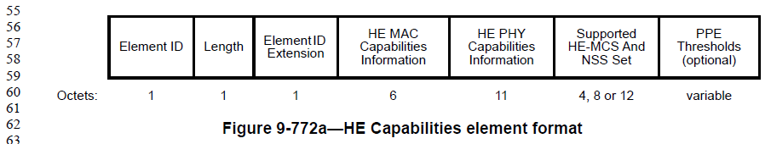

D4.1 P184

Proposed Resolution: CID 20778
Rejected.
While the commenter is correct that it is feasible for receivers to figure out whether the PPE Thresholds field is present in the HE Capabilities element without an explicit signalling such as the “PPE Thresholds Present” subfield, there is nothing technically incorrect about having the “PPE Thresholds Present” subfield either to simplify receiver processing.
There are also many instances where information is included in the HE Capabilities element even though it can be derived without explicit signalling. For example, an HE AP which supports transmitting 4 or more spatial streams must support SU Beamformer and MU Beamformer. Hence, one could argue that the “SU Beamformer” and “MU Beamformer” subfields are not needed in the HE Capabilities element if an AP indicates transmitting 4 or more spatial streams. However, the group has decided to keep the “SU Beamformer” and “MU Beamformer” subfields even in these cases to simplify the receiver processing.

CID 20993

CID | Clause | Page.Line | Comment | Proposed Change
20993 | 9.4.2.242.5 | 185.13 | Re CID 16325: the resolution deleted an important constraint on PPET values, rather than adding the missing other constraints | Reinstate the deleted "The value of the PPET8 NSTSn RUb subfield is always less than the value of the PPET16 NSTSn RUb subfield, except if the PPET8 subfield is 7." text and add "The value of the PPET8 NSTSi RUb subfield is less than or equal to the value of the PPET8 NSTSj RUb subfield for any given RUb, if both are present and i > j."

Discussion

The commenter is asking for two things in CID 20993:
- Revert the deletion of the yellow highlighted text which was deleted from D3.2.
- Add new restriction that if, for example, 64-QAM in 3SS requested 8 usec of nominal packet padding, then 64-QAM in 2SS shall not request 16 usec of nominal packet padding.

D3.2 P174:
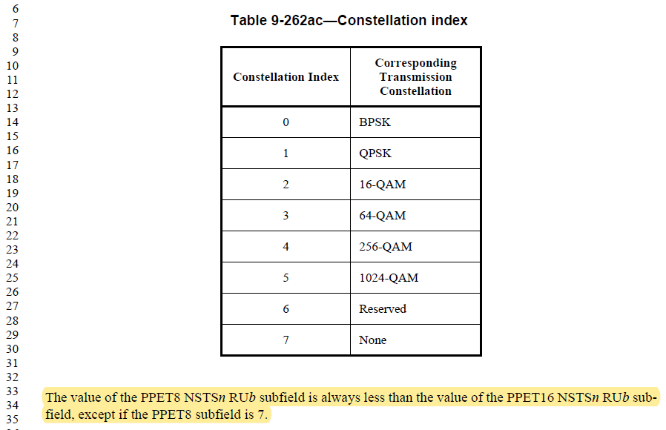

Regarding #1, agree with the commenter that it should not have been removed.

Regarding #2, it is a new requirement which was not present in D3.0 or D4.0. The commenter has not provided any justification on introducing new requirements at this point.

Proposed Resolution: CID 20993
Revised.
Agree with the commenter that the sentence at D3.2 P174L33 was erroneously deleted. Proposed text update in 11-19/0837 reinstates the sentence.
Regarding the second part of the comment which requests to add additional restriction on the possible values of PPET8 and PPET16, it is a new requirement which was not present in D3.0 or D4.0. The commenter has not provided any justification on introducing such new requirement. Furthermore, there is no interop issue with the current state without such new requirement. Hence, the new requirement should not be added to the draft.

Instruction to Editor: Implement the proposed text updates for CID 20993 in 11-19/0837r0.

Proposed Text Updates: CID 20993

TGax Editor: Insert the following sentence at D4.1 P191L34.

The value of the PPET8 NSTSn RUb subfield is always less than the value of the PPET16 NSTSn RUb subfield, except if the PPET8 subfield is 7.

CID 20666

CID | Clause | Page.Line | Comment | Proposed Change
20666 | 9.4.2.242.5 | 185.35 | "The RU Index Bitmask subfield contains a bitmask that indicates whether PPE threshold values are present  for each of four RU allocation sizes according to their RU allocation index values (see Table 9-321e (RU  allocation index)). For example, if B3 is set to 1, PPE threshold values are present for the RU allocation cor-  responding to RU allocation index 0 and if B3 is set to 0, PPE threshold values are not present for the RU  allocation corresponding to RU allocation index being 0." is not clear. B3 of the RU Index Bitmask is the wrong bit in the example | Delete the sentence starting "For example" in the cited text at the referenced location

Discussion

D4.1 P190:
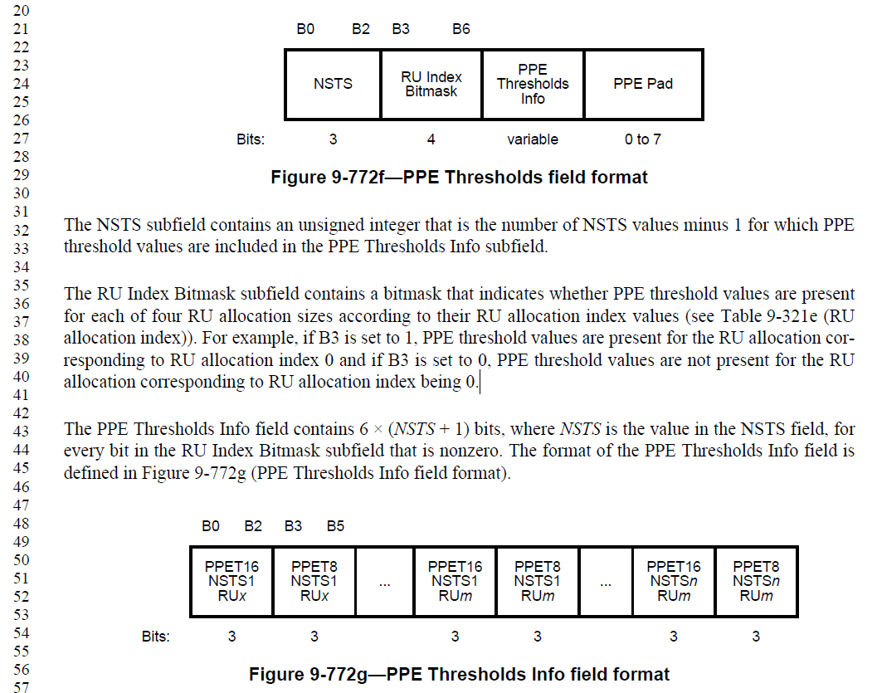

D4.1 P191:
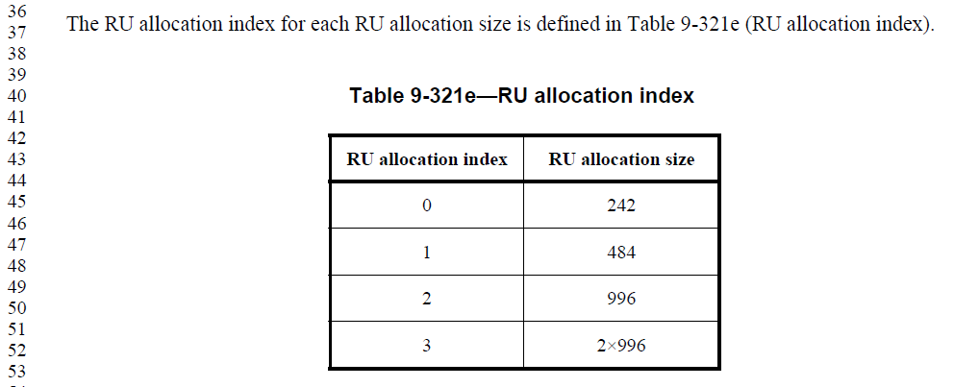

Agree with the commenter that it is hard to understand that 242-tone RU (RU allocation index 0) corresponds to B3 of the PPE Thresholds field format.

Proposed Resolution: CID 20666
Revised.
Agree with the commenter that it is hard to understand that 242-tone RU (RU allocation index 0) corresponds to B3 of the PPE Thresholds field format. Proposed text update in 11-19/0837 clarifies the text.

Instruction to Editor: Implement the proposed text updates for CID 20666 in 11-19/0837r0.

Proposed Text Updates: CID 20666

TGax Editor: Insert the following sentence at D4.1 P190L35.

The RU Index Bitmask subfield contains a bitmask that indicates whether the PPE Thresholds Info field contains PPET16 and PPET8 values for the four possible RU sizes indicated in Table 321e. The PPET16 and PPET8 values for RU allocation index k is present in the PPE Thresholds Info field only if the k-th bit of the RU Index Bitmask subfield ((3+k)-th bit of the PPE Thresholds field) is set to 1. For example, if B3 of the PPE Thresholds field is set to 1, PPET16 and PPET8 values are present in the PPE Thresholds Info field for the RU allocation size corresponding to RU allocation index 0 (242-tones). If the B3 is set to 0, then PPET16 and PPET8 values are not present in the PPE Thresholds Info field for the RU allocation size corresponding to RU allocation index being 0.

[End of File]

