IEEE P802.11
Wireless LANs
D4.0 Comment Resolution – Part 3
Date: 2019-5-14
Author(s):
Name | Affiliation | Address | Phone | email
Youhan Kim | Qualcomm |  |  | youhank@qti.qualcomm.com

Abstract
This submission proposes resolutions for the following comments from the letter ballot on P802.11ax D4.0:

20834

NOTE – Set the Track Changes Viewing Option in the MS Word to “All Markup” to clearly see the proposed text edits.

Revision History:

R0: Initial version.

CID 20834

CID | Clause | Page.Line | Comment | Proposed Change
20834 |  |  | "UL Packet Extension" -- no such field | Change "UL Packet Extension" to "Pre-FEC Padding Factor, PE Disambiguity" in 9.3.1.22.5 and 9.3.1.22.9. Delete "in the UL Packet Extension subfield" in 26.5.3.3.3 and 27.3.12 (2x). Change "the UL Packet Extension subfield" to "the Pre-FEC Padding Factor subfield" in 27.3.11.5.5

Background

D4.1 P107:
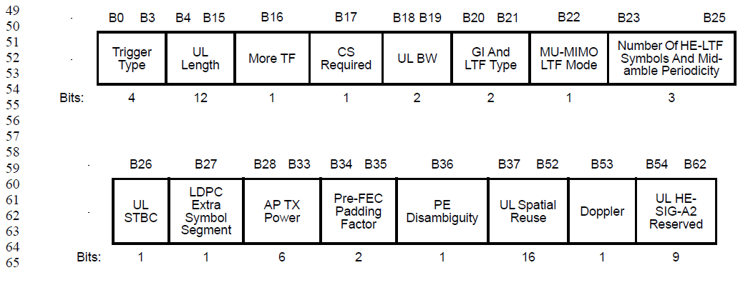

Proposed Resolution: CID 20834
Revised.
Proposed text update in 11-19/0836 fixes the term “UL Packet Extension” in a few more places.

Instruction to Editor: Implement the proposed text updates for CID 20834 in 11-19/0836r0.

Proposed Text Updates: CID 20834

9.3.1.22.5 MU-RTS variant

TGax Editor: Update D4.1 P117L20 as shown below.

The UL Length, GI And LTF Type, MU-MIMO LTF Mode, Number Of HE-LTF Symbols And Midamble Periodicity, UL STBC, LDPC Extra Symbol Segment, AP TX Power, Pre-FEC Padding Factor, PE Disambiguity, UL Spatial Reuse, Doppler and UL HE-SIG-A2 Reserved subfields in the Common Info field are reserved.

9.3.1.22.9 NDP Feedback Report Poll (NFRP) variant

TGax Editor: Update D4.1 P118L64 as shown below.

The UL STBC, LDPC Extra Symbol Segment, Pre-FEC Padding Factor, PE Disambiguity, UL Spatial Reuse, and Dop-pler subfields are reserved.

26.5.2.2.4 Allowed settings of the Trigger frame fields and TRS Control subfield

TGax Editor: Update D4.1 P333L1 as shown below.

- The Pre-FEC Padding Factor subfield is set to the default PE duration value, which is indicated by the AP in the Default PE Duration subfield of the HE Operation element it transmits and the pre- FEC padding factor is set to 4

26.5.2.3.3 TXVECTOR parameters for HE TB PPDU response to Trigger frame

TGax Editor: Update D4.1 P337L51 as shown below.

- The HE_TB_PE_DISAMBIGUITY parameter is set to the value indicated by the PE Disambiguity subfield in the Common Info field in the Trigger frame.

27.3.11.5.5 Encoding process for an HE TB PPDU

TGax Editor: Update D4.1 P591L24 as shown below.

— If the TXVECTOR parameter TRIGGER_METHOD is TRIGGER_FRAME, the initial parameters are NSYM,init = NSYM, and ainit = a, where a is the pre-FEC padding factor indicated in the Pre-FEC Pading Factor subfield of the Common Info field in the Trigger frame and NSYM is the common number of data OFDM symbols derived from the UL Length, Number Of HE-LTF Symbols And Midamble Periodicity, and Doppler subfields of the Common Info field in the Trigger frame

27.3.12 Packet extension

TGax Editor: Update D4.1 P610L56 as shown below.

The PE Disambiguity subfield in the Common Info field of the Trigger frame (see Table 9-31f) shall be set to 1 if the condition in Equation (27-118) is met for the HE TB PPDU solicited by the Trigger frame. Otherwise, it shall be set to 0.

TGax Editor: Update D4.1 P611L47 as shown below.

bPE-Disambiguity is the value indicated by the PE Disambiguity subfield of the HE-SIG-A field for an HE SU, HE ER SU or HE MU PPDU, or the value indicated by the PE Disambiguity subfield in the Common Info field in the Trigger frame (see Table 9- 31f (Pre-FEC Padding Factor and PE Disambiguity subfields)) for an HE TB PPDU.

[End of File]

