IEEE P802.11
Wireless LANs
Comment Resolutions for FDMA Transmit Spectrum Mask
Date: 2019-05-13
Author(s):
Name | Affiliation | Address | Phone | Email
Rui Cao | Marvell | 5488 Marvell Ln,  Santa Clara, CA 95054 | 408-222-0975 | ruicao@marvell.com
Sudhir Srinivasa | Marvell | 5488 Marvell Ln,  Santa Clara, CA 95054 |  | sudhirs@marvell.com

Abstract
This submission proposes resolutions for comments received on WUR Transmit Spectrum Mask for FDMA PPDU. The following is the list of CIDs:
- 2016

CID | Clause | Page.Line | Comment | Proposed Change | Resolution
2016 | 32.2.12.1 | 106.26 | Transmit mask is described for 20 MHz channel BW. It's not clear from the text describing the 40 MHz PPDU and 80 MHz PPDU transmission in 31.2.4.3 if a separate transmit mask is needed for 40 MHz and 80 MHz mask is needed. Is the 40 MHz PPDU and 80MHz PPDU transmission similar to a non-HT duplicated transmission. In addition, punctured transmissions for 20 MHz BW as described in 31.2.5.8. needs further clarification wrt the transmit mask. | Clarify the 40 MHz PPDU and 80 MHz PPDU transmission to determine if these transmissions are similar to non-HT duplication transmissions. Determine how punctured transmissions 40MHz and 80MHz PPDUs affect the transmit mask. Update text and add a plot of the overlapping transmit masks for the 40 MHz and 80 MHz PPDUs. | Revised.  Add description of the transmit spectrum mask for WUR FDMA PPDU.  TGba editor to make the changes shown in 11-19/0794r1.

TGba Editor: Please make the following changes (in red) in Section 31.2.12.1 of D2.1:

- Transmit spectrum mask
For operation using 20 MHz channel spacing, the transmitted spectrum shall have a 0 dBr (dB relative to the maximum spectral density of the signal) bandwidth not exceeding 18 MHz, –20 dBr at 11 MHz frequency offset, –28 dBr at 20 MHz frequency offset, and the maximum of –40 dBr and –53 dBm/MHz at 30 MHz frequency offset and above. The transmitted spectral density of the transmitted signal shall fall within the spectral mask, as shown in Figure 17-13 (Transmit spectrum mask for 20 MHz transmission).
NOTE 1—In the presence of additional regulatory restrictions, the device has to meet both the regulatory requirements and the mask defined in this subclause.
NOTE 2—Transmit spectral mask in Figure 17-13 (Transmit spectrum mask for 20 MHz transmission) is not drawn to scale.
NOTE 3—For rules regarding TX center frequency leakage levels, see 21.3.17.4.2 (Transmit center frequency leakage). The spectral mask requirements in this subclause do not apply to the RF LO.

For a WUR FDMA PPDU, the spectrum mask within each 20MHz subchannel will be the same as the spectrum mask of 20MHz WUR PPDU as defined above. The spectrum outside the WUR FDMA PPDU channel bandwidth will be the same as spectrum mask of 40MHz or 80MHz as defined in 21.3.17.1 (Transmit spectrum mask).

For a 40MHz mask WUR FDMA PPDU, the transmitted spectrum of the L-STF, L-LTF, L-SIG, and BPSK-Mark fields shall have a 0 dBr (dB relative to the maximum spectral density of the signal) bandwidth not exceeding 38 MHz, –20 dBr at 21 MHz frequency offset, –28 dBr at 40 MHz frequency offset, and the maximum of –40 dBr at 60 MHz frequency offset and above. The transmitted spectral density of of the L-STF, L-LTF, L-SIG, and BPSK-Mark fields of the transmitted signal shall fall within the spectral mask, as shown in Figure 21-30 (Example transmit spectrum mask for 40 MHz transmission).

For a 40MHz mask WUR FDMA PPDU, the transmitted spectrum of the WUR-Sync and WUR-Data fields within each 20MHz subchannel shall have a 0 dBr (dB relative to the maximum spectral density of the signal) bandwidth not exceeding 4.5 MHz from the center of the 20MHz subchannel, –15 dBr at 3.5 MHz, and -20 dBr at 11 MHz frequency offset from the center of the 20MHz subchannel. The transmitted spectrum of the WUR-Sync and WUR-Data fields shall have –28 dBr at 40 MHz frequency offset, and the maximum of –40 dBr at 60 MHz frequency offset and above. The transmitted spectral density of the WUR-Sync and WUR-Data fields of the transmitted signal shall fall within the spectral mask, as shown in Figure 31-10b (Transmit spectrum mask for WUR-Sync and WUR-Data fields of 40MHz WUR FDMA PPDU transmission).

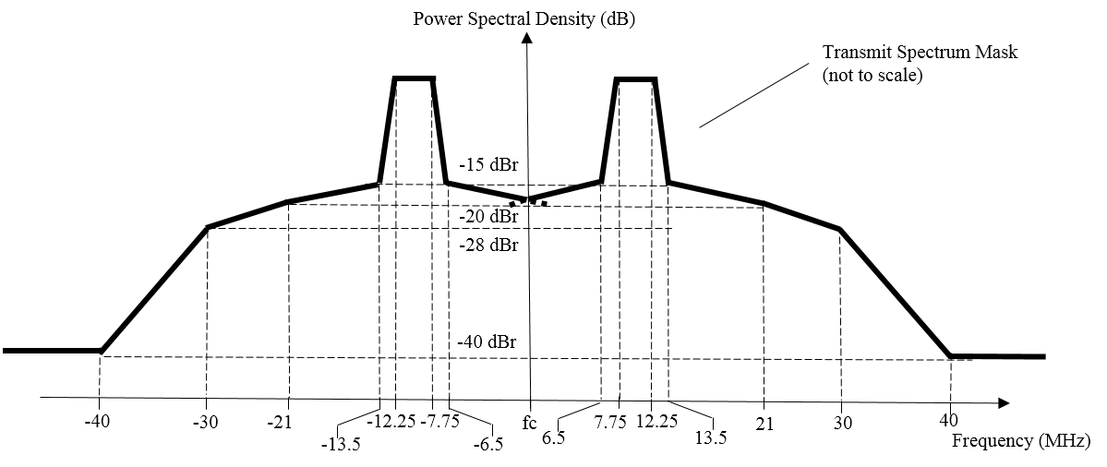
Figure 31-10b Transmit spectrum mask for WUR-Sync and WUR-Data fields of 40MHz WUR FDMA PPDU

For a 80MHz mask WUR FDMA PPDU, the transmitted spectrum of the L-STF, L-LTF, L-SIG, and BPSK-Mark fields shall have a 0 dBr (dB relative to the maximum spectral density of the signal) bandwidth not exceeding 78 MHz, –20 dBr at 41 MHz frequency offset, –28 dBr at 80 MHz frequency offset, and the maximum of –40 dBr at 120 MHz frequency offset and above. The transmitted spectral density of of the L-STF, L-LTF, L-SIG, and BPSK-Mark fields of the transmitted signal shall fall within the spectral mask, as shown in Figure 21-31 (Example transmit spectrum mask for 80 MHz transmission).

For an 80MHz mask WUR FDMA PPDU, the transmitted spectrum of the WUR-Sync and WUR-Data fields within each 20MHz subchannel shall have a 0 dBr (dB relative to the maximum spectral density of the signal) bandwidth not exceeding 4.5 MHz from the center of the 20MHz subchannel, –15 dBr at 3.5 MHz, -20dBr at 11 MHz frequency offset from the center of the 20MHz subchannel. The transmitted spectrum of the WUR-Sync and WUR-Data fields shall have –28 dBr at 80 MHz frequency offset, and the maximum of –40 dBr at 120 MHz frequency offset and above. The transmitted spectral density of the WUR-Sync and WUR-Data fields of the transmitted signal shall fall within the spectral mask, as shown in Figure 31-10c (Transmit spectrum mask for WUR-Sync and WUR-Data fields of 80MHz WUR FDMA PPDU transmission).

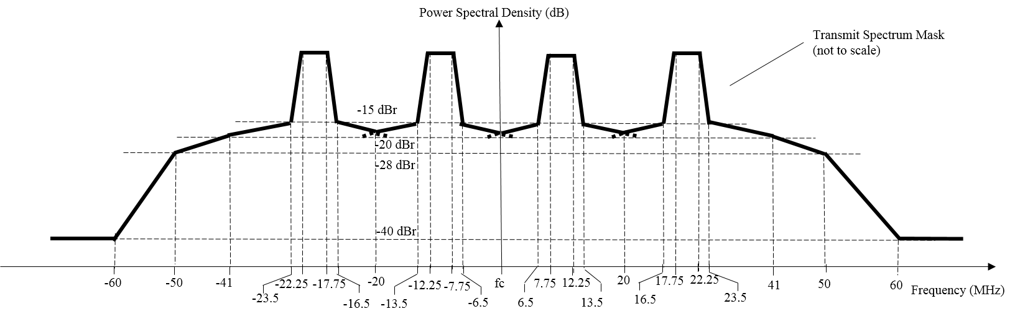

Figure 31-10c Transmit spectrum mask for WUR-Sync and WUR-Data fields of 80MHz WUR FDMA PPDU

