IEEE P802.11
Wireless LANs

Proposal for a transmit mask for the WUR-Sync and WUR-Data fields
Date: 2019-5-8
Author(s):
Name | Affiliation | Address | Phone | email
Minyoung Park | Intel Corporation |  |  | Minyoung.park@intel.com
Vinod Kristem | Intel Corporation

Abstract
This submission proposes

Revisions:
- Rev 0: Initial version of the document.
- Rev 1: Modified Tx mask based to be more relaxed.

Interpretation of a Motion to Adopt

A motion to approve this submission means that the editing instructions and any changed or added material are actioned in the TGba Draft. This introduction is not part of the adopted material.

Editing instructions formatted like this are intended to be copied into the TGba Draft (i.e. they are instructions to the 802.11 editor on how to merge the text with the baseline documents).

TGba Editor: Editing instructions preceded by “TGba Editor” are instructions to the TGba editor to modify existing material in the TGba draft. As a result of adopting the changes, the TGba editor will execute the instructions rather than copy them to the TGba Draft.

CID | P,L | Clause | Comment | Proposed Change | Resolutions
2062 | 106,21 | 31.2.12 | The signal bandwidth for WUR-Sync, WUR-Data and Padding fields shown in Figure 31-1, 31-2 and 31-3 should be specified.  Add a subclause in 31.2.12 WUR transmit specification to specify them. | Make a new subclause  "31.2.13.1 WUR Signal Bandwidth  The signal 3dB-bandwidth of WUR-Sync, WUR-Data and Padding fields, if it is applied, shown in Figure 31-1, 31-2 and 31-3 shall be 4MHz."  Shift the subclause numbers of existing subclauses up by 1, e.g.., change existing 31.2.13.1 to 31.2.13.2. | Revised.  A new paragraph is added to subclasue 31.2.12.1 (Transmit spectrum mask) that defines a transmit mask for the WUR-Sync and WUR-Data fields.  Instructions to TGba editor: Please incorporate the changes as shown in doc.: IEEE 802.11-19/0786r1 under the heading with the CID# 2062.

Discussion: In 802.11ba Draft 2.1, the transmit spectrum mask is defined for the L-STF, L-LTF, L-SIG, and BPSK-Mark fields that occupies approximately 16.6 MHz but not for the WUR-Sync and WUR-Data fields that occupies approximately 4.06 MHz signal bandwidth.

In subclause 17.3.9.3 (Transmit spectrum mask), transmit masks are defined for 20MHz, 10MHz, and 5 MHz channel operations. For the case of the 5 MHz channel spacing the transmit mask is defined for a signal occuping approximately 4.14 MHz as follows: “0 dBr bandwidth is 4.5 MHz and -20dBr at 2.75MHz frequency offset, -28 dBr at 5 MHz frequency offset, and the maximum of -40 dBr and -47dBm/MHz at 7.5 MHz frequency offset and above” (see the figure below).

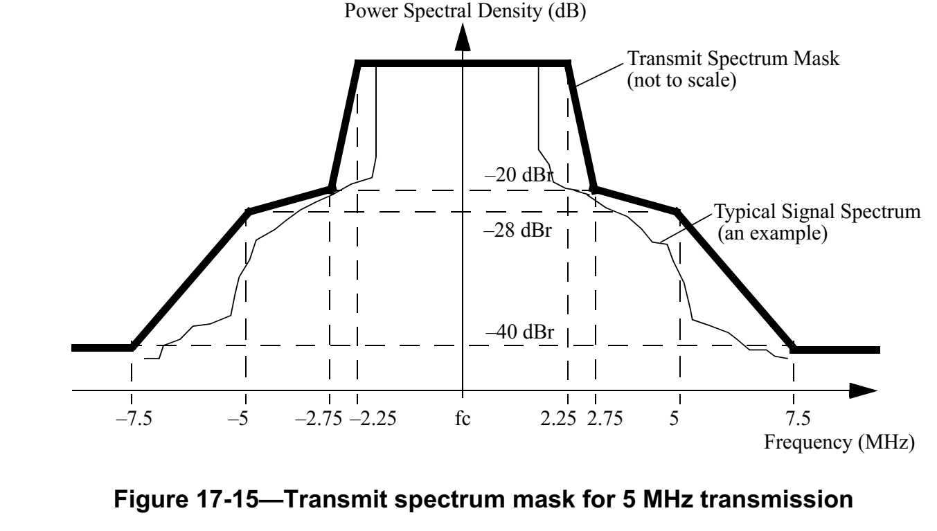
Considering the 13 tones 802.11ba D2.1 used to generate the WUR-Sync and WUR-Data fields of the WUR Basic PPDU, which occupies 4.06 MHz, this nicely matches the Clause 17’s 5 MHz channel operation case where 53 tones (including DC) occupies 4.14MHz. Since TGba is using just 13 tones (i.e. 13/53 ~ ¼ scaling), it is effectively shrinking the operation channel from 20MHz to 5 MHz (i.e. ¼ scaling), except that the tone spacing is 312.5KHz for LDR and effectively 312.5*2 KHz for HDR, which needs some adjustments to the 5 MHz chanel operation transmit mask. In this document, a similar approach is proposed to define a transmit mask for the WUR-Sync and WUR-Data fields.

The proposed method is to use 0 dBr bandwidth to be 4.5 MHz as defined in subclause 17.9.3 but relax the requirement between 2.25 MHz to 11 MHz as follows: -15 dBr at 3.5 MHz frequency offset, -20 dBr at 11 MHz frequency offset so that the transmitter doesn’t need to implement a new filter and use the 20 MHz transmit mask beyond 11 MHz frequency offset as same as the legacy preamble portion of the PPDU. This is shown in the following figure (blue line is the proposed mask for the WUR portion, i.e. WUR-Sync and WUR-Data).

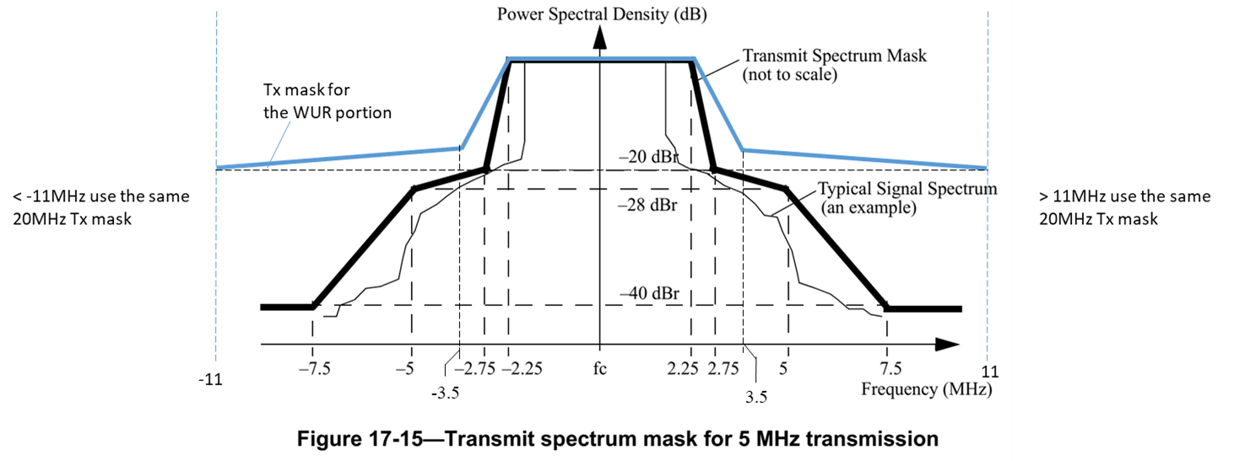

TGba Editor: Change the subclauses below in TGba Draft 2.1 as follows: (CID #2062)

31.2.12 WUR transmit specification
31.2.12.1 Transmit spectrum mask
For operation using 20 MHz channel spacing, the transmitted spectrum of the L-STF, L-LTF, L-SIG, and BPSK-Mark fields shall have a 0 dBr (dB relative to the maximum spectral density of the signal) bandwidth not exceeding 18 MHz, –20 dBr at 11 MHz frequency offset, –28 dBr at 20 MHz frequency offset, and the maximum of –40 dBr and –53 dBm/MHz at 30 MHz frequency offset and above. The transmitted spectral density of of the L-STF, L-LTF, L-SIG, and BPSK-Mark fields of the transmitted signal shall fall within the spectral mask, as shown in Figure 17-13 (Transmit spectrum mask for 20 MHz transmission).

For operation using 20 MHz channel spacing, the transmitted spectrum of the WUR-Sync and WUR-Data fields shall have a 0 dBr (dB relative to the maximum spectral density of the signal) bandwidth not exceeding 4.5 MHz, –15 dBr at 3.5 MHz frequency offset, -20 dBr at 11 MHz frequency offset, –28 dBr at 20 MHz frequency offset, and the maximum of –40 dBr and –53 dBm/MHz at 30 MHz frequency offset and above. The transmitted spectral density of the WUR-Sync and WUR-Data fields of the transmitted signal shall fall within the spectral mask, as shown in Figure 31-10a (Transmit spectrum mask for WUR-Sync and WUR-Data fields of WUR Basic PPDU transmission).

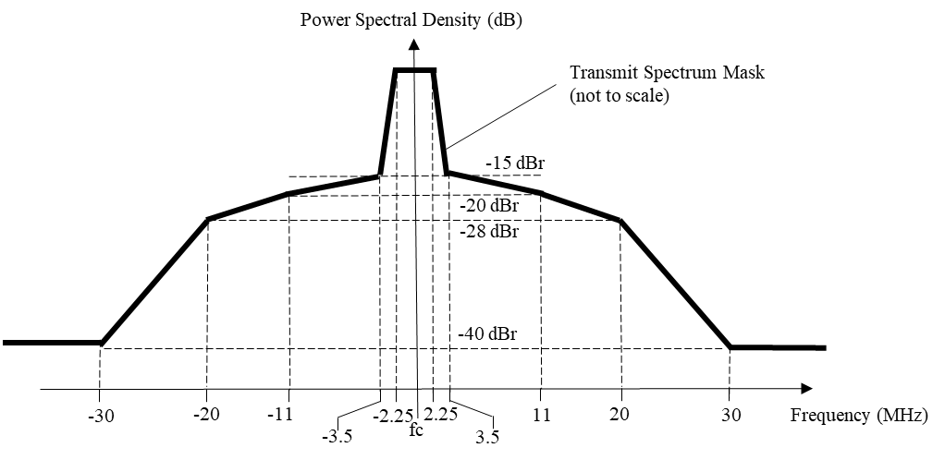
Figure 31-10a Transmit spectrum mask for WUR-Sync and WUR-Data fields of WUR Basic PPDU transmission

