IEEE P802.11
Wireless LANs
D3.0 CR on Hybrid Beamforming for CID 4310
Date: 2019-05-12
Author(s):
Name | Affiliation | Address | Phone | email
Kome Oteri | InterDigital | 9276 Scranton Road, #300, San Diego, CA, 92121 | +1 858 210 4826 | Kome.oteri@interidigital.com
Xioafei Wang
Li Hsiang Sun
Rui Yang
Introduction
This submission proposes resolutions for CID 4310 on Hybrid Beamforming.
Revisions:
- Rev 0: Initial version of document.

Interpretation of a Motion to Adopt
A motion to approve this submission means that the editing instructions and any changed or added material are actioned in the TGay Draft. This introduction is not part of the adopted material.
Editing instructions formatted like this are intended to be copied into the TGay Draft (i.e. they are instructions to the 802.11 editor on how to merge the text with the baseline documents).
TGay Editor: Editing instructions preceded by “TGay Editor” are instructions to the TGay editor to modify existing material in the TGay draft. As a result of adopting the changes, the TGay editor will execute the instructions rather than copy them to the TGay Draft.

CID | Commenter | Clause Number(C) | Page.Line | Comment | Proposed Change | Resolution
4310 | Oghenekome Oteri | 6.3 | 32.02 | MLME SAP interface for hybrid beamforming not done | Add MLME SAP interface for hybrid beamforming | Revised  Agree with the comment.  MLME primitives are added for SU MIMO HBF and MU-MIMO HBF.  TGay editor to make the changes shown in 11-19/0555r0 under all headings that include CID 4310

Discussion

We will use the MLME-SU-MIMO and MLME-MU-MIMO primitives as a baseline for the MLME for the hybrid beamforming protocol.

The MLME-SU-MIMO-BF-TRAINING.request primitive is shown below.

6.3.93.2.2 MLME-SU-MIMO-BF-TRAINING.request

MLME-SU-MIMO-BF-TRAINING.request(
PeerSTAAddress,
RequestMIMOBRP,
MIMOSetupControl
)

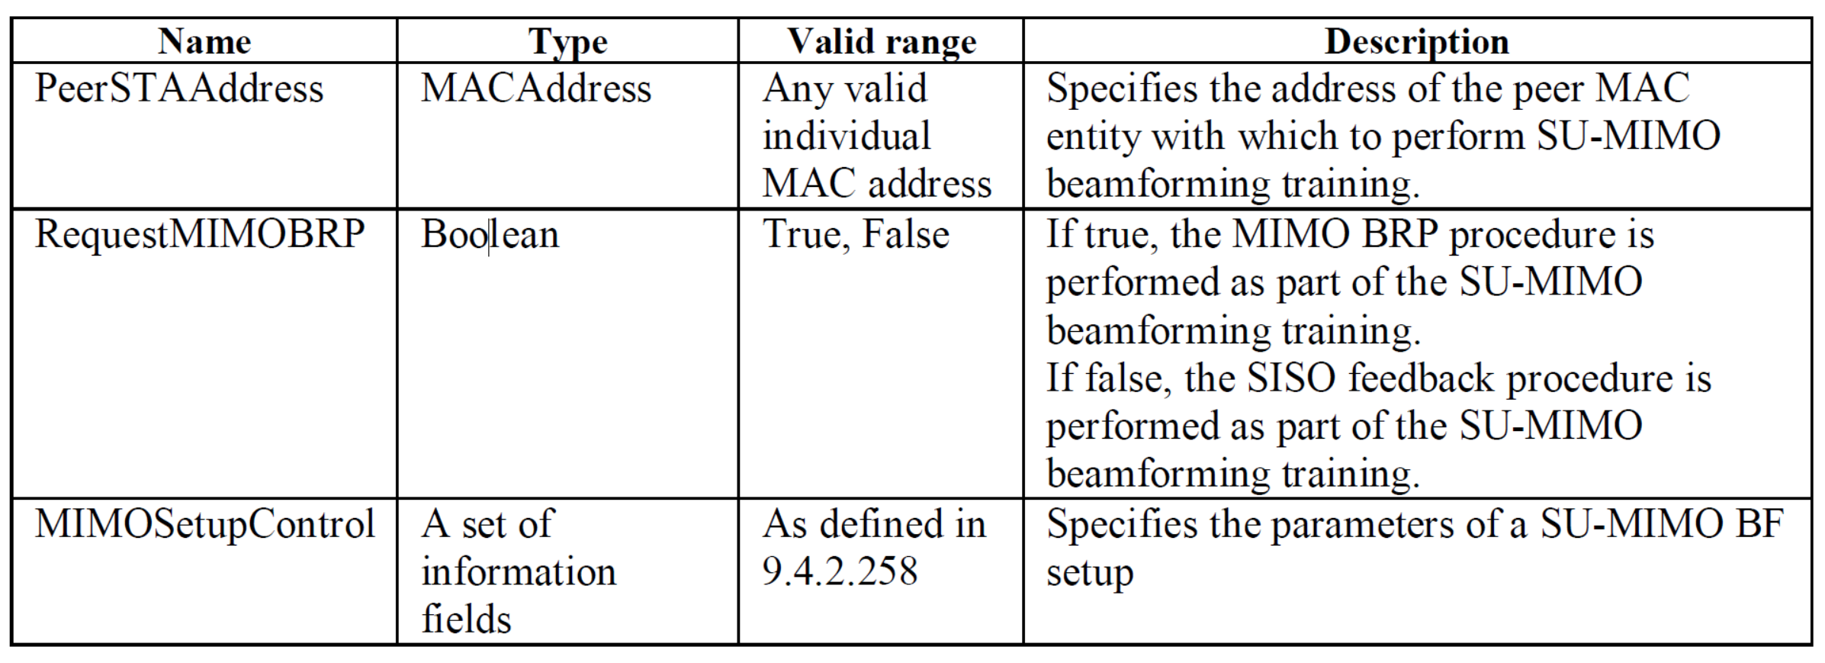

The frame exchange for the non-reciprocal MIMO phase of SU-MIMO beamforming and SU-MIMO hybrid beamforming are shown below:

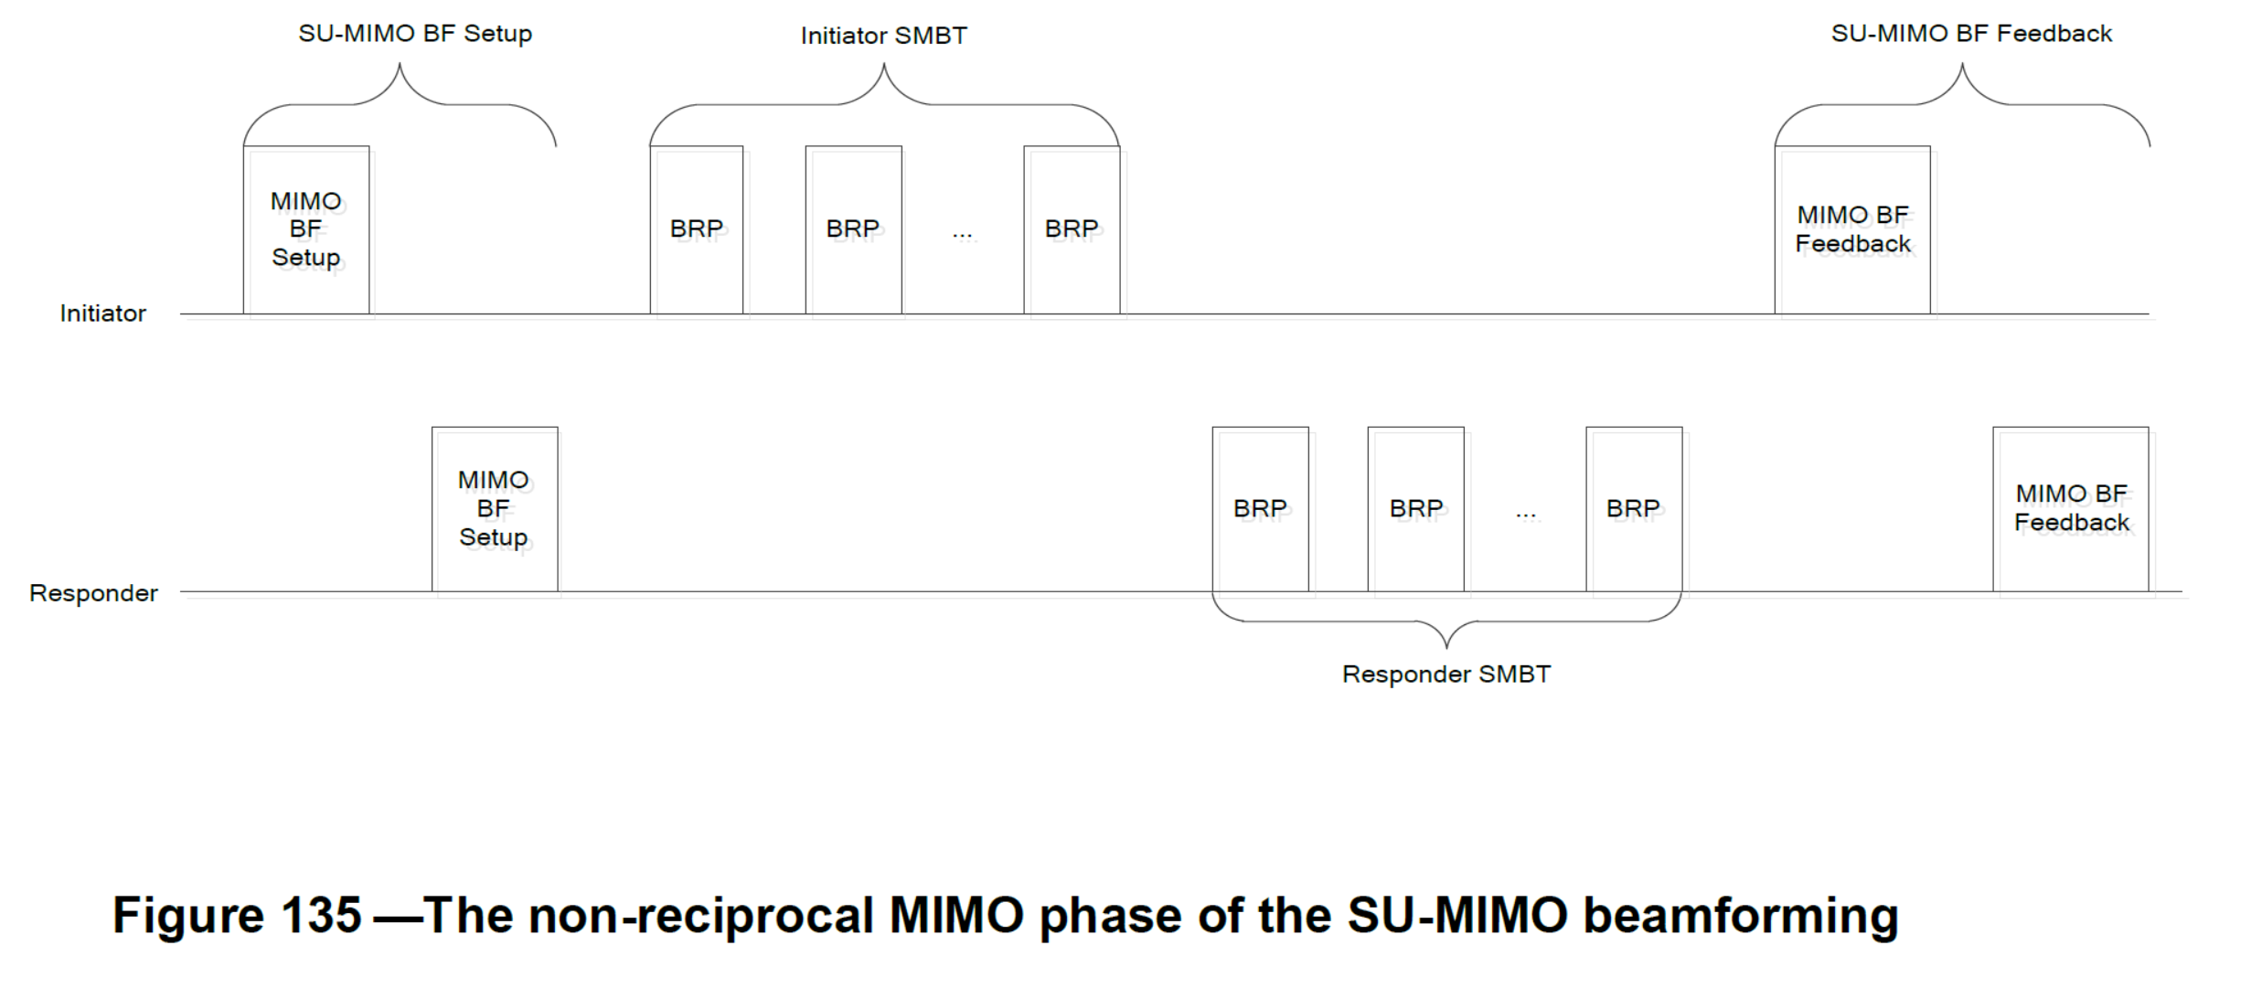

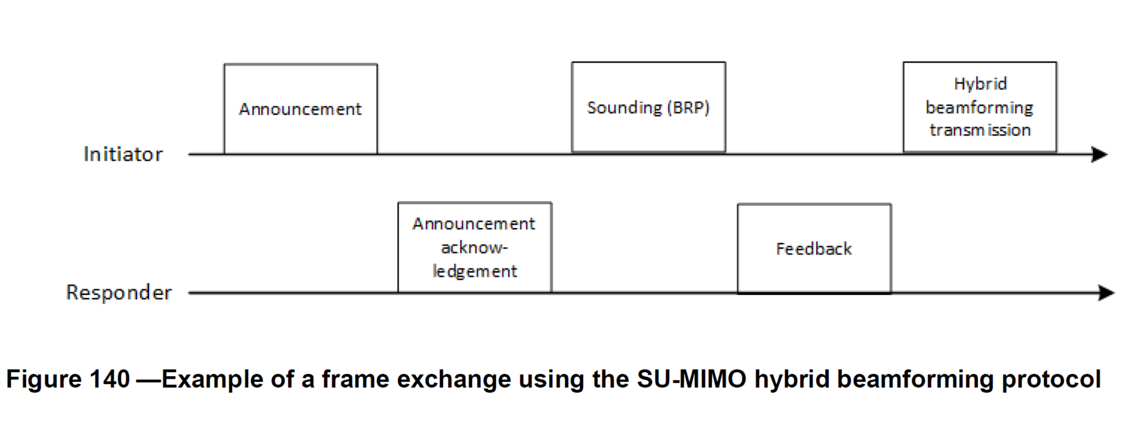

Based on the two frame exchange diagrams, we will do the following:
- Change the RequestMIMOBRP field to Sounding Type to indicate how the training in HBF is done.
- Change the MIMOSetupControl field to Control Trailer to indicate how to setup the HBF protocol. This is because the announcement contains the control trailer to set up the parameters used in the HBF protocol.

The new primitive becomes:
MLME-SU-MIMO-HYBRID-BF-PROTOCOL.request(
PeerSTAAddress,
SoundingType,
ControlTrailer
}

Name | Type | Valid range | Description
PeerSTAAddress | MACAddress | Any valid individual  MAC address | Specifies the address of the peer MAC entity with which to perform the SU-MIMO hybrid beamforming protocol.
Sounding Type | Boolean | True, False | If true, the BRP frames are used for the hybrid beamforming protocol.  If false, tracking is used for the SU-MIMO hybrid beamforming protocol.
ControlTrailer | A set of information fields | As defined in 29.3.7 | Specifies the parameters of an SU-MIMO hybrid beamforming Announcement in the SU MIMO hybrid beamforming protocol

The MLME-SU-MIMO-BF-TRAINING.confirm primitive is shown below:

6.3.93.2.3 MLME-SU-MIMO-BF-TRAINING.confirm

MLME-SU-MIMO-BF-TRAINING.confirm(
PeerSTAAddress,
ResultCode,
MIMOFeedbackControl,
MeasFeedback,
EDMGMeasFeedback
)

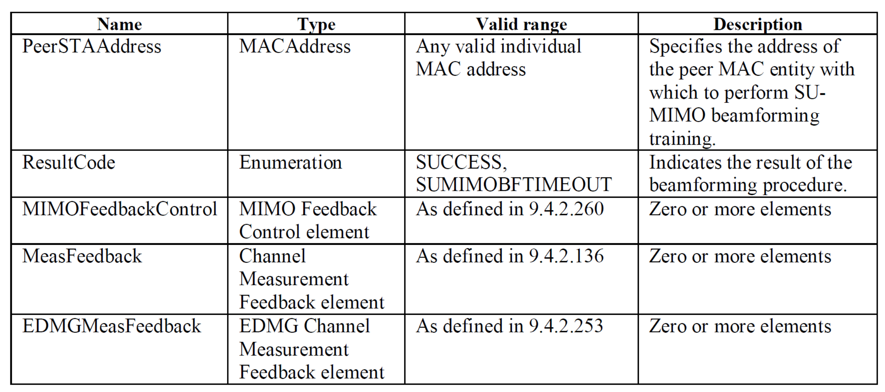

Based on the two frame exchange diagrams, the digital beamforming feedback is missing and we will do the following:
• add a DigitalBFFeedback field to enable digital beamforming feedback.

The new primitive becomes:
MLME-SU-MIMO-HYBRID-BF-PROTOCOL.confirm(
PeerSTAAddress,
ResultCode,
MIMOFeedbackControl,
MeasFeedback,
EDMGMeasFeedback ,
DigitalBFFeedback
)

Name | Type | Valid range | Description
PeerSTAAddress | MACAddress | Any valid individual  MAC address | Specifies the address of the peer MAC entity with which to perform the SU-MIMO hybrid beamforming protocol.
ResultCode | Enumeration | SUCCESS, SUMIMOHBFTIMEOUT | Indicates the result of the SU MIMO hybrid  beamforming procedure.
MIMOFeedbackControl | MIMO Feedback Control element | As defined in 9.4.2.260 | Zero or more elements
MeasFeedback | Channel Measurement Feedback element | As defined in 9.4.2.136 | Zero or more elements
EDMGMeasFeedback | EDMG Channel Measurement Feedback element | As defined in 9.4.2.253 | Zero or more elements
DigitalBFFeedback | Digital BF Feedback elements | As defined in 9.4.2.269 | Zero or more elements

The MLME-SU-MIMO-BF-TRAINING.indication primitive follows the same logic.

The new SU-MIMO and MU-MIMO hybrid beamforming primitives added to the specification below are based on this reasoning.

Changes to D3.0
TGay Editor: Please insert the the following at Pg 54 line 1, before the TDD MLME SAP (#4310)

6.3.93.4 SU-MIMO Hybrid Beamforming

6.3.93.4.1 General

This subclause describes the management procedures associated with SU-MIMO hybrid beamforming.

6.3.93.4.2 MLME-SU-MIMO-HYBRID-BF-PROTOCOL.request

6.3.93.4.2.1 Function

This primitive requests that the SU-MIMO hybrid beamforming protocol occurs with a peer STA.

6.3.93.4.2.2 Semantics of the service primitive

The primitive parameters are as follows:

MLME-SU-MIMO-HYBRID-BF-PROTOCOL.request(
PeerSTAAddress,
SoundingType,
ControlTrailer
)

Name | Type | Valid range | Description
PeerSTAAddress | MACAddress | Any valid individual  MAC address | Specifies the address of the peer MAC entity with which to perform the SU-MIMO hybrid beamforming protocol.
Sounding Type | Boolean | True, False | If true, the BRP frames are used for the hybrid beamforming protocol.  If false, tracking is used for the SU-MIMO hybrid beamforming protocol.
ControlTrailer | A set of information fields | As defined in 29.3.7 | Specifies the parameters of an SU-MIMO hybrid beamforming Announcement in the SU MIMO hybrid beamforming protocol

6.3.93.4.2.3 When generated
This primitive is generated by the SME to request that the SU-MIMO hybrid beamforming protocol be performed with a peer STA.

6.3.93.4.2.4 Effect on receipt

On receipt of this primitive, the MLME invokes the MAC sublayer SU-MIMO hybrid beamforming protocol procedures defined in 10.43.10.2.4

6.3.93.4.3 MLME-SU-MIMO-HYBRID-BF-PROTOCOL.confirm

6.3.93.4.3.1 Function

This primitive reports the outcome of a requested SU-MIMO hybrid beamforming protocol procedure.

6.3.93.4.3.2 Semantics of the service primitive

The primitive parameters are as follows:

MLME-SU-MIMO-HYBRID-BF-PROTOCOL.confirm(
PeerSTAAddress,
ResultCode,
MIMOFeedbackControl,
MeasFeedback,
EDMGMeasFeedback ,
DigitalBFFeedback
)

Name | Type | Valid range | Description
PeerSTAAddress | MACAddress | Any valid individual  MAC address | Specifies the address of the peer MAC entity with which to perform the SU-MIMO hybrid beamforming protocol.
ResultCode | Enumeration | SUCCESS, SUMIMOHBFTIMEOUT | Indicates the result of the SU MIMO hybrid  beamforming procedure.
MIMOFeedbackControl | MIMO Feedback Control element | As defined in 9.4.2.260 | Zero or more elements
MeasFeedback | Channel Measurement Feedback element | As defined in 9.4.2.136 | Zero or more elements
EDMGMeasFeedback | EDMG Channel Measurement Feedback element | As defined in 9.4.2.253 | Zero or more elements
DigitalBFFeedback | Digital BF Feedback elements | As defined in 9.4.2.269 | Zero or more elements

6.3.93.4.3.3 When generated

This primitive is generated by the MLME to report the result of the SU-MIMO hybrid beamforming protocol with a peer STA.

6.3.93.4.3.4 Effect on receipt

The SME is notified of the result of the procedure.

6.3.93.4.4 MLME-SU-MIMO-HYBRID-BF-PROTOCOL.indication

6.3.93.4.4.1 Function

This primitive indicates that the SU-MIMO hybrid beamforming protocol with a peer STA, and at the request of that peer, has completed.

6.3.93.4.4.2 Semantics of the service primitive

The primitive parameters are as follows:

MLME-SU-MIMO-HYBRID-BF-PROTOCOL.indication(
PeerSTAAddress,
ResultCode,
MIMOFeedbackControl,
MeasFeedback,
EDMGMeasFeedback,
DigitalBFFeedback
)

Name | Type | Valid range | Description
PeerSTAAddress | MACAddress | Any valid individual  MAC address | Specifies the address of the peer MAC entity with which to perform the SU-MIMO hybrid beamforming protocol.
ResultCode | Enumeration | SUCCESS, SUMIMOHBFTIMEOUT | Indicates the result of the hybrid  beamforming procedure.
MIMOFeedbackControl | MIMO Feedback Control element | As defined in 9.4.2.260 | Zero or more elements
MeasFeedback | Channel Measurement Feedback element | As defined in 9.4.2.136 | Zero or more elements
EDMGMeasFeedback | EDMG Channel Measurement Feedback element | As defined in 9.4.2.253 | Zero or more elements
DigitalBFFeedback | Digital BF Feedback elements | As defined in 9.4.2.269 | Zero or more elements

6.3.93.4.4.3 When generated
This primitive is generated by the MLME to indicate successful completion of an SU-MIMO hybrid beamforming protocol procedure requested by a peer STA.

6.3.93.4.4.4 Effect on receipt
The SME is notified of the result of the procedure.

6.3.93.5 MU-MIMO hybrid beamforming

6.3.93.5.1 General

This subclause describes the management procedures associated with MU-MIMO hybrid beamforming.

6.3.93.5.2 MLME-MU-MIMO-HYBRID-BF-PROTOCOL.request

6.3.93.5.2.1 Function

This primitive requests that the MU-MIMO hybrid beamforming protocol occurs with a group of peer STAs.

6.3.93.5.2.2 Semantics of the service primitive

The primitive parameters are as follows:

MLME-MU-MIMO-HYBRID-BF-PROTOCOL.request(
EDMGGroupID,
ControlTrailer
)

Name | Type | Valid range | Description
EDMGGroupID | Integer | As defined in 9.4.2.254 | Specifies the group of peer MAC entities with which to perform the MU-MIMO hybrid beamforming protocol.
ControlTrailer | A set of information fields | As defined in 29.3.7 | Specifies the parameters of an MU-MIMO hybrid beamforming Announcement in the MU-MIMO hybrid beamforming protocol

6.3.93.5.2.3 When generated

This primitive is generated by the SME to request that the MU-MIMO hybrid beamforming protocol be performed with a group of peer STAs.

6.3.93.5.2.4 Effect on receipt

On receipt of this primitive, the MLME invokes the MAC sublayer MU-MIMO hybrid beamforming protocol procedures defined in 10.43.10.2.4.
.

6.3.93.5.3 MLME-MU-MIMO-HYBRID-BF-PROTOCOL.confirm

6.3.93.5.3.1 Function

This primitive reports the outcome of a requested MU-MIMO hybrid beamforming protocol procedure.

6.3.93.5.3.2 Semantics of the service primitive

The primitive parameters are as follows:

MLME-MU-MIMO-HYBRID-BF-PROTOCOL.confirm(
EDMGGroupID,
ResultCode,
MIMOFeedbackControl,
MeasFeedback,
EDMGMeasFeedback
DigitalBFFeedback
)

Name | Type | Valid range | Description
EDMGGroupID | Integer | As defined in 9.4.2.254 | Specifies the group of peer MAC entities with which to perform the MU-MIMO hybrid beamforming protocol.
ResultCode | Enumeration | SUCCESS, MUMIMOHBFTIMEOUT | Indicates the result of the MU-MIMO hybrid beamforming procedure.
DMGBeamRefinement | DMG Beam Refinement element | As defined in 9.4.2.129 | Zero or more elements
MIMOFeedbackControl | MIMO Feedback Control element | As defined in 9.4.2.260 | Zero or more elements
MeasFeedback | Channel Measurement Feedback elements | As defined in 9.4.2.136 | Zero or more elements
EDMGMeasFeedback | EDMG Channel Measurement Feedback elements | As defined in 9.4.2.253 | Zero or more elements
DigitalBFFeedback | Digital BF Feedback elements | As defined in 9.4.2.269 | Zero or more elements

6.3.93.5.3.3 When generated

This primitive is generated by the MLME to report the result of the MU-MIMO hybrid beamforming protocol with a group of peer STAs.

6.3.93.5.3.4 Effect on receipt

The SME is notified of the result of the procedure.

6.3.93.5.4 MLME-MU-MIMO-HYBRID-BF-PROTOCOL.indication

6.3.93.5.4.1 Function

This primitive indicates that the MU-MIMO hybrid beamforming protocol occurs with a peer STA, and at the request of that peer, has completed.

6.3.93.5.4.2 Semantics of the service primitive

The primitive parameters are as follows:

MLME-MU-MIMO-HYBRID-BF-PROTOCOL.indication(
PeerSTAAddress,
ResultCode,
MIMOSelectionControl,
EDMGGroupIDSet,
DigitalBFFeedback
)

Name | Type | Valid range | Description
PeerSTAAddress | MACAddress | Any valid individual  MAC address | Specifies the address of the peer MAC entity with which to perform the MU-MIMO hybrid beamforming protocol.
ResultCode | Enumeration | SUCCESS, MUMIMOHBFTIMEOUT | Indicates the result of the MU-MIMO hybrid beamforming procedure.
MIMOSelectionControl | MIMO Selection Control element | As defined in 9.4.2.261 | Zero or more elements
EDMGGroupIDSet | EDMG Group ID Set element | As defined in 9.4.2.254 | Zero or more elements
DigitalBFFeedback | Digital BF Feedback elements | As defined in 9.4.2.269 | Zero or more elements

6.3.93.5.4.3 When generated

This primitive is generated by the MLME to indicate successful completion of a MU-MIMO hybrid beamforming training procedure requested by a peer STA.

6.3.93.5.4.4 Effect on receipt

The SME is notified of the result of the procedure.

REFERENCES

- IEEE P802.11ayTM/D3.0

Straw Poll

Do you agree to accept comment resolutions for CID 4310 as proposed in 11-19/0555r0?

