IEEE P802.11
Wireless LANs
LB 236 comments assigned to Hamilton
Date: 2019-08-22
Author(s):
Name | Affiliation | Address | Phone | email
Mark Hamilton | Ruckus/CommScope | 350 W Java Dr  Sunnyvale, CA 94089 | +1.303.818.8472 | mark.hamtilon2152@gmail.com
Abstract

This submission contains comments on REVmd LB 236, assigned to Mark Hamilton for preparation of proposed resolutions.

The first section contains comments with proposed resolutions ready for review or discussion by TGmd. The latter sections are comments not ready for discussion yet, or already completed.

R0 – initial version. CIDs ready for TGmd review: 2437, 2438, 2087, 2078, 2077, 2342, 2361, 2379, 2409, 2428, 2453, 2458, 2460, 2461, 2468, 2410 and 2391.
R1 – Minor updates (marked with blue highlight), after off-line review.
R2 – Moved agreed resolutions to the Completed section. Updated proposed resolutions for CIDs 2437, 2438, and 2342, based on discussion in the June 26, 2019 teleconference.
R3 – Moved agreed resolutions to the Completed section. CID 2410 still needs clarifying discussion. CIDs with new proposed resolutions ready for review: 2510
R4 – Updated resolution to CID 2437, after off-line review. Updated resolution to CID2410, as directed on June 28 teleconference. Added proposed resolutions for CIDs 2510, 2295, 2119, 2351, 2091, 2692, and 2480. CID 2340 needs discussion.
R5 – Moved agreed resolutions from July 11 telecon to the Completed section.
R6 – Proposed resolutions ready for review, for CIDs: 2692, 2480, 2009, 2188, 2250, 2252, 2275, 2618, 2230, 2235, 2239, 2472, 2242.
R7 – Moved agreed resolutions from July F2F (finalized with Motion “MAC-AD”) and Aug 6 telecon (ready for motion on “MAC-AE”) to the Completed section.
R8 – CID 2618 completed (instructions to deprecate the MIB attribute) as directed on Aug 6 telecon.
R9 – Proposed resolutions ready for review, for CIDs: 2242 (carried over, since R6), 2472, 2224, 2005, 2603, 2279, 2282, 2287, 2288.
R10 – Proposed resolutions ready for review, for CIDs: 2564, 2240
R11 – Moved agreed resolutions from August ad hoc to the Completed Section: CIDs: 2242, 2472 and 2224.
R12 – Moved agreed resolutions from August ad hoc to the Completed Section: CIDs: 2005, 2603, 2279, 2287, 2288, 2564, 2240. Added proposed resolutions for CIDs: 2486, 2495, 2502, 2503, 2513, 2617.
R13 – Moved agreed resolutions from August ad hoc to the Completed Section: CIDs: 2486, 2495, 2502, 2503, 2513, 2617. Added proposed resolutions for CIDs: 2556, 2581, 2566. Added for TG discussion, CID 2562.
R14 – Moved agreed resolutions from August ad hoc to the Completed Section: CIDs: 2556, 2581, 2566, 2292 (added on the fly) and 2296 (added on the fly).

For review by TG:

Not ready for review, yet:

CID | Page | Clause | Comment | Proposed Change
2282 | 1876.59 | 10.29.11 | Element fragmentation is written in declarative language. | Change "is" at P1876.62 to "shall be" (or perhaps "may be" for to avoid backwards non-compliance). Change "is not" on 1877.2 to "shall not be". Change "appears" on P1877.2 to "shall appear". Change "are" to "shall be" at P1878.27.

Discussion:

The cited locations are:

On P1876:
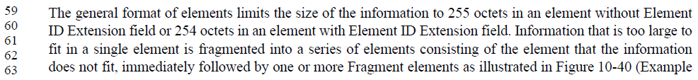

On P1877:

And on P1878:
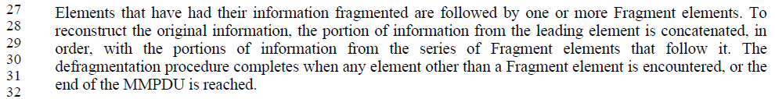

Agree that all these are declarative statements of required behaviour. Since this is clause 10, requirements should be expressed in normative language.

Proposed Resolution:

Accepted.

P1876, change wording to “A STA may transmit information that is too large in a single element to fit by fragmenting it into a series...” [Is this where we _define_ when fragmentation shall occur?]

“is not” -> “shall not be”

“appears” -> “shall be in”

“are” -> “shall be” [ Is this already specified in the procedure, and therefore can be declarative here? Check generally all the declarative verbs in here. Maybe all the verbs here need to be normative (this is the main clause)? ]

The subclause on defragmentation has the same problem?

CID | Page | Clause | Comment | Proposed Change
2562 | 1626.36 | 9.6.20.7 | "The MMPDU Frame Body subfield carries the content of the Frame Body field of an MMPDU that would  be constructed if the MMPDU for the corresponding management frame type were transmitted over the air  (i.e., all of the octets after the MAC header and up to, but not including, the FCS)." -- not clear if this includes encryption, if PMF is in effect | After "transmitted" add "unencrypted" in the cited text at the referenced location

Discussion:

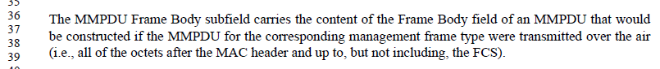

This is a great question – as an MMPDU is being formed and working its way down the “MAC stack”, at what point in the stack does it “kick out” and stop going down the NT stack and instead become payload for the TR stack?

Proposed Resolution:

??

CID | Page | Clause | Comment | Proposed Change
2692 | 2127.32 | 11.1.4.3.2 | Step (e) seems fully duplicative of steps (c) and (d) | Check and potentially remove step (e)

Discussion:

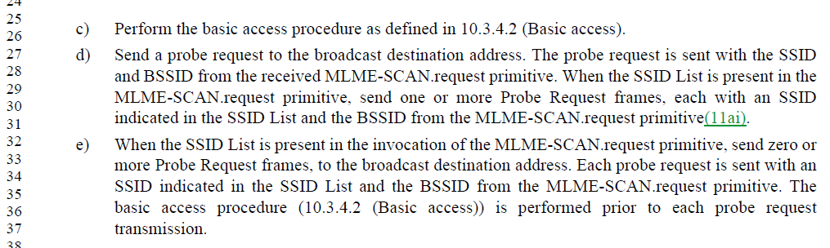

Dissecting these bullets, we see that (c) and (d) state:
- Perform basic access procedure [ is this done only once? ]
- Send a probe request to the broadcast address, with SSID and BSSID from MLME-SCAN parameters.
- If SSID List is present in MLME-SCAN.request, send one or more probe requests, each with an SSID from the list and BSSID from the primitive’s parameter. [ It’s unclear if these probes are sent to the broadcast address. ]

And, (e) states:
- If SSID List is present, send zero or more probe requests to the broadcast address, each with and SSID from the list and the BSSID from the primitive’s parameter.
- Each of the above probes is preceded by a basic access procedure.
- [ There is no mention of sending a probe with the SSID from the MLME-SCAN parameter. ]

The commenter claims that (e) is duplicative of text included in (c) and (d). For the most part, (e) does seem to be a subset of (c) and (d). However, there are two exceptions: 1) bullet (e) clarifies that the basic access procedure is required before the probes derived from the SSID List; 2) bullet (e) permits sending zero probes derived from the SSID List.

Exception (1) appears to be an oversight in (d), as there is no indication elsewhere that a STA may send multiple probe requests without performing channel access between them (unless permitted by the basic channel access procedure, such as a continuation TXOP).

Exception (2) is partially addressed by the purpose of the SSID List stated in 4.3.19.15:
The SSID List element enables the non-AP STA to request information on a list of SSIDs. This is intended to reduce the number of Probe Request frames sent by the non-AP STA.
To maximize the opportunity to send as few probe request frames as possible, it should be allowed for the STA to send only the “main” probe request (to the SSID provided directly in the primitive) containing an SSID List element, and complete the procedure (if sufficient responses are determined to have been received).

Proposed Resolution:

Revised.

Modify bullets (c) and (d) as shown:
c) Perform the basic access procedure as defined in 10.3.4.2 (Basic access). Send a probe request to the broadcast destination address. The probe request is sent with the SSID and BSSID from the received MLME-SCAN.request primitive. <Some hint here to include the SSID List>

<Something with Jouni about encouraging a single probe>

d) Send a probe request to the broadcast destination address. The probe request is sent with the SSID and BSSID from the received MLME-SCAN.request primitive. When the SSID List is present in the MLME-SCAN.request primitive, send one zero or more Probe Request frames <to the broadcast address>, each with an SSID indicated in the SSID List and the BSSID from the MLME-SCAN.request primitive(11ai). The basic access procedure (10.3.4.2 (Basic access)) is performed prior to each probe request transmission, as required <explain continuation TXOP>.

Delete bullet (e).

Renumber references (2x) to “step i)” to reference “step h)”. <Work with editors. Step l, also?>

Not (obviously) submission required:

CID | Page | Clause | Comment | Proposed Change
2340 | 1515.14 | 9.6.7.16 | "The Extended Capabilities element is optionally present if any of the fields in this element are nonzero." -- I think this is trying to say that the EC element is present if and only if there are some extended capabilities to advertise. However, as it's written it's actually saying you don't have to advertise your extended capabilities (even in assoc) even if you have some | Delete "optionally" in the cited text at the referenced location and also in Tables 9-412, 9-434, 9-435

Discussion:

The context for this comment is within the Action field of a TDLS Discovery Response (Public Action) frame:
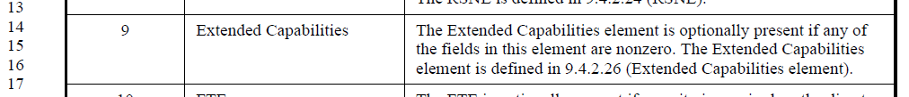

In all other frames, such as a Beacon, (Re)Association, etc. this field is described as:
The Extended Capabilities element is present if any of the fields in this element are nonzero.

Note that the RSNE and FTE fields are also “optionally present” in the TDLS Discovery Response frame. For FTE that might make sense, since use of FT is at the discretion of the STAs, although this is described based on other parameter state in the description of other frames, such as Reassociation Request.. RSN(E) is described as present (not optional) if RSNA is activated (“security is required”) for other frame types.

Need to check all this with Menzo. Is this optionality intentional for TDLS Discovery, for some reason?

CID | Page | Clause | Comment | Proposed Change
2237 | 1650.48 | 9.7.1 | In 9.7.1: "Each nonfinal A-MPDU subframe in an A-MPDU has padding octets ..." Next paragraph has, "In an HT PPDU, the final A-MPDU subframe is not padded." Is that redundant? Is there another option (for non HT PPDU)? Clarify if a non-HT PPDU has another option, or simplify if this is a general/always requirement. | Clarify if a non-HT PPDU has another option, or simplify if this is a general/always requirement.

Discussion:

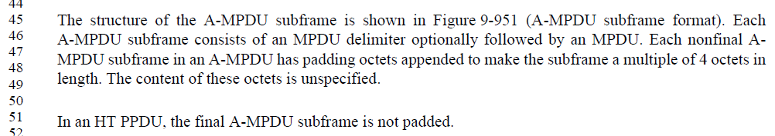

It seems that in VHT and S1G usage of A-MPDU (the “non-HT” usages, except for DMG (see below)), have unique rules for padding, and the last A-MPDU subframe is not necessarily padded (just) to a multiple of 4 octets, as described. So, it does seem that this requirement applies only to HT usage of A-MPDU. However, this could be made a bit more clear.

For DMG: ??? Carlos?

Proposed Resolution:

After the sentence, “In an HT PPDU, the final A-MPDU subframe is not padded.” add the sentence, “For VHT and S1G A-MPDU, specific padding is as described below.”

DMG ??

CID | Page | Clause | Comment | Proposed Change
2246 | 1982.58 | 10.42.2.1 | Grammar issues (and confusing references to "BI 1", "B1 2" and "BI 3") in 10.42.2.1. | A submission will be provided.

Discussion:

Note: it appears the refence should be to P1984.57.

????? Jiamin, Assaf?

CID | Page | Clause | Comment | Proposed Change
2576 | 1336.00 | 9.4.2.170 | The Reduced Neighbor Report is actually about BSSes not APs. So the fields therein should refer to BSSes not APs | Throughout the referenced subclause change "AP" to "BSS"
2577 | 2133.00 | 11.1.4.3.4 | " the SSID of the responding STA" -- BSSes have an SSID, not STAs | Change to "the SSID of the BSS the responding STA is a member of"
2578 | 2133.00 | 11.1.4.3.4 | " the SSID of the responding STA" -- BSSes have an SSID, not STAs. Ditto "compressed SSID of the AP.", "corresponding SSID of the responding AP.", "corresponding SSID of that AP", "SSID of the AP", "SSID of the AP or PCP". Ditto "BSSID of" | Change to refer to the BSS the STA/AP is a member of
2476 | 2131.00 | 11.1.4.3.4 | "The SSID in the Probe Request frame matches the SSID of the STA's." -- the STA's what? | Change the cited text to "The SSID in the Probe Request frame matches the SSID of the BSS the STA is a member of, if any." At line 21 change "STA's BSS" to "BSS the STA is a member of, if any"
2553 | 834.00 | 9.3.1.18 | Should not be spreading the rules for Duration field setting across multiple places | At the referenced location change "The Duration field is set to the value obtained from the Duration/ID field of the immediately previous Grant  frame minus the time, in microseconds, required to transmit the Grant Ack frame and its SIFS interval." to "The Duration field value is set as defined in 9.2.5 (Duration/ID field (QoS STA)). "
2558 | 819.00 | 9.3.1.5.1 | "The (11ah)Duration/ID field contains the AID value assigned to the STA transmitting the frame by the AP in  the (Re)Association Response frame that established that STA's current association, with the two MSBs set  to 1." -- not true if it's a PS-Poll+BDT | Add a new subclause heading "Non-BDT variant of the PS-Poll frame format" above this para

Submission Required:

CID | Page | Clause | Comment | Proposed Change
2123 | 1770.00 | 10.7 | The non-QoS STA is required not to transmit more than a certain amount of outstanding MPDUs at any time. However, is not clear what is the relationship between the subclauses that refer to MSDU from particular SA and MMPDU:  - Can the non-QoS STA transmit outstanding MPDU of one MSDU from particular SA OR outstanding MPDU of one MMPDU but not on the same time?  - Can the non-QoS STA transmit outstanding MPDU of one MSDU from particular SA AND outstanding MPDU of one MMPDU on the same time? | Please clarify the relationship between the 2 subclauses within that requirement (as proposed in comment)
2124 | 1771.00 | 10.7 | The QoS STA without Block ACK agreement is required not to transmit more than a certain amount of outstanding MPDUs at any time. However, is not clear what is the relationship between the subclauses that refer to MSDU from particular SA and MMPDU:  - Can the non-QoS STA transmit outstanding MPDU of one MSDU/ A-MSDU from particular SA OR outstanding MPDU of one MMPDU but not on the same time?  - Can the non-QoS STA transmit outstanding MPDU of one MSDU / A-MSDU from particular SA AND outstanding MPDU of one MMPDU on the same time? | Please clarify the relationship between the 2 subclauses within that requirement (as proposed in comment)
2125 | 1740.00 | 10.5 | "A STA shall support the concurrent reception of fragments of at least three MSDUs or MMPDUs." The requirement for STA to support concurrent reception of fragments of at least three MSDUs or MMPDUs is in conflict with the rule in section 10.7 for not having more than on outstanding MSDU (transmitted in one or more MPDUs) at any time. | Please resolve the conflict between having concurrent fragments of at least 3 MSDUs and the rule not to have more than a single outstanding MSDU at any time
2086 | 1497.00 | 9.6.6.5 | Spec is inconsistent in treating elements at the end of a frame as a field:  (1) Some frame definitions indicate if a "field" X is present it contains "element" Y (e.g., see the "DMG Link Margin" field in 9.6.6.5 Link Measurement Report frame format)  (2) Classic frames (e.g., beacon, probe, association...) just list the frame body, often in a table format, and list the elements after fields, which is also consistent with the sentence at P847L24.  (3) Some other frams (e.g., 9.6.7.7 Extended Channel Switch Announcement frame format) list the elements directly in a figure representing teh frame, without a table, which is also consistent with (2)  I think (1) is the anomaly, and propose not to represent any IE appended to a frame as a field in that frame. This will simplify the text too, as teher is no field to define (see example in proposed change). | Comment is general; by way of example, and using Link Measurement Report frame, either  -- Establish somewhere (e.g., P847L24) that everything is a field, and some fields include an element, (not in favor), or  - Preferably, indicate elements as just "elements" in all frame definitions, including those that are defined through a table (beacon, probe, association .., and they happen to follow this convention), and those without a table, e.g., Link Measurement Report.  The second path generally simplifies the text; in the Link Measurement Report frame example, if adopting the second (and preferred) path, the last two boxes in Figure 9-844 would be named as "DMG Link Margin element (optional)" and "DMG Link Adaptation Acknowledgement element (optional)", and the last two paragraphs in section 9.6.6.5 would go away.
2301 | 2308.00 | 11.15.8 | DSSS/CCK in 40 MHz language could still use more clarifications. | A submission will be provided.
2616 | 1439.00 | 9.4.3 | All the statements of the form "The $blah field contains zero or more subelements. The subelement format and ordering of  subelements are defined in 9.4.3 (Subelements)." are unclear as to whether you can have more than one subelement with the same Subelement ID. Having more than one could lead to interop issues (for example, if there are two Originator Requesting STA MAC Address subelements in a Location Civic request, how does the receiver know the requesting STA MAC address?) | Add a para at the end of 9.4.3: "Unless stated otherwise, no more than one subelement with the same Subelement ID, apart from Vendor Specific subelements, is present within an element."
2219 | 1683.00 | 10.2.1 | HCF doesn't really use DCF architecturally. It 'replaces' DCF. Consider folding DCF into HCF (EDCA), as a degenerate case. Would restructure 10.2, Figure 10-1, etc. | Change Figure 10-1 to show HCF (EDCA and HCCA) as directly using the PHY. Cleanup text in 10.2, 10.3 and 10.22 to not describe HCF as using DCF. A submission will be provided.

CID | Page | Clause | Comment | Proposed Change
2653 |  | 11.32.5 | It should be possible to use the ChannelList when doing OCT scanning to specify the peer NT-MLME channels. Currently, the Multi-band local in the MLME-SCAN.req is not used for anything except  identifying the local TR-MLME(s) -- it does not go on the air or anything.  We should therefore replace it with a list of { band ID, channel, MAC address }  tuples (or a single band ID parameter and a list of { channel, MAC address } tuples  if the TR-MLMEs have to be all on the same channel) and then OCT scanning will  just be a clear extension to normal scanning. I think you wouldn't need the  Multi-band peer because it would be implicit in the combination of the local  NT-MLME the SME sends to (which identifies an NT band and channel)  and the BSSID parameter. Then you'd be able to say "I want to find APs on  5G channels 36, 40 or 44, tunnelling over 2G4 channels 1, 2, 3" by setting  in the MLME-SCAN.req:  Channel List = 36, 40, 44  BSSID = wildcard  Local TRs = { 2G4, 1, MAC address for 1 }, { 2G4, 2, MAC address for 2 }, { 2G4, 3, MAC address for 3 }  and sending to an NT-MLME on the 5G ban | As it says in the comment

Discussion:

TBD

CID | Page | Clause | Comment | Proposed Change
2291 | 3096.50 | 20.9.2.2 | BRP packet structure has some problems in details.  The bullet list items in 20.9.2.2.1 both say, "BRP-[TR]X PPDUs are packets that have TRN training subfields appended to them." First, this isn't necessarily true, as the BRP PPDU could be a request for training TRNs, and not carry any itself. Also, these two sentences look like the define/describe BRP PPDUs, but they define the RX and TX variants identically, which isn't useful. The following sentences are the useful part.  The definition of "training field(s)" is not clear, so the meaning of "Traning Length" in Table 20-11 (etc) is not clear. In fact, this field is not a length at all, but a number _N_ that can be used to derive the number (and therefore length of) the AGC and TRN subfields.  Also, the AGC/TRN subfields are sometimes called "training fields" and sometimes "a training field". Since both of these fields actually have internal structure (they are not just a list of AGC sequences, nor TRN subfields, it is probably best to call these a distinguishable and singular name.  Why does subclause 20.9.2.2.2 start with (or detail at all) the rules about setting [TR]XVECTOR parameters?  20.4.2 and 20.5.2 claim to be definitions of the PPDU formats, but there is no (obvious) definition of the AGC and TRN subfields in those clauses. A reference would be helpful.  "A value of N in the Training Length field indicates 4├ùN AGC subfields" - does this mean the AGC (sub)field(s) has that many "AGC fields" (each of which is 4N repetitions of the Golay sequence), or there are just a total of 4N repetitions of the Golay sequence?  "and that the TRN-R/T field has N TRN-Units" - There is no TRN-R/T field. | A submission will be provided.

Discussion:

TBD

CID | Page | Clause | Comment | Proposed Change
2325 | 1757.00 | 10.6.7 | The CMMG rules being separated (in 10.6.8) causes the exclusion rules structure of 10.6.5.x to be confusing or broken. DMG started it with 10.6.7. | Delete 10.6.7 and 10.6.8
2324 | 1757.00 | 10.6.7 | The CMMG rules being separated (in 10.6.8) causes the exclusion rules structure of 10.6.5.x to be confusing or broken. DMG started it with 10.6.7. | Merge 10.6.7 and 10.6.8 into 10.6.5. I think perhaps the other Mark has some ideas about this

Discussion:

TBD

CID | Page | Clause | Comment | Proposed Change
2246 | 1982.58 | 10.42.2.1 | Grammar issues (and confusing references to "BI 1", "B1 2" and "BI 3") in 10.42.2.1. | A submission will be provided.

Discussion:

TBD

CID | Page | Clause | Comment | Proposed Change
2294 | 305.1 | 5.1.57 | There's no figure in clause 5 (like Figure 5-7) for a DMG Relay. Do we need one? | TGm to discuss. A submission will be provided, depending on direction decided.

Discussion:

TBD

CID | Page | Clause | Comment | Proposed Change
2266 | 284.48 | 4.10 | The 802.11 Style Guide says clause 4 should be written in delcarative, not normative, language, and that it is intended to provide only a general description of the system. There are parts of clause 4 (4.10, for example), that get quite detailed (like specific frame exchange diagrams) and seem to be both beyond a "general description" and potentially are the only normative specification for these behaviors. There are also a few uses of "may" and many uses of "can" that should be checked/changed to clearly informative language. | At least 4.10, and potentially all of clause 4, needs to be scrubbed for details that are beyond "general description" and/or are the best/only normative specification in the Standard of any behaviors, and move such text to a later clause.  TGm should consider whether claues 4 should be labelled as "Informative", if that is the intent of the clause.  TGm should discuss this topic, and based on agreement on direciton, a detailed submission for changes will be provided.

Discussion:

TBD

Completed:

CID | Page | Clause | Comment | Proposed Change
2087 | 867.35 | 9.3.3.11 | Refer to "Supported Rates and BSS Membership Selectors" as element | Change "field" to "element" in last column.

Discussion:

Here is the definition of the Supported Rates and BSS Membership Selectors in the Probe Response frame body:
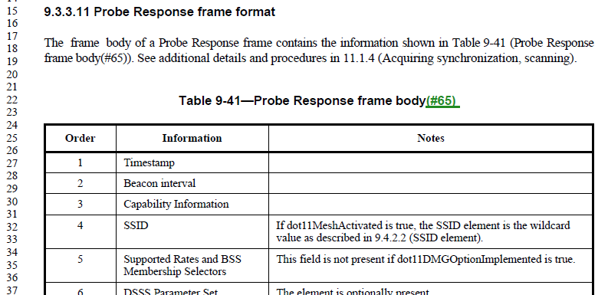

Subclause 9.4.2.3 defines the format for the Supported Rates and BSS Membership Selectors element:
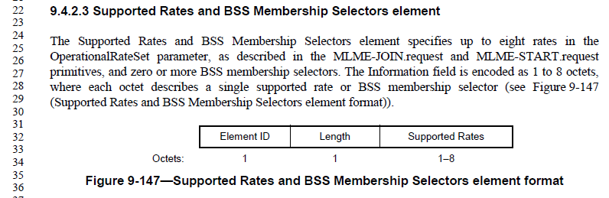

Supported Rates and BSS Membership Selectors is indeed an element (defined in 9.4.2 and not in 9.4.1), and additionally of varying length, so needs to be encoded as an element within the frame.

Proposed Resolution:

Accepted.

CID | Page | Clause | Comment | Proposed Change
2078 | 867.27 | 9.3.3.11 | There is no information for the first three fields of the Probe Response frame. The Timestamp field and how it is set for Probe Response) is important in particular. | Define what these fields do, whether they are always or optionally present (and under what conditions if optionally), and/or provide reference to relevant sections.

Discussion:

Here is the start of the definition of the Probe Response frame body; the first three fields are not described, per the comment:
In other frames, Timestamp (for example) has these “Notes”:
See 9.4.1.10 (Timestamp field) for Timestamp format.

Suggest adding similar Notes for all the first three fields. This same issue exists in many frame format tables.

Proposed Resolution:

Revised. Insert the following text in the first three rows, in the Notes column, in Table 9-41:
See 9.4.1.10 (Timestamp field) for Timestamp format.
See 9.4.1.3 (Beacon Interval field) for Beacon Interval format.
See 9.4.1.4 (Capability Information field) for Capability Information format.

Do the same for matching rows in Tables 9-34, 9-36, 9-37, 9-38, 9-39, and 9-46.

Note to Editor: This is the same resolution as for CID 2077.

CID | Page | Clause | Comment | Proposed Change
2077 | 879.18 | 9.3.3.16 | "Capability Information" notes missing | Define what this field does, whether it is always or optionally present (and under what conditions if optionally), and/or provide reference to relevant sections.

Discussion:

Here is the definition of the Capability Information field in the Timing Advertisement frame body:
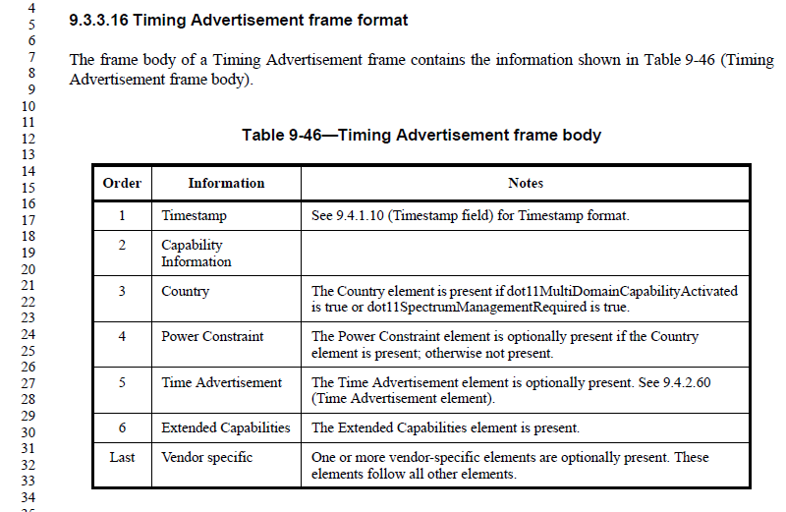

See the discussion above, for CID 2078.

Proposed Resolution:

Revised. Insert the following text in the first three rows, in the Notes column, in Table 9-41:
See 9.4.1.10 (Timestamp field) for Timestamp format.
See 9.4.1.3 (Beacon Interval field)
See 9.4.1.4 (Capability Information field)

Do the same for matching rows in Tables 9-34, 9-36, 9-37, 9-38, 9-39, and 9-46.

Note to Editor: This is the same resolution as for CID 2078.

CID | Page | Clause | Comment | Proposed Change
2118 | 1535.59 | 9.6.7.36 | "The FD RSN Information subfield contains an RSN Capability subfield, as specified in Figure 9-289 (RSN  Capabilities field format) in 9.4.2.24.4 (RSN capabilities)." In 9.4.2.24.4, the refered field is named as "RSN Capabilities". To be consistent and avoid search error, suggest renaming the "RSN Capability" subfield in 9.6.7.36 to "RSN Capabilities" subfield. | In 9.6.7.36, change "RSN Capability" to "RSN Capabilities", and change "RSN capability" to "RSN capabilities". 3 instances in total.
2396 | 1535.40 | 9.6.7.36 | Should rename the three instances of "RSN Capability"/"RSN capability" to "RSN Capabilities"/"RSN capabilities" so the same term is used as in RSNEs | Change each of the 3 instances of "RSN Capability"/"RSN capability" to "RSN Capabilities"/"RSN capabilities" (preserving case)

Discussion:

Agree with commenters: subclause 9.4.2.24.4 does in fact define “RSN Capabilities”, not “RSN Capability”:
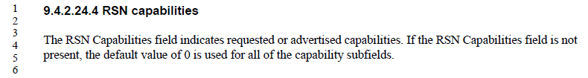

There are three occurrences of “RSN [Cc]apability” in the Draft, all in 9.6.7.36 on page 1535:
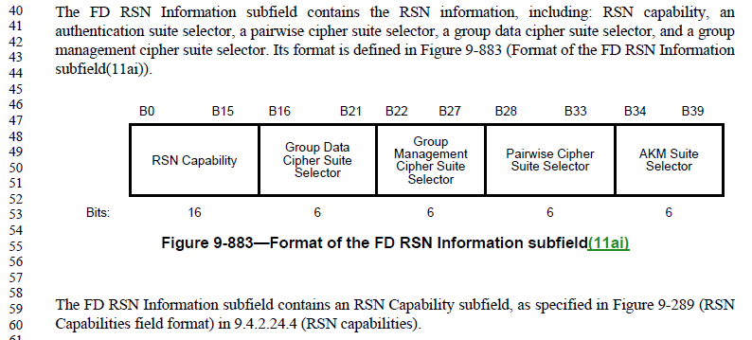
Proposed Resolution:

Accepted.

Note to EDITOR the resolutions of CIDs 2118 and 2396 are the same.

CID | Page | Clause | Comment | Proposed Change
2438 | 873.45 | 9.3.3.12 | "A Finite field element field" -- the Finite field element field is as its name indicates a field. What we need here is a description of what it contains | At the referenced location change "A Finite field element field from a finite field" to "An element from a finite field"

Discussion:

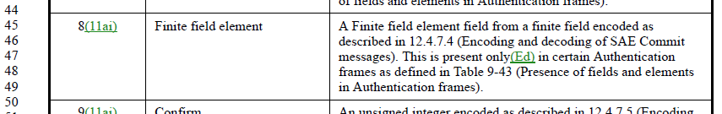
Here is the definition of the “Finite field element” field in the Authentication frame body:
Subclause 12.4.7.4 describes the usage of this field in SAE Commit messages:
From the context in 12.4.7.4, we can agree that this field (in an Authentication frame body) carries the description of one element of a finite field.

Originally proposed resolution:

Accepted.

From June 26 teleconference: Need to check with changes Dan has made in this area.

Update, June 28, 2019:

It appears that the “changes Dan has made” were partially in the resolution of CID 2531, and partially handed over to Mark Rison, to be resolved along with CID 2530, now contained in document 11-19/0856r3.

Neither of those resolutions changes the cited text above, in 9.3.3.12 (Authentication frame format). However, perhaps one of them should have? From these two changes, it seems we now have a field in the Authentication frame format, called “Finite Field Element field”, whose “Notes” description does not capitalize “element”, and whose presence in Table 9-43 calls it “The FFE field”. The definition of the field in 9.4.1.40 calls this the “FFE field”. Most of the text in clause 12 also calls it an FFE field.

In fact, in D2.2, there are now exactly two occurrences of the phrase “finite field element” (ignoring capitalization), this field name in Table 9-42, and the acronym list for what FFE stands for.

Recommend we change the name of the field, in Table 9-42, to FFE, to match all the other uses.

Finally, this is further complicated by CID 2302, which has these instructions:
Change "Finite field element (FFE) field" to "FFE field" throughout. Also in T9-42 change "A Finite field element field from a finite field" to "An element in a finite field" (cf. 9.4.1.40)
This change made the comment here (CID 2438) nearly moot. There is one subtle difference, CID 2302 changed the Notes to say “An element in a finite field” and this comment would change the Notes to say “An element from a finite field”. The phrase “from a finite field” is never used in the current draft. The phrase “in a finite field” is used in 9.4.1.10, where this field is defined. Thus, to keep it consistent, recommend we leave it as “in”.

Proposed Resolution:

Revised.

In Table 9-42 (Authentication frame body), change the entry in the “Information” column from “Finite Field element” (or “Finite Field Element field” after application of CID 2531), to “FFE field”.

CID | Page | Clause | Comment | Proposed Change
2342 | 1347.36 | 9.4.2.177 | "Value 0 is applied for  the Vendor Specific elements that are not in the range of the OUI Response Criteria." is gibberish | Delete the cited text at the referenced location

Discussion:

The cited location:
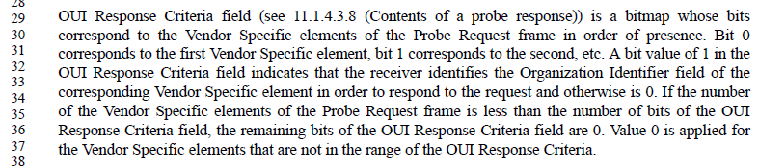

As can be seen, the OUI Response Criteria field is defined to have bit 0 correspond to the first Vendor Specific element. Thus, the only bits that can be missing, are off the end of the bitmap. Those bits are covered by the penultimate sentence. So, there are no Vendor Specific elements “that are not in the range of OUI Response Criteria” and need to be defined.

Agree with the commenter, the cited sentence is confusing at best, and appears to be unnecessary.

Originally proposed resolution:

Accepted.

From June 26 teleconference: No – reread that penultimate sentence. Fix the last sentence.

Update, June 28, 2019:

The ultimate sentence is meant to cover the case where there are more Vendor Specific elements in the Probe Request frame than there are bits in the OUI Response Criteria. The OUI Response Criteria, per 9.4.2.177 is a 2 octet field within the FILS Request Parameters element in a Probe Request frame, so it has fixed size and therefore limited range. There appears to be no limit to the number of Vendor Specific elements that can be included in the Probe Request, along with the FILS Request Parameters element. Thus, this condition can occur.

Proposed Resolution:

Revised.

Replace the cited sentence with:
If the number of bits in the OUI Response Criteria field is less than the number of Vendor Specific elements in the Probe Request frame, the corresponding bits not present in the OUI Response Criteria field are assumed to be 0.

CID | Page | Clause | Comment | Proposed Change
2361 | 1535.40 | 9.6.7.36 | "The FD RSN Information subfield contains the RSN information, including: RSN capability, an  authentication suite selector, a pairwise cipher suite selector, a group data cipher suite selector, and a group  management cipher suite selector. Its format is defined in Figure 9-883 (Format of the FD RSN Information  subfield(11ai)). " is an ideal breeding ground for spec rot | Change the cited text at the referenced location to "The FD RSN Information subfield is defined in Figure 9-883 (Format of the FD RSN Information  subfield(11ai)). "

Discussion:

Agree with the commenter, the cited sentence adds nothing that isn’t indicated in the Figure.

Proposed Resolution:

Accepted.

CID | Page | Clause | Comment | Proposed Change
2379 | 1771.01 | 10.7 | "For frames that are not sent within the context of a block ack agreement, a QoS STA shall not have  outstanding at any time more than:  --- one MSDU or A-MSDU for each TID from a particular SA  --- one MMPDU  transmitted in one or more MPDUs with a particular individual RA." is ambiguous as to whether you can only have MSDUs from one particular SA, or can you can MSDUs from multiple SAs (as long as you have only one from any given SA) | Change "a particular" to "any particular"

Discussion:

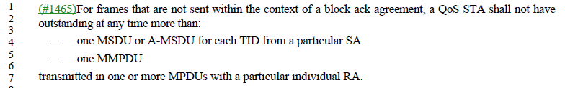

Agree with commenter, “any particular” is more clear.

However, there are two occurrences of “any particular” so we need to be clear about which one.

Proposed Resolution:

Revised. In 10.7, change “from a particular SA” to “from any particular SA” in two locations (D2.2 P1780.56 and P1781.4).

CID | Page | Clause | Comment | Proposed Change
2409 | 2238.50 | 11.6 | The "sync frame"s in Subclause 11.6 are higher-layer constructs and so are properly referred to as "sync packet"s | Throughout 11.6 change "sync frame" to "sync packet"

Discussion:

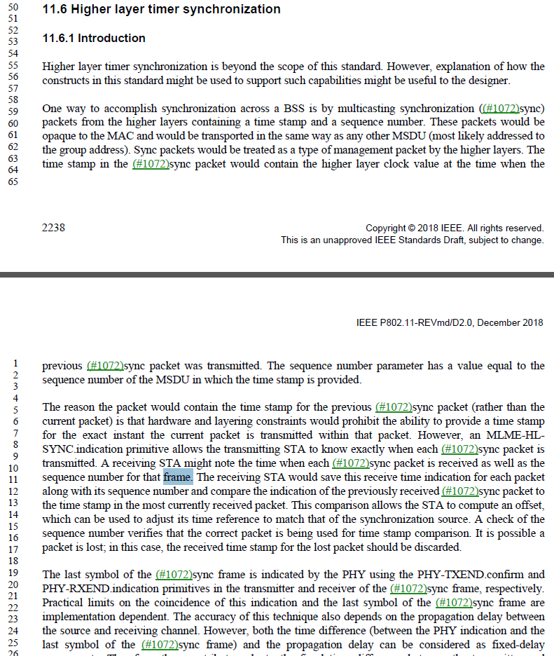

The first references to the sync protocol units uses “packet”, but starting in the third paragraph, the usage changes to “frame” more often. The inconsistent usage is confusing and appears to have no meaning/intention.

Agree with the commenter that this use of “frame” is at best confusing, since clause 3.1 lists “MAC frame” as a synonym for MPDU, and “PHY frame” as a synonym for PPDU, and those are the common uses in the Draft. As this subclause is discussing a higher layer protocol, these are not MPDUs or PPDUs, and it more clear to say “packet” to help disambiguate.

Proposed Resolution:

Accepted.

CID | Page | Clause | Comment | Proposed Change
2428 | 1532.19 | 9.6.7.36 | b14 and b15 of the FILS Discovery Frame Control subfield are used by an industry-wide proprietary specification | Mark b14 and b15 of the FILS Discovery Frame Control subfield as "Reserved (used by the Wi-Fi Alliance)"

Discussion:

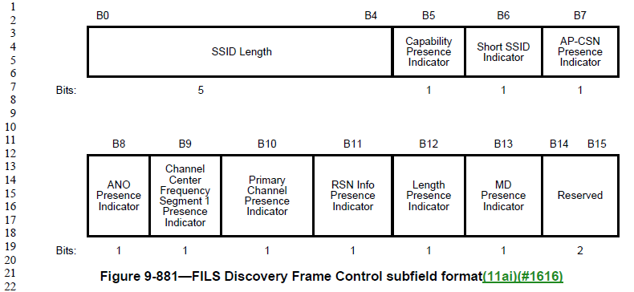

Per the liaison exchange in 11-19/0185 and 11-19/0277, it has been confirmed that the Wi-Fi Alliance does use these bits, and has requested that the bits be reserved for their use.

Propose to indicate these bits as not only “Reserved”, but that they are used by the Wi-Fi Alliance, in the same manner as Category value 17 (Table 9-53 and Table 11-17).

Proposed Resolution:

Revised.

In Figure 9-881 (P1532.19) change the indication for bits B14 and B15 from “Reserved” to “Reserved (used by the Wi-Fi Alliance *)” and add a footnote “* See http://www.wi-fi.org.”.

CID | Page | Clause | Comment | Proposed Change
2453 | 1874.58 | 10.28.4 | "NOTE 2---For a Clause 19 (High-throughput (HT) PHY specification) PHY, this equation simplifies to" this equation is only used for HT PPDUs ("A STA that is transmitting a PPDU with the FORMAT parameter of the TXVECTOR equal to HT_MF(#67) shall set the value of the L_LENGTH parameter to" above) so this qualification is confusing | Just say "NOTE 2---This equation simplifies to"

Discussion:

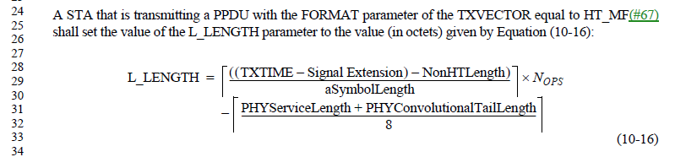

This is the only reference to Equation 10-16, so it does seem correct that this is intended only for transmitters that have set the TXVECTOR FORMAT to HT_MF. Since Note 2 is filling in variables and simplifying, based on HT PHY parameters, it would appear to the be equivalent equation.

Can just replace NOTE 2.

Proposed changes:

Replace NOTE 2 (P1874.58) with the following:

Equation (10-16) can be simplified to Equation (10-16a)

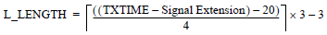 (10-16a)

Proposed Resolution:

Revised; Incorporate the proposed changes in doc 11-19/551r3: https://mentor.ieee.org/802.11/dcn/19/11-19-0551-03-000m-revmd-lb236-comments-assigned-to-hamilton.docx, for CID 2453 which replaces the note with an equation.

CID | Page | Clause | Comment | Proposed Change
2458 | 1152.16 | 9.4.2.53 | "in this country" -- it's not clear which country is being referred to | Delete "in this country" throughout the referenced subclause

Discussion:

There are 4 occurrences of “in this country” in subclause 9.4.2.53. All are of the form, “operating classes that [the STA | it] is capable of operating with in this country”. For example:

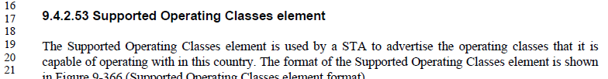

Agree with the commenter that “this country” is not clear. The point of the phrase is that these are operating classes within which the STA is currently configured to operate.

Proposed Resolution:

Revised.

Change all four occurrences as shown:
“operating classes that within which [the STA | it] is capable of operating with in this country currently configured to operate”

CID | Page | Clause | Comment | Proposed Change
2460 | 2497.64 | 11.46.3.2 | "MA-UNITDATA.indicate" -- no such primitive | Change to "MA-UNITDATA.indication"

Discussion:

Agree with the comment. Based on a search, this is the only occurrence of “.indicate” in the Draft.

Proposed Resolution:

Accepted.

CID | Page | Clause | Comment | Proposed Change
2461 | 2363.37 | 11.22.16.2 | "- dot11DMGOptionImplemented shall be true for a DMG STA.  - dot11S1GOptionImplemented shall be true for an S1G STA." -- both of these are always true, by definition | Delete the cited text at the referenced location

Discussion:

The fourth paragraph of 11.22.16.2:
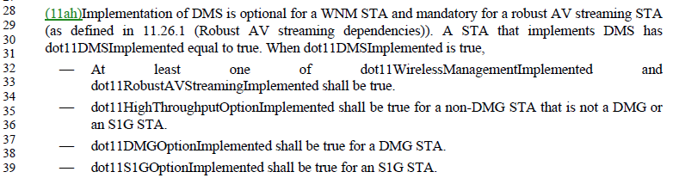

It is correct that stating these requirements here, in the subclause about DMS procedures, should be redundant. However, there is no statement that a DMG STA is a STA with dot11DMGOptionImplemented equal to true. There is such a statement for an S1G STA, however:

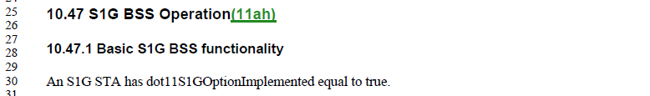

Proposed Resolution:

Revised.

Delete the last two bullets of the fourth paragraph of 11.22.16.2, as proposed by the commenter.

Add a new first paragraph to 11.38 (DMG MAC sublayer attributes):
A DMG STA has dot11DMGOptionImplemented equal to true.

CID | Page | Clause | Comment | Proposed Change
2468 | 1655.00 | 9.7.3 | "at most one of the following is present: x, y, z" is not clear. Does it mean that only what is specified in x or y or z can be present, or can e.g. you have stuff in x plus other stuff as long as it is not in y or z? | Add ", and no other frames" before the colon in each case

Discussion:

This phrase occurs within Table 9-528:
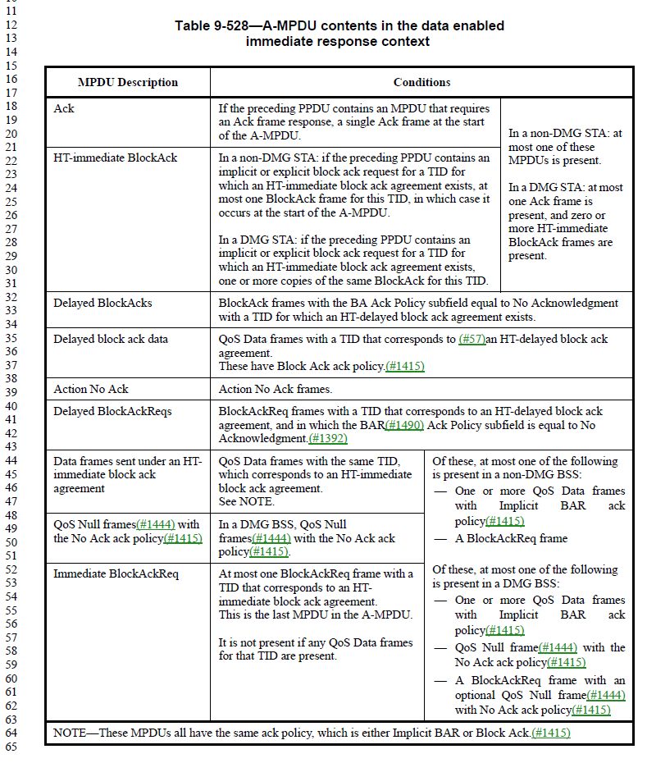
From the context, it appears that the intention is to include either none of the items in the following list, or only one of them. The suggestion to say “and no other frames” is confusing, because it seems to go beyond this list and say no other frames can be included in the A-MPDU.

From off-line email discussion:
Proposed: Replace “at most one of the following is present” with “either none or only one of the following is present” in Table 9-528.

It seems that the commenter does not think these occurrences are the ones that are not clear. So, this change is not necessary. Does anyone else think they are necessary/useful?

Rather, it is the usage in the first row(s) that is causing the concern:
In a non-DMG STA: at
most one of these
MPDUs is present.

In a DMG STA: at most
one Ack frame is
present, and zero or
more HT-immediate
BlockAck frames are
present.

To address this, the proposal is to add “of these” to the second phrase. (It’s already in the first phrase.)

Proposed Resolution:

Revised. Replace “In a non-DMG STA: at most one” with “Of these, in a non-DMG STA: at most one” in Table 9-528. Replace “In a DMG STA: at most one” with “Of these, in a DMG STA: at most one” in Table 9-528.

CID | Page | Clause | Comment | Proposed Change
2391 | 2285.55 | 11.10.14 | "A multiple BSSID set is characterized as follows:  --- All members of the set use a common operating class, channel, Channel Access Functions, and  antenna connector. " -- sounds as if they can't do MIMO | Change the cited text at the referenced location to "A multiple BSSID set is characterized as follows:  --- All members of the set use a common operating class, channel, Channel Access Functions, and  (set of) antenna connector(s). "

Discussion:

As discussed on the June 24 teleconference, there is a definition of “antenna connector” already in the baseline, which includes these plural situations within the singular term:
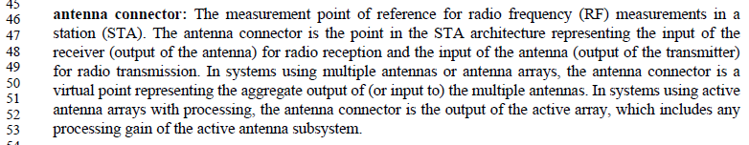

After discussion agreed that the singular is correct, given this definition. However:
- We still want to keep one capitalization correction in the 11.10.14 context (shown in the Proposed Resolution below)
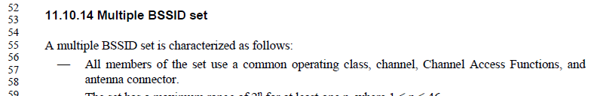
- We still want to keep the addition of the word “same” in the 11.10.14 context (also shown below)
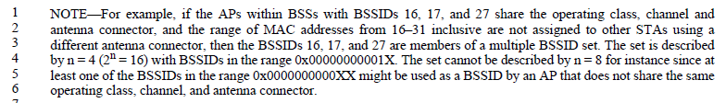
- We want to fix any existing uses of antenna connector that are (optionally) plural, to use the agreed singular style (these are also listed below).
This same text appears in 16.3.6.11, 17.3.8.7 and 19.3.17.

Proposed Resolution:

Revised.

In the first bullet of 11.10.14, replace “Channel Access Functions” with “channel access functions”

In the first line of the NOTE in 11.10.14, insert the word “same”, to be: “share the same operating class, channel, …”

In 15.4.4.10, 16.3.6.11, 17.3.8.7 and 19.3.17, change “transmit and receive antenna connector(s)” to “transmit antenna connector and receive antenna connector”. Change “if the connector” to “if that connector”.

In Table 19-1, RSSI entry, change “the power observed at the antenna connectors” to “the power observed at the antenna connector”.

In 19.3.19.1 and 21.3.18, change “input levels are measured at the antenna connectors” to “input levels are measured at the antenna connector”.

In 20.3.3.8 and 24.3.3.8 (two occurrences), change “defined at the antenna connector(s)” to “defined at the antenna connector”.

In Tables 21-1, 22-1 and 23-1, RSSI entry for FORMAT is VHT, change “power observed at the antenna connectors” to “power observed at the antenna connector”.

CID | Page | Clause | Comment | Proposed Change
2437 | 873.25 | 9.3.3.12 | "An unsigned integer indicating a finite cyclic group" -- need to say how many octets, because this is needed to be able to disambiguate the various things that can be in an Auth frame (esp. one that includes e.g. a Password Identifier field) | Change the cited text at the referenced location to "A 42-octet long unsigned integer indicating a finite cyclic group"

Discussion:

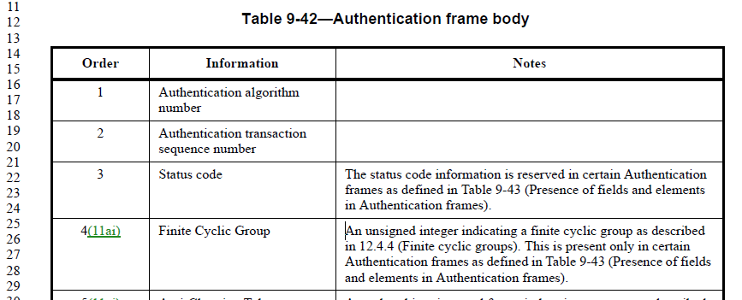
Here is the definition of the Finite Cyclic Group field in the Authentication frame body:

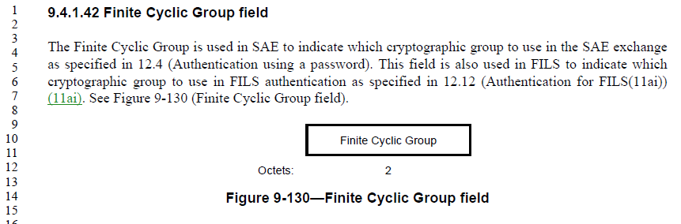
Subclause 9.4.1.42 defines the format for this field (because it is not an element):
However, this definition of the format is a little unclear, as it only specifies it is 2 octets, without a clear reference to what is in those octets. Suggest adding a reference to how these 2 octets indicate a finite cyclic group.

Originally proposed resolution:

Revised. Insert text in 9.4.1.42 as shown:
The Finite Cyclic Group is used in SAE to indicate an unsigned integer taken from the IANA registry for “Group Description”, which specifies the cryptographic group to use in the SAE exchange as specified in 12.4 (Authentication using a password).

Revisit, June 28, 2019:

After review by a security expert and other off-line discussion, the alternative resolution below is proposed. This resolution has the benefit of covering the FILS scenario as well, with the same mention of using the IANA registry.

One additional concern was discovered: The dot11RSNAConfigDLCGroupIdentifier (within the dot11RSNAConfigDLCGroupTable) is defined in the MIB to be an “unsigned32”. These Identifier values are supposed to be used as the values in the Finite Cyclic Group field, at least for FILS. Thus, these need to be 2 octet (unsigned, 16-bit) values. The IANA registry for Group Description values (https://www.iana.org/assignments/ipsec-registry/ipsec-registry.xhtml#ipsec-registry-10) also clearly assumes 16-bit values. Recommend changing the MIB structure so this table holds 16-bit Identifier values.

Proposed Resolution: - Below is agreed on June 28 telecon, with these comments:
- Updated resolution based on review by Dan Harkins
- Update the Table 9-42 in the resolution.
- Either we should specify the registry or make the text more generic.
- This will be the resolution unless some new proposal is brought.

Revised.
In 9.4.1.42, replace:
The Finite Cyclic Group field(M101) is used in SAE to indicate (M101)the cryptographic group to use in the SAE exchange as specified in 12.4 (Authentication using a password). This field is also used in FILS to indicate (M101)the cryptographic group to use in FILS authentication as specified in 12.12 (Authentication for FILS(11ai)) (11ai). See Figure 9-130 (Finite Cyclic Group field format(#2607)).
with:
The Finite Cyclic Group field is used by SAE, as specified in 12.4 (Authentication using a password), and FILS, as specified in 12.12 (Authentication for FILS), to indicate an unsigned integer taken from an IANA registry for "Group Description" which specifies the cryptographic group to use in the exchange. See Figure 9-130 (Finite Cyclic Group field).

In the MIB definition of Dot11RSNAConfigDLCGroupEntry, change the type of dot11RSNAConfigDLCGroupIdentifier from “Unsigned32” to “Unsigned32 (0..65535)”.

Update the reference in Table 9-42 (row for Finite Cyclic Group) from “as described in 12.4.4” to “as described in 9.4.1.42”.

From off-line discussion, since June 28:

Propose to update the resolution to make clause 9 generic w.r.t. SAE, FILS and AP PeerKey protocols, which all use this field (in similar ways). Note that SAE mentions this table in 12.2.4, 12.4.4.1; AP PeerKey mentions this table in 12.11.2; FILS mentions this table in 12.12.

Also, noted that the proposed changes to the MIB were incorrect in form, and should have updated the definition of the sub-element in the table entry.

Finally, agreed to update the wording within the SAE, FILS and AP PeerKey descriptions in clause 12, and within the MIB Description, to all be similar, to avoid confusion.

Proposed Resolution:

Revised.

In 9.4.1.42, replace:
The Finite Cyclic Group field(M101) is used in SAE to indicate (M101)the cryptographic group to use in the SAE exchange as specified in 12.4 (Authentication using a password). This field is also used in FILS to indicate (M101)the cryptographic group to use in FILS authentication as specified in 12.12 (Authentication for FILS(11ai)) (11ai). See Figure 9-130 (Finite Cyclic Group field format(#2607)).
with:
The Finite Cyclic Group field is used as specified in Clause 12 to indicate an unsigned integer, from a repository maintained by IANA as “Group Description” attributes for IETF RFC 2409 (IKE) [B18][B33], that specifies the cryptographic group to use in a cryptographic exchange. See Figure 9-130 (Finite Cyclic Group field).

In the MIB definition of dot11RSNAConfigDLCGroupIdentifier, change the SYNTAX from “Unsigned32” to “Unsigned32 (0..65535)”.

Update the reference in Table 9-42 (row for Finite Cyclic Group) from “as described in 12.4.4” to “as described in 9.4.1.42”.

Update the second paragraph of 12.2.3.2 (to be similar to wording in 12.4.4.1 and 12.11.2):
“If PFS is desired, the STA selects a finite cyclic group from the (M85)dot11RSNAConfigDLCGroupTable, which comprises identifying numbers from a repository maintained by IANA as “Group Description”
attributes for IETF RFC 2409 (IKE) [B18][B33]. The STA then …”

In C.3 update the wording (to also align):
This variable uniquely identifies a domain parameter set for a group in the repository maintained by IANA registry as `Group Description' attributes for IETF RFC 2409 (IKE) [B18][B33].

CID | Page | Clause | Comment | Proposed Change
2410 |  | 9 | It is reasonable to expect people reading the 802.11 specification to be capable of understanding the concept "minus 1" without needing further details | In Table 9-31 replace ":  Set to 0 to request Nc = 1  Set to 1 to request Nc = 2  ...  Set to 7 to request Nc = 8" with ".".  In Table 9-72 replace ":  Set to 0 for Nc = 1  Set to 1 for Nc = 2  ...  Set to 7 for Nc = 8" with "." and ":  Set to 1 for Nr = 2  ...  Set to 7 for Nr = 8" with ".".  In Table 9-87 and Table 9-57 replace ":  Set to 0 for Nc = 1  Set to 1 for Nc = 2  Set to 2 for Nc = 3  Set to 3 for Nc = 4" with "." and ":  Set to 0 for Nr = 1  Set to 1 for Nr = 2  Set to 2 for Nr = 3  Set to 3 for Nr = 4" with ".".  In Table 9-57 replace ":  Set to 1 for Nr = 2  Set to 2 for Nr = 3  Set to 3 for Nr = 4" with ".".  In 9.3.4.2 delete " For example, when the number of SSW  frames allowed per sector sweep is 5, the subfield contains the value 4.". In 9.4.2.170.2 delete "For example, a value of 0 indicates that one TBTT Information field is included. " In 9.6.7.36 delete " (the length of the Short SSID in octets minus 1)". In 9.3.1.8.3 delete "For example, a value of 2 in  the TID_INFO subfield means that information for three TIDs is present." and change "less one" to "minus one" in the preceding sentence

Discussion:

From Table 9-31 in 9.3.1.19:
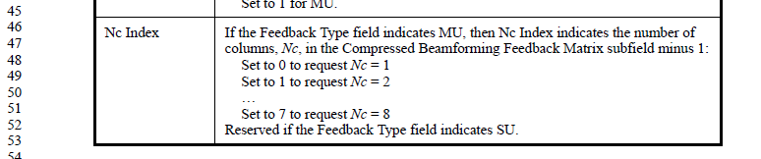
The above example appears to agree with the comment, assuming the text is sufficiently clear about what the “minus 1” is subtracted from, then the list of examples is not needed. However, the sentence leading up to the “minus 1” is a bit confusing, and could be hard to parse, especially for non-native speakers.

Recommend re-wording:
“If the Feedback Type field indicates MU, then Nc Index indicates the number of columns minus 1, (Nc-1), in the Compressed Beamforming Feedback Matrix subfield:”
and removing the “examples”.

In Tables 9-72, 9-87 and 9-57, the Nc Index and Nr Index Descriptions are similar but much simpler (no complex sentence leading into the “minus 1”), except that in Table 9-57 for Nr, there is no row for “Set to 0” and instead there is a statement that “The value 0 is reserved.”:
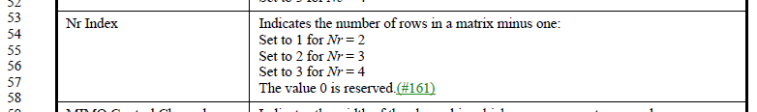
In these cases, it seems fine to remove the examples, as long as the exception line is retained.

In 9.3.4.2, the cited text is:
Here, again, the placement of the “minus one” is a little confusing, since it could be attempted to apply it to the “per sector sweep slot”. Recommend keeping the example here.

In 9.4.2.170.2, the cited text is:
In this case, the comma saves it. Okay to remove the example.

In 9.6.7.36, the cited text is:
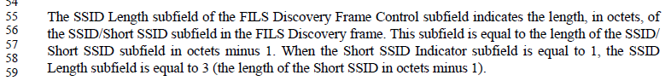
This example, just on the face of it, is confusing. Clearly, the situation is confusing. Recommend keeping the example to help the reader confirm they understand the interrelationship of these fields.

And, finally, in 9.3.1.8.3, the cited text is:
This case is straightforward. Recommend deleting the example. Agree with changing “less one” to “minus one”.

Proposed Resolution – agreed on June 28:

Revised.

In Table 9-31, replace
“If the Feedback Type field indicates MU, then Nc Index indicates the number of columns, Nc, in the Compressed Beamforming Feedback Matrix subfield minus 1:”
with
“If the Feedback Type field indicates MU, then Nc Index indicates the number of columns minus 1, (Nc-1), in the Compressed Beamforming Feedback Matrix subfield:”
and replace
":
Set to 0 to request Nc = 1
Set to 1 to request Nc = 2
...
Set to 7 to request Nc = 8"
with
".".

[ Note to editor, the ‘-‘ in ‘Nc-1’ should be a minus glyph, not a hyphen. ]

In Table 9-72 replace
":
Set to 0 for Nc = 1
Set to 1 for Nc = 2
...
Set to 7 for Nc = 8"
with
"."
and replace
":
Set to 1 for Nr = 2
...
Set to 7 for Nr = 8"
with
"."

In Table 9-87 and Table 9-57 replace
":
Set to 0 for Nc = 1
Set to 1 for Nc = 2
Set to 2 for Nc = 3
Set to 3 for Nc = 4"
with
"."
and in Table 9-87 only, replace
":
Set to 0 for Nr = 1
Set to 1 for Nr = 2
Set to 2 for Nr = 3
Set to 3 for Nr = 4"
with
"."
and in Table 9-57 only, replace
":
Set to 1 for Nr = 2
Set to 2 for Nr = 3
Set to 3 for Nr = 4"
with
".".
[ Note to Editor, in Table 9-57, “Nr Index” row, retain the statement “The value 0 is reserved.” ]

In 9.4.2.170.2 delete "For example, a value of 0 indicates that one TBTT Information field is included. "

9.3.1.8.3 delete "For example, a value of 2 in the TID_INFO subfield means that information for three TIDs is present." and change "less one" to "minus one" in the preceding sentence

Need to revisit the two missing textual context deletions:

In 9.3.4.2, the cited text is:

Proposal: in 9.3.4.2, make changes as shown:
The FSS subfield specifies indicates the number of SSW frames allowed per sector sweep slot minus one (10.43.5 (Beamforming in A-BFT)). The subfield contains the number of SSW frames allowed minus one. The range of this subfield is 0 to 15. For example, when the number of SSW frames allowed per sector sweep is 5, the subfield contains the value 4.

In 9.6.7.36, the cited text is:

In this case, the example provided is to cover the special case where an independent bit (the Short SSID Indicator) has a given value, that implies the length of the field discussed in the paragraph (the SSID/Short SSID subfield) is fixed, because a Short SSID has fixed length (4 octets), thus the SSID Length subfield happens to be known and predictable, as “3”. Thus, the example is not ‘helping’ the reader understand what “minus one” means, but rather to notice the linkage between these subfields, and the a prior known value of this SSID Length subfield, in this specific case.

Proposal: in 9.6.7.36, make the last sentence a NOTE, and delete the parenthetical phrase at the end.

Proposed Resolution:

Revised.

In Table 9-31, replace
“If the Feedback Type field indicates MU, then Nc Index indicates the number of columns, Nc, in the Compressed Beamforming Feedback Matrix subfield minus 1:”
with
“If the Feedback Type field indicates MU, then Nc Index indicates the number of columns minus 1, (Nc-1), in the Compressed Beamforming Feedback Matrix subfield:”
and replace
":
Set to 0 to request Nc = 1
Set to 1 to request Nc = 2
...
Set to 7 to request Nc = 8"
with
".".

[ Note to editor, the ‘-‘ in ‘Nc-1’ should be a minus glyph, not a hyphen. ]

In Table 9-72 replace
":
Set to 0 for Nc = 1
Set to 1 for Nc = 2
...
Set to 7 for Nc = 8"
with
"."
and replace
":
Set to 1 for Nr = 2
...
Set to 7 for Nr = 8"
with
"."

In Table 9-87 and Table 9-57 replace
":
Set to 0 for Nc = 1
Set to 1 for Nc = 2
Set to 2 for Nc = 3
Set to 3 for Nc = 4"
with
"."
and in Table 9-87 only, replace
":
Set to 0 for Nr = 1
Set to 1 for Nr = 2
Set to 2 for Nr = 3
Set to 3 for Nr = 4"
with
"."
and in Table 9-57 only, replace
":
Set to 1 for Nr = 2
Set to 2 for Nr = 3
Set to 3 for Nr = 4"
with
".".
[ Note to Editor, in Table 9-57, “Nr Index” row, retain the statement “The value 0 is reserved.” ]

In 9.4.2.170.2 delete "For example, a value of 0 indicates that one TBTT Information field is included. "

9.3.1.8.3 delete "For example, a value of 2 in the TID_INFO subfield means that information for three TIDs is present." and change "less one" to "minus one" in the preceding sentence

In 9.3.4.2, make changes as shown:
The FSS subfield specifies indicates the number of SSW frames allowed per sector sweep slot minus one (10.43.5 (Beamforming in A-BFT)). The subfield contains the number of SSW frames allowed minus one. The range of this subfield is 0 to 15. For example, when the number of SSW frames allowed per sector sweep is 5, the subfield contains the value 4.

In 9.6.7.36, make the last sentence a NOTE, and delete the parenthetical phrase at the end.

CID | Page | Clause | Comment | Proposed Change
2510 | 1148.04 | 9.4.2.47 | "The Wrapped Key field contains the wrapped IGTK being distributed. The length of the resulting AES-Key-wrapped IGTK in the Wrapped Key field is Key Length + 8 octets." Assuming this wrapping is the wrapping described in 13.8.5 per the description of GTK KDEs above, the second statement is only true of the IGTK is exactly 8 octets long, which even if true now might not be in the future (i.e. spec rot). Actually, even that's not possible since the wrapping (padding) only occurs "if the key length is less than 16 octets or  if it is not a multiple of 8", but Figure 9-356/358 suggest the field is at least 24 octets long | Change the cited text to just "The Wrapped Key field contains the encrypted IGTK as described in 13.8.5 (FT authentication sequence:  contents of fourth message)." (cf. 1147.40)

Discussion:
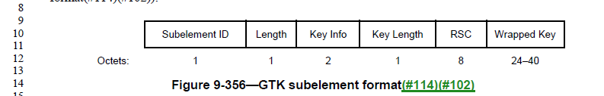

From discussion with Dan:

AES-keywrap always adds 64 bits to the wrapped data, to carry the integrity check used by the receiver to know that the decryption was successful. So, len(AES-Keywrap(GTK)) will always be len(GTK)+64.

In fact, we don’t have any ciphers in use in 802.11 that use a 64-bit key, so the IGTK is never 8 octets, currently.

Proposed Resolution:

Rejected: IGTK for FT is always wrapped with the NIST AES key wrap algorithm. The length resulting from the NIST AES key wrap algorithm is the length of the IGTK plus 8 octets, regardless of the length of the IGTK. The IGTK is (currently) always at least 16 octets long, so the figures are correct.

CID | Page | Clause | Comment | Proposed Change
2295 | 3778.50 | C.3 | dot11AuthenticationResponseTimeout is deprecated, but it doesn't say why (by convention, it should). There is no obvious reason why this is deprecated. | Change "Deprecated" to "current"

Discussion:

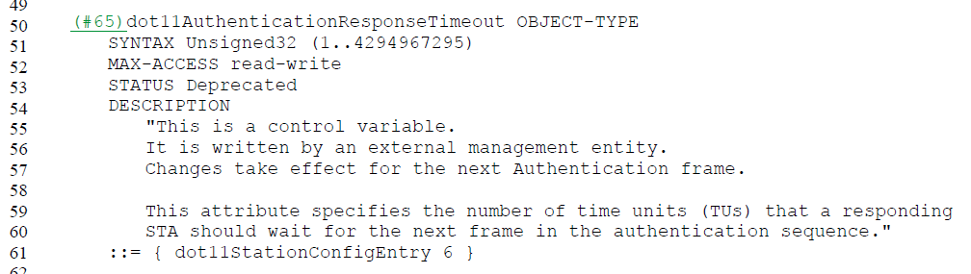

Currently, the only mention of dot11AuthenticationResponseTimeout (outside the MIB) is in the context of EAP-RP Authentication, added with FILS (in 12.12.2.3.5):

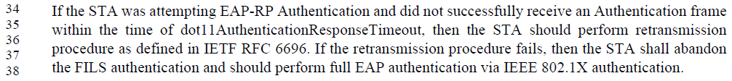

Per the MIB description, dot11AuthenticationResponseTimeout is supposed to be used to timeout each message exchange in an Authentication sequence. While AuthenticateFailureTimeout does a timeout across the entire sequence (apparently, per the MLME-AUTHENTICATE.request primitive description). It does not seem that we really need both.

A reasonable answer to the CID might be to add that it was deprecated because it was redundant with AuthenticateFailureTimeout, which can serve effectively the same purpose, while the implementation can follow the rules for RFC 6696 as an implementation detail, if applicable.

If dot11AuthenticationResponseTimeout is left as deprecated, the text quoted above (for EAP-RP) needs to be updated to not depend on this attribute. Suggest:

Replace the quoted text in 12.12.2.3.5, with:
If the STA was attempting EAP-RP Authentication and did not successfully receive an Authentication frame within the time of dot11AuthenticationResponseTimeout, then the STA should perform retransmission procedure as defined in IETF RFC 6696, and with implementation-specific timeouts as guided by the AuthenticateFailureTimeout provided in the MLME-AUTHENTICATE.request. If the retransmission procedure fails, then the STA shall abandon the FILS authentication and should perform full EAP authentication via IEEE 802.1X authentication.

Proposed Resolution:

Revised.

In 12.12.2.3.5, modify the sentence as shown:
If the STA was attempting EAP-RP Authentication and did not successfully receive an Authentication frame within the time of dot11AuthenticationResponseTimeout, then the STA should perform retransmission procedure as defined in IETF RFC 6696, and with implementation-specific timeouts as guided by the AuthenticateFailureTimeout parameter in the MLME-AUTHENTICATE.request.

In C.3, add the following as a new first sentence in the DESCRIPTION for the MIB attribute dot11AuthenticationResponseTimeout:
Deprecated, as redundant in purpose with the AuthenticateFailureTimeout parameter provided in an MLME-AUTHENTICATE.request.

CID | Page | Clause | Comment | Proposed Change
2119 | 584.13 | 6.3.71.4.2 | "PeerSTAAddress" shall be "STAAddress" to be consistent with MLME-GAS.indication. In MLME-GAS.request and MLME-GAS.confirm primitives, the first parameter is "STAAddress". In MLME-GAS.indication primitive, the parameter is named as "PeerSTAAddress". To be consistent, "PeerSTAAddress" shall be "STAAddress" in MLME-GAS.indication. | In 6.3.71.4.2, change "PeerSTAAddress" to "STAAddress" at 584.13 and 584.29.

Discussion:

As the comment says, in the MLME-GAS.indication, the first parameter is called “PeerSTAAddress”, but in other MLME-GAS primitives have “STAAddress”.

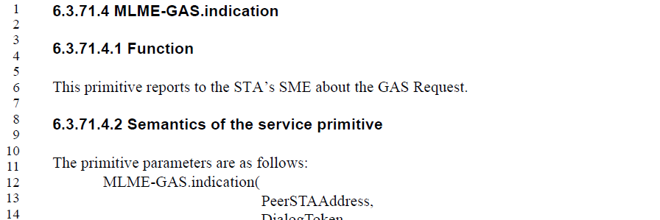

(Some of?) This came from 802.11aq, which added the concept that a GAS request could be a group address behaviour. But, it appears to be inconsistent, now. The current situation can be summarized as follows:

Primitive | Parameter name | Comments
.request | STAAddress | Described as a peer, or the broadcast address, to which the request is sent. Non-specific is correct. No change.
.indication | PeerSTAAddress | Described as the peer entity from which the query (request) message was received. Should be specific to a single peer, and is. No change.
.response | STAAddress | Described as the entity or the broadcast address, to which the response is sent. Non-specific is correct. No change.
.confirm | STAAddress | Described as the peer entity from which the response is received. Should be “PeerSTAAddress”. Recommend changing it.

Proposed Resolution:

Revised. Change “STAAddress” to “PeerSTAAddress” in the parameter list and parameter description table for the MLME-GAS.confirm primitive (subclause 6.3.71.3.2, P582.25).

CID | Page | Clause | Comment | Proposed Change
2351 |  |  | It's sometimes "fragment BA option", sometimes "procedure", sometimes "session" | "procedure" seems most popular, so change "fragment BA session" to "fragment BA procedure" in 9.9.2.6.1 (2x), 9.9.2.6.2 (2x); "fragment block ack operation" to "fragment block ack procedure" in 4.3.14.1

Discussion:

This author suggests the feature is called just “fragment BA”. (Many other features are just the name, not with a noun trailing.) Similarly, for “asymmetric block ack”. Thus, the following are proposed:

Title of 10.3.2.12 can stay as “procedure” to match style of other nearby subclauses:
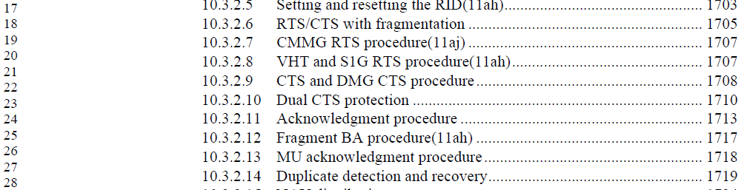

Delete “operation” in 4.3.14.1, and shorten to “fragment BA”/”asymmetric BA”:
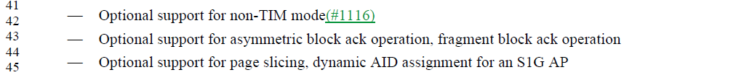

Change “the fragment BA procedure” -> “fragment BA” in Table 9-13, Table 9-535. (2x in each table.) For example:
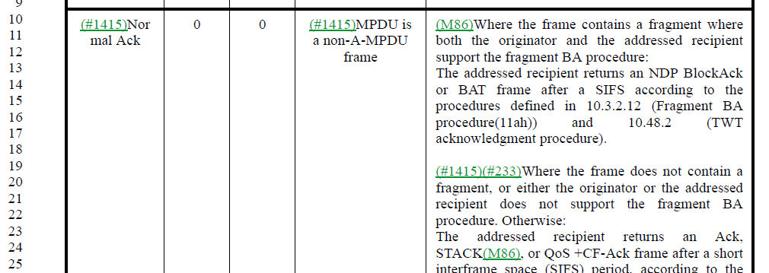

Change “fragment BA procedure” to “fragment BA” in Table 9-301, PICS (S1GM22.3). For example:
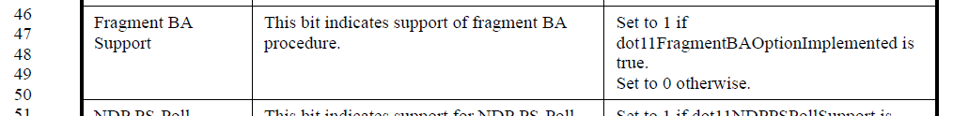

Leave “fragment BA session” in 9.9.2.6.1 and 9.9.2.6.2, to match “BlockAck session” (Note “BlockAck session” and “Block Ack session” is not defined, just assumed the reader knows what we mean.)
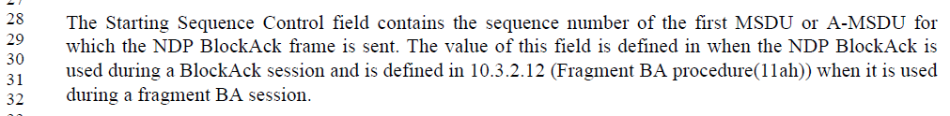
No change.

Change “the fragment BA procedure” to “fragment BA” in NOTE 3 in 10.2.6,:

Change “the fragment block ack option” -> “fragment BA” in the MIB:

Change “the asymmetric block ack operation” -> “asymmetric BA”, and “asymmetric BlockAck operation” -> “asymmetric BA”, in Table 9-54:
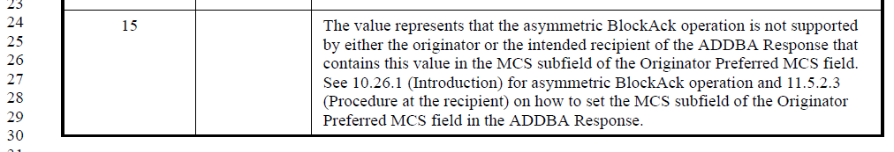

Change “Asymmetric Block Ack Operation” -> “Asymmetric BA” and “asymmetric block ack operation” -> “asymmetric block ack” in PICS (S1GM27)
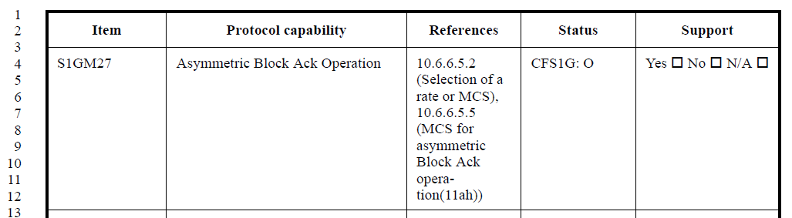

Change “Asymmetric Block Ack” .> “Asymmetric BA” in Table 9-301:
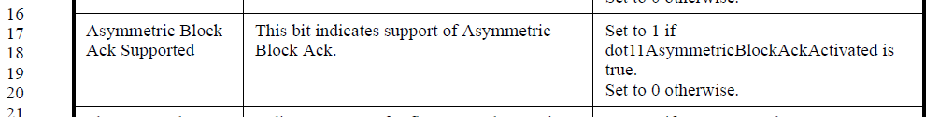

Change “asymmetric block ack [operation]” to “asymmetric BA” where shown (4 places):
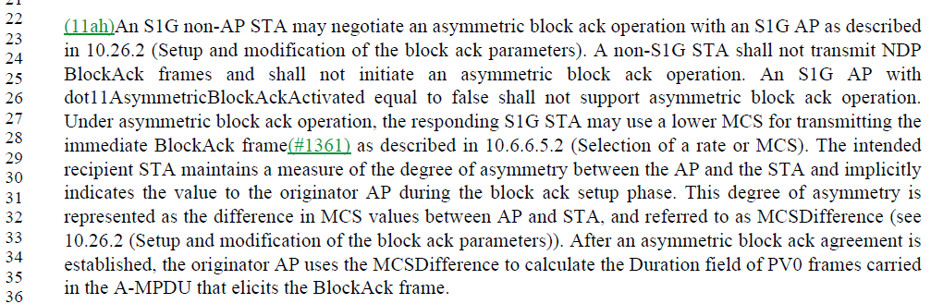

Change “[Tt]he asymmetric Block ACK” -> “asymmetric BA” in MIB (x2):
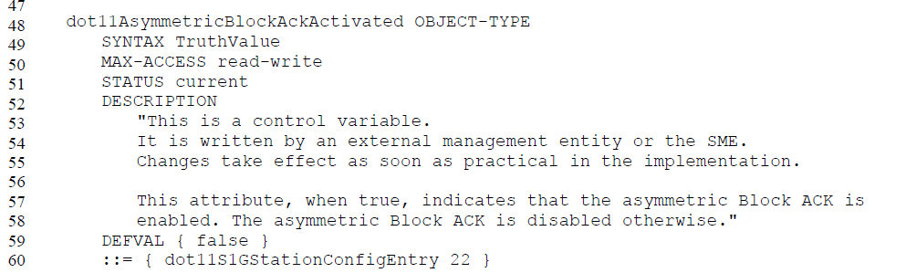

Proposed Resolution:

Revised.

Delete “operation” in 4.3.14.1, and shorten to “fragment BA”/”asymmetric BA”:

Change “the fragment BA procedure” -> “fragment BA” in Table 9-13, Table 9-535. (2x in each table.) For example:

Change “fragment BA procedure” to “fragment BA” in Table 9-301, PICS (S1GM22.3). For example:

Change “the fragment BA procedure” to “fragment BA” in NOTE 3 in 10.2.6,:

Change “the fragment block ack option” -> “fragment BA” in the MIB:

Change “the asymmetric block ack operation” -> “asymmetric BA”, and “asymmetric BlockAck operation” -> “asymmetric BA”, in Table 9-54:

Change “Asymmetric Block Ack Operation” -> “Asymmetric BA” and “asymmetric block ack operation” -> “asymmetric block ack” in PICS (S1GM27)

Change “Asymmetric Block Ack” -> “Asymmetric BA” in Table 9-301:

Change “asymmetric block ack [operation]” to “asymmetric BA” where shown (4 places):

Change “[Tt]he asymmetric Block ACK” -> “asymmetric BA” in MIB (x2):

CID | Page | Clause | Comment | Proposed Change
2091 | 1474.15 | 9.5.2 | Change (I think 3) instances of "unicast adress" to "individual address". | As suggested, first one listed only.  Additionally, after removing these last remaining references to "unicast address", remove "unicast address" from Section 3.4 (Abbreviations and acronyms) altogether (2 instances).

Discussion:

There are the following occurrences of “unicast” in the draft, discussed below.

In Definitions (subclause 3.1):
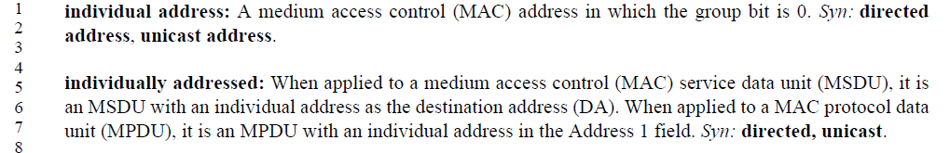
Since these are explaining that the reader’s understanding of “unicast address(ed)” is defined as “individual address(ed)” in the Standard, it seems appropriate to keep these occurrences.

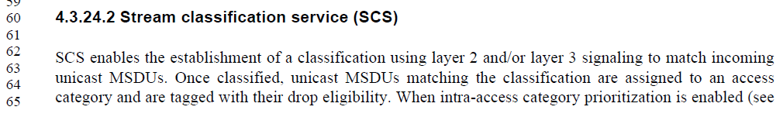
Recommend these occurrences are changed to “individually addressed”.

In 4.3.28.2:
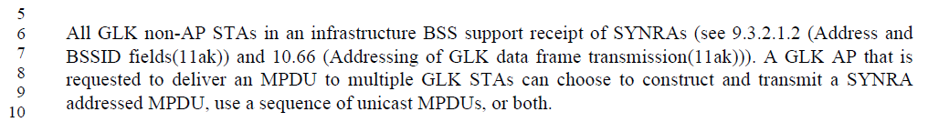
Recommend replacing “unicast MPDUs” with “individually addressed MPDUs”.

In the MLME-GAS.request primitive, and similarly in the MLME-GAS.response primitivie:
Recommend changing these occurrences to “an individually addressed GAS frame”.

In 9.5.2 (Dynamic Allocation Info field, within certain DMG frames):
Recommend changing this to “an individual address”.

In 10.3.2.14.2 (Transmitter requirements for duplicate detection and recovery), there are 4 occurrences:
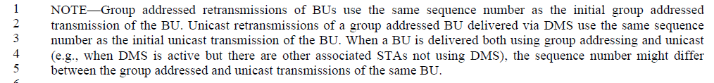
Recommend changing this as shown:
NOTE—Group addressed retransmissions of BUs use the same sequence number as the initial group addressed transmission of the BU. Unicast Individually addressed retransmissions of a group addressed BU delivered via DMS use the same sequence number as the initial unicast individually addressed transmission of the BU. When a BU is delivered both using group and individual addressing and unicast (e.g., when DMS is active but there are other associated STAs not using DMS), the sequence number might differ between the group and individually addressed and unicast transmissions of the same BU.

In 10.55.4 (Group addressed frame operation for S1G relay):
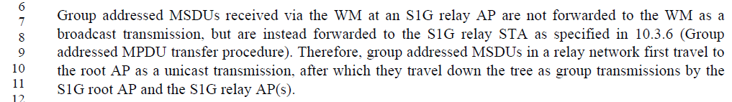
Recommend changing this to “an individually addressed transmission”.

In 11.2.3.1:
Recommend changing this to “individually addressed frames”.

In 11.22.16.3.1 (in the comparison of DMS and GCR):
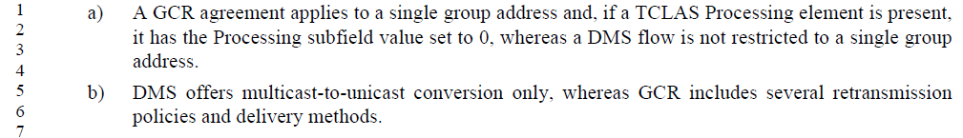
Recommend changing “multicast-to-unicast” to “group-to-individually addressed”. This is consistent with the previous bullet and also how the DMS subclause describes DMS’ operation.

In 11.23.3.1:
Recommend changing this to “an individually or group addressed GAS Query Response.”

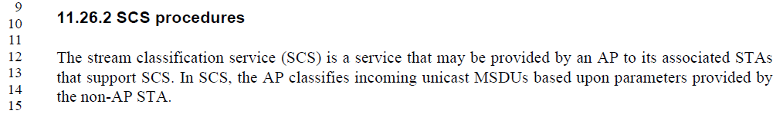
Recommend changing this to “incoming individually addressed MSDUs”. Make the same change in a very similar occurrence at line 53 on the same page.

In 11.46.3.2 (FILS higher layer protocol encapsulation):
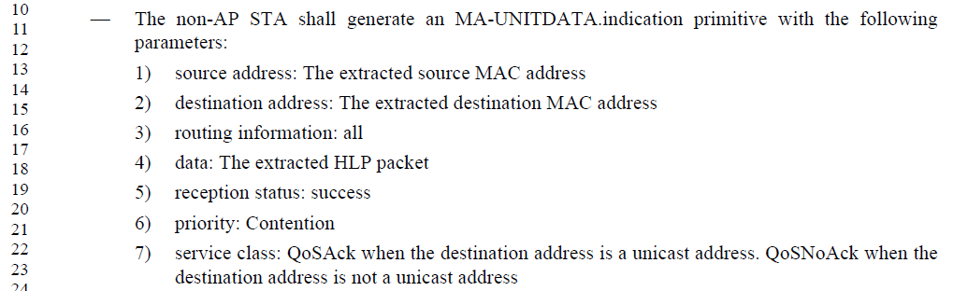
Recommend changing this to “an individual address” in both occurrences.

In 12.7.10.1 (RSNA state machine’s initialization state):
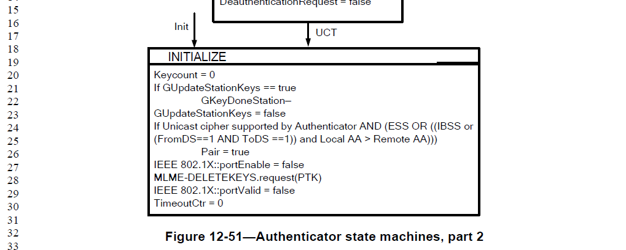
There does not appear to be any significance to the term “unicast cipher” other than the normal English usage, as “cipher(s) that apply to unicast [individually-addressed] communication”. Recommend changing this to “If pairwise cipher is supported …”

In the MIB and R.4.2.4, occurrences of “dot11NonAPStationUnicastCipherSuite”: due to the complexity and ‘ripple-effect’ of changing a MIB name, recommend leaving this unchanged.

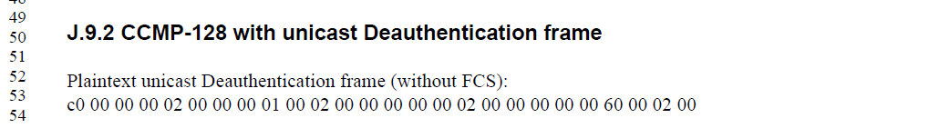
Recommend changing both occurrence to “individually-addressed”.

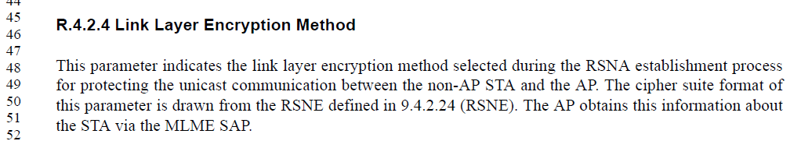
Recommend changing to “pairwise communication”.

Proposed Resolution:

Revised.

Change two occurrences of “unicast” to “individually addressed” in 4.3.24.2:

In 4.3.28.2, replace “unicast MPDUs” with “individually addressed MPDUs”:

In the MLME-GAS.request primitive, and similarly in the MLME-GAS.response primitive, change occurrences of “a unicast GAS frame” to “an individually addressed GAS frame”:

In 9.5.2, change “unicast address” to “an individual address”:

In 10.3.2.14.2, there are 4 occurrences:
Change this as shown:
NOTE—Group addressed retransmissions of BUs use the same sequence number as the initial group addressed transmission of the BU. Unicast Individually addressed retransmissions of a group addressed BU delivered via DMS use the same sequence number as the initial unicast individually addressed transmission of the BU. When a BU is delivered both using group and individual addressing and unicast (e.g., when DMS is active but there are other associated STAs not using DMS), the sequence number might differ between the group and individually addressed and unicast transmissions of the same BU.

In 10.55.4, change “a unicast transmission” to “an individually addressed transmission”:

In 11.2.3.1, change “unicast frames” to to “individually addressed frames”:

In 11.22.16.3.1, change “multicast-to-unicast” to “group-to-individually addressed”:

In 11.23.3.1, change “a unicast or group addressed GAS Query Response” to “an individually or group addressed GAS Query Response.”:

In 11.26.2, change “incoming unicast addressed MSDUs” to “incoming individually addressed MSDUs”. Make the same change in a very similar occurrence at line 53 on the same page.

In 11.46.3.2 (FILS higher layer protocol encapsulation), change “a unicast address” to “an individual address” in both occurrences:

In 12.7.10.1, in the RSNA state machine’s initialization state, change “If Unicast cipher” to “If Pairwise cipher”:

In J.9.2, change both occurrences of “unicast” to “individually addressed”:

In R.4.2.4, change “unicast communications” to “pairwise communications”.

CID | Page | Clause | Comment | Proposed Change
2480 | 966.32 | 9.4.2.1 | Missing elements 77, 218, 219, 227 | Add a row for each of these, showing them explictly as reserved

Discussion:

The referenced entries in Table 9-94, in Draft 2.2 are in context:

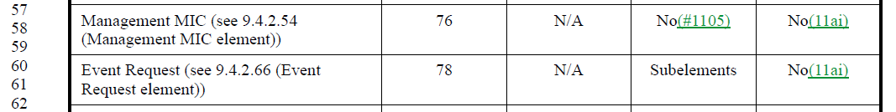
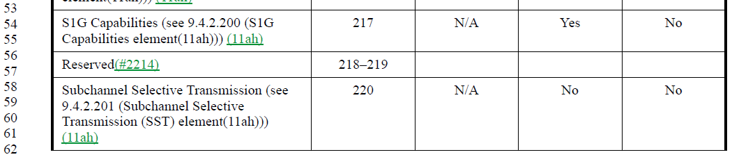
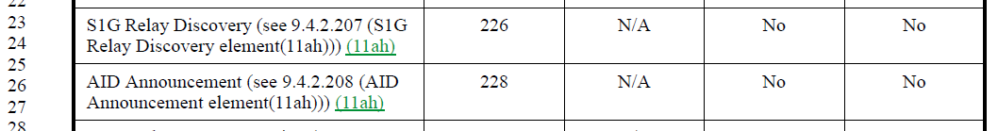

Entries for 218 and 219 were added with CID 2214. Element numbers 77 and 227 are indeed missing.

Proposed Resolution:

Revised.

Add a row in the Element IDs table for entries 77 and 227, with “Element” column of “Reserved” and “Element ID extension”, “Extensible” and “Fragmentable” columns left blank.

Note to commenter, entries for 218 and 219 were added as a result of resolution for CID 2214.

CID | Page | Clause | Comment | Proposed Change
2009 | 2130.51 | 11.1.4.3.4 | There are too many double negations in this paragraph making it hard to follow - e.g., "shall not respond... is not a mesh STA and none of following are met..." | Reorganize the paragraph to remove double negations

Discussion:

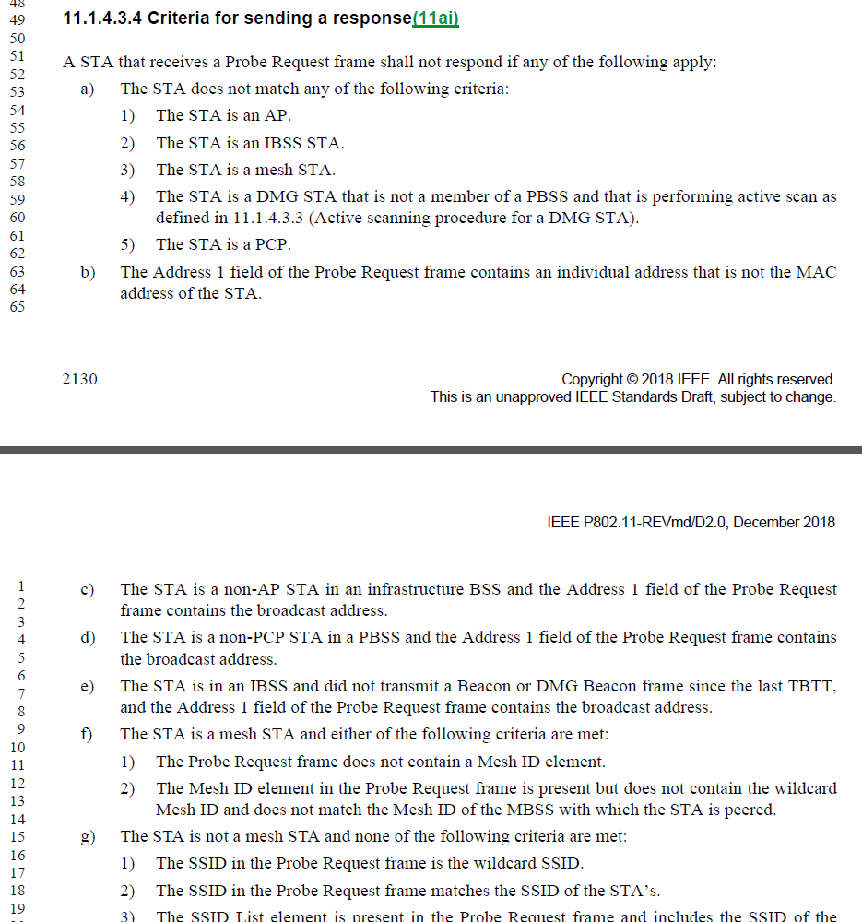

Agree with the commenter that this is expressed in very negative language, from the first statement (“shall not respond if”) to then list a number of items such as “does not match”, “is not a mesh STA and none of the following”. It would be more understandable to state things in a positive/affirmative manner.

However, that said:
- To remove the fundamental double-negative we would need to reverse the whole thing to “A STA shall|may respond if …” Saying it _shall_ respond is clearly too strong; there are lots of reasons (including implementation-specific choices) why it might not respond, and we can’t require it). But, saying it _may_ respond seems weak, and doesn’t convey the intention of these requirements. We lose the idea that it “shall not” respond in the cases that would not be listed. It is sort of implied, in that we gave it permission to respond in only the listed cases, but “may” is not so exclusive in interpretation. “May only” is discouraged by the Style Guide, which recommends using a negative shall instead. 😊
- There are other reasons sprinkled throughout the clause/spec for why a STA shall not respond. So, to make this permissive (“A STA may respond if”) would be in potential conflict with something else that says, no, it actually may (shall) not respond, because of such-and-such. By leaving this as a negative shall, and thus listing the exclusion reasons why it shall not, we can still have other reasons why it shall not elsewhere, and they are not in conflict.

Proposed Resolution:

Rejected. The negative style of this subclause is necessary (even if harder to read) to create clear “shall” (or “shall not”) requirements, and not a “may” statement which is less clear about specific requirements. Further, listing specific rules for why the STA shall not respond, here, avoids any confusion with requirements elsewhere in the draft that have additional reasons that a STA shall not respond.

CID | Page | Clause | Comment | Proposed Change
2188 | 1217.60 | 9.4.2.79 | Table 9-222 - TFS Action Code field values: table call for "the STA is to be sent" - this is poor wording - it should say the "AP will transmit" | Replace the "STA is to be sent" with "AP will transmit"

Discussion:

This wording is within the table explaining the bits in a TFS Request.

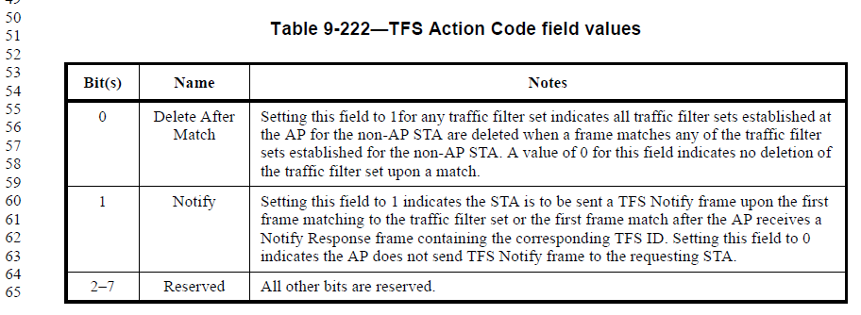

As this is only a request from the non-AP STA, it is also confusing to say the “AP will” transmit the frame, until the negotiation for such behaviour has completed. Suggest it might be slightly more clear to say that this is a request.

Proposed Resolution:

Revised.

Change “is to be sent” to “requests to be sent”

CID | Page | Clause | Comment | Proposed Change
2250 | 2204.40 | 11.3.5.4 | At (D0.1 numbering) P1774L9, this should be clear that it is for reassociation to the same AP, for these to be not affected. | To the start of the sentence, add, "If the reassociation is to the same AP, "

Discussion:

The current cite (in D2.0) is P2204.40, as indicated. It’s unclear why the comment noted the page/line reference as it was in D0.1. So, ignoring that…

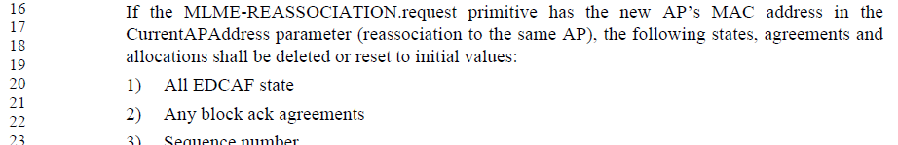
. . .
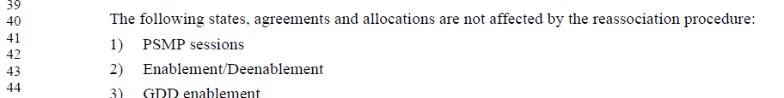

The comment is on the second snippet above. It can be seen that the first snippet introduces these lists with a clear statement that this applies when the reassociation is to the same AP. But, that is not repeated in the snippet that starts the second list.

One option is to repeat the entire same language about the addresses matching. Another option is to just repeat the “to the same AP”, but this might not be understood, and the similarity to language further above is far enough away to not be obvious.

Proposed Resolution:

Revised.

Add to the start of the cited sentence, add, “If the reassociation is to the same AP (as described above), …”

CID | Page | Clause | Comment | Proposed Change
2252 | 1794.47 | 10.23.5 | Wording in 10.22.5 is a bit confusing saying that 3us is the "ceiling" for the example BSS. | Change "3 ╬╝s would be the ceiling for BSS maximum one-way distance" to "3 ╬╝s would be the maximum round-trip delay for a BSS with maximum coverage distance"

Discussion:

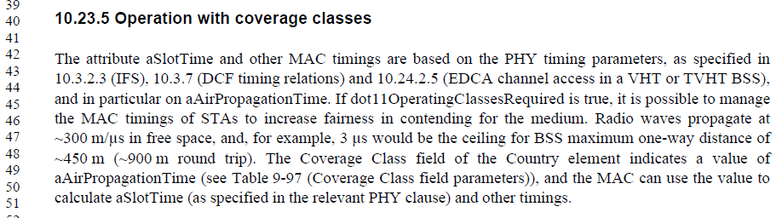

Agree with the commenter, the phrasing “ceiling for … maximum” is confusing.

What is trying to be conveyed here is to consider the maximum extent of an example BSS, and then to note that within such a BSS, the round-trip time has a maximum delay for a signal that needs to reach that extent of the coverage and return. The proposed wording does seem a bit more clear

Proposed Resolution:

Accepted.

CID | Page | Clause | Comment | Proposed Change
2275 | 2203.14 | 11.3.5.3 | CID 1588 was mostly done - the fixes in 9.4.1.8 are good. But, we still need something in 11.3.5.3 that says these rules about AID assignment are used for different device/BSS types. | Add a numbered item, "3) In either case, the AID(s) are allocated from the ranges described in 9.4.1.8. Same thing in 11.3.5.5 item (k).

Discussion:

CID 1588 was:

1588 | 842.06 | 9.4.1.8 | "An AID value is assigned by a mesh STA ..." is behavioral stuff, that shouldn't be in clause 9. It's already covered in 14.3.1. Move the non-DMG STA, S1G STA and DMG STA paragraphs, too, probably to 11.3.5.3(k) and 11.3.5.5(k). | Change the two sentences about mesh AIDs to, "In mesh BSS operation, the AID field is a value that represents the 16-bit ID of a neighbor peer mesh STA, assigned during mesh peering." Move the text in the two paragraphs after Figure 9-84, to be duplicated in 11.3.5.3(k) and 11.3.5.5(k).

Resolved as:
REVISED (EDITOR: 2018-05-07 15:35:54Z) -

Change the two sentences about mesh AIDs to, "In mesh BSS operation, the AID field is a value that represents the 16-bit ID of a neighbor peer mesh STA, assigned during mesh peering."

Change
“A non-DMG and non-S1G STA assigns the value of the AID in the range of 1 to 2007; the 5 MSBs of the AID field are reserved. An S1G STA assigns the value of the AID in the range of 1 to 8191; the 3 MSBs of the AID field are reserved.
A DMG STA assigns the value of the AID field in the range 1 to 254. The value 255 is reserved as the
broadcast AID, and the value 0 corresponds to the AP or PCP. The 8 MSBs of the AID field are reserved.”

To :
“The value of the AID field for a non-DMG and non-S1G STA is in the range of 1 to 2007, and the 5 MSBs of the AID field are reserved.
The value of the AID field for an S1G STA is in the range of 1 to 8191, and the 3 MSBs of the AID field are reserved.
The value of the AID field for A DMG STA is in the range 1 to 254. The value 255 is reserved as the
broadcast AID, and the value 0 corresponds to the AP or PCP. The 8 MSBs of the AID field are reserved.”

The commenter seems to be referencing text that mentions the allocation of AID(s) but does not reference the clause 9 discussion about the ranges for these AIDs:
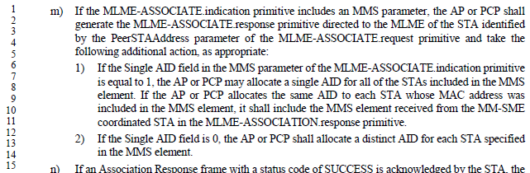

However, such an explicit reference to 9.4.1.8 is not used in other parts of clause 11 that discuss AID allocation, either (except for some special discussion in the Mesh clause). There is no clear reason why this particular AID assignment (for MMSL clusters) needs such an explicit reference, rather than assuming the general rules apply in this case as they would in any other case.

Proposed Resolution:

Rejected. The commenter fails to identify why this particular scenario needs more explicit reference to the clause 9 rules than any other scenario in clause 11.

CID | Page | Clause | Comment | Proposed Change
2230 | 1235.44 | 9.4.2.91 | In 9.4.2.92, (at the end) "A STA uses this field to indicate" should be "A STA may use this field to indicate" because this field is optional. | Change "uses" to "may use" per the comment.

Discussion:

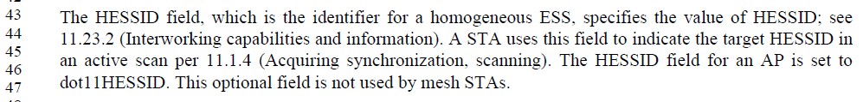

As seen above in the frame format definition, this field is indeed optiona:

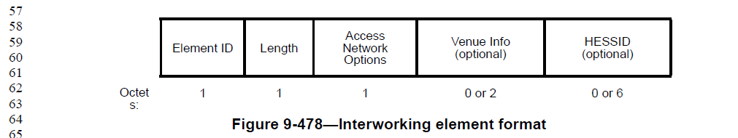

Proposed Resolution:

Accepted.

CID | Page | Clause | Comment | Proposed Change
2235 | 1683.65 | 10.2.1 | 10.2.1 (for non-DMG STA) lists PCF, HCF and MCF as using DCF. But, there is no mention similar to the bullets that DCF is provided in all these STA types. It seems like a non-QoS, non-mesh STA can only use PCF. (This is clarified in 10.2.2, but still ...) | At the end of the first bullet, add "The MAC also provides direct access to the DCF service."

Discussion:

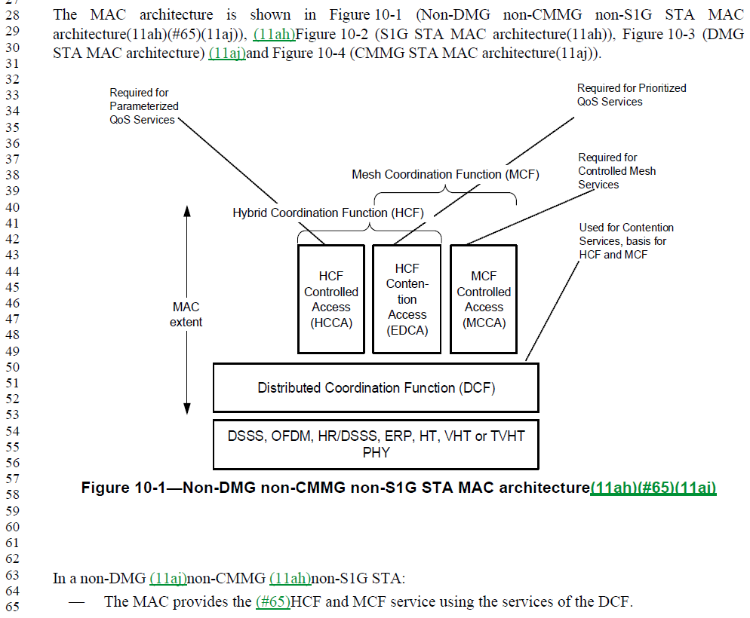
The commenter is correct.

Proposed Resolution:

Accepted.

CID | Page | Clause | Comment | Proposed Change
2239 | 1095.59 | 9.4.2.26 | 9.4.2.27 (Extended Capabilities element), the length of the Extended Capabilities field is a variable n. Presumbaly this is not a fixed length for backward compatibility with older implementations that had less bits to indicate. But, this isn't really made clear anywhere, and at this point (this reviion of the Standard), we could say it is 0 to 11 octets although more might exist in a received element (from a future device). Or, perhaps just say "variable" in the figure and explain all this in the text? Second, Table 9-153 implies that there are "n" bits, not "n" octets, so that's in conflict. | Change the "Octets" count to "variable' in Figure 9-291.  In the third paragraph, replace the sentence, "The length of the Extended Capabilities field is a variable n" with "The length of the Extended Capabilities field is variable. In the current version of this Standard, the length is 11 octets, however older implementations may send less octets and the rest of the Extended Capabilities field bits are assumed to be zero. Similarly, future implementations may send more octets, and the extra octets are ignored upon reception by a current or older implementation."  In Table 9-153, change "n" in the last row to 87.

Discussion:

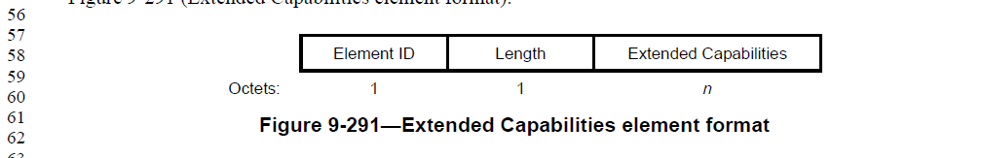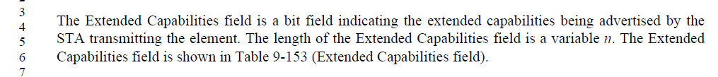

The commenter is correct that Figure 9-291 indicates the Extended Capabilities field is n octets long. Likewise, Table 9-153 indicates each bit position, from 0 to n:
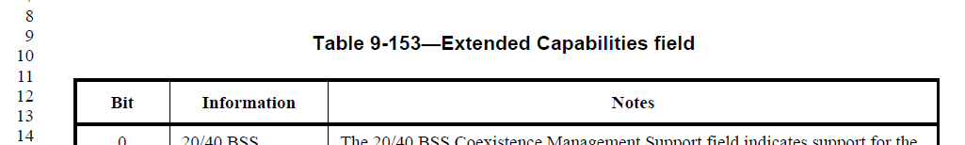
. . .

So, at a minimum, Figure 9-291 needs to be corrected. A logical approach seems to be to just say “Variable” as suggested, and clarify in the text.

Proposed Resolution:

Revised.

Change “n” to "variable' in Figure 9-291.
In the third paragraph, replace the sentence, "The length of the Extended Capabilities field is a variable n" with "The length of the Extended Capabilities field is variable. If fewer bits are received in an Extended Capabilities field than shown in Table 9-153, the rest of the Extended Capabilities field bits are assumed to be zero."
In Table 9-153, change "n" in the last row to 87.

CID | Page | Clause | Comment | Proposed Change
2618 | 2351.42 | 11.22.7.1 | "A STA with dot11BSSTransitionActivated equal to true shall support BSS transition management" -- should also have implemented set to true. This was rejected in CID 1382 on the basis that "For dot11BSSTransitionActivated to be true, logically, dot11BSSTransitionImplemented must also be true without needing to state so" but this while plausible sounding needs to be supported by actual normative text | In the referenced subclause, delete "A STA that implements BSS  transition management has dot11BSSTransitionImplemented equal to true. When  dot11BSSTransitionImplemented is true, dot11WirelessManagementImplemented shall be true." In C.3. delete the OBJECT-TYPE for dot11BSSTransitionImplemented and its inclusion in Dot11WirelessMgmtOptionsEntry

Discussion:

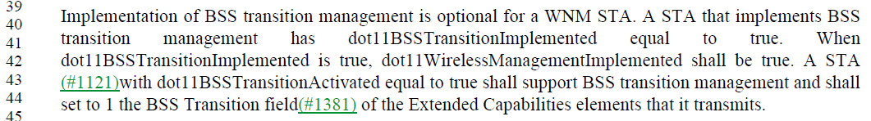

Per (relatively) recent agreement about MIB attribute definitions, there is rarely value in having both <xxx>Implemented and <xxx>Activated. In this particular case, there is no reference to dot11BSSTransitionImplemented outside the MIB, so this seems to be an example that can easily be simplified.

Proposed Resolution:

Revised.

At the cited location, delete "A STA that implements BSS transition management has dot11BSSTransitionImplemented equal to true."

At the cited location, change
"When dot11BSSTransitionImplemented is true, dot11WirelessManagementImplemented shall be true."
to
"When dot11BSSTransitionActivated is true, dot11WirelessManagementImplemented shall be true."

Deprecate dot11BSSTransitionImplemented in the MIB:
- Change its STATUS to "Deprecated".
- Insert a new first line in the DESCRIPTION: "Deprecated as unnecessary; dot11BSSTransitionActivated is used instead".
- For any reference to the variable in any GROUPs, re-instate this reference:
  - Change the group's STATUS to "Deprecated".
  - In the DESCRIPTION, insert a new first line: "Superseded by YYYY." (Note that "YYYY" is the new GROUP name.)
  - Make a copy of the group, set its STATUS to "Current" and increment (or add) a number after the name of the group name (e.g. dot11SMTbase11 -> dot11SMTbase12).
  - Remove dot11BSSTransitionImplemented in the new group.
  - For each reference to the group from a compliance statement, update it to refer to the new group.

CID | Page | Clause | Comment | Proposed Change
2242 | 2311.47 | 11.15.12 | This sentence doesn't parse correctly. | Change "The STA sets the Forty MHz Intolerant field of the 20/40 BSS Coexistence element based on A STA's FortyMHzIntolerant" to "The STA sets the Forty MHz Intolerant field of the 20/40 BSS Coexistence element per the rules listed in 11.15.11."

Discussion:

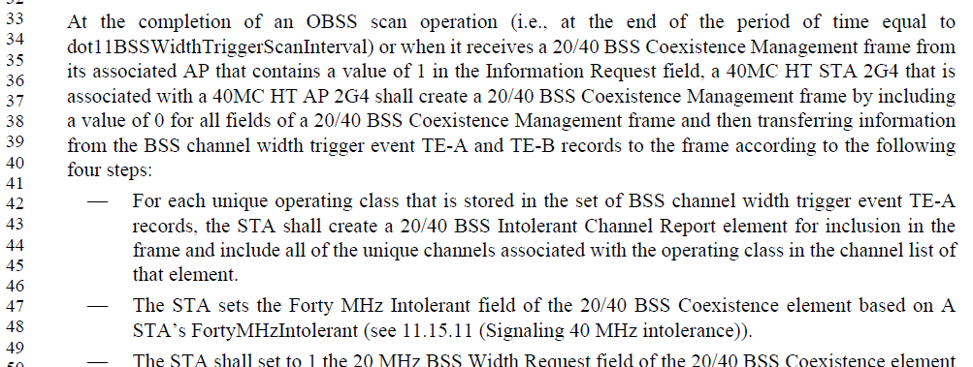

The sentence does have some grammar issues. Subclause 11.15.11 does make the intention clear:
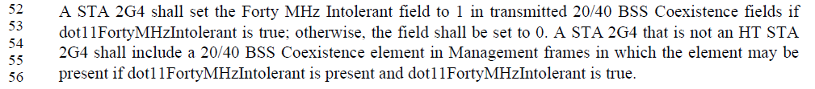

One possible solution is to change “A STA” to “the STA’s” and change “FortyMHzIntolerant” to “dot11FortyMHzIntolerant”. That would make the grammar and logic correct, although it still leaves what exactly “based on” means, without referencing 11.15.11, and by referencing 11.15.11 all the information is now provided (and would therefore be redundant, which is a maintenance concern). So, the suggestion to remove the technical details from here (11.15.12) and just reference 11.15.11 seems like a good idea.

Proposed Resolution:

Revised. Change "The STA sets the Forty MHz Intolerant field of the 20/40 BSS Coexistence element based on A STA's FortyMHzIntolerant (see 11.15.11)." to "The STA sets the Forty MHz Intolerant field of the 20/40 BSS Coexistence element per the rules listed in 11.15.11.".
CID | Page | Clause | Comment | Proposed Change
2472 | 998.13 | 9.4.2.18 | "A value of 1  indicates that the switch occurs immediately before the next TBTT. " -- don't include statements of the obvious from immediately preceding sentence | Delete the cited text at the referenced location and in 9.4.2.52. In 9.4.2.22 delete "A value of 1 indicates the quiet interval starts during the beacon interval starting at the next TBTT."

Discussion:

<Updated based on comments received on Aug 6 teleconference.>

The cited text (in 9.4.2.18) is:

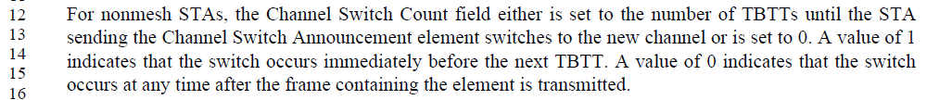

The commenter claims that the value of 1 is obvious, in this context. Here’s the logic:
- The count is the “number of TBTTs until the STA ... switches to the new channel”.
- So, if the value is 1, that implies there is 1 TBTT “until” the STA switches channels.
- It has been argued that “until” means that the channel switch happens _at_ the next TBTT, in this case.
- However, if an AP switches channels _at_ the TBTT, it will have to delay the Beacon transmission while waiting for dot11ChannelSwitchTime plus an equivalent of a “ProbeDelay”. (Note that ProbeDelay is only defined for non-AP STAs, which perform an active scanning procedure. But the concept of waiting this same period of time before transmitting a Beacon on a new channel seems to be the parallel concept, to the wait before transmitting a Probe Request on a new channel.) Based on this, it has also been argued that the channel switch should happen “immediately before” the next TBTT, to allow for these delays before the next TBTT, so the Beacon can be transmitted roughly on time.
- Due to this ambiguity, the example of stating explicitly that ‘1’ means the switch happens just before the next TBTT/Beacon seems a useful clarification.
- Presumably, the same logic applies to any other number larger than 1. For example, if the value is 3, then the switch occurs just before the 3rd TBTT in the future.
- Perhaps it would be better to replace “until” with “just before”, something similar to:
  - “the number of TBTTs, just before which the STA … switches to the new channel”
… but there has been no support for this change, due to the disagreement about what “until” is intended to mean.
- The example of what 0 means is clearly non-obvious, and the commenter does not suggest removing that example, so that is easily agreed to remain.
From all the above, given no consensus on what “until” means, it seems the example is necessary to provide as much clarity as possible about the intent. Thus, the proposal is to leave this example, as is.

The same applies to 9.4.2.52, which currently has nearly identical wording.

The text in the other location (9.4.2.22) is:

This case is different. There is no ambiguity of what “until the beacon interval during which the next quiet interval starts” means. Thus, in this case, agree with the commenter it is unnecessary to have the example for the case where the value is 1.

Proposed Resolution:

Revised. The language “number of TBTTs until” is not obvious to indicate “just before” or “just after” that number of TBTTs happens. The example in 9.4.2.18 clarifies this. Similarly, the example in 9.4.2.52 deals with the same ambiguity. However, the text in 9.4.2.22 is clear and unambiguous without such an example, so the description of the behaviour when the Quiet Count field is set to 1 is unnecessary.

REVmd Editor: Delete the sentence “A value of 1 indicates the quiet interval starts during the beacon interval starting at the next TBTT.” from 9.4.2.22.

CID | Page | Clause | Comment | Proposed Change
2224 | 168.36 | 3.1 | The definition of "TCLAS" has some wording problems. Clarify it. | Replace  "The specification of certain parameter values to identify a protocol data unit (PDU) or a medium access control (MAC) service data unit (MSDU). The classification process is performed above the MAC service access point (MAC SAP), within the MLME, or within the MAC, based on the type of classification."  with  "The specification of one of several types of matching filter to classify protocol data units (PDUs) or medium access control (MAC) service data units (MSDUs) as belonging to a particular traffic stream (TS). Depending on the type of classification, the filter is applied within the MLME above the MAC, or within the MAC itself."

Discussion:

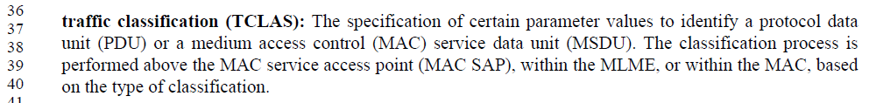

It is not understandable from this how “parameter values” (parameters to what?) can be used “to identity a PDU or MSDU.” The proposed new wording states this more clearly that the TCLAS is a specification of a filter for matching against such PDUs or MSDUs, to identify them, and further clarifies that the result of this identification is to associate the PDU/MSDU with a TS. This seems to be an improvement to the first sentence.

The second sentence re-write does three things:
- Editorially, reverse the order of the clause specifying the basis for the different styles of processing, which is arguably more clear, but only marginally and could be argued either way.
- Change the concept from “classification process” to “appl[ying] the filter”, which aligns the second sentence with the newly worded first sentence, so that seems useful to do, along with the first sentence change, above.
- It also clarifies the wording that the filter/classification processing is done “above the MAC service access point (MAC SAP), within the MLME” to state that this is a single concept (in the MLME which is above the MAC SAP), not a list of two separate possibilities (above the MAC SAP in some unstated location, and as a separate concept, within the MLME). Any discussion of behaviour happing “above the MAC SAP” and not within any 802.11 entity is, by definition, outside the scope of 802.11 behaviour. Since the MAC SAP includes a “priority” parameter with each MSDU, there is no reason to discuss or standardize any such behaviour happening “above the MAC SAP” or use TCLAS structures/concepts to do so. The behaviour within 802.11 scope is happening either within the MLME or within the MAC below the MAC SAP. The new wording for the second sentence lays out these two possibilities more clearly.

Proposed Resolution:

Accepted. Note to the Editor: Please expand the acronym for “MLME”.

CID | Page | Clause | Comment | Proposed Change
2005 | 1129.06 | 9.4.2.36 | Delayed Block Ack and Immediate Block Ack were removed from Capabilities Information field (see 9.4.1.4) | Figure 9-335 should be updated to not show Delayed Block Ack and Immediate Block Ack subfields

Discussion:

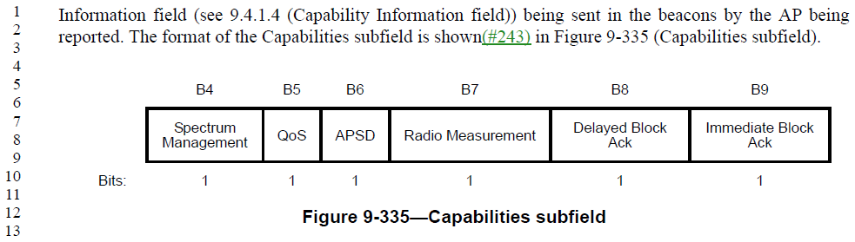

As stated explicitly, the bit fields within the Capabilities subfield (of a BSSID Information field, itself contained within a Neighbor Report element) are semantically equivalent to the bits within a Capability Information field as described in 9.4.1.4.

In 9.4.1.4, bits 14 and 15, which used to be “Delayed Block Ack” and “Immediate Block Ack” respectively (for non-DMG STAs) are now reserved as part of removing those concepts from the draft, as seen here:

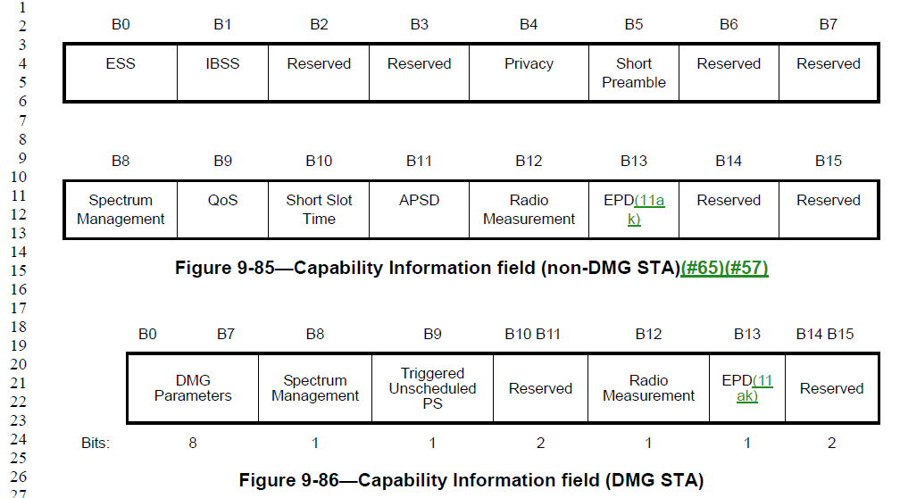

For DMG STAs, there never was a concept of these capabilities, and that remains the case in the latest draft.

Thus, agree with the commenter that these bits are no longer used or have any meaning, and should be marked Reserved.

Proposed Resolution:

Revised. In Figure 9-335, replace subfield names “Delayed Block Ack” and “Immediate Block Ack” with “Reserved”. Note to Editor, “Delayed Block Ack” has already been changed in 11-19/639r1 for CID 2289.

CID | Page | Clause | Comment | Proposed Change
2603 | 2212.52 | 11.3.9.3 | "beacon interval units" is confusing, because it might be understood as the units for a BI, namely Tus | Reword as "units of a beacon interval" (3x)

Discussion:

The correct cite appears to be P2213 lines 3, 5 and 8, as these are the only occurrences of this phrase:

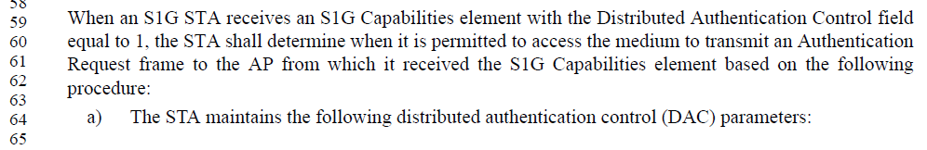
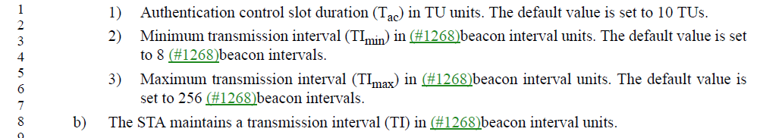

Based on the default values given in the next sentences, it is clear that the intention here is that these values are in units of beacon intervals.

While the acronym “BI” has been removed (reworded to avoid) in D2.0, we assume the commenter meant that “beacon interval units” could be confused for “the same units as used for a beacon interval”, which is TUs. Thus, agree that the rewording is accurate, and could help avoid confusion.

Lastly, with respect to how “units of” is described elsewhere in the Draft, in those cases where the units is a noun/noun phrase (and not an abbreviation or acronym), the noun/noun phrase is used in the plural: “units of microseconds”, “units of octets”, “units of TUs”, etc.

Proposed Resolution:

Revised. At P2213, lines 3, 5 and, 8, replace “beacon interval units” with “units of beacon intervals”.

CID | Page | Clause | Comment | Proposed Change
2279 | 1739.45 | 10.4 | 10.4 ("MPDU fragmentation") 4th paragraph references 9.2.3 as the requirement for support for various MSDU sizes. That would probably be better as a reference to 9.2.4.7, since that's where MSDU size limits are discussed. | Change the reference to 9.2.3 to be reference to 9.2.4.7.

Discussion:

As noted, subclause 9.2.3 describes the general frame format (i.e., the fixed order of FC, Duration/ID, Address 1, and so on). This subclause does mention:
It seems unnecessary to refer the reader to 9.2.3, only to hope they find the reference there to 9.2.4.7.1 where the maximum frame sizes are discussed. Rather a direct reference to 9.2.4.7.1 seems nicer to the reader.

In 9.2.4.7.1, it is explicitly stated that the maximum length of the frame body is affected by other aspects, including the presence of security encapsulation and the presence of Mesh Control fields, and those are described in following subclauses of 9.2.4.7. Thus, an understanding of all of 9.2.4.7 is best, to completely understand the constraints on frame body size, and therefore MPDU size.

Proposed Resolution:

Accepted.

CID | Page | Clause | Comment | Proposed Change
2287 | 1902.12 | 10.37.5.2 | Mixes of "AID subfield" and "AID field" in this subclause. Also, there is no "AID subfield", only an "AID12 subfield" or an "AID13 subfield". Since this is a VHT subclause, it must be specifying a non-S1G STA, and therefore the STA Info field has a AID12 subfield (and not an AID13 subfield). | Change "AID field" to "AID12 subfield" at P1924.62 and P1925.3. Replace "AID subfield" with "AID12 subfield" throughout this subclause.

Discussion:

(Note: references to P1924 and P1925 in the comment are sensible (and within 10.37.5.2), the reference to P1902.12 appears to be in error.)

The referenced frame (VHT NDP Announcement) format is defined in 9.3.1.19, as:
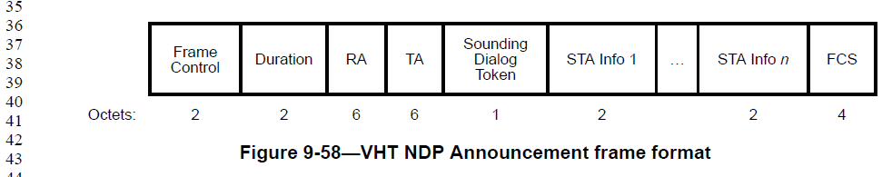

Since subclause 10.37.5.2 is “Rules for VHT sounding protocol sequences”, it does seem that this is the non-S1G case. Therefore, the “STA Info 1 … n” fields in this frame are defined per:

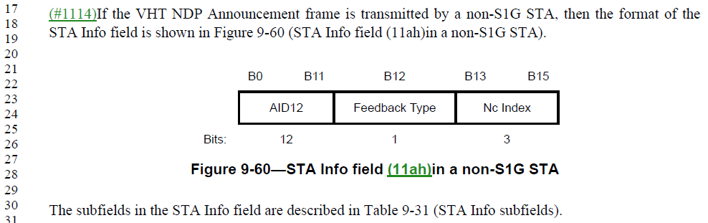
However, confusingly, the information that follows about the details of the STA Info field is:
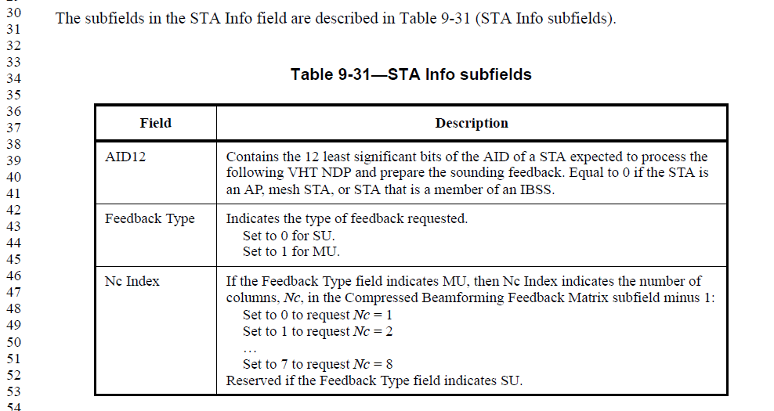
And, this text starts out saying “The subfields in the STA Info field…” and labels Table 9-31 as “STA Info subfields”, yet heads the left column of Table 9-31 with “Field”.

Conclusions:
- Agree with the commenter, there is no “AID subfield” in this format.
- There are AID12 (sub)fields, and these are called subfields in all mentions within 9.3.1.19 except the heading of Table 9-31, the predominant usage seems to be “AID12 subfield”
- Thus, agree with the proposed changes.
- In addition, suggest changing the heading on the left column of Table 9-31 to “Subfield”, for consistency.

Proposed Resolution:

Revised.

Make changes as suggested by the commenter (Change "AID field" to "AID12 subfield" at P1924.62 and P1925.3. Replace "AID subfield" with "AID12 subfield" throughout this subclause.). Also, change the heading of the left column of Table 9-31 from “Field” to “Subfield”.

CID | Page | Clause | Comment | Proposed Change
2288 | 2159.19 | 11.2.3.11 | In 11.2.3.11 (PSMP stuff): "a STA_INFO field that has the STA_INFO Type subfield equal to 2 and the AID field matching the STA's AID". But, PSMP defines a "PSMP STA Info" field, with subfields of STA_INFO Type and STA_ID.  Is the STA_AID subfield in PSMP STA Info formatted per 9.4.1.8? | Change the first "STA_INFO field" to "PSMP STA Info", and change the first "AID" to "STA_ID".  At the end of the sentence at P913.1, add ", and is formatted per 9.4.1.8 (AID field)."

Discussion:

PSMP is obsolete. No need for this maintenance.

Proposed Resolution:

Rejected. Generally, features that are marked deprecated or obsolete are not maintained. PSMP is obsolete.

CID | Page | Clause | Comment | Proposed Change
2564 | 646.9 | 6.3.89.1 | "The direct MLME-to-MLME primitive exchange should be viewed as shorthand for an exchange through  the SMEs and multi-band entity, i.e., an MLME addresses another local MLME entity by sending that  primitive through its SME and the multi-band entity to the SME of the MLME entity of a STA that is  enabled to transmit, which reflects that primitive to the appropriate recipient. " -- huh? An SME is an endpoint, not a relay! | Delete the cited text at the referenced location

Discussion:

The architecture for an OCT-capable multi-band device is similar to that shown in Figure 4-29 (although this is not explicitly made clear, and perhaps it should be – but that’s a different comment):
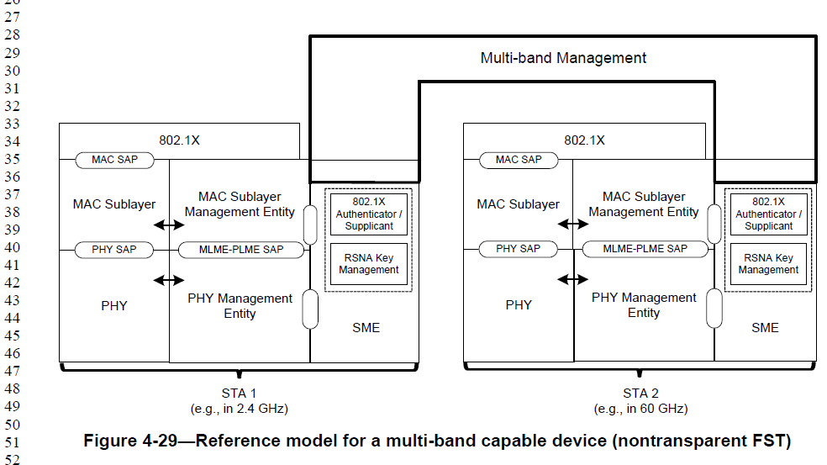

From that diagram, and the description following (as applicable to OCT), it can be seen that there are SMEs in each STA within the multi-band device. These SMEs use the multi-band management entity to interconnect, and arrange for the described mechanism of “forwarding” MLME primitives between the STAs. The cited text is describing this arrangement and operation.

Also, a note to the commenter, an OCT device is not a relay, so the confusion about a relay not including an SME is not relevant to the OCT concepts.

Proposed Resolution:

Rejected. An OCT-capable, multi-band device is not a relay. It is a type of multi-band device similar in structure to that shown in Figure 4-29. As such, there are SMEs within each STA, which can coordinate with each other through the multi-band management entity, to arrange the “exchange of MLME primitives” as described. Thus, the comment fails to identify a problem.

CID | Page | Clause | Comment | Proposed Change
2240 | 1355.56 | 9.4.2.185 | Editorial (?): What does "onwards in 12.7.2" mean? | Change the sentence to, "The KDE List field contains one of more KDEs encapsulated using the format shown(#243) in Figure 12-35.

Discussion:

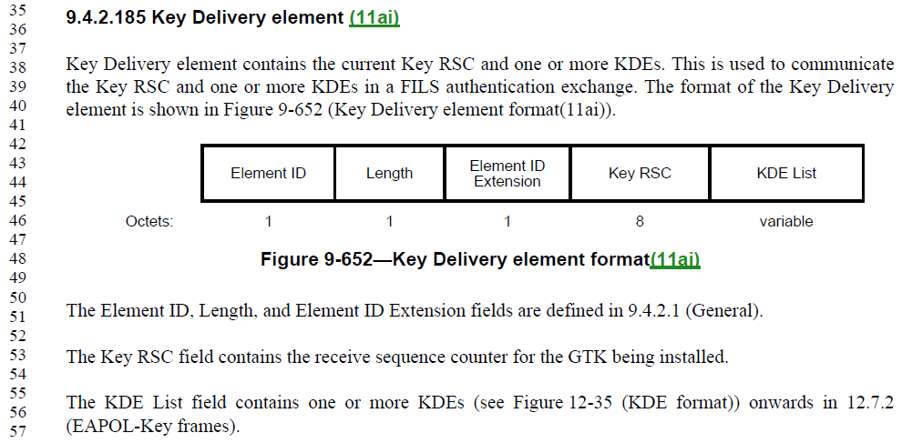

Agree with the commenter that “contains one of more KDEs onwards in 12.7.2” is not clear. Likely, an initial intent was for this to be part of the “see”, as in: “(see Figure 12-35 onwards in 12.7.2)”, and that would be a simple change. However, it is just as easy to just reference the point of the “see”, that we are referencing the format shown in Figure 12-35, and the text that supports that figure is clearly implied.

Proposed Resolution:

Accepted.

CID | Page | Clause | Comment | Proposed Change
2486 | 1725.12 | 10.3.2.17 | Field name components should not start with a lowercase letter | Change "Link Adaptation  per Normal Control  Response Capable" to "Link Adaptation  Per Normal Control  Response Capable" throughout. In Table 9-301 change "normal control frame" to "a Control frame that is not an NDP CMAC frame". In 10.3.2.17 change "normal control response frame" to "control response frame that is not an NDP CMAC frame". In 10.33.3 change "normal control response frames" to "control response frames that are not NDP CMAC frames" and "normal control frame" to "a Control frame that is not an NDP CMAC frame"

Discussion:

Changes are (easier to see):
- Change
"Link Adaptation per Normal Control Response Capable"
to
"Link Adaptation Per Normal Control Response Capable"
throughout.
- In Table 9-301 change
"normal control frame"
to
"a Control frame that is not an NDP CMAC frame".
- In 10.3.2.17 change
"normal control response frame"
to
"control response frame that is not an NDP CMAC frame".
- In 10.33.3 change
"normal control response frames"
to
"control response frames that are not NDP CMAC frames"
and
"normal control frame"
to
"a Control frame that is not an NDP CMAC frame"

These are clearly not all lowercase letter issues (only the first one is), but other wording changes requested. Take these separately.

Other field names have words like “of” and “for” in lower case. It’s not clear that “per” is a significant word, which would be in upper case, or a ‘helper’ word, which would be in lower case. There are other examples where “Per” is used (for example, OBSS Scan Passive Total Per Channel, OBSS Scan Active Total Per Channel, and FTMs Per Burst), but also where “per” is used (for example, Measurement Duration per Direction, Normal Number of Frames per Channel, and In-Motion Number of Frames per Channel). Thus, the change is fine.

As for the changes from “normal control…” to some phrase that avoids this phrase, this seems like a good suggestion, as the phrase “normal control” is not defined. A minor nit on these changes, the phrase “normal control frame” has been edited to use the (correct) uppercase C on Control (“normal Control frame”), so the change should be clarified to cover this spelling.

Proposed Resolution:

Revised. In D2.0:

- Change
"Link Adaptation per Normal Control Response Capable"
to
"Link Adaptation Per Normal Control Response Capable"
throughout.
- In Table 9-301 change
"normal control frame"
to
"a Control frame that is not an NDP CMAC frame".
- In 10.3.2.17 change
"normal control response frame"
to
"control response frame that is not an NDP CMAC frame".
- In 10.33.3 change
"normal control response frames"
to
"control response frames that are not NDP CMAC frames"
and
"normal control frame" (or “normal Control frame”)
to
"a Control frame that is not an NDP CMAC frame"

CID | Page | Clause | Comment | Proposed Change
2495 |  | 11.22.16.2 | Sometimes "DMSID" is used implicitly to refer to the DMSID field (e.g. "the DMSID shall be set to") and sometimes conversely "DMSID field" is used to refer to the identifier itself (e.g. "The DMSID field is assigned by the AP") | Add "field" after "DMSID" throughout the document, except in Figures

Discussion:

DMSID is indeed a field name, in the DMS Descriptor, as seen in Figure 9-475:
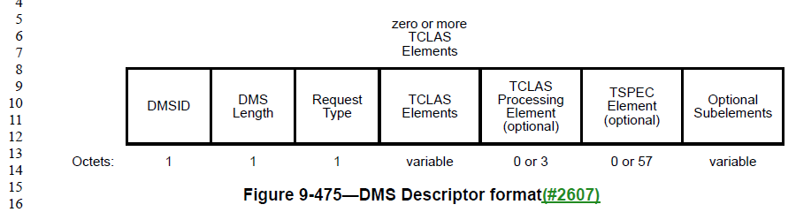

There are uses in clause 9 that appear to be correct/sensible, for the context, such as:
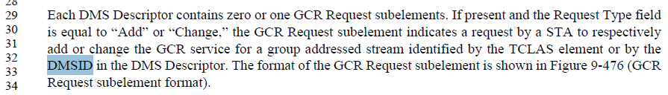
In this case, it is the ID itself that identifies a stream (not the DMSID field, which is what carries the ID), so the usage without “field” is correct.

However, other uses, as pointed out by the commenter, seem incorrect:
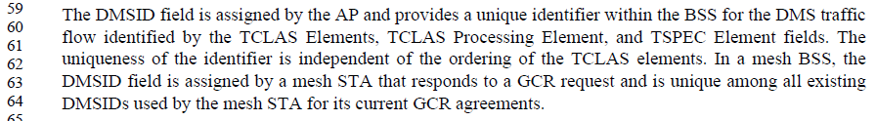
Where it is the ID itself that is assigned by the AP, and the DMSID field, again, is what carries this ID within the protocol. So, this usage (two places in this paragraph) should not have the word “field”. The third usage, of “DMSIDs” (without field) is correct.

In fact, most of the usage in 11.22.16.2 seems to be a reference to the ID itself, and not the field that carries it.

This wording, while awkward, would be completely incomprehensible if “field” were added after all “DMSID”s:
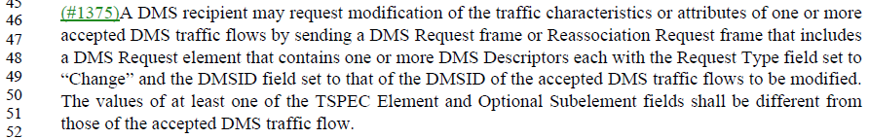
The wording could be improved by removing “that of the”, however.

Proposed Resolution:

Revised.

In 9.4.2.88, P1244L59 (D2.3), change “The DMS field is assigned” to “The DMSID is assigned”. Same thing at P1244L63.

In 11.22.16.2, delete the phrase “that of” in 5 occurrences. (All occurrences are in a phrase like “DMSID field set to that of the DMSID” such-and-such.)

At P2385L56 (D2.3), change “the DMSID shall be set to that of the DMS Descriptor” to “the DMSID field shall be set to the DMSID carried in the DMS Descriptor”. Same thing at P2385L59.

CID | Page | Clause | Comment | Proposed Change
2502 | 1582.12 | 9.6.13.20 | "The Subelement ID field is set to 0." duplicates Table 9-427 | Delete the cited sentence at the referenced location
2503 | 1582.45 | 9.6.13.20 | "The Subelement ID field is set to 1." duplicates Table 9-427 | Delete the cited sentence at the referenced location

Discussion:

Note that these two changes are just two of many changes listed in 11-19/856r8, after the resolution for CIDs 2584 and 2585, in a section titled “Stand-alone changes re optional subelements”.

Agree with the commenter, the direction of the group when considering the changes in 11-19/856 was to make the subelement specifications editorially consistent with the element specifications. The two changes proposed here are in that direction.

Proposed Resolution:

Accepted.

CID | Page | Clause | Comment | Proposed Change
2513 | 2302.12 | 11.15.3.3 | "When switching a 20/40 MHz BSS to 20 MHz BSS mode" -- "20 MHz BSS mode" is not described anywhere. Ditto "the 20/40 BSS mode" in O.5.2 | change "to 20 MHz BSS mode" in 11.15.3.3 to "to an operating channel width of 20 MHz"; change "the 20/40 BSS mode" in O.5.2 to "40 MHz operating channel width"

Discussion:

Indeed, there are only four occurrences of the phrase “BSS mode” in the entire draft – two of them are within the phrase “infrastructure BSS mode” and the other two are the two cited locations. So, agree that these are not defined terms and should be changed. The phrase “operating channel width of [20 or 40] MHz” is the normal terminology.

Proposed Resolution:

Accepted.

CID | Page | Clause | Comment | Proposed Change
2617 | 2351.00 | 11.22.7.1 | "A STA with dot11BSSTransitionActivated equal to true shall support BSS transition management" -- should also have implemented set to true. This was rejected in CID 1382 on the basis that "For dot11BSSTransitionActivated to be true, logically, dot11BSSTransitionImplemented must also be true without needing to state so" but this while plausible sounding needs to be supported by actual normative text | In the cited text at the referenced location add "shall have dot11BSSTransitionImplemented set to true," after "equal to true"

Discussion:

This same topic was covered in CID 2618, which has the identical “Comment”, with an alternative “Proposed Change” to remove the dot11BSSTransitionImplemented MIB attribute completely. The group agreed to that approach, and agreed the resolution to CID 2618.

Proposed Resolution:

Revised.

At the cited location, delete "A STA that implements BSS transition management has dot11BSSTransitionImplemented equal to true."

At the cited location, change
"When dot11BSSTransitionImplemented is true, dot11WirelessManagementImplemented shall be true."
to
"When dot11BSSTransitionActivated is true, dot11WirelessManagementImplemented shall be true."

Deprecate dot11BSSTransitionImplemented in the MIB:
- Change its STATUS to "Deprecated".
- Insert a new first line in the DESCRIPTION: "Deprecated as unnecessary; dot11BSSTransitionActivated is used instead".
- For any reference to the variable in any GROUPs, re-instate this reference:
---- Change the group's STATUS to "Deprecated".
---- In the DESCRIPTION, insert a new first line: "Superseded by YYYY." (Note that "YYYY" is the new GROUP name.)
---- Make a copy of the group, set its STATUS to "Current" and increment (or add) a number after the name of the group name (e.g. dot11SMTbase11 -> dot11SMTbase12).
---- Remove dot11BSSTransitionImplemented in the new group.
---- For each reference to the group from a compliance statement, update it to refer to the new group.

Note to Editor, this is the same resolution as for CID 2618.

CID | Page | Clause | Comment | Proposed Change
2556 | 785.05 | 9.2.4.2 | "In all other frames sent by non-QoS STAs and Control frames sent by QoS STAs," -- not all Control frames | Change the cited text at the referenced location to "In all other frames sent by non-QoS STAs and other Control frames sent by QoS STAs,"

Discussion:

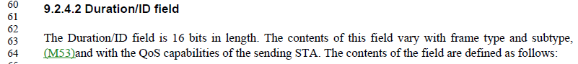
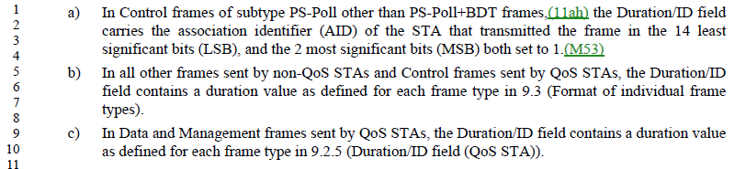

Indeed, there is overlap between bullet a) and “Control frames sent by QoS STAs.

Proposed Resolution:

Accepted.

CID | Page | Clause | Comment | Proposed Change
2581 | 2137.01 | 11.1.4.3.8 | "If a Probe Request frame includes a Request element that contains the element ID of the Reduced Neighbor  Report Request element" is garbled | Add "contains" after "that" in the cited text at the referenced location

Discussion:

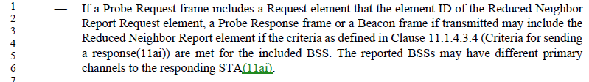

Yes, the sentence has an error. The proposed change makes sense.

Proposed Resolution:

Revised. Add "contains" after "that" in the cited text at the referenced location. Delete “Request” in “Neighbor Report Request element”.

CID | Page | Clause | Comment | Proposed Change
2566 | 2478.14 | 11.41 | "It might take a long time for a STA to change its operating mode following the transmission of the Operating  Mode Notification frame and during that time the STA might not be able to receive frames resulting in frame loss. If a  non-AP STA cannot tolerate frame loss during that period it can set the Power Management subfield of the Frame  Control field of the Operating Mode Notification frame to 1 to indicate that the STA has entered power save. When the  non-AP STA has completed its operating mode change, it can send another frame (such as a QoS Null) with the Frame  Control Power Management subfield set to 0 to indicate that the STA has exited power save." -- the mixing of plain "STA" and "non-AP STA" is confusing (it suggests two different STAs") | Delete "non-AP " throughout the cited text at the referenced location

Discussion:

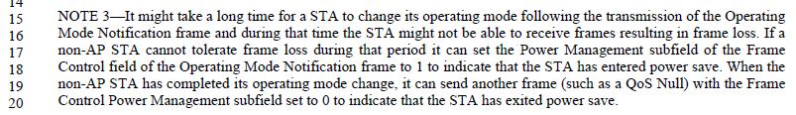

Agree with the commenter, things are mixed up. However, it could be argued that the first sentence also applies to APs, which is worth continuing to note here.

So, no change is technically needed. Could simplify the language editorially by using “it” more often.

Proposed Resolution:

Revised.

At the cited location, change:

It might take a long time for a STA to change its operating mode following the transmission of the Operating
Mode Notification frame and during that time the STA might not be able to receive frames resulting in frame loss. If a non-AP STA cannot tolerate frame loss during that period it can set the Power Management subfield of the Frame Control field of the Operating Mode Notification frame to 1 to indicate that the STA has entered power save. When the non-AP STA has completed its operating mode change, it can send another frame (such as a QoS Null) with the Frame Control Power Management subfield set to 0 to indicate that the STA has exited power save.

to:

It might take a long time for a STA to change its operating mode following the transmission of the Operating
Mode Notification frame and during that time it might not be able to receive frames resulting in frame loss. If a
non-AP STA cannot tolerate frame loss during that period it can set the Power Management subfield of the Frame
Control field of the Operating Mode Notification frame to 1 to indicate that it has entered power save. When it has completed its operating mode change, it can send another frame (such as a QoS Null) with the Frame
Control Power Management subfield set to 0 to indicate that it has exited power save.

CID | Page | Clause | Comment | Proposed Change
2292 | 2462.26 | 11.35.3 | Clause 10.40 (DMG dynamic tone pairing) was removed. The reference to 10.40 in the NOTE in 11.35.3 is now broken. The NOTE would appear to still be valid (the destination REDS does need its antenna pattern to cover the source REDS and RDS). Is there still text somewhere that describes how this is accomplished? If so, put a reference to that text here. If not, we have a gap. | Replace the broken text (the stuff in parenthesis) with an appropriate reference.

Discussion:

This issue is already covered by the resolution to CID 2293. Repeat the resolution here.

Proposed Resolution:

Revised.

At 2460.49, replace “A source REDS, a destination REDS, and an RDS can establish the types of relay operation as specified in (An example of the fast link adaptation procedure is shown in Link adaptation using the CMMG link measurement(#64)..).” with “A source REDS, a destination REDS, and an RDS can establish the types of relay operation as specified in 10.46.1.”.

At 2463.16, replace “NOTE–As described in (An example of the fast link adaptation procedure is shown in Link adaptation using the CMMG link measurement(#64)..),” with “NOTE–As described in 10.46.3.2.3,”.

At 3724.18, replace “(An example of the fast link adaptation procedure is shown in Link adaptation using the CMMG link measurement(#64)..)” with “10.46”.

Note to Editor: This is the same resolution as for CID 2293.

CID | Page | Clause | Comment | Proposed Change
2296 | 1166.49 | 9.4.2.56 | Per CID 1412, "dual beacon" went from deprecated to obsolete in REVmd, but "STBC Beacon" (and some references to dual beacon) is still only deprecated. Change all these references to Obsolete. Similar issues with "Dual CTS" | At the cited location, change "deprecated" to "obsolete". Also at 1166.61, P1735.32, P3664.9, and P3664.18.

Discussion:

This issue is already covered by the resolution to CID 2140. Repeat the resolution here.

Proposed Resolution:

Revised.

At this time, WEP is obsolete and TKIP are deprecated.

Relative to D2.0
(WEP and TKIP)
At 203.35 replace "A deprecated" with "An obsolete" .
At 298.48 change "The use of WEP for confidentiality, authentication, or access control is deprecated" to "WEP is obsolete"
At 2513.28 change "The use of WEP for confidentiality, authentication, or access control is deprecated" to "WEP is obsolete"
At 3546.36, Change “Wired equivalent privacy (WEP) algorithm. This capability is deprecated (applicable only to systems that are backward compatible).” To “Wired equivalent privacy (WEP) algorithm. This capability is obsolete. Support for this mechanism might be removed in a later revision of the standard.”
At 3554.7. Add the following sentence at the end of the existing text. “This capability is deprecated (applicable only to systems that are backward compatible).”

(dual CTS)
At 1166.62 change "deprecated" to "obsolete".
At 1735.32 change “deprecated” to “obsolete”.
At 3664.18 change “deprecated” to “obsolete”.

(dual beacon)
At 1166.50 change "deprecated" to "obsolete".

Note to commenter: This resolution adds to the changes suggested by the commenter.

Note to Editor: This is the same resolution as for CID 2140.

