IEEE P802.11
Wireless LANs
802.11bd Specification Framework Document
Date: 2019-03-13
Author(s):
Name | Affiliation | Address | Phone | email
Bahar Sadeghi | Intel | 2111 NE 25th Ave, Hillsboro OR 97124, USA | +1-503-724-893 | bahareh.sadeghi@intel.com

Abstract
This document provides the framework from which the draft TGbd amendment will be developed. The document provides an outline of each the functional blocks that will be a part of the final amendment. The document is intended to reflect the working consensus of the group on the broad outline for the draft specification. As such it is expected to begin with minimal detail reflecting agreement on specific techniques and highlighting areas on which agreement is still required. It may also begin with an incomplete feature list with additional features added as they are justified. The document will evolve over time until it includes sufficient detail on all the functional blocks and their inter-dependencies so that work can begin on the draft amendment itself.

Revision history
Revision | Date | Changes
0 | March 13, 2019 | Initial draft (approved by TG motion at the March 2019 meeting [1])
1 | April 9, 2019 | Added motioned text approved at the March 2019 meeting to Section 3. [1]
2 | June 10, 2019 | Added motioned text approved at the May 2019 meeting to Section 3. [2]

Definitions

Abbreviations and acronyms

BW bandwidth
LDPC low-density parity check
L-LTF non-HT Long Training field
L-SIG non-HT Signal field
L-STF non-HT Short Training field
NGV next generaion V2X
OCB outside the context of a BSS
OFDM orthogonal frequency division multiplexing
PHY physical layer
PPDU PHY protocol data unit
QAM quadrature amplitude modulation
STA station

Operation in 5.9GHz band

Physical layer

This section describes the functional blocks in the physical layer.

11bd supports the 10MHz bandwidth PPDUs.
11bd supports the 20MHz bandwidth PPDUs.
[ [1] Motion #3]

11bd 10MHz BW PPDU format includes L-STF, L-LTF, and L-SIG fields as shown in Figure 3-1;
- L-STF means short training field of 11p.
- L-LTF means long training field of 11p.
L-SIG means signal field of 11p.

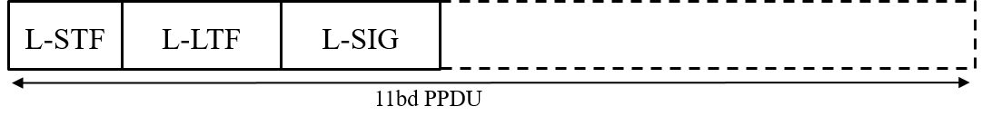
Figure 3-1 11bd 10MHz BW PPDU format
[ [1] Motion #2]

In 20MHz bandwidth, L-STF, L-LTF, and L-SIG for 10MHz PPDU are duplicated as shown in the figure below (Figure 3-2).
s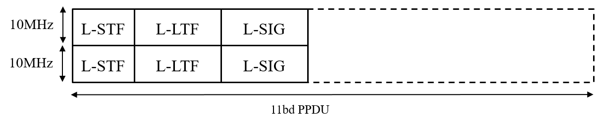
Figure 3-2 11bd 20MHz BW PPDU format
[ [1] Motion #4]

11bd PPDU includes an NGV-Signal field to indicate the transmission information.
The location of NGV-SIG field is TBD.
[ [2] Motion #9]

11bd PPDU design shall support Midamble(s) in Data field.
Midamble is composed by long training field, with design TBD.
Midamble periodicity is TBD.
[ [2] Motion #10]

11bd devices shall support 256 QAM. The 256 QAM constellation mapping is the same as that defined in 21.3.10.9 (Constellation mapping).
[ [2] Motion #11]

11bd amendment shall support LDPC.
[ [1] Motion #5]

11bd devices shall support LDPC codes, with the same code structure and coding methods as defined in 19.3.11.7 (LDPC Codes).
[ [2] Motion #12]

10MHz 11bd Data symbol shall use 11ac 20MHz OFDM numerology.
[ [2] Motion #13]

11bd shall support the same subcarrier spacing in both 10MHz PPDU and 20MHz PPDU.
[ [2] Motion #8]

11bd only supports single spatial stream PPDU when operating on OCB broadcast mode.
[ [2] Motion #15]

MAC layer

This section describes the functional blocks in the MAC layer.

An 11bd STA shall indicate the NGV capability in MAC level, when transmitting an 11p PPDU.
[ [1] Motion #7]

Positioning

This section describes the functional blocks that support positioning in conjuction with V2X communications.

Interoperability, coexistence and backward compatibility

This section describes the functional blocks that support interoperability, coexistence and backward compability with deployed OCB devices.

An 11bd STA shall be capable of the following operations:
- To decode 11p PPDUs with TBD receive sensitivity threshold (TBD value is -85dBm or lower).
- To transmit PPDU format up on request from upper layer, the PPDU format can be either 11p PPDU or 11bd PPDU.
[ [1] Motion #6]

When an 11bd STA transmits an 11p group-addressed or unicast PPDU, the Duration/ID field of a frame in an 11p PPDU indicates that transmitter of the PPDU is an NGV capable STA.
[ [2] Motion #16]

Operation of 11bd device with 10MHz bandwidth is allowed in a 20MHz channel.
[ [2] Motion #14]

Operation in 60GHz band

Physical layer

This section describes the functional blocks in the physical layer.

MAC layer

This section describes the functional blocks in the MAC layer.

References:
[1] IEEE 802.11-19/0237r4 TGbd March 2019 meeting agenda
[2] IEEE 802.11-19/0514r4 Motion Booklet for IEEE 802.11 TGbd

