IEEE P802.11
Wireless LANs
802.11bd Specification Framework Document
Date: 2019-03-13
Author(s):
Name | Affiliation | Address | Phone | email
Bahar Sadeghi | Intel | 2111 NE 25th Ave, Hillsboro OR 97124, USA | +1-503-724-893 | bahareh.sadeghi@intel.com

Abstract
This document provides the framework from which the draft TGbd amendment will be developed. The document provides an outline of each the functional blocks that will be a part of the final amendment. The document is intended to reflect the working consensus of the group on the broad outline for the draft specification. As such it is expected to begin with minimal detail reflecting agreement on specific techniques and highlighting areas on which agreement is still required. It may also begin with an incomplete feature list with additional features added as they are justified. The document will evolve over time until it includes sufficient detail on all the functional blocks and their inter-dependencies so that work can begin on the draft amendment itself.

Revision history
Revision | Date | Changes
0 | March 13, 2019 | Initial draft (approved by TG motion at the March 2019 meeting [1])
1 | April 9, 2019 | Added motioned text approved at the March 2019 meeting to Section 3. [1]

Definitions

Abbreviations and acronyms

BW bandwidth
LDPC low-density parity check
L-LTF non-HT Long Training field
L-SIG non-HT Signal field
L-STF non-HT Short Training field
OCB outside the context of a BSS
PPDU PHY protocol data unit

Operation in 5.9GHz band

Physical layer

This section describes the functional blocks in the physical layer.

11bd supports the 10MHz bandwidth PPDUs.
11bd supports the 20MHz bandwidth PPDUs.
[[1] Motion #3]

11bd 10MHz BW PPDU format includes L-STF, L-LTF, and L-SIG fields as shown in Figure 3-1;
- L-STF means short training field of 11p.
- L-LTF means long training field of 11p.
L-SIG means signal field of 11p.

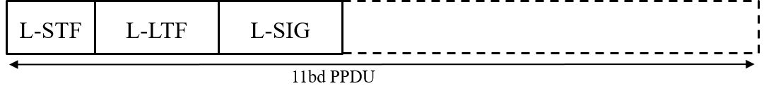
Figure 3-1 11bd 10MHz BW PPDU format
[[1] Motion #2]

In 20MHz bandwidth, L-STF, L-LTF, and L-SIG for 10MHz PPDU are duplicated as shown in the figure below (Figure 3-2).
s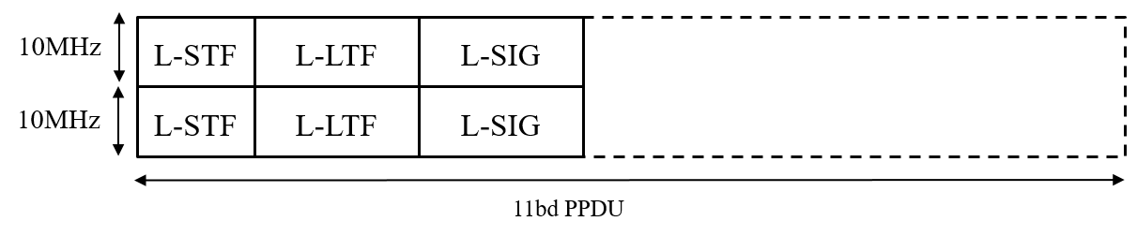
Figure 3-2 11bd 20MHz BW PPDU format
[[1] Motion #4]

An 11bd STA shall be capable of the following operations:
- To decode 11p PPDUs with TBD receive sensitivity threshold (TBD value is -85dBm or lower).
- To transmit PPDU format up on request from upper layer, the PPDU format can be either 11p PPDU or 11bd PPDU.
[[1] Motion #6]

11bd amendment shall support LDPC.
[[1] Motion #5]

MAC layer

This section describes the functional blocks in the MAC layer.

An 11bd STA shall indicate the NGV capability in MAC level, when transmitting an 11p PPDU.
[[1] Motion #7]

Positioning

This section describes the functional blocks that support positioning in conjuction with V2X communications.

Interoperability, coexistence and backward compatibility

This section describes the functional blocks that support interoperability, coexistence and backward compability with deployed OCB devices.

Operation in 60GHz band

Physical layer

This section describes the functional blocks in the physical layer.

MAC layer

This section describes the functional blocks in the MAC layer.

References:
[1] IEEE 802.11-19/0237r4 TGbd March 2019 meeting agenda

