IEEE P802.11
Wireless LANs
CR for CID 2109
Date: 2019-03-11
Author(s):
Name | Affiliation | Address | Phone | email
Ganesh Venkatesan | Intel |  |  | Ganesh.venkatesan@intel.com
Dibakar Das | Intel | 2111 NE 25th Ave, Hillsboro -97124 |  | Dibakar.das@intel.com
Edward Au | Huawei |  |  | edward.ks.au@gmail.com
Abstract
This document proposes resolution to CID 2109
Introduction

CID | Clause Number | Page | Line | Comment | Proposed Change | Resolution
2109 | 11.4.4.3 | 2219 | 38 | The figure 11-19 does not reflect TS Setup | Fix the Figure | Revise: Replace the content of Figure 11-19 in REVmd 2.0 wih the content in Figure 11-16 in REVmd 1.0.

Discussion:
Figure 11-16 in Cl. 11.4.4.3 in REVmd D1.0 has been renumbered as Figure 11-19 in REVmd D2.0. During the process, the content of the figure (describing the message exchanges for an AP-initiated TS setup) has been lost and replaced with the contents of Figure 11-16 (which describes a state transition diagram for non-Mesh STAs).

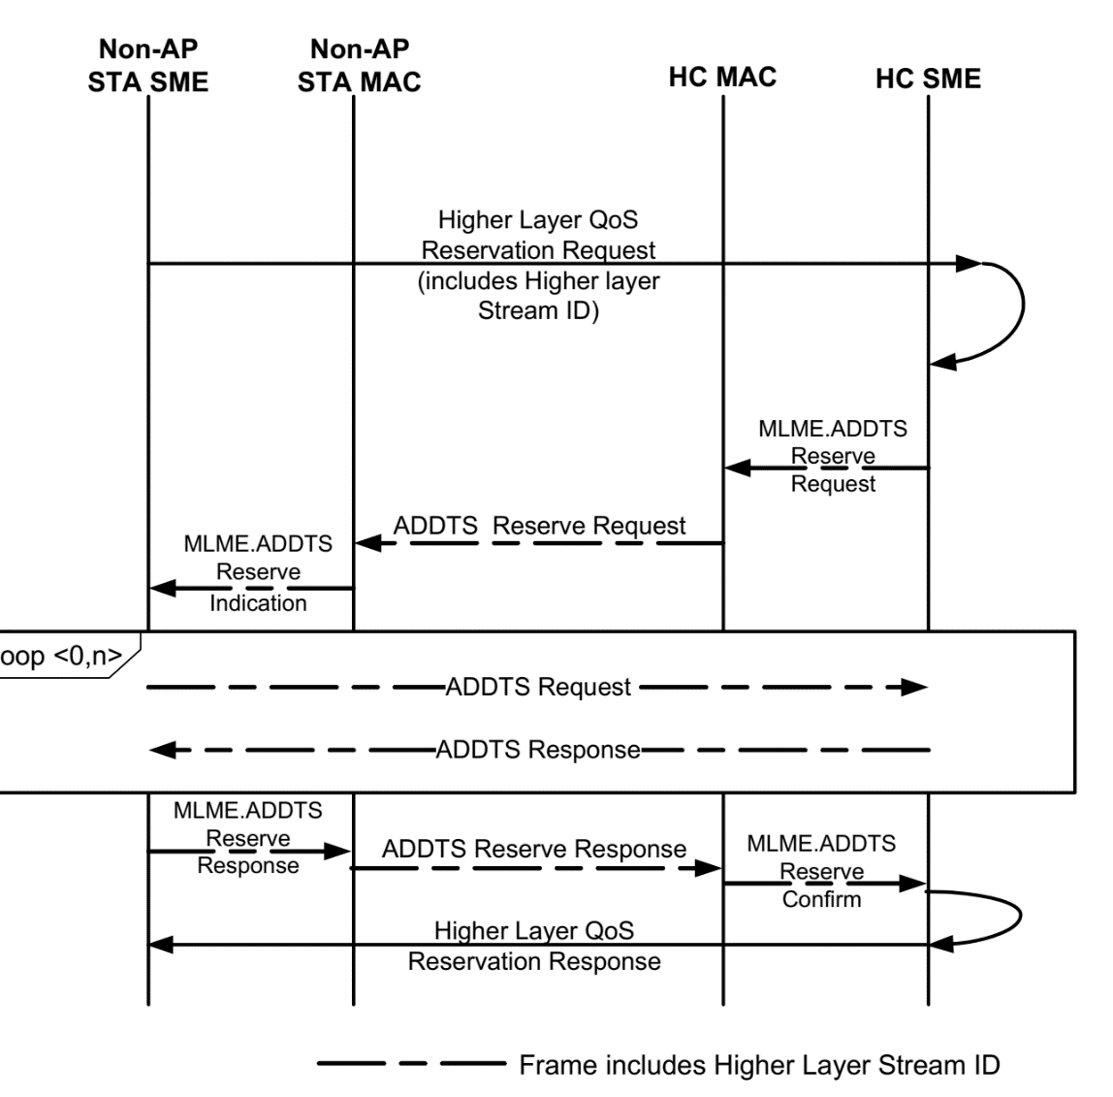
Figure 11-16 in REVmd 1.0

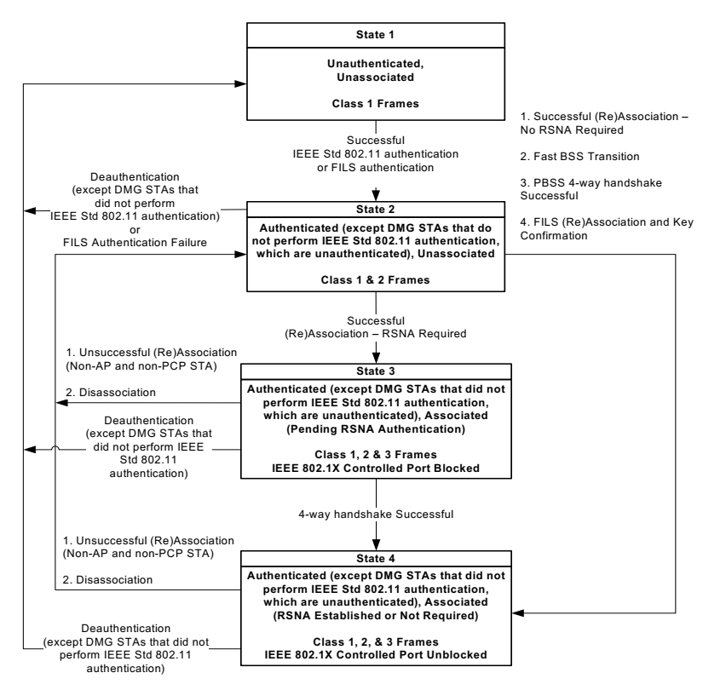
Figure 11-19 in REVmd 2.0

References:

