IEEE P802.11  
Wireless LANs

|  |  |  |  |  |
| --- | --- | --- | --- | --- |
| CR for CID 21497, 21501, 21502 | | | | |
| Date: 2019-03-011 | | | | |
| Author(s): | | | | |
| Name | Affiliation | Address | Phone | email |
| Xiaogang Chen | Intel | 2111 NE 25th Ave, Hillsboro, OR, 97124 |  | Xiaogang.c.chen@Intel.com |
| Laurent Cariou | Intel |  |  |  |
| Ehud Reshef | Intel |  |  |  |
| Ziv Avital | Intel |  |  |  |
| Ilan Sutskover | Intel |  |  |  |

Abstract

This submission proposes text changes of TGax Draft 4.0.

Revisions:

* Rev 0: Initial version of the document.

Interpretation of a Motion to Adopt

A motion to approve this submission means that the editing instructions and any changed or added material are actioned in the TGax Draft. This introduction is not part of the adopted material.

***Editing instructions formatted like this are intended to be copied into the TGax Draft (i.e. they are instructions to the 802.11 editor on how to merge the text with the baseline documents).***

***TGax Editor: Editing instructions preceded by “TGax Editor” are instructions to the TGax editor to modify existing material in the TGax draft. As a result of adopting the changes, the TGax editor will execute the instructions rather than copy them to the TGax Draft.***

|  |  |  |  |  |  |  |  |
| --- | --- | --- | --- | --- | --- | --- | --- |
| **CID** | **Commenter** | **Clause** | **Page** | **Line** | **Comment** | **Proposed change** | **Resolution** |
| 21497 | Xiaogang Chen | 27.3.9 | 515 | 58 | "The total power of the time domain HE modulated field signals summed over all transmit chains should not exceed the total power of the time domain pre-HE modulated field signals summed over all transmit chains if ..." The Tx power could be limited by the pre-HE if the pre-HE portion is not be able to deboosted. | Will come up with a contribution to solve the issue | Revised  -TGax editor to make the changes shown in 11-19/0422r0 under all headings that include CID 21497. |

**Discussions:**

For HE TB PPDU, the Pre-HE portion may be **transmitted on wider bandwidth than** the HE portion if the HE portion is populated on some RUs. E.g. the inner 242 tone RUs in 80MHz. That means the **HE portion is transmited across 20MHz but Pre-HE portion is transmitted across 40MHz**.

For the above mentioned HE TB PPDU, in some of the band edge, we found the following Tx power limitation issue due to the OOBE caused by IM3 (one example is shown in the table below for band 36).

*If* ***both the HE portion and the Pre-HE protion*** *of TB PPDU are transmitted in channel 44 (20MHz), they can be transmitted by 20dBm; however, if HE portion is transmitted in channel 44 (20MHz) but pre-HE portion is transmitted in channel 46F (40MHz), the Tx power of HE portion will be limited by 18dBm instead of 20dBm. The reason is the IM3 of 40MHz is much worse than the 20MHz. The IMs push the PA back off more to accommodate the OOBE especially in the band edge.*

**Table 1 Measured Tx power (in dBm) for different band**

|  |  |  |  |  |  |
| --- | --- | --- | --- | --- | --- |
| 20MHz | | | 40MHz | | |
| Central Frequency | Central Channel | SISO | Central Frequency | Central Channel | SISO |
| 5180 | 36 | 17.00 | 5190 | 38F | 17.00 |
| 5200 | 40 | 20.00 |
| 5220 | 44 | 20.00 | 5230 | 46F | 18.00 |
| 5240 | 48 | 20.00 |

**We propose to make it optional to deboost the pre-HE portion in base band, such that the HE portion is not limited by the Tx power of pre-HE portion given the fact that PA will be the same across the whole PPDU.**

**Proposed changes:**

*---------------------------------Modifications for CID 21497 start here---------------------------*

*To the TGax Editor: modify P.L. 498.64 as following.*

If(#15480) the TXVECTOR parameter BEAM_CHANGE is 1 or not present and power boost in HE modulated fields is not present, the ~~The~~ total power of the time domain HE modulated field signals summed over all transmit chains should not exceed the total power of the time domain pre-HE modulated field signals summed over all transmit chains, ~~if(#15480) the TXVECTOR parameter BEAM_CHANGE is 1 or not present and power boost in HE modulated fields is not present~~ except for the HE TB PPDU, in which case the total power of the time domain HE modulated field signals summed over all transmit chains may exceed the total power of the time domain pre-HE modulated field signals summed over all transmit chains for up to 3dB.

*To the TGax Editor: modify P.L. 499.38 as following.*

For the pre-HE portion of the HE TB PPDU,  which means can be any value between  and 1. For the HE-SIG-A and Data fields in an HE ER SU PPDU, and all fields in other HE PPDUs, .

*To the TGax Editor: modify equation 28-7 as following (add a new entry highlighted as red)*



*To the TGax Editor: modify P.L. 506.29 as following (add a new entry highlighted as red)*



*To the TGax Editor: modify equation 28-16 as following*

Add “” between and the left bracket as shown below.



*To the TGax Editor: Add the highlighted equation after P.L. 524.43*

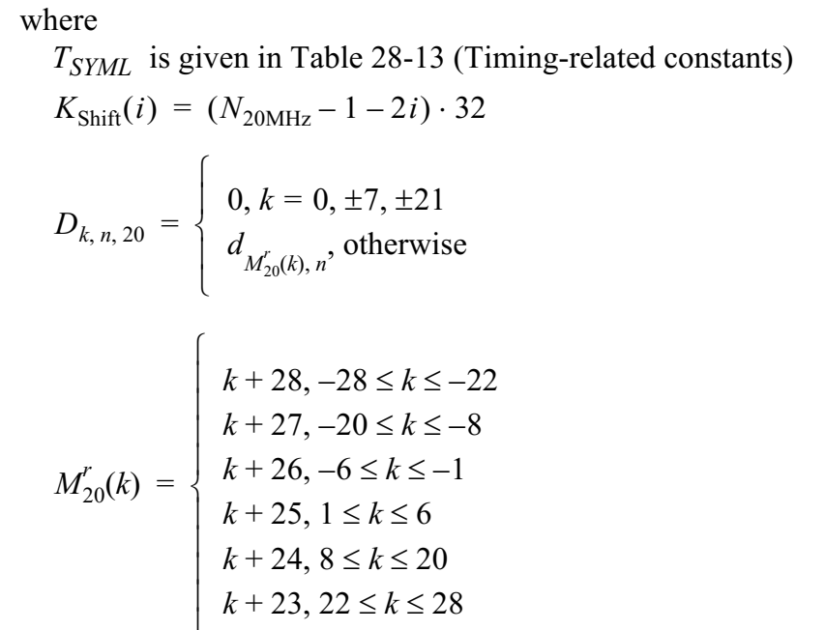



*---------------------------------Modifications for CID 21497 end here---------------------------*

|  |  |  |  |  |  |  |  |
| --- | --- | --- | --- | --- | --- | --- | --- |
| **CID** | **Commenter** | **Clause** | **Page** | **Line** | **Comment** | **Proposed change** | **Resolution** |
| 21501 | Xiaogang Chen | 9.4.2.242.3 | 172 | 20 | When a client joining DL MUMIMO, it could significantly degrade the performance of this client due to some reasons, e.g. AP scheduling issue, feedback issue, etc. From our observation, the degradation has more impact on the 160MHz capable STAs. Given the cost to support 160MHz and the limited number of 160MHz capable clients, it doesn't worth the performance compromise to support DLMUMIMO for 160MHz client. We propose to add capability bit to disallow the 160MHz capable client to join DLMUMIMO. | add a capability bit of "Rx 160MHz DLMUMIMO support" | Revised  -TGax editor to make the changes shown in 11-19/0422r0 under all headings that include CID 21501. |

**Discussions**: We have observed that in some cases the complexities of DL MU MIMO could result with overall degraded performance. From our observation, the real-world degradation is more severe when using 160MHz channel BW. Given the limited number of 160MHz capable client and the cost to enable 160MHz support, we propose to add a STA capability bit for DL MU MIMO support in 160MHz.

**Proposed changes:**

*---------------------------------Modifications for CID 21501 start here---------------------------*

*To the TGax Editor: modify the reserved field of* **Figure 9-772c—HE PHY Capabilities Information field format** *(P.L. 173.55) as shown bellow.*

|  |  |  |
| --- | --- | --- |
| Subfield | Definition | Encoding |
| DL MUMIMO Support 160MHz | For a non-AP STA, indicates support for the reception of a DL MU-MIMO transmission in 160MHz bandwidth. | Set to 0 if not supported. Set to 1 if supported. |



*---------------------------------Modifications for CID 21501 end here---------------------------*

|  |  |  |  |  |  |  |  |
| --- | --- | --- | --- | --- | --- | --- | --- |
| **CID** | **Commenter** | **Clause** | **Page** | **Line** | **Comment** | **Proposed change** | **Resolution** |
| 21502 | Xiaogang Chen | 27.3.17 | 612 | 01 | The TB NDP feedback doesn't work well for the case of very high dynamic range. AP should have the flexibility to mute the STAs that cannot meet the target RSSI after power control. | The commentor will have a contribution to solve this issue. | Revised  -TGax editor to make the changes shown in 11-19/0422r0 under all headings that include CID 21502. |

**Discussions:** The dynamic range of the power from non-AP STAs could be very large, e.g. 50dB. The current TB NDP feedback has the following issues give extreamly large power dynamic range.

1. AGC dynamic range issue at the AP;
2. Detection performance impacts if STAs are spatial multiplexed;
3. EVM is not defined for NDP packet. The EVM leakage could jeopardize neighbor tones.

To solve these issues, a quick pach is to allow the AP to block a non-AP STA from responding to the NFRP trigger frame. The blocked STA may have much higher or much lower RSSI measured by the AP. Such that this STA may jeopardize the detection of the NDP feedback from other STAs.

**Proposed changes for CID 21502:**

*To the TGax Editor: add the follow paragraph and figure after P.L. 116.21 (after subclause 9.3.1.22.9)*

The Trigger Dependent User Info subfield of the NFRP Trigger frame is defined in Figure 9-64Ix (Trigger Dependent User Info subfield for the NFRP variant).



Figure 9-64Ix (Trigger Dependent User Info subfield for the NFRP variant)

The size of the NFRP Feedback Blocking Bit Map is determined by the UL BW subfield indicated in the Common Info field of the NFRP Trigger frame and is defined in table 9-31xx.

Table 9-31xx Relation between the UL BW subfield value and the size of the NFRP Feedback Blocking Bit Map

|  |  |
| --- | --- |
| UL BW subfield value | Number of Octets of the NFRP Feedback Blocking Bit Map |
| 0 | 5 |
| 1 | 9 |
| 2 | 18 |
| 3 | 36 |
| Note - If the value of UL BW subfield equal to 0, the last 4 bits of the NFRP Feedback Blocking Bit Map are reserved. | |

The NFRP Feedback Blocking Bit Map subfield indicates the non-AP STAs that are blocked from responding the NFRP trigger frame. Bit B*AIDn – Starting AID* is set to 1 to indicate the non-AP STA with AID equal to *AIDn* does not response to the NFRP trigger frame. Bit B*AIDn – Starting AID* is set to 0 to indicate the non-AP STA with AID equal to *AIDn* can response to the NFRP trigger frame.

*To the TGax Editor: add the follow bullet in P.L. 348.56*

A non-AP STA with AID equal to *AIDn* is scheduled to respond to the NFRP Trigger frame if all the following conditions are met:

— The non-AP STA is associated with the BSSID indicated in the TA field of the NFRP Trigger frame  
or the non-AP STA is associated with a nontransmitted BSSID of a multiple BSSID set and the TA  
field of the NFRP Trigger frame is set to the transmitted BSSID of that multiple BSSID set.

— ~~The non-AP STA’s AID~~ *AIDn* is greater than or equal to the starting AID and less than starting AID +  
*NSTA*, using the Starting AID subfield in the eliciting Trigger frame, and with *NSTA* the total number  
of non-AP STAs that are scheduled to respond to the NFRP Trigger frame. *NSTA* is calculated by the  
following equation, with UL BW subfield and Multiplexing Flag subfield from the eliciting Trigger  
frame:   
*NSTA* = 18 × 2*BW* × (*Multiplexing Flag + 1*)

* In the NFRP Feedback Blocking Bit Map subfield, bit B*AIDn – Starting AID* is set to 0.

**-----------------------Proposed changes for CID 21502 end--------------**