IEEE P802.11
Wireless LANs
D4.0 PHY Comment Resolution – Part 1
Date: 2019-3-11
Author(s):
Name | Affiliation | Address | Phone | email
Youhan Kim | Qualcomm |  |  | youhank@qti.qualcomm.com

Abstract
This submission proposes resolutions for the following comments from the letter ballot on P802.11ax D4.0:

21209, 21421, 20665, 21386, 20635, 21387, 20096, 21428, 20379, 21217, 20089, 21365, 20148, 20149, 20360, 20986

NOTE – Set the Track Changes Viewing Option in the MS Word to “All Markup” to clearly see the proposed text edits.

Revision History:

R0: Initial version.
R1: Updated during presentation. CID 21365 deferred.

CID 21209

CID | Clause | Page.Line | Comment | Proposed Change
21209 | 26.12 | 412.17 | I believe the usage of "shall" may be too heavy handed. What about group addressed control frames? Does this apply to Trigger frames? What about Multi-STA BlockACK in a Broadcast RU of a Cascaded Frame Exchange. The AP should have the freedom to select a PE that is supported by all intended recipients. | Replace with "A STA transmitting an HE PPDU that carries a group addressed MPDU shall set the value of the TXVECTOR  parameter NOMINAL_PACKET_PADDING to 16 ╬╝s." with "A STA transmitting an HE PPDU that carries a group addressed MPDU shall set the value of the TXVECTOR  parameter NOMINAL_PACKET_PADDING to a value supported by all intended recipients of the RU containing the MPDU. A STA transmitting an HE PPDU that carries a group addressed MPDU may set the value of the TXVECTOR  parameter NOMINAL_PACKET_PADDING to 16 ╬╝s."

Discussion

D4.0 P412:

The commenter is pointing out that when transmitting a, say, multicast frame, the transmitter should be aware of the capability of each receiver in the multicast group. Hence, it is sufficient to require that the transmitter does not violate the capability of any of the receivers in the multicast frame.

However, when transmitting a broadcast frame (e.g., Beacon frame in an HE SU PPDU), the transmitter cannot know the capability of all the receivers of that frame. For example, there may be unassociated STAs which are scanning in the channel. In such cases, the transmitter needs to ensure that the amount of packet padding used in the PPDU can be supported by any STA.

Proposed Resolution: CID 21209
Revised.
Agree with the commenter that NOMINAL_PACKET_PADDING does not have to be 16 usec for multicast packets. However, broadcast packets must use NOMINAL_PACKET_PADDING of 16 usec.

Instruction to Editor: Implement the proposed text changes in 11-19/0379r1 for CID 21209.

Proposed Text Updates: CID 21209

TGax Editor: Update D4.0 P412L17 as shown below.

A STA transmitting an HE PPDU that carries a broadcast addressed MPDU shall set the value of the TXVECTOR parameter NOMINAL_PACKET_PADDING to 16 µs. A STA transmitting an HE PPDU that carries a group addressed, but not broadcast addressed, MPDU shall not set the value of the TXVECTOR parameter NOMINAL_PACKET_PADDING to a value which is less than that required for any of the intended recipients in the group address.

CID 21421

CID | Clause | Page.Line | Comment | Proposed Change
21421 | 27.3.1.2 | 475.27 | The box at the bottom of Figure 27-4 has the words "Group of subcarriers over several OFDM symbols" This is confusing. It seems to be describing other parts of the figure, but instead is adds another box in the figure, which is different than the two subfigures below. Is it another RU allocation. | Remove the box with the phrase "Group of subcarriers over several OFDM symbols" inside the box. If a description is needed, add that to the text and not the figure.

Background

D4.0 P475:
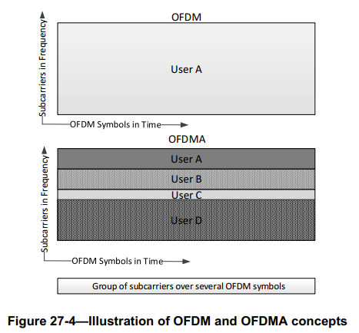

Proposed Resolution: CID 21421
Revised.
Agree with the commenter that the box with phrase “Group of subcarriers over several OFDM symbols” is not needed in the figure.

Instruction to Editor: Delete the box containing the phrase “Group of subcarriers over several OFDM symbols” from Figure 27-4. (An updated Visio file with the box deleted has been attached to 11-19/0379r1 under Proposed Resolution for CID 21421.)

CID 20665

CID | Clause | Page.Line | Comment | Proposed Change
20665 | 27.3.2.2 | 475.51 | It is not clear what the subcarrier assignments for things that are not RUs (i.e. SU/ER PPDUs) are. Tables 27-7 etc. only give them for RUs | Change the caption for Table 27-7 to "Data and pilot subcarrier indices for RUs in a 20 MHz HE PPDU and in a non-OFDMA 20 MHz HE PPDU" and at the end of the table add a para "The data and pilot subcarrier indices for a non-OFDMA 20 MHz HE PPDU are the same as those for a 242-tone RU." Ditto in Tables 27-8 and 27-9

Discussion

D4.0 P477:
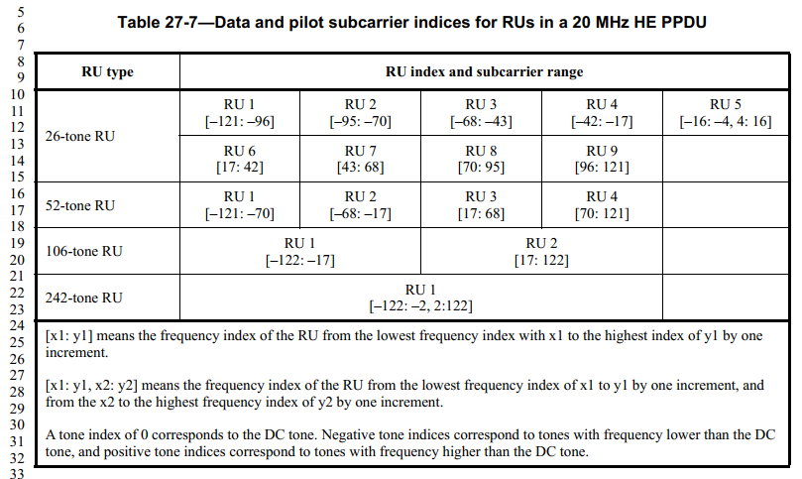

The commenter is pointing out that it is not explicitly stated on how Table 27-7 represents the subcarrier indices for HE SU and HE ER SU PPDUs. Text update proposed by the commenter seems appropriate. Proposed resolution expands the text update to tables for 40 and 80 MHz PPDUs as well.

Proposed Resolution: CID 20665
Revised.
Agree with the commenter. Instructions below expands the proposal by the commenter to Tables 27-8 and 27-9.

Instruction to Editor:
Update the title of Table 27-7 (D4.0 P477L5) to “Data and pilot subcarrier indices for RUs in a 20 MHz HE PPDU and in a non-OFDMA 20 MHz HE PPDU”.
At D4.0 P477L32, add “The data and pilot subcarrier indices for a non-OFDMA 20 MHz HE PPDU are the same as those for a 242-tone RU.”
Update the title of Table 27-8 (D4.0 P477L35) to “Data and pilot subcarrier indices for RUs in a 40 MHz HE PPDU and in a non-OFDMA 40 MHz HE PPDU”.
At D4.0 P478L14, add “The data and pilot subcarrier indices for a non-OFDMA 40 MHz HE PPDU are the same as those for a 484-tone RU.”
Update the title of Table 27-9 (D4.0 P478L16) to “Data and pilot subcarrier indices for RUs in an 80 MHz HE PPDU and in a non-OFDMA 80 MHz HE PPDU”.
At D4.0 P479L16, add “The data and pilot subcarrier indices for a non-OFDMA 80 MHz HE PPDU are the same as those for a 996-tone RU.”

CID 21386

CID | Clause | Page.Line | Comment | Proposed Change
21386 | 27.3.2.2 | 477.25 | "from the lowest frequency index with x1 to the highest index of y1" | Change to "from the lowest frequency index x1 to the highest index y1"

Discussion

D4.0 P477:

The phrase “from the lowest frequency index with x1 to the highest index of y1” is awkward and deserves some editorial update as the commenter has suggested. However, the notation of [x:y] or [x1:y1, x2:y2] is used in many other places in the draft without a proper definition. For example, it is used throughout (multiple times) in 27.3.2.2, 27.3.10.8.3 and 27.3.10.10 (this was not an exhaustive search, so there may be more).

Proposed resolution defines the notation [x:y] and [x1:y1, x2:y2] in 27.3.2.1 (General – Subcarrier and resource allocation).

Proposed Resolution: CID 21386
Revised.
Agree with the commenter that the phrase needs to be re-worded. The notations [x:y] and [x1:y1, x2:y2] are used in many other places in the draft without proper definition. Proposed text update in 11-19/0379r1 defines these notations in 27.3.2.1.

Instruction to Editor: Implement the proposed text changes in 11-19/0379r1 for CID 21386.

Proposed Text Updates: CID 21386

TGax Editor: Add definitions for [x1:y1] and [x1:y1,x2:y2] at D4.0 P475L50 as shown below.

    - Subcarrier and resource allocation
      - General
An OFDM symbol is constructed of subcarriers, the number of which is a function of the PPDU bandwidth. There are several subcarrier types:
- Data subcarriers, which are used for data transmission (see 27.3.2.2)
- Pilot subcarriers, which are used for phase information and parameter tracking (see 27.3.2.4)
- Unused subcarriers, which are not used for either data or pilot transmission. The unused subcarriers are the DC subcarrier (see 27.3.2.2), the Guard band subcarriers at the band edges (see 27.3.2.2), and the Null subcarriers (see 27.3.2.3).

Following notations are used when describing the indices for a set of subcarriers:
[x1:y1] represents the set of subcarriers whose index k satisfies x1 ≤ k ≤ y1.

[x1:y1, x2:y2] represents the set of subcarriers whose index k satisfies either x1 ≤ k ≤ y1 or x2 ≤ k ≤ y2.

TGax Editor: Delete the following lines from D4.0 P477L25, P478L6 and P479L9.

CID 20635

CID | Clause | Page.Line | Comment | Proposed Change
20635 | 27.3.2.4 | 483.24 | "If pilot subcarriers are present in the HE-LTF field of an HE SU PPDU, HE MU PPDU, HE ER SU PPDU, or HE TB PPDU, the pilot subcarrier locations in the HE-LTF field and Data field shall be the same for the 4x HE-LTF. In a 1x HE-LTF, the pilot subcarrier locations in the HE-LTF only consist of the pilot subcarriers for the Data field that are multiples of four. If pilot subcarriers are present in a 2x HE-LTF, then their locations shall be the same as those pilots in a 4x data symbol. All pilot subcarriers are at the even indices enumerated in Table 27-11 (Pilot subcarrier indices)." is not clear:  1) "shall be the same" -- but no pointer to where the pilots for the Data field are;  2) the term "4x data symbol" is undefined;  3) all the numbers in T27-10 are even so no need to qualify as "at the even indices" | Delete the cited text at the referenced location

Discussion

D4.0 P483:
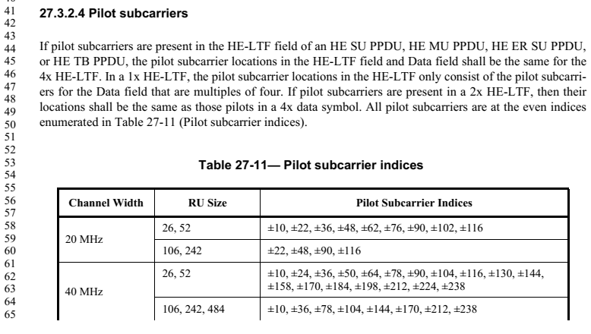
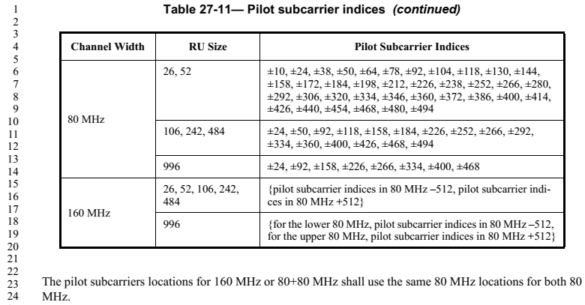

Regarding the first concern:
1) "shall be the same" -- but no pointer to where the pilots for the Data field are
Table 27-11 defines the pilot subcarrier location for Data field. However, note that 27.3.11.3 (Pilot subcarriers) defines a more detailed location information for the pilot subcarriers in the Data field – as a function of PPDU BW, RU size and RU location. Hence, Table 27-11 is redundant, and should be replaced by a simple reference to 27.3.11.3.

Regarding the second concern:
2) the term "4x data symbol" is undefined;
We should add a reference to 27.3.10.10 (HE-LTF) where the 4x, 2x and 1x HE-LTF types are defined.

Regarding the third concern:
3) all the numbers in T27-10 are even so no need to qualify as "at the even indices"
Agree with the commenter that this is redundant information.

Proposed Resolution: CID 20635
Revised.
Agree with the commenter that additional clarity is needed in the cited text. Note that much of the details are defined in 27.3.10.10 (HE-LTF) and 27.3.11.3 (Pilot subcarriers). All three concerns raised by the commenter are addressed in 11-19/0379r1 by removing redundant information and inserting references to other sections, and some re-wording of the text.

Instruction to Editor: Implement the proposed text changes in 11-19/0379r1 for CID 20635.

Proposed Text Updates: CID 20635

TGax Editor: Update 27.3.2.4 at D4.0 P483L43 as shown below.

27.3.2.4 Pilot subcarriers
Within the HE modulated fields (see 27.3.9) of an HE PPDU, pilot subcarriers are present in the Data field, and may be present in the HE-LTF field (see 27.3.10.10). Pilot subcarrier indices of a data symbol is defined in 27.3.11.13.
One of the following three HE-LTF types may be used in an HE PPDU: 1x HE-LTF, 2x HE-LTF and 4x HE-LTF (see 27.3.10.10). If pilot subcarriers are present in the HE-LTF field of an HE PPDU, the pilot subcarrier locations in the 4x HE-LTF and 2x HE-LTF are the same as those in the Data field. In a 1x HE-LTF, the pilot subcarrier locations in the HE-LTF only consist of the pilot subcarrier locations for the Data field that are multiples of four.

CID 21387

CID | Clause | Page.Line | Comment | Proposed Change
21387 | 27.3.2.6 | 485.37 | Sentence in wrong section? "The value of GI duration shall be the same for all users in an HE MU PPDU." is in section "Resource allocation for an HE TB PPDU" | Move sentence to section 27.3.2.5

Background

D4.0 P485:
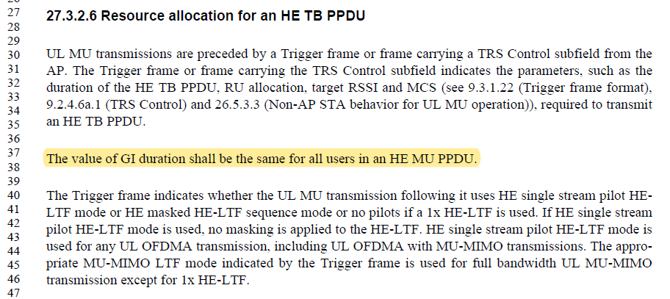

Proposed Resolution: CID 21387
Revised.
Agree with the commenter that the cited sentence does not belong in 27.3.2.6. However, 27.3.2.5 is also on “resource allocation and user identification” in an HE MU PPDU, to which GI duration is not directly related to.

Also, note that the TXVECTOR parameter GI_TYPE is not an “MU” type, meaning that it can have only a single value (not an array) even for HE MU PPDUs. Also, the GI type (together with LTF type) is signalled in the HE-SIG-A in an HE MU PPDU. Hence, there is no way to indicate different GI values for different users. Thus, there is no need to write a rule requiring that GI duration “shall be the same” for all users.

Instruction to Editor: Delete the sentence “The value of GI duration shall be the same for all uesrs in an HE MU PPDU” from D4.0 P485L37.

CID 20096

CID | Clause | Page.Line | Comment | Proposed Change
20096 | 27.3.2.7 | 486.09 | The operation of the HE PHY operation for 6 GHz is the same as 5 GHz. To be consistent with text, the data pilot subcarrier indices for 20 MHz HE PPDU should include the 6 GHz band. | change text to read "...in the 2.4, 5 and 6 GHz bands.

Discussion

D4.0 P486:

Agree with the commenter that this rule applies to 6 GHz as well.

Proposed Resolution: CID 20096
Accepted.

CID 21428

CID | Clause | Page.Line | Comment | Proposed Change
21428 | 27.3.3.2.3 | 488.29 | Need to specify "UL" | Change "MU-MIMO LTF Mode" to "UL MU-MIMO LTF Mode"

Discussion

D4.0 P488:
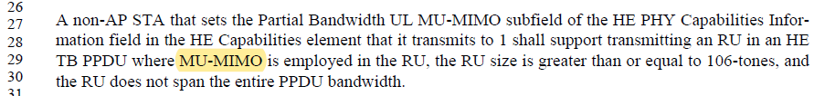

Commenter is correct that MU-MIMO at P488L29 is UL MU-MIMO.

Proposed Resolution: CID 21428
Revised.
Agree with the commenter.
Instruction to Editor: At P488L29, change “MU-MIMO” to “UL MU-MIMO”

CID 20379

CID | Clause | Page.Line | Comment | Proposed Change
20379 | 27.3.10.5 | 522.27 | The spec says: "In an HE PPDU, the RATE field shall be set to the value representing 6 Mb/s". However, the RXTIME calculation in 27-132 and 27-133 is calculated without taking into account the value of the RATE field and always assumes 6 Mbps. This value of 6 Mbps is also not used to classify EHT PPDU compared to other PPDUs. Therefore, it should be allowed to set the RATE field to any allowed value (valid RATE), while the calculation of the RXTIME considers 6 Mbps as today. | Remove the requirement to set the RATE field in L-SIG to 6Mbps throughput the spec.

Discussion

Let us assume that the commenter meant “HE PPDU” instead of “EHT PPDU”.

D4.0 P522:
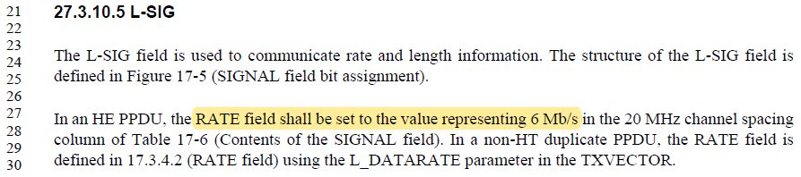

Commenter is suggesting to allow HE PPDUs to indicate any valid 11a rate (6/9/12/18/24/36/48/54 Mbps) in the L-SIG. Argument here is that the RXTIME computation does not rely on the L-SIG rate. However, the division by 3 in Equations (27-133), (27-120) and (27-121) is because the L-SIG rate if 6 Mbps. If other rates are to be allowed, then these equations are no longer valid.

D4.0 P641:
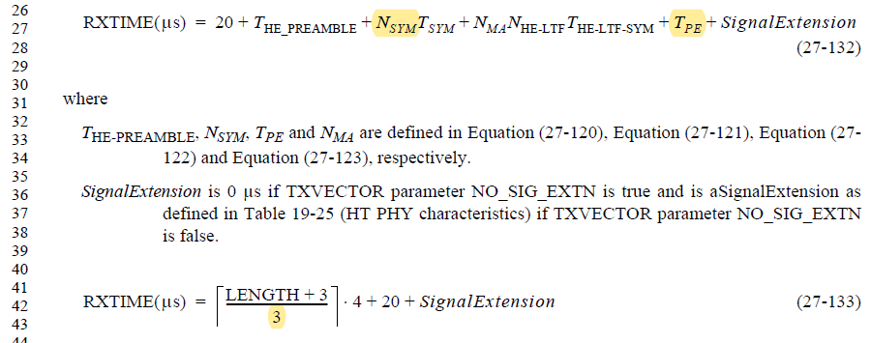

D4.0 P606:
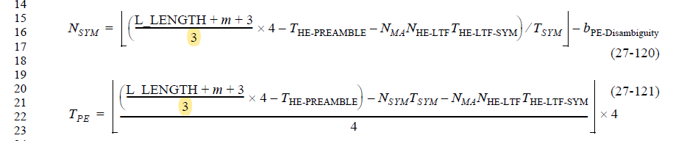

More importantly, the HE PHY receiver procedure (27.3.21) is clear that if the L-SIG rate is not set to 6 Mbps, HE receive procedure is not initiated. Hence, changing the 11ax draft now to allow any L-SIG rate to be used for HE PPDUs will break interoperability with any devices following D4.0.

D4.0 P639:
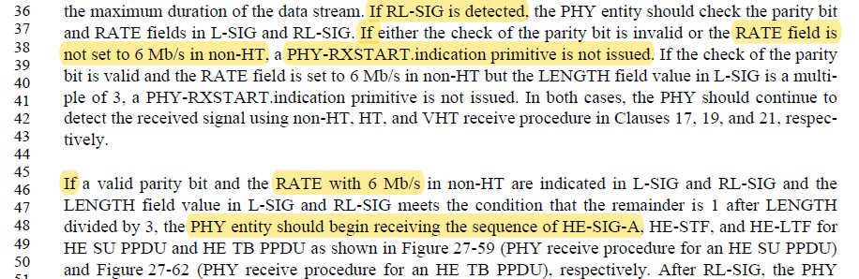

Proposed Resolution: CID 20379
Rejected.
HE PHY receive procedure (27.3.21) is clear that receivers do not consider PPDUs to be HE unless the L-SIG rate is 6 Mbps. The division by 3 in Equations (27-133) and (27-120)/(27-121) (both used by (27-132)) require that the L-SIG rate is set to 6 Mbps for HE PPDUs.

CID 21217

CID | Clause | Page.Line | Comment | Proposed Change
21217 | 27.3.12 | 602.60 | For HE-TB, "the spectrum used by the Data field" is ambiguous for RUs <RU242. Is the Data field spectrum a) the same as the RU allocation (i.e. 2/4/8/20/40 .. MHz wide) or b) the PPDU mask, which is 20/20/20/20/40/ ... MHz wide? Obviously there are spectral requirements on the PPDU mask rather than the RU, and the EVM test validates energy at the subcarrier speacing after the GI is removed, but does not constrain the spectrum when the GI is present. Therefore an entirely defensible interpretation of this language is option b), yet that probably/hopefully is not the intent. | Insert some simple example language such as "(e.g. the approximately 2 MHz occupied by data and pilot tones for an RU26)"

Discussion

D4.0 P602:
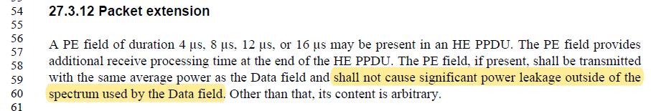

It does not hurt to provide some more clarity as the commenter has suggested. Proposed resolution makes the following update.

D4.0 P602L60:
A PE field of duration 4 µs, 8 µs, 12 µs, or 16 µs may be present in an HE PPDU. The PE field provides additional receive processing time at the end of the HE PPDU. The PE field, if present, shall be transmitted with the same average power as the Data field and shall not cause significant power leakage outside of the spectrum used by the Data field. Other than that, its content is arbitrary. In case of OFDMA HE PPDUs, the spectrum used by the Data field for the purpose of PE is commensurate with the location(s) and size(s) of the occupied RU(s), not the PPDU bandwidth. For example, the Data field an OFDMA HE PPDU using a single 26-tones RU would have a spectrum which is approximately 2 MHz wide.

Proposed Resolution: CID 21217
Revised.
Agree with the commenter that it would be helpful to provide additional clarity.

Instruction to Editor: Add the following text at the end of P602L60.
“In case of OFDMA HE PPDUs, the spectrum used by the Data field for the purpose of PE is commensurate with the location(s) and size(s) of the occupied RU(s), not the PPDU bandwidth. For example, the Data field an OFDMA HE PPDU using a single 26-tones RU would have a spectrum which is approximately 2 MHz wide.”

CID 20089

CID | Clause | Page.Line | Comment | Proposed Change
20089 | 27.3.14.3 | 609.31 | Calls out the transmit power accuracy is based on the entire range of transmit power that a Station is capable of. The transmit range is dependent on the band of operation e.g., 5 GHz, 6 GHz and limits are set forth by the regulatory domain. | Change text to read "....that the STA is capable of as specified by the regulatory domain (as defined in Annex E).

Discussion

D4.0 P609:
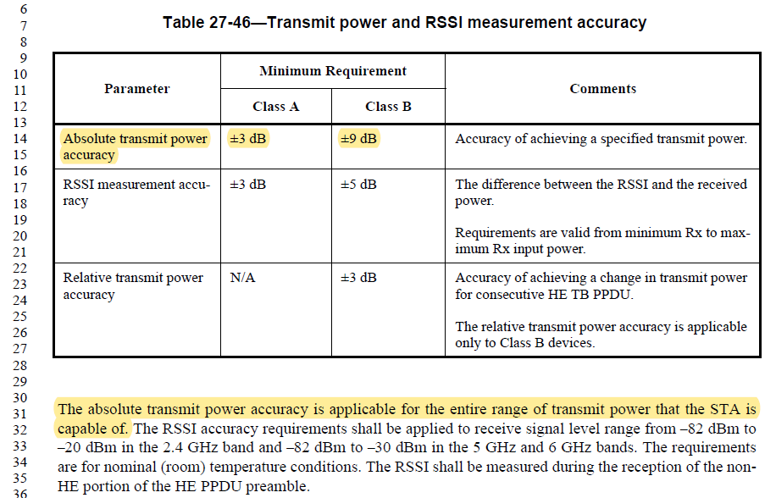

Regulatory rules do not dictate the transmit power range a STA is “capable” of. Rather, regulatory rules provide restrictions on the transmit power range a STA “may use”. For example, a STA may be capable of transmitting maximum 25 dBm, but regulatory rules for a certain domain may require that the STA does not transmit more than 20 dBm. As another example, the fact that a regulatory domain requires max. TX power to be no higher than, say, 20 dBm does not mean that a STA has to be able to transmit at 20 dBm. So it does not seem appropriate to say that TX power range of a “STA is capable of as specified by regulatory”.

Intention of the commenter is probably that the STA should not be tested be for accuracy for range which is outside of what the regulatory requires. E.g., if the STA can transmit up to 30 dBm, but the regulatory rules caps the maximum TX power at 20 dBm, then there is no need to test the TX power accuracy for powers higher than 20 dBm for that regulatory region. Note that 27.3.23 (Regulatory requirements) already specifies that STAs are subject to regulatory requirements, so there is no need to spell out regulatory requirement again here.

Proposed Resolution: CID 20089
Revised.
Regulatory rules do not dictate the transmit power range a STA is “capable” of, but rather, the range a STA “may use”. So, it is not appropriate to say “STA is capable of as specified by the regulatory domain”. Instead, the proposed text update below clarifies that only the TX power range the STA intends to use (taking into consideration of both what the STA is capable of, and what the regulatory allows).

Instruction to Editor: At D4.0 P609L30, change “entire range of transmit power that the STA is capable of” to “the entire range of transmit power that the STA is intending to use for the current band of operation.”

CID 21365 - Skip

CID | Clause | Page.Line | Comment | Proposed Change
21365 | 27.3.18 | 615.34 | Next, for each frequency at which "neither" of the two 80 MHz interim masks have values greater than or equal to -20 dBr and less than or equal to 0 dBr, the higher value of the two interim masks shall be taken as the overall interim spectral value. | Should replace 'neither' with 'either'.

Discussion

D4.0 P615:
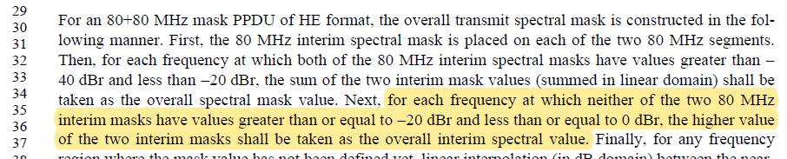
…
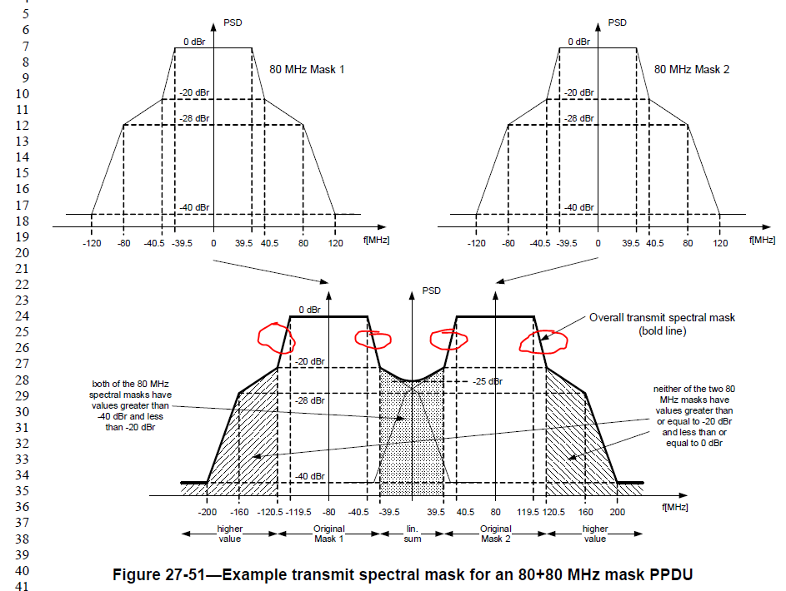

Agree with the commenter that “either” is correct.

Proposed Resolution: CID 21365
Accepted.

CID 20148

CID | Clause | Page.Line | Comment | Proposed Change
20148 | 27.3.18.4.4 | 623.01 | The index i_RU index should be I_sc for variable Qu | as in the comment

Discussion

D4.0 P623:
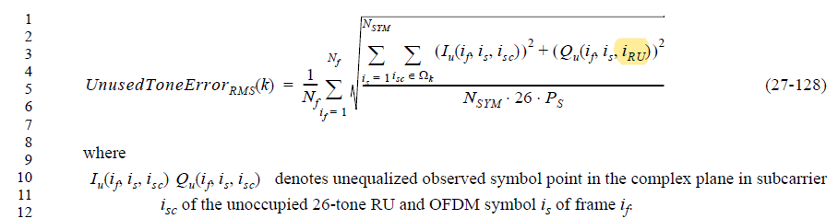

Agree with the commenter

Proposed Resolution: CID 20148
Accepted.

CID 20149, 20360

CID | Clause | Page.Line | Comment | Proposed Change
20149 | 27.3.19.1 | 624.38 | LDPC should be used for 1024QAM even when bandwidth is 20MHz | as in the comment
20360 | 27.3.19.1 | 624.38 | If the PPDU bandwidth is 20 MHz, BCC is used | For 20MHz 1024 QAM, need to use LDPC

Background

D4.0 P624:
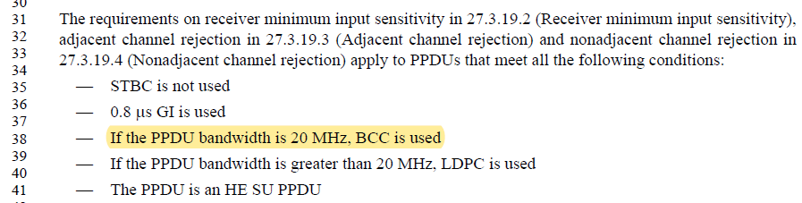

Proposed Resolution: CID 20149, 20360
Revised.
Commenter is correct that 1024-QAM may be used for 20 MHz HE PPDUs, in which case LDPC is the only option for coding.

Instruction to Editor: Implement the proposed text changes in 11-19/0379r1 for CID 20149, 20360.

Proposed Text Updates: CID 20149, 20360

TGax Editor: Update D4.0 P624L38 as shown below.

- If the PPDU bandwidth is 20 MHz and MCS is less than 10, BCC is used. Otherwise, LDPC is used.

CID 20986

CID | Clause | Page.Line | Comment | Proposed Change
20986 | 27.3.10.10 | 562.17 | Re CID 16340: the proposed change was to make the requirement apply to both tx and rx, but the resolution is to make it apply to tx only. No justification is provided for this | In the referenced subclause change "A STA that declares support for UL MU-MIMO  shall support transmission of 1x HE-LTF for full bandwidth UL MU-MIMO." to "A STA that declares support for UL MU-MIMO  shall support transmission (as a non-AP STA) and reception (as an AP) of 1x HE-LTF for full bandwidth UL MU-MIMO."

Background

From D3.0 comment resolution (11-18/1123r24):
CID | Clause | Page.Line | Comment | Proposed Change | Resolution | Edit Notes
16340 | 28.3.10.10 | 496.42 | "It is mandatory to support 1x HE-LTF  for full bandwidth UL MU-MIMO, for a STA declaring support for UL MU-MIMO." is not clear as to whether this is tx or rx or both | State this is for both tx and rx | REVISED (PHY: 2018-09-20 08:38:09Z)  Editor please replace on 496.42  “It is mandatory to support 1x HE-LTF…”  With  "It is mandatory to support the transmission of 1x HE-LTF  for full bandwidth UL MU-MIMO, for a STA declaring support for UL MU-MIMO transmission" | EDITOR: 2018-10-02 23:01:40Z - The requirement is on an implementation so reword to "A STA that declares support for UL MU-MIMO shall support transmission of 1x HE-LTF for full bandwidth UL MU-MIMO"

D4.0 P562:
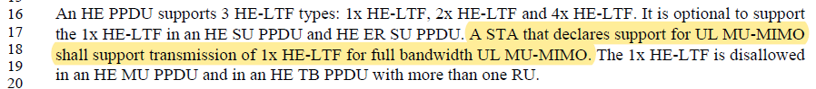

Proposed Resolution: CID 20986
Rejected.
An AP can choose not to indicate 1x HE-LTF for HE TB PPDU when transmitting Triggering frames. As such, it is optional for an AP to support 1x HE-LTF when receiving HE TB PPDUs.

[End of File]

