IEEE P802.11
Wireless LANs
CIDs 2709, 2710, 2711
Date: 06/03/2019
Author(s):
Name | Affiliation | Address | Phone | email
Sigurd Schelstraete | Quantenna Communications | 1704 Automation Parkway, San Jose CA 95131,  USA |  | sigurd@quantenna.com
Abstract
This document discusses CIDs 2709, 2710 and 2711.

Introduction

2709 | 19.3.21 | 3037 | 11 | "non-HT preamble" is used in Figure 19-27 but it is not defined explicitly. It should be defined as L-STF + L-LTF + L-SIG. Subclause 19.3.9.3 (Non-HT portion of the HT-mixed format preamble) may be an appropriate place to define it.  Note that the term "non-HT preamble" is also used in P3033 (Figure 19-22) and in P3044L14 (parameter in eq. 19-90 and 19-91), however, it means L-STF + L-LTF which is different from the usage here. I think these should be renamed. Comments for this issue are submitted sepalately. | In 19.3.9.3 (Non-HT portion of the HT-mixed format preamble) at P2976L48, change the sentence "The transmission of the non-HT training fields and the L-SIG as part of ..." to "The transmission of non-HT preamble (the non-HT training fields and the L-SIG) as part of ..."

2710 | 19.3.20 | 3033 | 17 | "non-HT preamble" is used to indicate training fields "L-STF + L-LTF". It is confusing because "non-HT portion of the HT-mixed format preamble" includes L-SIG. In P3037L11 (Figure 19-27), non-HT preamble seems to include L-SIG.  Since the term "HT-Training" is used for "HT-STF + HT-LTF" in the same figure, "training" is better than "preamble" for "L-STF + L-LTF". | Replace "Non-HT Preamble" with "Non-HT Training" in the figure 19-22.

2711 | 19.4.3 | 3044 | 14 | "non-HT preamble" is used to indicate training fields "L-STF + L-LTF". It is confusing because "non-HT portion of the HT-mixed format preamble" includes L-SIG. "HT preamble" is also used to indicate training fields HT-STF + HT-LTFs, however, HT preamble in subclause 19.3.9 includes HT-SIG.  The term "training" is better than "preamble" in subclause 19.4.3. | Replace "T_LEG_PREAMBLE" with "T_LEG_TRAINING" (eq 19-90 and 91, P3044L14).  Replace "T_HT_PREAMBLE" with "T_HT_TRAINING" (eq 19-90 and 91, P3044L15).  Replace "T_GF_HT_PREAMBLE" with "T_GF_HT_TRAINING" (eq 19-92 and 93, P3044L18).  Replace "non-HT preamble" in P3044L14 with "non-HT training fields".  Replace "HT preamble" in P3044L15 with "HT training fields".  Replace "preamble" in P3044L18 with "training fields".

Discussion

2711
CID 2711 is about he highlighted text below.

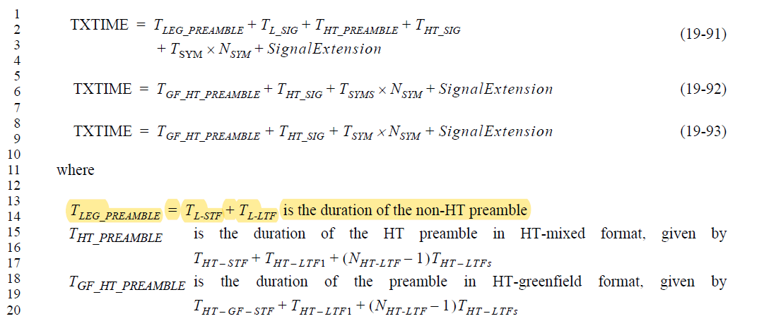

The comment likely stems from the fact that typically “preamble” means everything before the data field. At least, that seems to be the convention starting with HT. For Clause 17 however, it appears preamble is indeed defined as L-STF + L-LTF only (see 17.3.3).

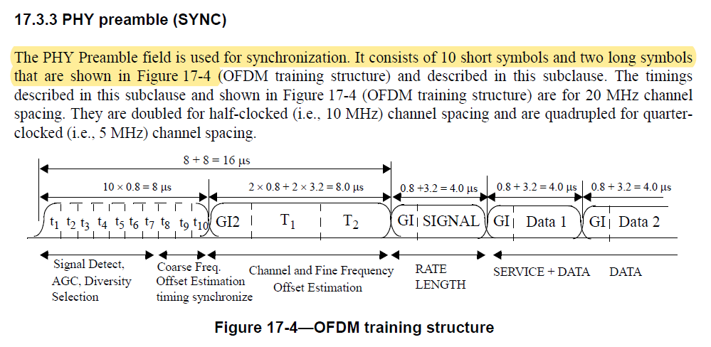

As such, the use of the term “non-HT preamble” on page 3044 is strictly speaking correct. It’s true that there is some similarity with the term “non-HT portion of HT preamble”, but even though the terms are similar, the wording is clearly distinct.

The main issue may be referring to T_HT_PREAMBLE as “the HT preamble in HT-mixed format”. Per 19.3.9.2, the HT-mixed format preamble contains more than just the training fields.

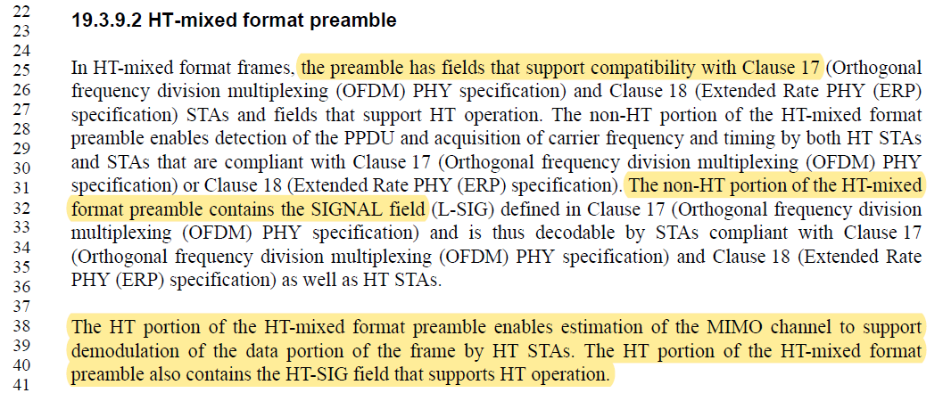

On page 3044 however, T_HT_PREAMBLE only refers to the HT-specific training fields.

Proposed resolution:
Revised

- Change T_HT_PREAMBLE to T_HT_TRAINING
- Change T_GF_HT_PREAMBLE to T_GF_HT_TRAINING

Modify text on pages 3043 and 3044 as shown below

TXTIME = T_{LEG_PREAMBLE} + T_{L_SIG} + T_{HT_PREAMBLE} T_{HT_TRAINING} + T_{HT_SIG}  + T_{SYM} × $\left\lceil \frac{T_{SYMS}×N_{SYM}}{T_{SYM}}\right\rceil$ + SignalExtension | (19-90)
TXTIME = T_{LEG_PREAMBLE} + T_{L_SIG} + T_{HT_PREAMBLE} T_{HT_TRAINING} + T_{HT_SIG}  + T_{SYM} × N_{SYM} + SignalExtension | (19-91)
TXTIME = T_{GF_HT_PREAMBLE}T_{GF_HT_TRAINING} + T_{HT_SIG} + T_{SYMS} × N_{SYM} + SignalExtension | (19-92)
TXTIME = T_{GF_HT_PREAMBLE}T_{GF_HT_TRAINING} + T_{HT_SIG} + T_{SYM} × N_{SYM} + SignalExtension | (19-93)

Where
T_{LEG_PREAMBLE} = T_{L-STF} + TL-LTF is the duration of the non-HT preamble
T_{HT_PREAMBLE} T_{HT_TRAINING} is the duration of the HT preambletraining in HT-mixed format, given by T_{HT – STF} + T_{HT – LTF1} + (NHT-LTF – 1) T_{HT – LTFs}
T_{GF_HT_PREAMBLE} T_{GF_HT_TRAINING} is the duration of the preambletraining in HT-greenfield format, given by T_{HT – GF – STF} + T_{HT – LTF1} + (NHT-LTF – 1) T_{HT – LTFs}

2709
CID 2709 is about the highlighted text shown below. Only part of Figure 19-27 is shown.
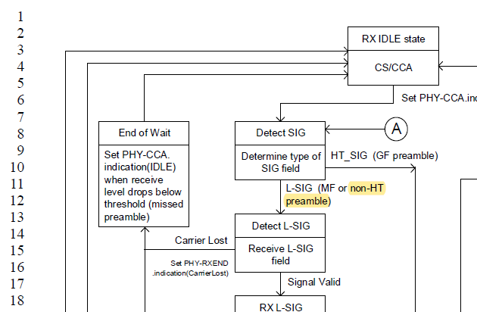

Figure 19-27 is essentially a flowchart showing how to move throught the reception process. The specific step shown above is about deciding whether the format of the signal is GF or not. If it is, a HT_SIG GF preamble is expected. If not, the regular L-SIG is expected and needs to be evaluated.
The two possible outcomes are labelled in Figure 19-27 as “HT_SIG (GF preamble)” and “L-SIG (MF or non-HT preamble)”. The commenter argues that “non-HT preamble” is not clearly defined and used in a different meaning elsewhere.

Since the decision is more about the format of the packet, the issue could be avoided by referring to the format of the received packet, rather than the preamble. I.e.: replace “(MF or non-HT preamble)” with “(MF or non-HT format)” and replace “HT_SIG (GF preamble)” with “HT_SIG (GF format)”. With this, the decision flow is unaffected and the language is less ambiguous.

Proposed resolution:
Revised.

In Figure 19-27, replace “(MF or non-HT preamble)” with “(MF or non-HT format)” and replace “HT_SIG (GF preamble)” with “HT_SIG (GF format)”.

2710

CID 2710 is about the use of the term “non-HT preamble” in Figure 19-22, as highlighted below.

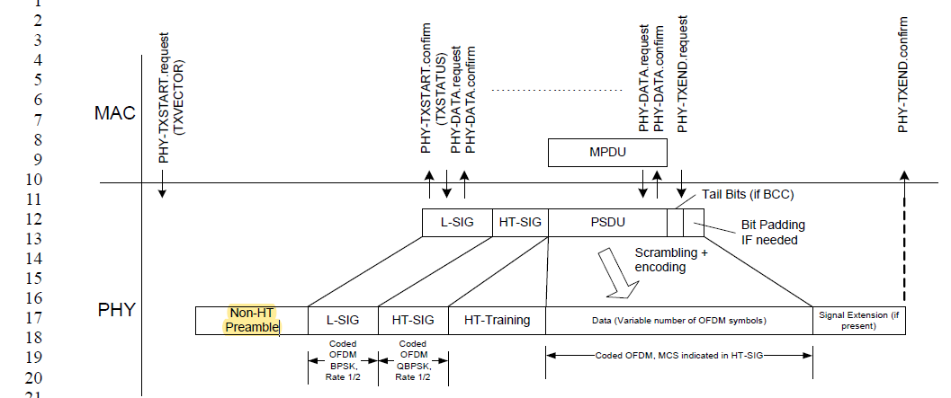

The commenter argues that this is not the right term. The comment is similar to what was discussed under CID 2711. As explained there, use of the term “non-HT preamble” to indicate L-STF + L-LTF is consistent with the way the preamble is defined in 17.3.3.

Proposed resolution:
Reject.

Use of the term “non-HT preamble” to indicate L-STF + L-LTF is consistent with the way the preamble is defined in 17.3.3.

