IEEE P802.11
Wireless LANs
CID 2708
Date: 06/03/2019
Author(s):
Name | Affiliation | Address | Phone | email
Sigurd Schelstraete | Quantenna Communications | 1704 Automation Parkway, San Jose CA 95131,  USA |  | sigurd@quantenna.com
Abstract
This document discusses CID 2708.

Introduction

2708 | 21.3.8.3.3 | 3158 | 14 | D_k,n,BW in eq.(21-28) seems to be a mistake for D_k,n,20 as in Line 26. D_k in VHT-SIG-A is duplicated over every 20 MHz. | Replace D_k,n,BW with D_k,n,20.

Discussion

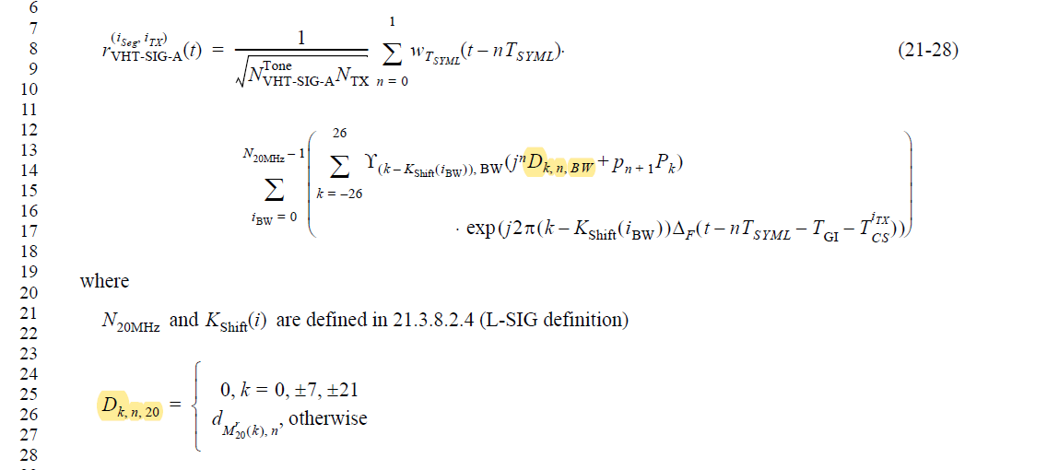

The comment is about the notation D_{k,n,BW} used in (21-28) as highlighted above. The subscript “BW” may imply that the values depend on the full BW of the PPDU. However, as pointed out by the commenter, VHT-SIG-A is sent in “duplicate” format, where each 20 MHz within the BW is modulated with the same values. Moreover, on line 26, reference is made to D_{k,n,20} instead of D_{k,n,BW}.

This can for instance be compare with the expression for L-SIG, which is repeated over 20 MHz segments in similar fashion:

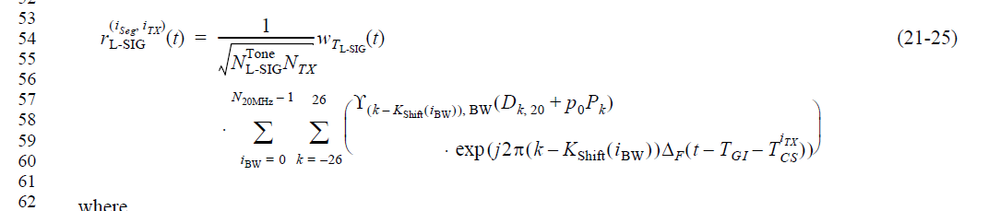

Here, “20” is used as subscript instead of “BW”.

Proposed resolution
The comment appears correct.

Propose to accept the comment and resolve with the resolution proposed by the commenter.

