IEEE 802.11
Wireless LANs
PHY Evaluation Methodology Simulation Calibration
Date: 2018-03-07
Author(s):
Name | Affiliation | Address | Phone | email
Nikola Serafimovski | pureLiFi |  |  | nikola.serafimovski@purelifi.com
Tamas Weszely | pureLiFi |  |  | tamas.weszely@purelifi.com
Chong Han | pureLiFi |  |  | Chong.han@purelifi.com

Abstract
This document proposes a procedure simulation calibration for the evaluation of PHY proposals in TGbb.

Introduction

System model

802.11a
The block diagram in Figure XX shows the full system model between the PHY TX and PHY RX.
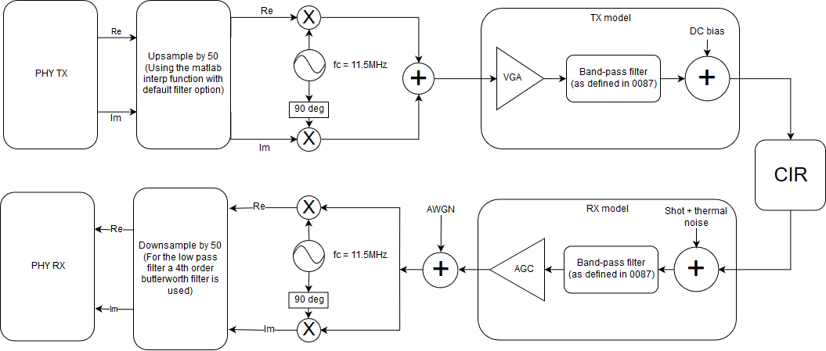
Up/Downsampling:
The baseband signal should be upsampled by 50 to simulate the analogue blocks of the system. For this block an ideal filter should be used.
For the downsampling, a low order (<4) analogue filter shall be modeled. The line below can be used to generate such a filter in matlab:
[b, a] = butter(4, 0.01);
Up/Downconversion:
The baseband signal shall be upconverted by:
BW/2 + offset
For the system shown above, the selected offset was 1.5MHz.

PHY evaluation methodology

Scenarios

Proposals for PHY contributions shall be evaluated against simulation scenarios described in TGbb doc. 11-18/1423r8 which is based on the TGbb usage model doc. 11-18/1109r5 after selecting the primary usage models. Simulations shall implement the TGbb channel modeling described in doc. 11-18/1582r4. TGbb has made available a number of channel impulse responses that can be downloaded from Mentor in doc. 11-18/1603r1.

Choice of process:
- Simulation scenarios
  - AWGN
  - Industrial Wireless
  - Enterprise
- Parameters to be used
  - Copy corresponding PHY parameters from doc. 11-18/1423r8 for the relevant simulation environments.
- Analytical front-end model
  - Convolute the channel filters describing the analogue front-end model defined in doc.11-19/0087r1 with the following Channel Impulse responses:
    - Industrial Wireless Figure 28(g), CIR D7 (all LEDs transmit simultaneously)
      - Go to doc. 11-18-1603r1 \ simulation scenario enterprise \ overall cirs \ Optical CIRs \ D7
    - Enterprise Figure 15(a), CIRs D1 and D2
      - Go to doc. 11-18-1603r1 \ simulation scenario-enterprise conference room \ individual cirs \ Optical cirs \ S1-D1 and S1-D2 and S3-D1 and S3-D2

Simulator calibration:

The following basic PHY shall be simulated and presented with the results of a new proposal.

DCO-OFDM using 802.11a frame format. Full buffer with following selected parameters.
20MHz baseband
64 subcarriers
52 occupied,
Convolutional Code from 802.11a
Code Rate ½
MCS = QPSK
To verify the simulation model, the SNR should be measured at the PHY RX with 0 noise added in the AWGN block and the CIR block removed from the system. Shot and thermal noise should be added as defined by the noise floor in doc. IEEE 802.11-18/1423r8.

After the system is verified, the following simulation results are to be obtained for all selected CIR:
    - Preamble misdetection rate vs. SNR for 100,000 packets with small packet size (100B)
    - Header error rate vs. SNR for 10,000 packets with small packet size (100B)
    - PER vs. SNR for entire packet for 1000 packets with maximum packet size.

Metrics
The aim of the evaluation is first to demonstrate that the PHY is consistently defined and parametrized. Therefore, proposers shall evaluate the preamble detection performance, the error rate of the header and the error rate of the payload.

1) Preamble
For the preamble, the detection probability (for false alarm rate = 0.1%) vs. SNR (cf. doc. 15-18-0106/r0) and the required SNR where the probability of misdetection (timing error) is <0.1%, measured over at least 100,000 packets of size 100B.

2) Header
For the header, proposers are required to present the PER vs. SNR including all associated channel and line coding (if applicable) assuming random data for the header information, measured over at least 10,000 packets of size 100B. A packet error occurs of there is at least one bit error in the header or there is a preamble error.

3) Payload
For the payload, PER vs. SNR shall be plotted incl. any channel coding (if applicable) assuming random data for the payload, measured over 1,000 packets. Proposers shall use their lowest and highest modulation and coding scheme (MCS) that is intended to be supported. Providing results for intermediate MCS is considered optional.

4) Throughput at PHY SAP should be specified by the proposers
If there are any questions, please use the TGbb email reflector.

