IEEE 802.11
Wireless LANs
PHY Evaluation Methodology Simulation Calibration
Date: 2018-02-14
Author(s):
Name | Affiliation | Address | Phone | email
Nikola Serafimovski | pureLiFi |  |  | nikola.serafimovski@purelifi.com
Tamas Weszely | pureLiFi |  |  | tamas.weszely@purelifi.com

Abstract
This document proposes a procedure simulation calibration for the evaluation of PHY proposals in TGbb.

Introduction

System model

802.11a
The block diagram in Figure XX shows the full system model between the PHY TX and PHY RX.
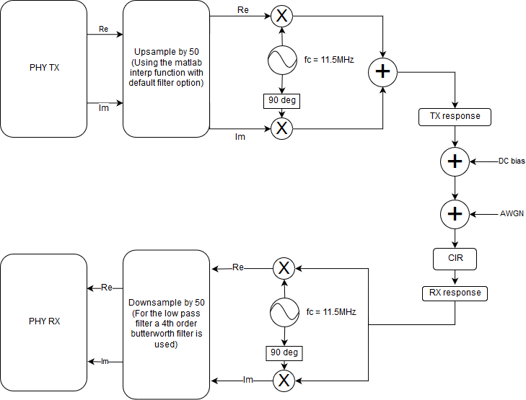
Up/Downsampling:
The baseband signal should be upsampled by 50 to simulate the analogue blocks of the system. For this block an ideal filter should be used.
For the downsampling, a low order (<4) analogue filter shall be modeled. The line below can be used to generate such a filter in matlab:
[b, a] = butter(4, 0.01);
Up/Downconversion:
The baseband signal shall be upconverted by:
BW/2 + offset
The optimal offset should be experimentally determined for each standard. For the system shown above, the optimum offset was 1.5MHz.

PHY evaluation methodology

Scenarios

Proposals for PHY contributions shall be evaluated against simulation scenarios described in TGbb doc. 11-18/1423r8 which is based on the TGbb usage model doc. 11-18/1109r5 after selecting the primary usage models. Simulations shall implement the TGbb channel modeling described in doc. 11-18/1582r4. TGbb has made available a number of channel impulse responses that can be downloaded from Mentor in doc. 11-18/1603r1.

Choice of process:
- Simulation scenarios
  - AWGN
  - Industrial Wireless
  - Enterprise
- Parameters to be used
  - Copy corresponding PHY parameters from doc. 11-18/1423r8 for the relevant simulation environments.
- Analytical front-end model
  - Convolute the channel filters describing the analogue front-end model defined in doc.11-19/0087r1 with the following Channel Impulse responses:
    - Industrial Wireless Figure 28(g), CIR D7 (all LEDs transmit simultaneously)
      - Go to doc. 11-18-1603r1 \ simulation scenario enterprise \ overall cirs \ Optical CIRs \ D7
    - Enterprise Figure 15(a), CIRs D1 and D2
      - Go to doc. 11-18-1603r1 \ simulation scenario-enterprise conference room \ individual cirs \ Optical cirs \ S1-D1 and S1-D2 and S3-D1 and S3-D2

Simulator calibration:

The following basic PHY shall be simulated for all selected CIRs and presented with the results of a new proposal.

DCO-OFDM using 802.11a frame format. Full buffer with following selected parameters.
20MHz baseband
64 subcarriers
52 occupied,
Convolutional Code from 802.11a
Code Rate ½
MCS = QPSK
To verify the simulation model, the SNR should be measured at the PHY RX, with 0 noise added at the AWGN block. Shot and thermal noise should be added.
If the measured SNR is reasonable (>40dB?), PER vs. SNR at the output of the AWGN block to be measured for at least 100,000 packets.

