IEEE P802.11
Wireless LANs
Resolutions to S1G PHY
Date: 2019-03-10
Author(s):
Name | Affiliation | Address | Phone | email
Yujin Noh | Newracom |  |  | yujin.noh at newracom.com
Abstract
This submission shows
- Resolution for comments received from TGm comment collection (11Revmd D2.0)
- The proposed changes are based on 11Revmd D2.1.
- The submission provides resolutions to 7 CIDs:
2627, 2313, 2312, 2311, 2261, 2270 and 2323

Revisions:
- Rev 0: Initial version of the document.
- Rev 1: update to CID 2323
- Rev 2: update to CID 2312, CID 2313, CID 2270 and CID 2323
- Rev 3: update to fix editorials
- Rev 4: update remaining CIDs - 2313, 2312, 2270
  - Resolution to CIDs 2627, 2323, 2261 and 2311 (Comment Group PHY Motion B) accepted on March
- Rev 5: update to CIDs 2312 and 2313
- Rev 6: update to CIDs 2312 and 2313
  - Resolution to CIDs 2270 ready to motion

CID | P.L | Comment | Proposed Change | Resolution
2627 | 3294.48 | "Set to S1G_SHORT_PREAMBLE defined in 23.3.8.2.1 " -- S1G_SHORT_PREAMBLE is not defined there, it's an enum value. And anyway it should not be specified to be set here, rather it should be set in the PHY spec (see 18/0710) | Delete the referenced row. At 3293.40 change "The PREAMBLE_TYPE =  S1G_SHORT_PREAMBLE. " to "The S1G_SHORT preamble (see 23.3.8.2.1) is used." | Revised.  These changes make the change on page 3293, and other related changes, but do not delete the referenced row  TGm Editor: make changes according to this document 11-19-0261-03-00m Resolutions to S1G PHY

Discussion

At 3332.32, given three preamble formats defined with S1G_1M preamble, S1G_SHORT preamble, and S1G_LONG preamble, those terms are used to implement the resolution as below.

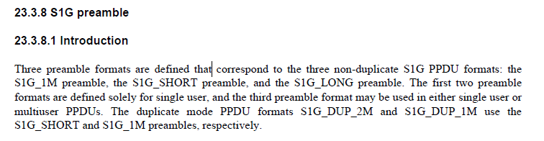

To TGm Editor: P3295L24 replace the current text with the proposed changes below.
------------- Begin Text Changes ---------------
- TXVECTOR and RXVECTOR parameters (11ah)
Parameter | Condition | Value | TXVECTOR | RXVECTOR
PREAMBLE_TYPE | FORMAT is S1G and (CH_BANDWIDTH is CBW2 or CBW4 or CBW8 or CBW16) | Determine the type of preamble of the S1G PPDU.  Enumerated type:  S1G_SHORT_PREAMBLE indicates the short preamble defined in 23.3.8.2.1 (S1G_SHORT preamble).  S1G_LONG_PREAMBLE indicates the long preamble defined in 23.3.8.2.2 (S1G_LONG preamble). | Y | Y
 | FORMAT is S1G_DUP_2M | Set to S1G_SHORT_PREAMBLE defined in 23.3.8.2.1 (S1G_SHORT preamble). (#2627) | Y | Y
 | Otherwise | Not present | N | N

------------- End Text Changes -----------------------

To TGm Editor: P3294L28 replace the current text with the proposed changes below.
------------- Begin Text Changes ---------------

The PPDU bandwidth is determined by the CH_BANDWIDTH parameter, and the preamble type (i.e., S1G_1M_PREAMBLE, S1G_SHORT_PREAMBLE, S1G_LONG_PREAMBLE S1G_1M preamble, S1G_SHORT preamble, and S1G_LONG preamble) is determined by the PREAMBLE_TYPE parameter.
- The 1 MHz format PPDU (S1G_1M) is used for non-duplicate S1G transmissions at 1 MHz bandwidth (i.e., CH_BANDWIDTH = CBW1), and for S1G_DUP_1M transmissions of any bandwidth (i.e., CH_BANDWIDTH = CBW1, CBW2, CBW4, CBW8, or CBW16). The PREAMBLE_TYPE = S1G_1M_PREAMBLE. The S1G_1M preamble (see 23.3.8.3) is used. Support for the S1G_1M is mandatory.
- The greater than or equal to 2 MHz short format (S1G_SHORT) is used for non-duplicate S1G transmissions and for S1G_DUP_2M transmissions, at bandwidths of 2 MHz and higher (i.e., CH_BANDWIDTH = CBW2, CBW4, CBW8, or CBW16). The PREAMBLE_TYPE = S1G_SHORT_PREAMBLE. The S1G_SHORT preamble (see 23.3.8.2.1) is used. This PPDU format is similar to the HT-greenfield format in Clause 19 (High-throughput (HT) PHY specification), which does not contain a legacy portion in the preamble. Support for S1G_SHORT is mandatory.
- The greater than or equal to 2 MHz long format (S1G_LONG) is used for non-duplicate S1G transmissions at bandwidths of 2 MHz and higher (i.e., CH_BANDWIDTH = CBW2, CBW4, CBW8, or CBW16). The S1G_LONG format is not used for S1G_DUP_2M transmissions. The PREAMBLE_TYPE = S1G_LONG_PREAMBLE. The S1G_LONG preamble (see 23.3.8.2.2) is used. This PPDU format is similar to the HT-mixed format in Clause 19 (High-throughput (HT) PHY specification). Support for S1G_LONG is optional if a STA supports only 1 MHz and 2 MHz PPDUs, and is mandatory if a STA supports wider than 2 MHz PPDUs. All S1G STAs shall support detecting and decoding up to the SIG-A field of S1G_LONG PPDUs.

------------- End Text Changes -----------------------

CID | P.L | Comment | Proposed Change | Resolution
2313 | 3337.27 | "If set to 1, then the SIG field format is  shown in Figure 23-21" -- huh? This makes no sense, since the table this statement is in is all about the SIG field format | Change to "If set to 1, ignore eveything else in this subclause and look at Figure 23-21 instead." | Revised  TGm Editor: make changes according to this document 11-19-0261-06-00m Resolutions to S1G PHY
2312 | 3337.27 | "Used to indicate that frame is an NDP CMAC  frame(#1143). If set to 1," -- not clear what if set to 0 | At the end of the para add "If set to 0, then the SIG format is undefined." | Revised.  The NDP indication field is defined to let the receiver know that frame is an S1G NDP CMAC frame. When it is equal to 0, it transmits non S1G NDP CMAC frame and not limited to S1G Sounding NDP PPDU.  TGm Editor: make changes according to this document 11-19-0261-06-00m Resolutions to S1G PHY

Discussion

As for CID 2313, NDP for sounding is defined only using the S1G_SHORT, and NDP for sounding is not allowed for 1 MHz transmissions at 3374.46. NDP CMAC frames may either use an S1G_SHORT, or an S1G_1M.

As for CID 2312, in case a value of an NDP Indicaton field in S1G_SHORT preamble is set to 0, specific settings in SIG field are described at 3375.02 as below
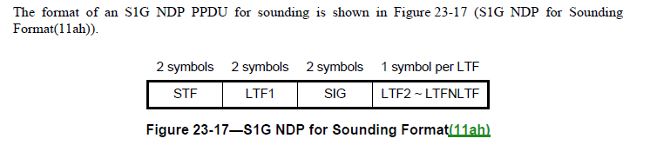

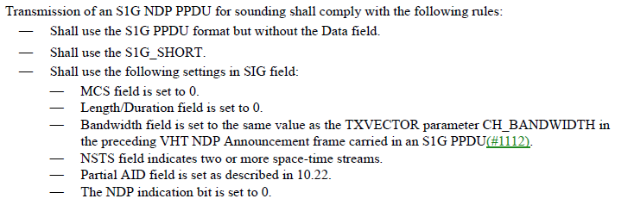

To TGm Editor: P3338L27 replace the current text with the proposed changes below.
------------- Begin Text Changes ---------------

Table 23-11—Fields in the SIG field of short preamble
Symbol | Bit | Field | Description
SIG-2 | B13 | NDP  Indication | Indicate that frame is an S1G NDP CMAC frame:  Set to 1 for an S1G NDP CMAC frame (see Figure 23-21 (SIG field format for ≥ 2 MHz NDP CMAC frame(11ah))). Ignore the SIG field and follow the description in 9.9 (NDP CMAC frames(11ah)) and set to 0 otherwise.  Used to indicate that frame is an NDP CMAC frame. If set to 1, then the SIG field format is shown in Figure 23-21 (SIG field format for ≥ 2 MHz NDP CMAC frame(11ah)) (in 23.3.11) and the SIG field contents follow the description in 9.9 (NDP CMAC frames(11ah)). (#2312 and #2313)

------------- End Text Changes -----------------------

To TGm Editor: P3358L38 replace the current text with the proposed changes below.
------------- Begin Text Changes ---------------

Table 23-18—Fields in the SIG field of S1G_1M PPDU
Symbol | Bit | Field | Description
SIG-5 | B25 | NDP  Indication | Indicate that frame is an S1G NDP CMAC frame:  Set to 1 for an S1G NDP CMAC frame (see Figure 23-20 (SIG field format for 1 MHz NDP CMAC frame (11ah))). Ignore the SIG field and follow the description in 9.9 (NDP CMAC frames(11ah)) and set to 0 otherwise.  Used to indicate that frame is an NDP CMAC frame(#1143). If set to 1, then the SIG field format is shown in Figure 23-20 (SIG field format for 1 MHz NDP CMAC frame(11ah)) (in 23.3.11) and the SIG field contents follow the description in 9.9 (NDP CMAC frames(11ah)). (#2312 and #2313)

------------- End Text Changes -----------------------

CID | P.L | Comment | Proposed Change | Resolution
2311 | 3356.08 | "The SIG field format of NDP CMAC frames is described in Figure 23-20 (SIG field format for 1 MHz  NDP CMAC frame(11ah)) (in 23.3.11)" | Append "and Figure 23-21" | Revised.  Put the appended text before the parenthesis.  TGm Editor: make changes according to this document 11-19-0261-03-00m Resolutions to S1G PHY

To TGm Editor: P3357L01 replace the current text with the proposed changes below.
------------- Begin Text Changes ---------------

23.3.8.3.4 SIG definition

The SIG field carries information required to interpret S1G_1M PPDUs. The structure of the 6 symbol SIG field (which carries 6 information bits per symbol) is shown in Figure 23-16 (Structure of the 6 symbol SIG field of S1G_1M PPDU(11ah)). Note that unlike other SIG field structures the indexing of the bits incorporates all the SIG field symbols, i.e., B0–B5 denote the first symbol, B6–B11 the second, and so on. The SIG field format of NDP CMAC frames is described in Figure 23-20 (SIG field format for 1 MHz NDP CMAC frame(11ah)) and Figure 23-21 (SIG field format for ≥ 2 MHz NDP CMAC frame(11ah)) (in 23.3.11).

------------- End Text Changes -----------------------

CID | P.L | Comment | Proposed Change | Resolution
2261 | 3402.62 | What is the "8." in equations 23-65 and 23-67? | Delete "8." in equations 23-65 and 23-67. | Revised.  In order to convert byte (unit in LENGTH field) to bit to get N_{SYM}, 8 is a required element in both Equation (23-65) and Equation (23-67)  TGm Editor: make changes according to this document 11-19-0261-03-00m Resolutions to S1G PHY

Discussion
In order to convert byte (unit in LENGTH field) to bit to get N_{SYM}, 8 is a required element in both Equation (23-65) and Equation (23-67) with minor modification of multiplication symbol “$∙$”

To TGm Editor: P3403L62 replace the current text with the proposed changes below.
------------- Begin Text Changes ---------------

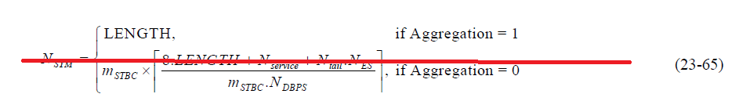
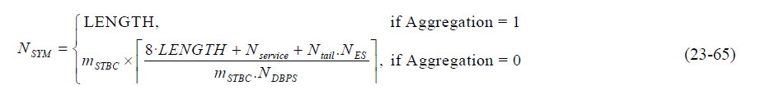

------------- End Text Changes -----------------------

To TGm Editor: P3404L27 replace the current text with the proposed changes below.
------------- Begin Text Changes ---------------

------------- End Text Changes -----------------------

CID | P.L | Comment | Proposed Change | Resolution
2270 | 3406.55 | In Table 23-36, dot11S1GTravelingPilotOptionActivated should indicate it is Dynamic. | Change "Static" to "Dynamic" for dot11S1GTravelingPilotOptionActivated row | Accepted.

Discussion

At 3408.52, there is a definition of S1G PHY MIB attributes as below
.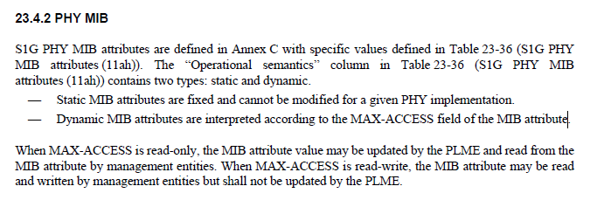

Dynamic MIB can be changed during the lifetime of a BSS. Generally, if written by PHY, MAC-ACCESS is read-only, and if written by management entity, MAC-ACCESS is read-write.

At 4211.64, there is a description on dot11S1GTravelingPilotOptionActivated as belw

dot11S1GTravelingPilotOptionActivated OBJECT-TYPE
SYNTAX TruthValue
MAX-ACCESS (#1246)read-write
STATUS current
DESCRIPTION
"This is a control variable.
It is written by an external management entity.
Changes take effect as soon as practical in the implementation.
This attribute, when true, indicates that the traveling pilot option is
enabled."
DEFVAL { false }
::= { dot11PhyS1GEntry 27 }

To TGm Editor: P3407L56 replace the current text with the proposed changes below.
------------- Begin Text Changes ---------------

Table 23-36—S1G PHY MIB attributes (continued)
Managed object | Default value/range | Operational semantics
… | … | …
dot11S1GMaxNTxChainsActivated | Implementation  dependent | Dynamic
d ot11S1GTravelingPilotOptionImplemented | Implementation  dependent | Static
dot11S1GTravelingPilotOptionActivated | Implementation  dependent | Static  Dynamic

------------- End Text Changes -----------------------

CID | P.L | Comment | Proposed Change | Resolution
2323 | 4086.43 | "dot11S1GControlFieldOptionImplemented [...]  This attribute, when true, indicates that the STA implementation is  capable of receiving the VHT variant HT Control field." -- this is rather counter-intuitive | After the cited text add "See 10.8." At the end of 10.8 add a para "An S1G shall not use an HT Control field other than a VHT variant HT Control field. An S1G STA shall not use a VHT variant HT Control field for any purpose other than link adaptation (see 10.33.3)." | Accepted.  TGm Editor: make changes according to this document 11-19-0261-03-00m Resolutions to S1G PHY

To TGm Editor: P4089L43 replace the current text with the proposed changes below.
------------- Begin Text Changes ---------------

dot11S1GControlFieldOptionImplemented OBJECT-TYPE
SYNTAX TruthValue
MAX-ACCESS read-only
STATUS current
DESCRIPTION
"This is a capability variable.
Its value is determined by device capabilities.
This attribute, when true, indicates that the STA implementation is
capable of receiving the VHT variant HT Control field." See 10.8.(Ed)
::= { dot11S1GStationConfigEntry 3 }

------------- End Text Changes -----------------------

To TGm Editor: P1772L06 replace the current text with the proposed changes below.
------------- Begin Text Changes ---------------

(11ah)If the value of dot11S1GControlFieldOptionImplemented is true, an S1G STA shall set the +HTC-VHT
Capable subfield of the S1G Capabilities Information field of the S1G Capabilities element that it transmits to 1.

An S1G shall not use an HT Control field other than a VHT variant HT Control field. An S1G STA shall not use a VHT variant HT Control field for any purpose other than link adaptation (see 10.33.3).

------------- End Text Changes -----------------------

