IEEE P802.11
Wireless LANs
TGbb:
Evaluation methodology for PHY and MAC proposals
Date: 2019-05-13
Author(s):
Name | Affiliation | Address | Phone | Email
Kai Lennert Bober | Fraunhofer HHI |  |  | kai.lennert.bober@hhi.fraunhofer.de
Volker Jungnickel |  |  |  | volker.jungnickel@hhi.fraunhofer.de
Malte Hinrichs |  |  |  | malte.hinrichs@hhi.fraunhofer.de
Nikola Serafimofski | pureLiFi |  |  | nikola.serafimovski@purelifi.com
Abstract
This document defines methodologies for the evaluation of PHY and MAC proposals in the TGbb.

- Introduction and overview
- PHY proposal evaluation methodology

Scenarios

Proposals for PHY contributions shall be evaluated against simulation scenarios described in TGbb doc. 11-18/1423r8 which is based on the TGbb usage model doc. 11-18/1109r5 after selecting the primary usage models. Simulations shall implement the TGbb channel modeling described in doc. 11-18/1582r4. TGbb has made available a number of channel impulse responses that can be downloaded from Mentor in doc. 11-18/1603r1.

Choice of process:

- Simulation scenarios
  - AWGN
  - Industrial Wireless
  - Enterprise
- Parameters to be used
  - Copy corresponding PHY parameters from doc. 11-18/1423r8 for the relevant simulation environments.
- Analytical front-end model
  - Filter the following channel impulse responses with the digital filters describing the analogue front-end model defined in doc.11-19/0087r1:
    - Industrial Wireless Figure 28(g), CIR D7 (all LEDs transmit simultaneously)
      - Go to doc. 11-18-1603r1 \ simulation scenario industrial wireless \ overall cirs \ Optical CIRs \ D7
    - Enterprise Figure 15(a), CIRs D1 and D2
      - Go to doc. 11-18-1603r1 \ simulation scenario enterprise-conference room \ individual cirs \ optical cirs \
        - S1 \ D1
        - S1 \ D2
        - S3 \ D1
        - S3 \ D2

Simulator calibration:

The following basic PHY shall be simulated in addition to the above requirements for AWGN channel and presented with the results together with a new proposal.

DCO-OFDM using 802.11a frame format. Full buffer with following selected parameters.
Baseband bandwidth $B=20 MHz$
FFT size 64 subcarriers, 52 subcarriers occupied
Convolutional Code from 802.11a
Code Rate ½
MCS: QPSK
The block diagram in the following Figure shows the full system model between the baseline PHY TX and PHY RX.
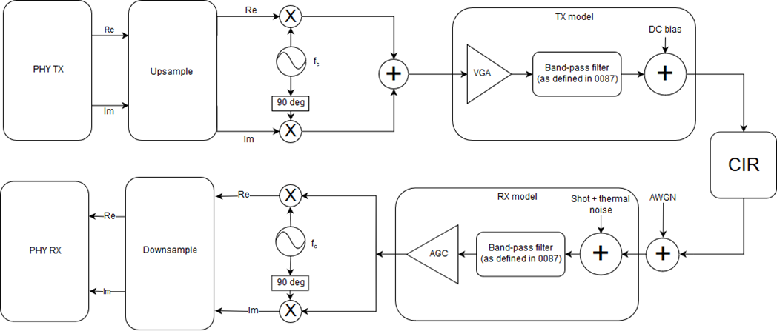
Up/Downsampling:
The baseband signal shall be upsampled to a sample rate of 1 GS/s to simulate the analogue blocks of the system. After upsampling, an ideal anti-alias filter shall be applied.
Before processing in PHY RX, the signal is downsampled to baseband samplerate again. Before this step, a fourth-order low-pass filter shall be applied to model analogue anti-aliasing. The line below can be used to generate such a filter in Matlab for a baseband bandwidth of B = 20 MHz:
[b, a] = butter(4, 0.01);
Up/Downconversion:
The baseband signal shall be upconverted by:
$$f_{c}=\frac{B}{2}+f_{offset}$$
For the basic PHY described above, set $f_{offset}=1.5 MHz$.
To verify the simulation model, the SNR should be measured at the PHY RX with 0 noise added in the AWGN block and the CIR block removed from the system. Shot and thermal noise should be added as defined by the noise floor in doc. IEEE 802.11-18/1423r8.

Metrics

The aim of the evaluation is first to demonstrate that the PHY is consistently defined and parametrized. Therefore, proposers shall evaluate the preamble detection performance, the error rate of the header and the error rate of the payload.

1) Preamble

For the preamble, the probability of accurate detection (for false alarm rate = 0.1%) vs. SNR (cf. doc. 15-18-0106/r0) and the required SNR where the probability of misdetection (timing error) is <0.1%, measured over at least 100,000 packets of size 100B.

2) Header

For the header, proposers are required to present the PER vs. SNR, where SNR is measured after the Rx frontend in Figure 1 of 11-19/0087r1, and PER vs. E_{b}/N₀, where E_{b} is the average energy per bit for uncoded data going into the FEC (for the relation to SNR see doc. 15-18/0339r0 slide 28) including all associated channel and line coding (if applicable) assuming random data for the header information, measured over at least 10,000 packets of size 100B. A packet error occurs if there is at least one bit error in the decoded header.

3) Payload

For the payload, proposers are required to present the PER vs. SNR, where SNR is measured after the Rx frontend in Figure 1 of 11-19/0087r1, and PER vs. E_{b}/N₀, where E_{b} is the average energy per bit for uncoded data going into the FEC (for the relation to SNR see doc. 15-18/0339r0 slide 28) incl. any channel coding (if applicable) assuming random data for the payload, measured over 1,000 packets. Proposers shall use their lowest and highest modulation and coding scheme (MCS) that is intended to be supported. Providing results for intermediate MCS is considered optional. A packet error occurs if there is at least one bit error in the decoded payload.

4) Throughput at PHY SAP should be specified by the proposers.

If there are any questions, please use the TGbb email reflector.
- MAC proposal evaluation methodology
  - Scenarios
  - Parameters
  - Metrics

- References
Please, refer also to previous evaluation results on Mentor from 802.15 TG13

https://mentor.ieee.org/802.15/documents?is_dcn=malte%20&is_group=0013&is_options=5
https://mentor.ieee.org/802.15/documents?is_dcn=sang-kyu&is_group=0013&is_options=5

