IEEE P802.11
Wireless LANs
TBD resolution for secure non-TB and TB ranging
Date: 2019-1-15
Author(s):
Name | Company | Address | Phone | Email
Girish Madpuwar | Broadcom | Electronic City, Bangalore India |  | Girish.madpuwar@broadcom.com
Abstract

This submission proposes resolutions of TBD on draft 0.6.
- CIDs: none

CID | Clause Number | Page | Comment | Proposed Change | Resolution
none | 11.22.6.4.6 | 86  Draft 0.6 | Resolve TBD in this section | As in comment | accpeted

11.22.6.4.6 Secure Non-TB and -TB Ranging Measurement Exchange Protocol
11.22.6.4.6.1 Secure Non-TB ranging mode

An ISTA that sends a Ranging NDP Announcement frame to a RSTA shall set:
— The SAC subfield in the STA Info SAC field in the Ranging NDP Announcement frame to the same value as in the LTF Generation SAC field in the Secure LTF Parameters field in the last received Fine Timing Measurement frame or last received Location Measurement Report frame from the RSTA, if the ISTA has not sent any Ranging NDP Announcement frame after the last received Fine Timing Measurement frame or last received Location Measurement Report frame from the RSTA;
— Otherwise the SAC subfield in the STA Info SAC field in the Ranging NDP Announcement frame to 0x0000 value to indicate that a new LTF Sequence Generation information is needed.

An ISTA that sends an HE Ranging NDP PPDU a SIFS after transmission of the Ranging NDP Announcement frame to a RSTA shall set the TXVECTOR parameter LTF_SEQUENCE as follows:
— HE_LTF , if the SAC subfield in the STA Info SAC field in the Ranging NDP Announcement is set to 0x0000 value;
— Otherwise the LTF sequence generation information corresponding to the Secure LTF Parameters field in the last received Fine Timing Measurement frame or last received Location Measurement Report frame from the RSTA.

After transmission of the HE Ranging NDP frame to the RSTA, the ISTA’s MAC sublayer shall issue a PHY-RXLTFSEQUENCE.request primitive with a LTFVECTOR parameter that as follows:
-- HE_LTF, if the SAC subfield in the STA Info SAC field in previously transmitted Ranging NDP Announcement is set to 0x0000 value;
-- Otherwise the LTF sequence generation information corresponding to the Secure LTF Parameters field in the last received Fine Timing Measurement frame or last received Location Measurement Report frame from the RSTA.

When a RSTA receives a Ranging NDP Announcement from an ISTA frame in which the SAC subfield in the STA Info SAC field is set to 0x0000 value, the RSTA shall:
- Issue a PHY-RXLTFSEQUENCE.request primitive with a LTFVECTOR parameter that is set toHE_LTF;
- Send an HE Ranging NDP PPDU with the TXVECTOR parameter LTF_SEQUENCE set to HE_LTF to the ISTA, if the RSTA receives an HE Ranging NDP PPDU from the ISTA a SIFS after the ranging NDP Announcement frame;
- Send a Location Measurement Report frame that includes the Secure LTF Parameters field to the ISTA, if the RSTA receives an HE Ranging NDP PPDU from the ISTA a SIFS after the ranging NDP Announcement frame.

When a RSTA receives a Ranging NDP Announcement frame from an ISTA in which the value of the SAC subfield in the STA Info SAC field is equal to the value of the LTF Generation SAC subfield in the Secure LTF Parameters field in the last transmitted Fine Timing Measurement frame or last transmitted Location Measurement Report frame to the ISTA, the RSTA shall:
- Issue a PHY-RXLTFSEQUENCE.request primitive with a LTFVECTOR parameter that is set to the LTF sequence generation information in the Secure LTF Parameters field in the last transmitted Fine Timing Measurement frame or last transmitted Location Measurement Report frame to the ISTA;
- Send an HE Ranging NDP PPDU with the TXVECTOR parameter LTF_SEQUENCE set to the LTF sequence generation information in the Secure LTF Parameters field in the last transmitted Fine Timing Measurement frame or last transmitted Location Measurement Report frame to the ISTA, if the RSTA receives an HE Ranging NDP PPDU from the ISTA a SIFS after the ranging NDP Announcement frame;
- Send a Location Measurement Report frame that includes the Secure LTF Parameters field to the ISTA, if the RSTA receives an HE Ranging NDP PPDU from the ISTA a SIFS after the ranging NDP Announcement frame.

When a RSTA receives a Ranging NDP Announcement frame from an ISTA in which a value of the SAC subfield in the STA Info SAC field is either not equal to 0x0000 or the value of the LTF Generation SAC subfield in the Secure LTF Parameters field in the last transmitted Fine Timing Measurement frame or last transmitted Location Measurement Report frame to the ISTA, the RSTA shall:
- Not issue a PHY-RXLTFSEQUENCE.request primitive;
- Not send an HE Ranging NDP PPDU to the ISTA;
Not send a Location Measurement Report frame to the ISTA.

When a Location Measurement Report frame contains range measurement results measured from an UL NDP and a DL NDP, an RSTA shall include the Secure LTF Parameters field in the Location Measurement Report frame and set the Range Measurement SAC subfield in the Secure LTF Parameters field in the Location Measurement Report frame to the same value as in the SAC subfield in the STA Info SAC field in the Ranging NDP Announcement frame that solicited the UL NDP and the DL NDP.

When a STA sending an HE Ranging NDP PPDU sets the TXVECTOR parameter LTF_SEQUENCE to HE_LTF, the STA shall not use the ToD value of HE Ranging NDP PPDU for the secure range measurement.

When a STA receiving an HE Ranging NDP PPDU sets the LTFVECTOR parameter in the PHY-RXLTFSEQUENCE.request primitive to HE_LTF, the STA shall not use the ToA value of the HE Ranging NDP PPDU and set the Invalid Measurement Indication subfield to 1 in the ToA Error field in the Location Measurement Report carrying the ToA value of the HE Ranging NDP PPDU.

The LTF Generation SAC and its associated LTF Sequence Generation Information parameters carried in an initial Fine Timing Measurement frame, a Location Measurement Report frame, and a Ranging NDP Announcement frame are illustrated in Figure 11-xx (Normal secure measurement exchange in Non-TB mode).

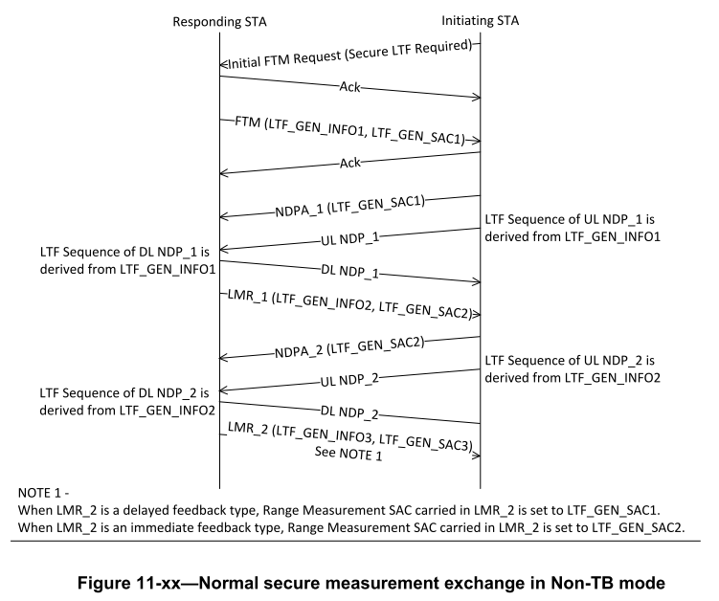

When there is a transmission failure within a secure measurement exchange sequence, the recovery procedure of the LTF Generation SAC and its associated LTF Sequence Generation Information parameters is illustrated in Figure 11-yy (Error recovery of secure measurement exchange in Non-TB mode).

Figure 11-yy—Error recovery of secure measurement exchange in non-TB mode

11.22.6.4.6.2 TB mode
An RSTA sends a Location variant TB Uplink Sounding Trigger frame where the LTF Generation SAC subfield in the Trigger Dependent User Info field in the Location variant TB Uplink Sounding Trigger frame is set to the same value as in the LTF Generation SAC field in the Secure LTF Parameters field in the most recently transmitted an initial Fine Timing Measurement frame or a Location Measurement Report frame, except when a current LTF Generation SAC and its associated LTF Sequence Generation Information stored as the RSTA have been discarded. In which case, an RSTA that sends a Location variant TB Uplink Sounding Trigger frame shall set the LTF Generation SAC subfield in the Trigger Dependent User Info field in the Location variant TB Uplink Sounding Trigger frame to 0x0000 value to indicate that a new LTF Sequence Generation information is needed.

If the RSTA successfully receives an UL NPD a SIFS after the Location variant TB Uplink Sounding Trigger frame, the RSTA shall respond with a Ranging NDP Announcement frame followed after a SIFS by a DL NDP and followed after a SIFS by a Location Measurement Report frame, where the Location Measurement Report frame shall contain a Secure LTF Parameters field with a new LTF Generation SAC and a new LTF Sequence Generation Information associated with the LTF Generation SAC. Otherwise, the RSTA shall follow the rules in 10.22.2.2 (EDCA backoff procedure) as the frame exchange is not successful, and it shall discard a current LTF Generation SAC and its associated LTF Sequence Generation Information stored at the RSTA.

The RSTA determines the LTF sequence of the UL NDP and the LTF sequence of the DL NDP with the LTF Sequence Generation Information in the Secure LTF Parameters field in the most recently transmitted an initial Fine Timing Measurement frame or a Location Measurement Report frame that is associated with the LTF Generation SAC subfield in the Trigger Dependent User Info field in the transmitted Location variant TB Uplink Sounding Trigger frame, except when the LTF Generation SAC subfield in the Trigger Dependent User Info field in the transmitted Location variant TB Uplink Sounding Trigger frame is equal to the 0x0000 value to indicate that a new LTF Sequence Generation information is needed. In which case, the LTF sequence of the UL NDP and the LTF sequence of the DL NDP are determined to theHE_LTF sequence.

NOTE1 – HE_LTF sequence is not suitable for a secure range measurement.

When an ISTA receives a Location variant TB Uplink Sounding Trigger frame and a value of the LTF Generation SAC subfield in the Trigger Dependent User Info field in the Location variant TB Uplink Sounding Trigger frame is equal to a value of the LTF Generation SAC subfield in the Secure LTF Parameters field stored at the ISTA, the ISTA determines the LTF sequence of an UL NDP transmitted a SIFS after the Location variant TB Uplink Sounding Trigger frame and LTF sequence of a DL NDP received a SIFS after a Ranging NDP Announcement frame with the LTF Sequence Generation Information associated with the value of the LTF Generation SAC subfield in the Trigger Dependent User Info field in the Location variant TB Uplink Sounding Trigger frame. The ISTA discards a current LTF Generation SAC and its associated LTF Sequence Generation Information stored at the ISTA.

When an ISTA receives a Location variant TB Uplink Sounding Trigger frame and a value of the LTF Generation SAC subfield in the Trigger Dependent User Info field in the Location variant TB Uplink Sounding Trigger frame is equal to 0x0000, the ISTA determines the LTF sequence of an UL NDP transmitted a SIFS after the Location variant TB Uplink Sounding Trigger frame and LTF sequence of a DL NDP received a SIFS after a Ranging NDP Announcement frame to HE_LTF sequence. .

When an ISTA receives a Location variant TB Uplink Sounding Trigger frame and a value of the LTF Generation SAC subfield in the Trigger Dependent User Info field in the Location variant TB Uplink Sounding Trigger frame is not equal to 0x0000 or a value of the LTF Generation SAC subfield in the Secure LTF Parameters field stored at the ISTA, the ISTA can not determines the LTF sequence of an UL NDP transmitted a SIFS after the Location variant TB Uplink Sounding Trigger frame and LTF sequence of a DL NDP received a SIFS after a Ranging NDP Announcement frame and discards a current LTF Generation SAC and its associated LTF Sequence Generation Information stored at the ISTA.

When a Location Measurement Report frame contains range measurement results calculated from an UL NDP and a DL NDP that have a secure LTF sequence suitable for a range measurement, a STA that transmits the Location Measurement Report frame shall include the Secure LTF Parameters field in the Location Measurement Report frame and set a value of the Range Measurement SAC subfield in the Secure LTF Parameters field in the Location Measurement Report frame to the same value as in the LTF Generation SAC field in the Trigger Dependent User Info field in the Location variant TB Uplink Sounding Trigger frame that solicited the UL NDP and the DL NDP.

The LTF Generation SAC and its associated LTF Sequence Generation Information parameters carried in an initial Fine Timing Measurement frame, a Location Measurement Report frame, and a Location variant TB Uplink Sounding Trigger frame are illustrated in Figure 11-xx (Normal secure measurement exchange in TB mode).
- Figure 11-xx— Normal secure measurement exchange in TB mode

When there is a transmission failure within a secure measurement exchange sequence, the recovery procedure of the LTF Generation SAC and its associated LTF Sequence Generation Information parameters is illustrated in Figure 11-yy (Error recovery of secure measurement exchange in TB mode).

- Figure 11-yy— Error recovery of secure measurement exchange in TB mode

