IEEE P802.11
Wireless LANs
IEEE 802.11 TGbc Selection Procedure
Date: 2019-01-15
Author(s):
Name | Affiliation | Address | Phone | email
Marc Emmelmann | Koden-TI | Berlin, Germany |  | emmelmann@ieee.org
Abstract
This document contains the selection procedure that will be followed by the IEEE 802.11bc Task Group. Once adopted, this document will be executed and followed by the IEEE 802.11bc Task Group to allow the body to adopt Draft 1.0 of IEEE 802.11bc. After adoption of Draft 1.0, the typical IEEE 802.11 Working Group balloting process will begin.

Text in Rev. 0 is based on the text describing the TGax selection procedure [2] and on the discussion of TGbc on the selection procedure to adopt for TGbc [1].

Unless specified otherwise, the votes referenced in this selection procedure require a 75% TG approval (i.e. affirmative votes from 75% of the 802.11 voting members present during the voting that vote either YES or NO).

- The TG adopts the selection procedure and may change the selection procedure with a 50% approval vote.
- The TG shall adopt, through a 75% approval vote, a Functional Requirements document that must be met by the proposed specification.
  - The Functional Requirements document may be modified at any time by a 75% approval vote
- The TG shall create a Specification Framework document that outlines the main functional blocks of the proposed specification.
  - The Specification Framework document shall be created by incorporating individual functional blocks that have been approved by a 75% approval vote.
  - Submissions proposing individual functional blocks for adoption into the Specification Framework document should identify the functional requirements listed in the Functional Requirement document, which they address.
  - The Specification Framework document may be modified at any time by a 75% approval vote

- The TG editor is responsible for maintaining the 802.11bc Draft Spec document (this is the text of the Draft 1.0 Amendment).
  - The TG editor solicits spec text contributions that implement all the functional blocks in the Specification Framework document or subsets thereof
  - Collaboration on these contributions is encouraged
  - The 802.11bc Draft Spec document shall be created by incorporating individual spec text contributions that have been approved by a 75% approval vote
  - In case of multiple contributions addressing the same spec framework elements, taskgroup straw-polling and Motions will guide the editor regarding which Spec Text Contribution to use
  - The 802.11bc Draft Spec document may be modified at any time by a 75% approval vote

- The selection procedure terminates when a motion stating: ‘The 802.11bc Draft Spec document is complete, i.e. address all aspects of the Specification Framework document, and coherent enough for WG Letter Ballot” is approved by a 75% approval vote.
- The TG may decide to conduct an internal TG review and comment process, before the document is sent out to WG Letter Ballot.

The following flow chart illustrates the TGbc Selection Procedure.
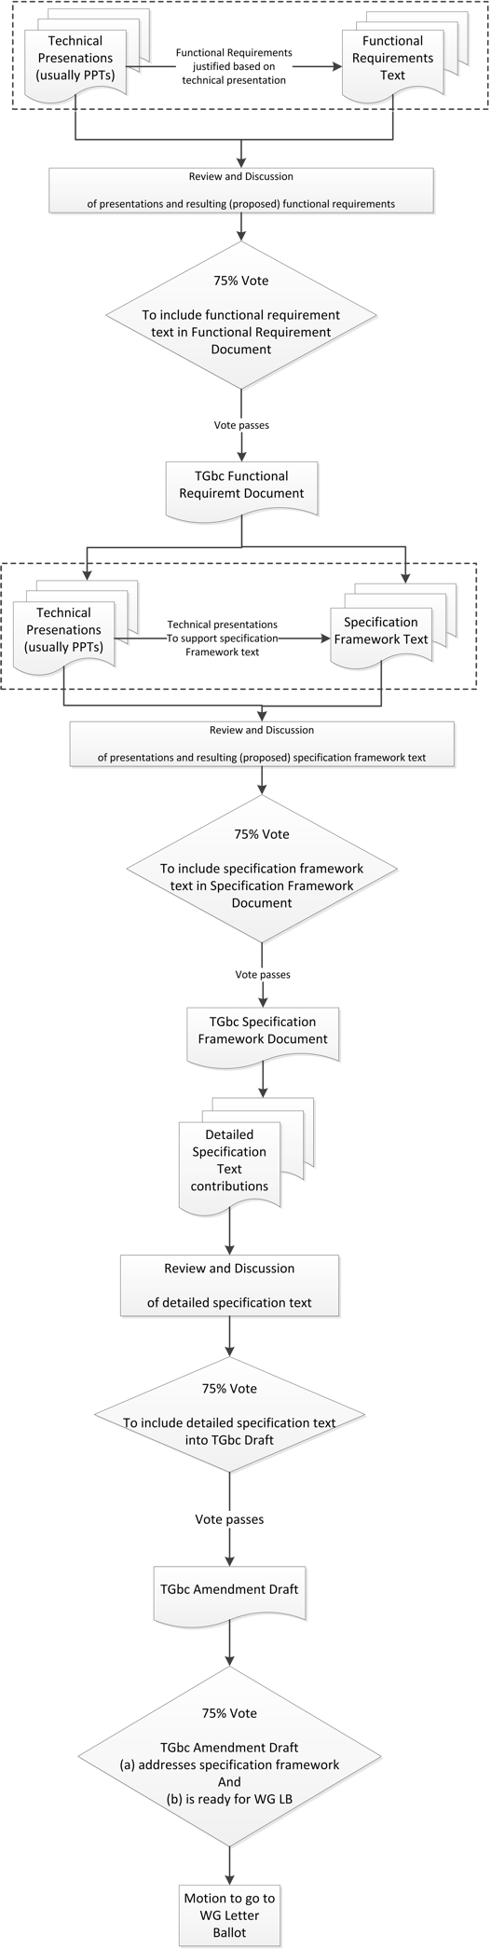
References:

[1] TGbc Selection Procedure discussion, 11-19/0090r0
[2] 802.11ax Selection Procedure, 11-14/0938r4.

