IEEE P802.11
Wireless LANs
Proposed Spec Text change on Trigger Frame MAC padding
Date: 2019-01-14
Author(s):
Name | Affiliation | Address | Phone | Email
Tianyu Wu | Samsung |  |  | Tianyu.wu@samusng.com
Xiaogang Chen | Intel

Abstract
This submission proposes spec text change related to Trigger frame MAC padding in D3.3 27.5.3.2.3.

Revisions:
- Rev 0: Initial version of the document.

Interpretation of a Motion to Adopt

A motion to approve this submission means that the editing instructions and any changed or added material are actioned in the TGax Draft. This introduction is not part of the adopted material.

Editing instructions formatted like this are intended to be copied into the TGax Draft (i.e. they are instructions to the 802.11 editor on how to merge the text with the baseline documents).

TGax Editor: Editing instructions preceded by “TGax Editor” are instructions to the TGax editor to modify existing material in the TGax draft. As a result of adopting the changes, the TGax editor will execute the instructions rather than copy them to the TGax Draft.

Discussions:

Background:
When LDPC encoded, the Trigger frame MAC padding bits in the OFDM symbol containing the last coded bit of LDPC codeword that encodes the last bit of SCH will NOT contribute to the MAC processing time as illustrated in the following figure: 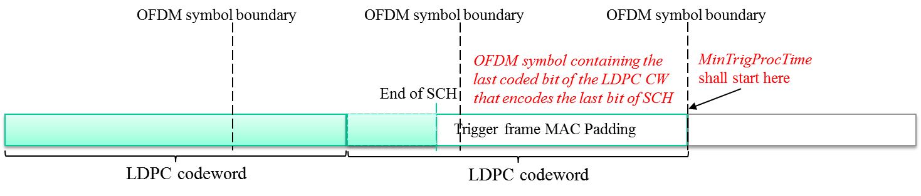
When LDPC encoded, the Trigger frame MAC padding itself may not be sufficient for MinTrigProcTime requested by STA.

Current spec text reads:
In 11ax D3.3 pp318 ln 30, it reads “ An AP may use any type of padding to satisfy the MinTrigProcTime requirement of a non-AP STA(#16592)(#16122), such as using the Padding field in a Trigger frame, post-EOF A-MPDU padding, or aggregating other MPDUs in the A-MPDU. ”

However, the meaning of “satisfy the MinTrigProcTime” is not very clear for Trigger frames carried in LDPC encoded PPDU. It’s not mentioned whether the Trigger frame MAC padding part as shown in the figure above will be counted to satisfy MinTrigProcTime or not.

Proposal:
We propose to further clarify it by adding either of the following 2 options after the above quoted spec text:

Option 1: If Trigger frame is carried in a PPDU with LDPC encoding, the transmitting AP shall ensure that the duration of the Data field of the PPDU that is after the OFDM symbol containing the last coded bit of the LDPC codeword that encodes the last bit of SCH, is greater than or equal to the MinTrigProcTime.

Option 2: If Trigger frame is carried in a PPDU with LDPC encoding, the transmitting AP shall ensure that the duration of PPDU that is after the OFDM symbol containing the last coded bit of the LDPC codeword that encodes the last bit of SCH, is greater than or equal to the MinTrigProcTime + T_{PE,nominal}.

The difference of Opt1 and Opt 2 is whether extra PE time can be used to satisfy the MinTrigProcTime.

Option1:
TGax Editor: Please change 11ax D3.3 P318Ln30 as shown below.

An AP may use any type of padding to satisfy the MinTrigProcTime requirement of a non-AP STA(#16592)(#16122), such as using the Padding field in a Trigger frame, post-EOF A-MPDU padding, or aggregating other MPDUs in the A-MPDU.

If a Trigger frame or frame containing a TRS Control subfield is carried in a PPDU with LDPC encoding, the transmitting AP
- Shall ensure that T_{TrigProc} is greater than or equal to the MinTrigProcTime specified by the non-AP STAs that are the recipients of the Trigger frame.
- Shall ensure that, for Trigger frame that contains at least one User Info field with AID12 subfield set to 0, T_{TrigProc} is greater than or equal to the largest MinTrigProcTime of all associated non-AP STAs.
- Should ensure that, for Trigger frame that contains at least one User Info field with AID12 subfield set to 2045, T_{TrigProc} is at least 16μs.
- Shall ensure that, for NFRP Trigger frame, T_{TrigProc} is at least 16μs.
Where T_{TrigProc} is defined as the duration of the Data field of the PPDU that is after the OFDM symbol containing the last coded bit of the LDPC codeword that encodes the last bit of SCH.

Option2:
TGax Editor: Please change 11ax D3.3 P318Ln30 as shown below.

An AP may use any type of padding to satisfy the MinTrigProcTime requirement of a non-AP STA(#16592)(#16122), such as using the Padding field in a Trigger frame, post-EOF A-MPDU padding, or aggregating other MPDUs in the A-MPDU.

If a Trigger frame or frame containing a TRS Control subfield is carried in a PPDU with LDPC encoding, the transmitting AP
- Shall ensure that T_{TrigProc} is greater than or equal to the MinTrigProcTime specified by the non-AP STAs that are the recipients of the Trigger frame.
- Shall ensure that, for Trigger frame that contains at least one User Info field with AID12 subfield set to 0, T_{TrigProc} is greater than or equal to the largest MinTrigProcTime of all associated non-AP STAs.
- Should ensure that, for Trigger frame that contains at least one User Info field with AID12 subfield set to 2045, T_{TrigProc} is at least 16μs.
- Shall ensure that, for NFRP Trigger frame, T_{TrigProc} is at least 16μs.
Where T_{TrigProc} is defined as the duration of PPDU that is after the OFDM symbol containing the last coded bit of the LDPC codeword that encodes the last bit of SCH minus T_{PE,nominal}.

