IEEE P802.11
Wireless LANs
11ax D3.0 MAC Comment Resolution for Capability of MU Transmission and Reception
Date: 2018-12-03
Author(s):
Name | Affiliation | Address | Phone | email
Po-Kai Huang | Intel Corporation | 2200 Mission College Blvd, Santa Clara, CA 950542200 |  | po-kai.huang@intel.com
Danny Ben-ari
Arik Klein
Daniel Bravo
Stacey Robert
Abstract
This submission proposes resolutions for comments of TGax Draft D3.3 with the following CIDs:

16487

Revisions:

- Rev 0: Initial version of the document.
- Rev 1: Incorporate offline suggestion by Youhan and Jarkko. Align the section number with 3.3. Changes are marked with green.

Interpretation of a Motion to Adopt

A motion to approve this submission means that the editing instructions and any changed or added material are actioned in the TGax D3.3 Draft. This introduction is not part of the adopted material.

Editing instructions formatted like this are intended to be copied into the TGax D3.3 Draft (i.e. they are instructions to the 802.11 editor on how to merge the text with the baseline documents).

TGax Editor: Editing instructions preceded by “TGax Editor” are instructions to the TGax editor to modify existing material in the TGax draft. As a result of adopting the changes, the TGax editor will execute the instructions rather than copy them to the TGax Draft.

CID | Commenter | P.L | Clause | Comment | Proposed Change | Resolution
16487 | Naveen Kakani | 333.00 | 27.8.1 | Table 27-9 is missing HE and the Columns are referring to VHT. | Make the following change:  Edit Table 27-9:  1. Delete the last two columns as the intent is to signal the Nss for 160MHz and not the center frequency  2. Change the header of the column starting with "VHT NSS Support" to "NSS Support" | Revised –  Agree in principle with the commenter. We provide revision to clarify that 27-9 is for the HE STA using VHT PPDU. Further, we observe that there is ambiguity on the interprepation of transmitting bandwidth and receiving bandwidth for HE NSS calculation under MU operation.  We fix the ambiguities in the proposed text.  TGax editor to make changes as shown in 11-18/2085r1 that are marked with CID 16487.

Discussion:

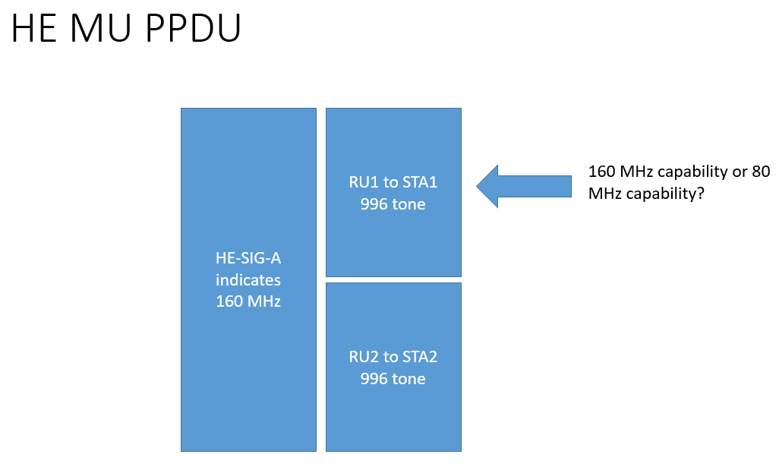

In HE capabilities element, a STA can indicate MCS and NSS capabilities for 80 MHz and 160 MHz separately in Supported HE-MCS And NSS Set field.

In DL HE MU PPDU, the bandwidth indicated in HE-SIG-A may be set to 160 MHz, and a non-AP STA maybe only allocated with 996 tone RU in this case. If the non-AP STA is 80 MHz operating STA or 20 MHz operating STA, then the RX MCS and NSS capability of the non-AP STA should be based on the 80 MHz capability rather than the bandwidth indicated in HE-SIG-A. We fix this obvious error.

Subfield | Definition | Encoding
Rx HE-MCS Map  ≤ 80 MHz | Indicates the maximum value of the  RXVECTOR parameter MCS of a PPDU  that can be received at all channel widths  less than or equal to 80 MHz supported  by this STA for each number of spatial  streams. | The format and encoding of this subfield are  defined in Figure 9-768d (Supported HE-MCS  And NSS Set field format) and the associated  description.  The Rx HE-MCS Map ≤ 80 MHz subfield is  always present in the Supported HE-MCS And  NSS Set field.

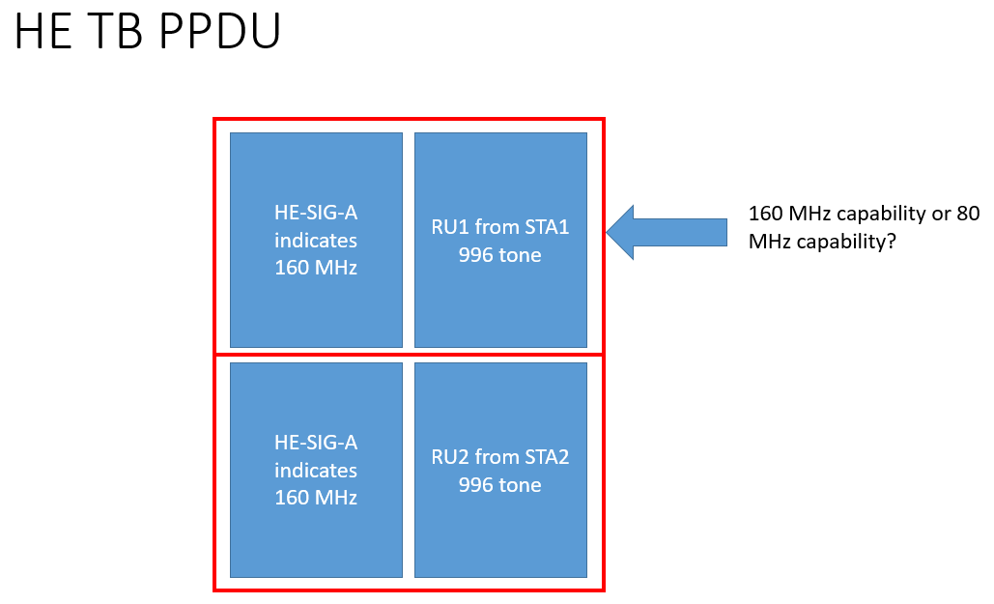

Similarly, for HE TB PPDU, the bandwidth indicated in HE-SIG-A maybe set to 160 MHz, and a non-AP STA maybe only allocated with 996 tone RU in this case. If the non-AP STA is 80 MHz operating STA or 20 MHz operating STA, then the TX MCS and NSS capability of the non-AP STA should be based on the 80 MHz capability rather than the bandwidth indicated in HE-SIG-A. We fix this obvious error.

HE-MCS Map  ≤ 80 MHz | Indicates the maximum value of the  TXVECTOR parameter MCS of a PPDU  that can be transmitted at all channel  widths less than or equal to 80 MHz sup  ported by this STA for each number of  spatial streams. | The format and encoding of this subfield are  defined in Figure 9-768d (Supported HE-MCS  And NSS Set field format) and the associated  description.  The Tx HE-MCS Map ≤ 80 MHz subfield is  always present in the Supported HE-MCS And  NSS Set field.

Propose:

TGax editor: Change 9.4.241.4 Supported HE-MCS And NSS Set field as follows: (Track change on)
        - Supported HE-MCS And NSS Set field
The Supported HE-MCS And NSS Set field indicates the combinations of HE-MCSs and spatial streams that a STA supports for reception and the combinations that it supports for transmission. The structure of the field is shown in Figure 9-768d (Supported HE-MCS And NSS Set field format).
 | Rx HE-MCS Map ≤ 80 MHz | Tx HE-MCS Map ≤ 80 MHz | Rx HE-MCS Map 160 MHz | Tx HE-MCS Map 160 MHz | Rx HE-MCS Map 80+80 MHz | Tx HE-MCS Map 80+80 MHz
Octets: | 2 | 2 | 0 or 2 | 0 or 2 | 0 or 2 | 0 or 2
- Supported HE-MCS And NSS Set field format

The subfields of the Supported HE-MCS And NSS Set field, and their presence, are defined in Table 9-322c (Subfields of the Supported HE-MCS And NSS Set field).
- Subfields of the Supported HE-MCS And NSS Set field
Subfield | Definition | Encoding
Rx HE-MCS Map ≤ 80 MHz | When the operating channel width of this STA is greater than 80 MHz, indicates the maximum value of the RXVECTOR parameter MCS of a PPDU that can be received by the STA when the bandwidth of the PPDU is less than or equal to 80 MHz for each number of spatial streams.  When the operating channel width of this STA is less than or equal to 80 MHz, indicates the maximum value of the RXVECTOR parameter MCS of a PPDU that can be received by the STA for each number of spatial streams.(#16487) | The format and encoding of this subfield are defined in Figure 9-768d (Supported HE-MCS And NSS Set field format) and the associated description.  The Rx HE-MCS Map ≤ 80 MHz subfield is always present in the Supported HE-MCS And NSS Set field.
Tx HE-MCS Map ≤ 80 MHz | When the operating channel width of this STA is greater than 80 MHz, indicates the maximum value of the TXVECTOR parameter MCS of a PPDU that can be transmitted by the STA when the bandwidth of the PPDU is less than or equal to 80 MHz for each number of spatial streams.  When the operating channel width of this STA is less than or equal to 80 MHz, indicates the maximum value of the TXVECTOR parameter MCS of a PPDU that can be transmitted by the STA for each number of spatial streams.(#16487) | The format and encoding of this subfield are defined in Figure 9-768d (Supported HE-MCS And NSS Set field format) and the associated description.  The Tx HE-MCS Map ≤ 80 MHz subfield is always present in the Supported HE-MCS And NSS Set field.
Rx HE-MCS Map 160 MHz | When the operating channel width of this STA is equal to 160 MHz, indicates the maximum value of the RXVECTOR parameter MCS of a PPDU that can be received by the STA when the bandwidth of the PPDU is 160 MHz for each number of spatial streams. | The format and encoding of this subfield are defined in Figure 9-768d (Supported HE-MCS And NSS Set field format) and the associated description.  The Rx HE-MCS Map 160 MHz subfield is present if B2 of the Channel Width Set subfield of the HE PHY Capabilities Information field is set to 1; otherwise, it is not present.
Tx HE-MCS Map 160 MHz | When the operating channel width of this STA is equal to 160 MHz, indicates the maximum value of the TXVECTOR parameter MCS of a PPDU that can be transmitted by the STA when the bandwidth of the PPDU is 160 MHz for each number of spatial streams. | The format and encoding of this subfield are defined in Figure 9-768d (Supported HE-MCS And NSS Set field format) and the associated description.  The Tx HE-MCS Map 160 MHz subfield is present if B2 of the Channel Width Set subfield of the HE PHY Capabilities Information field is set to 1; otherwise, it is not present.
Rx HE-MCS Map 80+80 MHz | When the operating channel width of this STA is equal to 80+80 MHz, indicates the maximum value of the RXVECTOR parameter MCS of a PPDU that can be received by the STA when the bandwidth of the PPDU is 80+80 MHz for each number of spatial streams. | The format and encoding of this subfield are defined in Figure 9-768d (Supported HE-MCS And NSS Set field format) and the associated description.  The Rx HE-MCS Map 80+80 MHz subfield is present if B3 of the Channel Width Set subfield of the HE PHY Capabilities Information field is set to 1; otherwise, it is not present.
Tx HE-MCS Map 80+80 MHz | When the operating channel width of this STA is equal to 80+80 MHz, indicates the maximum value of the TXVECTOR parameter MCS of a PPDU that can be transmitted by the STA when the bandwidth of the PPDU is 80+80 MHz for each number of spatial streams. | The format and encoding of this subfield are defined in Figure 9-768d (Supported HE-MCS And NSS Set field format) and the associated description.  The Tx HE-MCS Map 80+80 MHz subfield is present if B3 of the Channel Width Set subfield of the HE PHY Capabilities Information field is set to 1; otherwise, it is not present.
The Rx HE-MCS Map and Tx HE-MCS Map subfields(#16034) have the structure shown in Figure 9-768e (Rx HE-MCS Map and Tx HE-MCS Map subfields and Basic HE-MCS And NSS Set field).
 | B0 B1 | B2 B3 | B4 B5 | B6 B7 | B8 B9 | B10 B11 | B12 B13 | B14 B15
 | Max HE-MCS For 1 SS | Max HE-MCS For 2 SS | Max HE-MCS For 3 SS | Max HE-MCS For 4 SS | Max HE-MCS For 5 SS | Max HE-MCS For 6 SS | Max HE-MCS For 7 SS | Max HE-MCS For 8 SS
Bits: | 2 | 2 | 2 | 2 | 2 | 2 | 2 | 2
- Rx HE-MCS Map and Tx HE-MCS Map subfields and Basic HE-MCS And NSS Set field

The Max HE-MCS For n SS subfield (where n = 1, ..., 8) is encoded as follows:
- 0 indicates support for HE-MCS 0-7 for n spatial streams
- 1 indicates support for HE-MCS 0-9 for n spatial streams
- 2 indicates support for HE-MCS 0-11 for n spatial streams
- 3 indicates that n spatial streams is not supported for HE PPDUs
The maximum received HE NSS for a given MCS is equal to the smaller of:
- The maximum value of n for which the Max HE-MCS For n SS has a value that indicates support for that MCS (0, 1, or 2 for MCS 0-7, 1 or 2 for MCS 8-9, 2 for MCS 10-11)
- The maximum supported NSS as indicated by the value of the Rx NSS field of the Operating Mode Notification frame if the value of Rx NSS Type is 0 or of the OM Control subfield
NOTE—An HE-MCS indicated as supported in the Rx HE-MCS Map fields for a particular number of spatial streams might not be valid at all bandwidths (see 28.5 (Parameters for HE-MCSs)) and might be affected by 27.15.4.3 (Additional rate selection constraints for HE PPDUs).
The maximum transmit HE NSS for a given MCS is equal to the smaller of:
- The maximum value of n for which the Max HE-MCS For n SS has a value that indicates support for that MCS (0, 1, or 2 for MCS 0-7, 1 or 2 for MCS 8-9, 2 for MCS 10-11)
- The maximum supported NSTS as indicated by the value of the Tx NSTS field of the OM Control subfield sent by a non-AP STA
NOTE—An HE-MCS indicated as supported in the Tx HE-MCS Map fields for a particular number of space-time streams might not be valid at all bandwidths (see 28.5 (Parameters for HE-MCSs)) and might be affected by 27.15.4.3 (Additional rate selection constraints for HE PPDUs).

TGax editor: Change 9.2.4.6a.2 OM Control as follows: (Track change on)

- OM Control
If the Control ID subfield in a Control subfield of an A-Control subfield is 1, the Control Information subfield of the Control subfield contains information related to the operating mode (OM) change of the STA transmitting the frame containing this information (see 27.8 (Operating mode indication)). The format of the subfield is shown in Figure 9-21b (Control Information subfield for OM Control).
 | B0 B2 | B3 B4 | B5 | B6 B8 | B9 | B10 | B11
 | Rx NSS | Channel Width | UL MU Disable | Tx NSTS | ER SU Disable | DL MU-MIMO Resound  Recommendation | UL MU Data Disable
Bits: | 3 | 2 | 1 | 3 | 1 | 1 | 1
- Control Information subfield for OM Control

When the operating channel width of the STA is greater than 80 MHz, the Rx NSS subfield indicates the maximum number of spatial streams, N_{SS}, that the STA supports in reception for PPDU bandwidths less than or equal to 80 MHz and is set to N_{SS} – 1. (#16487)
When the operating channel width of the STA is less than or equal to 80 MHz, the Rx NSS subfield indicates the maximum number of spatial streams, N_{SS}, that the STA supports in reception and is set to N_{SS} – 1. (#16487)

When the operating channel width of the STA is greater than 80 MHz, the maximum number of spatial streams that the STA supports in reception(#16036) for PPDU bandwidths greater than 80 MHz is defined in 27.8 (Operating mode indication). (#16487)
The Channel Width subfield indicates the operating channel width supported by the STA for both reception and transmission. It is set to 0 for 20 MHz, 1 for primary 40 MHz, 2 for primary 80 MHz, and 3 for 160 MHz and 80+80 MHz. The value 0 indicates a primary 20 MHz, unless the STA is an SST STA in which case it indicates any of the negotiated 20 MHz subchannels of the SST operation (see 27.7.7 (HE subchannel selective transmission)).(#15864)

(…existing texts…)

TGax editor: Change 27.9 Operating mode indication as follows: (Track change on)
  - Operating mode indication
    - General
(…existing texts…)
The OMI initiator supports receiving PPDUs with a bandwidth up to the value indicated by the Channel Width subfield and with a number of spatial streams, Nss, as indicated in the Rx NSS subfield of the OM Control subfield and calculated in the Equation (27-3).
When the operating channel width of the STA is greater than 80 MHz, the maximum number of HE spatial streams that the HE STA supports in reception(#16036) for a given HE-MCS as a function of the received HE PPDU bandwidth BW at an HE STA transmitting an OM Control subfield is defined in Equation (27-3). (#16487)
- floor (Rx-NSS-from-OMI × (Max-HE-NSS-at-BW / Max-HE-NSS-at-80))
where
Rx-NSS-from-OMI is Rx NSS from the OM Control subfield transmitted by the STA
Max-HE-NSS-at-BW is the maximum HE NSS among all HE-MCS at BW MHz from the Supported HE-MCS and NSS Set field transmitted by the STA as described in 27.15.4 (Rate selection constraints for HE STAs)
Max-HE-NSS-at-80 is the maximum HE NSS among all HE-MCS at 80 MHz from the Supported HE-MCS and NSS Set field transmitted by the STA
NOTE— When the operating channel width of the STA is greater than 80 MHz, the Rx NSS subfield indicates the maximum number of spatial streams for PPDU bandwidths that are equal to or less than 80 MHz. When the operating channel width of the STA is less than or equal to 80 MHz, the Rx NSS subfield indicates the maximum number of spatial streams, N_{SS}, that the STA supports in reception. (#16487)

The maximum number of VHT spatial streams that the HE STA supports in reception and transmission for a channel width and the VHT NSS are defined in Table 27-9 (Setting of the Channel Width and VHT NSS at an HE STA transmitting the OM Control subfield). (#16487).

Table 27-9—Setting of the Channel Width and VHT NSS at an HE STA transmitting the OM Control subfield(#16487)
OM Control subfield |  | VHT capabilities of STA transmitting OM Control subfield |  |  | VHT NSS Support of STA transmitting the OM Control subfield as a function of the PPDU bandwidth (× Max VHT NSS) (see requirements R1 and R2) |  |  |  |  |  | Location of 160 MHz center frequency if BSS bandwidth is 160 MHz. |  | Location of secondary 80 MHz center frequency if BSS bandwidth is 80+80 MHz
Channel Width | Supported Channel Width |  | Extended NSS BW Support | 20 MHz |  | 40 MHz | 80 MHz | 160 MHz | 80+80 MHz
0 | 0-2 |  | 0-3 | 1
1 | 0-2 |  | 0-3 | 1 |  | 1
2 | 0-2 |  | 0-3 | 1 |  | 1 | 1
3 | 0 |  | 1 | 1 |  | 1 | 1 | 1/2 |  | CCFS2
3 | 0 |  | 2 | 1 |  | 1 | 1 | 1/2 | 1/2 | CCFS2 |  | CCFS2
3 | 0 |  | 3 | 1 |  | 1 | 1 | 3/4 | 3/4 | CCFS2 |  | CCFS2
3 | 1 |  | 0 | 1 |  | 1 | 1 | 1 |  | CCFS1
3 | 1 |  | 1 | 1 |  | 1 | 1 | 1 | 1/2 | CCFS1 |  | CCFS2
3 | 1 |  | 2 | 1 |  | 1 | 1 | 1 | 3/4 | CCFS1 |  | CCFS2
3 | 1 |  | 3 | 2 |  | 2 | 2 | 2 | 1 | CCFS1 |  | CCFS1
3 | 2 |  | 0 | 1 |  | 1 | 1 | 1 | 1 | CCFS1 |  | CCFS1
3 | 2 |  | 3 | 2 |  | 2 | 2 | 1 | 1 | CCFS1 |  | CCFS1
R1: VHT NSS support shall be rounded down to the nearest integer.
R2: The maximum VHT NSS support shall be 8.
NOTE 1—The Max VHT NSS value is indicated in the Rx NSS field. The Max VHT NSS is signaled at the bandwidth indicated in the VHT Capabilities element. For all allowed MCS values, the Max VHT NSS values are same, but the supported NSS can be different. (#16487).
NOTE 2—(1/2 or 3/4) × Max VHT NSS support might end up being 0, indicating no support. (#16487).
NOTE 3—Any other combination than the ones listed in this table is reserved.
(#164878). NOTE 4—CCFS1 refers to the value of the Channel Center Frequency Segment 1 field of the most recently transmitted VHT Operation element (if any) or HE Operation element(#16227, #17090).
NOTE 5—CCFS2 refers to the value of the Channel Center Frequency Segment 2 field of the most recently transmitted HT Operation element.
NOTE 6—CCFS1 is nonzero when the current BSS bandwidth is 160 MHz or 80+80 MHz and the NSS support is at least Max VHT NSS. CCFS2 is zero in this case.
NOTE 7—CCFS2 is nonzero when the current BSS bandwidth is 160 MHz or 80+80 MHz and the NSS support is less than Max VHT NSS. CCFS1 is zero in this case.
NOTE 8—At most one of CCFS1 and CCFS2 is nonzero.
NOTE 9—A supported multiple of Max VHT NSS applies to both transmit and receive. (#16487).

NOTE 10—Some combinations of Supported Channel Width Set and Extended NSS BW support might not occur in practice.
NOTE 11– The maximum number of HE spatial streams is specified by the Equation(27–3). (#16487).

(…existing texts ….)

TGax editor: Change 27.15.4 Rate selection constraints for HE STAs as follows: (Track change on)

- Rate selection constraints for HE STAs
- Rx Supported HE-MCS and NSS Set
The Rx supported HE-MCS and NSS set of a first HE STA is determined by a second HE STA for each <HE-MCS, NSS> tuple NSS = 1, …, 8 and bandwidth (≤ 80 MHz, and 160 MHz or 80+80 MHz) from the Supported HE-MCS And NSS Set field of the HE Capabilities element received from the first STA as follows:
- If support for the HE-MCS for NSS spatial streams at that bandwidth is mandatory (see 28.1.1 (Introduction to the HE PHY)(#16721)), then the <HE-MCS, NSS> tuple at that bandwidth is supported by the first STA on receive.
- Otherwise, if the Max HE-MCS For n SS subfield (n = NSS) in each Rx HE-MCS Map For b subfield for b ∈ {≤ 80 MHz, 160 MHz, 80+80 MHz} indicates support and neither the Operating Mode field nor the OM Control subfield is received from the first HE STA, then the <HE-MCS, NSS> tuple at that bandwidth is supported by the first STA on receive as defined in 9.4.2.241.4 (Supported HE-MCS And NSS Set field).
- Otherwise,
- If the Operating Mode field is received from the first HE STA, the <HE-MCS, NSS> tuple is supported by the first STA on receive as defined 9.4.2.241.4 (Supported HE-MCS And NSS Set field) and by Equation (9-ax2). (#16487)
- If the OM Control subfield is received from the first HE STA, the <HE-MCS, NSS> tuple is supported by the first STA on receive as defined 9.4.2.241.4 (Supported HE-MCS And NSS Set field) and by Equation (9-ax2). (#16487)
- Otherwise, the <HE-MCS, NSS> tuple at that bandwidth is not supported by the first STA on receive.
The <HE-MCS, NSS> tuples excluded by 27.15.4.3 (Additional rate selection constraints for HE PPDUs) can also be eliminated from the Rx supported HE-MCS and NSS set.
An HE STA shall not, unless explicitly stated otherwise, transmit an HE PPDU unless the <HE-MCS, NSS> tuple and bandwidth used are in the Rx supported HE-MCS and NSS set of the receiving STA(s).
- Tx Supported HE-MCS and NSS Set
The Tx supported HE-MCS and NSS set of a first HE STA is determined by a second STA for each <HE-MCS, NSS> tuple NSS = 1, …, 8 and bandwidth (≤ 80 MHz, and 160 MHz or 80+80 MHz) from the Supported HE-MCS And NSS Set field received from the first STA as follows:
- If support for the <HE-MCS, NSS> tuple at that bandwidth is mandatory (see 28.1.1 (Introduction to the HE PHY)(#16722)), then the <HE-MCS, NSS> tuple at that bandwidth is supported by the first STA on transmit.
- Otherwise, if the Max HE-MCS For n SS subfield (n = NSS) in each Tx HE-MCS Map For b subfield for b ∈ {≤ 80 MHz, 160 MHz, 80+80 MHz} indicates support, then the <HE-MCS, NSS> tuple is supported by the first STA on transmit as defined in 9.4.2.241.4 (Supported HE-MCS And NSS Set field). (#16487)
- Otherwise, the <HE-MCS, NSS> tuple at that bandwidth is not supported by the first STA on transmit.
A non-AP STA may exclude certain numbers of space-time streams, N_{STS}, as defined in 27.8.3 (Transmit operating mode (TOM) indication) from its Tx supported HE-MCS and NSS set.

