IEEE P802.11
Wireless LANs
Changes to D3.2
Date: 2018-11-14
Author(s):
Name | Affiliation | Address | Phone | email
Xiaogang Chen | Intel | 2111 NE 25th Ave, Hillsboro, OR, 97124 |  | Xiaogang.c.chen@Intel.com

Abstract
This submission proposes resolutions for comments of TGax Draft 3.2 with the following CIDs: CID 16970, 16969, 16974, 16975.

Revisions:

- Rev 0: Initial version of the document.
- Rev1: Revise the resolution for 3 CIDs.

Interpretation of a Motion to Adopt

A motion to approve this submission means that the editing instructions and any changed or added material are actioned in the TGax Draft. This introduction is not part of the adopted material.

Editing instructions formatted like this are intended to be copied into the TGax Draft (i.e. they are instructions to the 802.11 editor on how to merge the text with the baseline documents).

TGax Editor: Editing instructions preceded by “TGax Editor” are instructions to the TGax editor to modify existing material in the TGax draft. As a result of adopting the changes, the TGax editor will execute the instructions rather than copy them to the TGax Draft.

CID | P.L. | Clause | Comment | Proposed changes | Resolution
16970 | 128.64 | 9.4.1.65 | CQI only feedback refer the SNR calculation to HE Compressed beamforming feedback. However, the SNR calculation in HE compressed BF is defined as " Each SNR value per subcarrier in stream i (before being averaged) corresponds to the SNR associated with column i of the beamforming feedback matrix V determined at the beamformee. Each SNR corresponds to the predicted SNR at the beamformee when the beamformer applies all columns of the matrix V." CQI only feedback doesn't feedback V, so which V should be referred for SNR calculation?  Also CQI only feedback cannot guarantee BFer apply the same V as BFee, so the "predicted SNR" is not applicable to CQI only FB. | Replace "The SNR per subcarrier calculation is defined in 9.4.1.63 (HE Compressed Beamforming Report field)", with "The SNR value per subcarrier in stream i (before being averaged) corresponds to the SNR associated with column i of the orthogonal matrix determined at the beamformee." | Revised  -TGax editor to make the changes shown in 11-18/2033r1 under all headings that include CID 16970.
Discussions:

The refered SNR calculation in HE compressed beamforming report is as following:
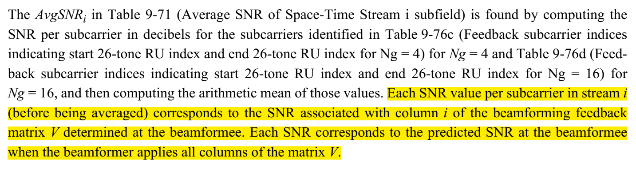

BF matrix V is determined by:
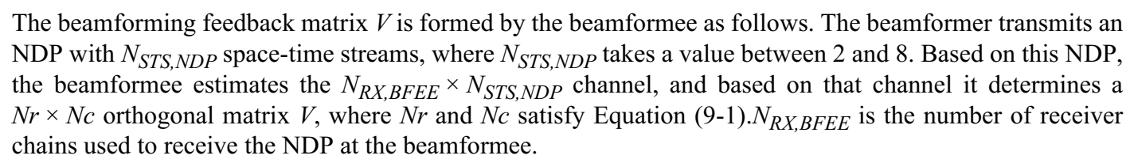

The N_STS,NDP for CQI only feedback is from 1~8 but for HE compressed feedback it’s 2~8, so refereeing to the V in HE compressed feedback is not clean.
In addition, regarding “Each SNR corresponds to the predicted SNR at the beamformee when the beamformer applies all columns of the matrix V”. CQI only feedback itself doesn’t feedback V, so the pre-condition “when the beamformer applies all columns of the matrix V” doesn’t stand.

Proposed changes:
To the TGax Editor: modify P.L. 134.62 as following (CID 16970).

The SNR per subcarrier calculation is defined in 9.4.1.63 (HE Compressed Beamforming Report field). The SNR value per subcarrier in stream i (before being averaged) corresponds to the SNR associated with column i of the beamforming matrix determined at the beamformee. The SNR per subcarrier computation should be done on at least 4 subcarriers in a 26-tone RU.

CID | P.L. | Clause | Comment | Proposed changes | Resolution
16969 | 303.10 | 27.6 | sounding for 20MHz operating devices are not defined in spec | define the sounding rule for 20MHz device. e.g. Keep the current RU index in NDPA and the (S,E) tone index unchanged. For the 20MHz operating devices, they only feedback the CSI for the available tones overlapped with the (S,E) tone index. Since AP knows the available tones of 20MHz device, AP can parse the feedback information w/o ambiguity. E.g. 80MHz AP request CSI for RU 9 and RU10 ( -260 : -204), 20MHz device will feedback CSI for tone -204:-250. | Rejected  -See the reason in discussion.
16974 | 304.17 | 27.6.2 | The description of full bandwidth feedback need to be refined for 20MHz operating non-AP STA. | as commented. | Rejected  -See the reason in discussion.
16975 | 308.38 | 27.6.3 | If NDPA BW is greater than 20MHz, need to include 20MHz BW in the 2nd column of table 27-4 to support 20mHz device sounding | as commented | Rejected  -See the reason in discussion.

Discussions:
The current spec doesn’t explicitly if a 20MHz operating STA can be sounded together with other 80MHz operating STAs in one PPDU. The only clue is the table 27-4, which implicitly means 20MHz operating STA can only be sounded with 20MHz NDPA. However, after some offline discussion, there are other issues, e.g. NDP is SU PPDU and 20MHz operating STA may only be able to receive MU PPDU with BW>20MHz. To avoid debating in current stage, I propose to leave the current spec as is.
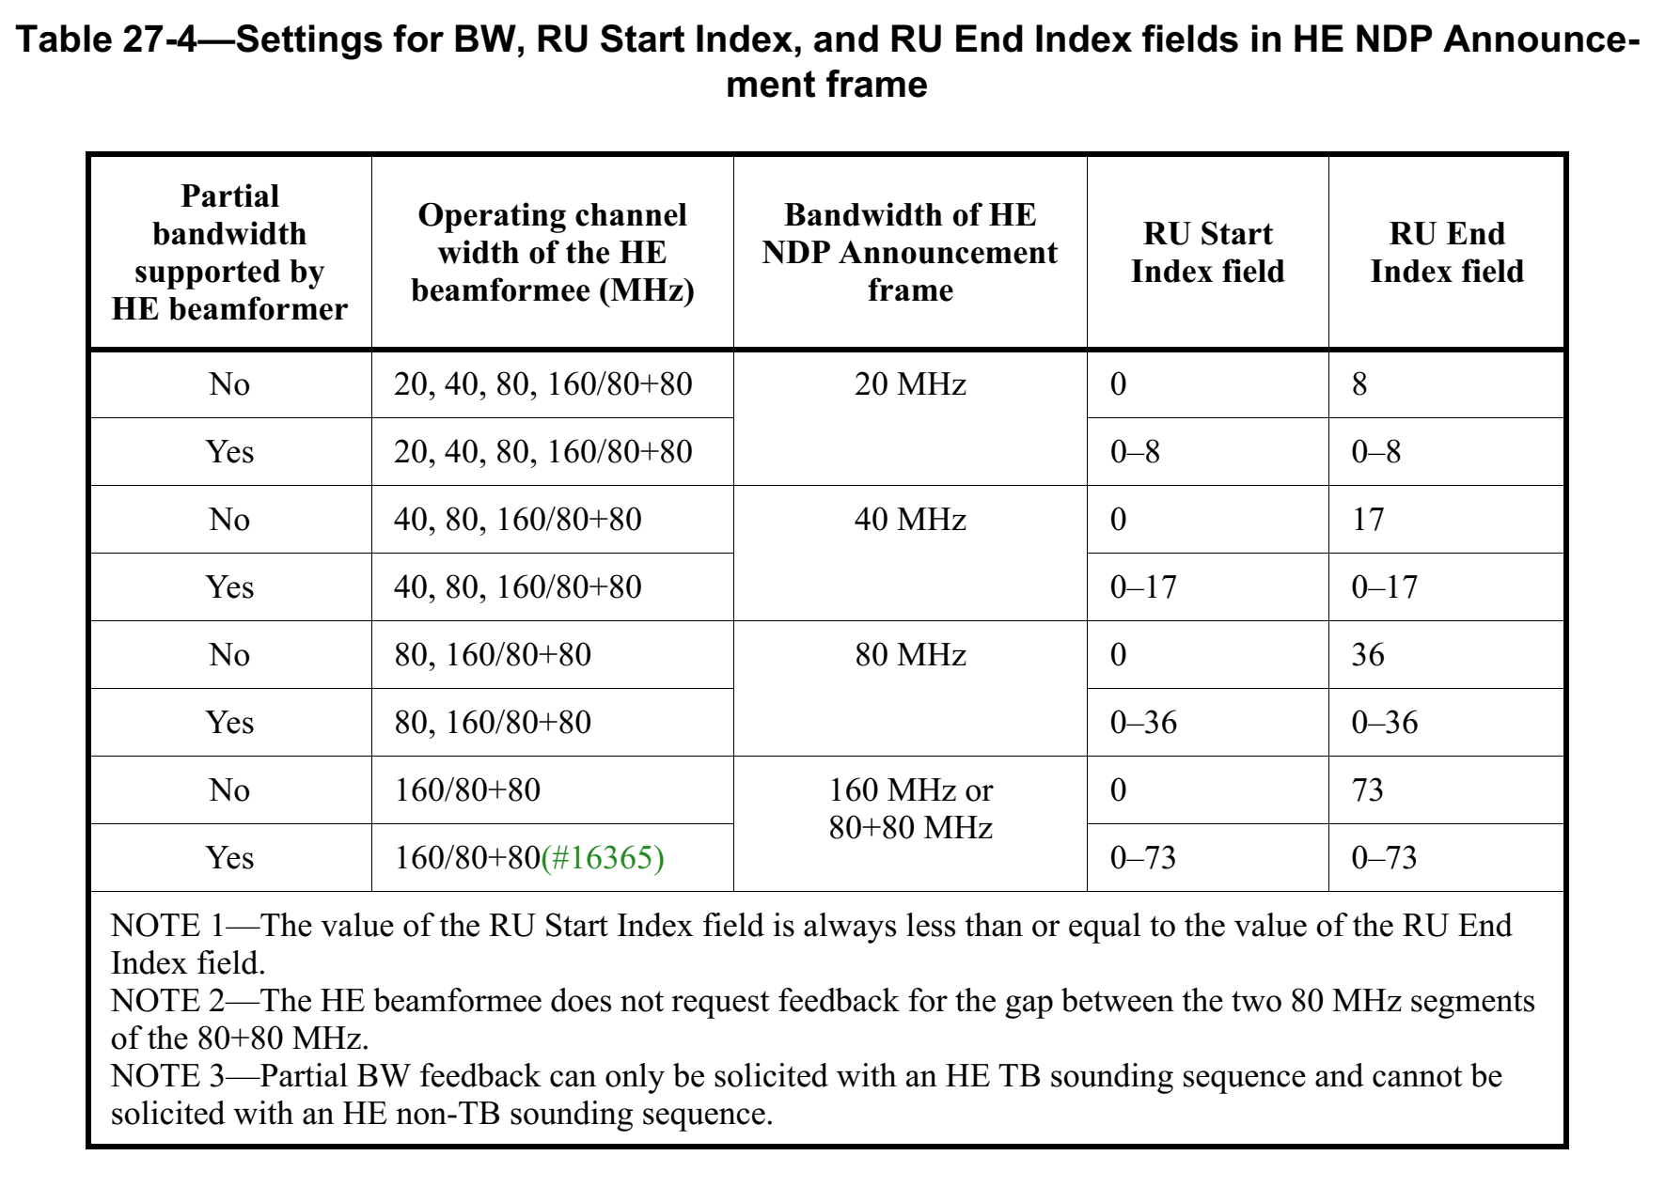

Proposed changes:
Reject all of the three comments.

