IEEE P802.11  
Wireless LANs

|  |  |  |  |  |
| --- | --- | --- | --- | --- |
| Resolution for SIG_B_Compression_Mode definition in TxVector | | | | |
| Date: 2018-11-13 | | | | |
| Author(s): | | | | |
| Name | Affiliation | Address | Phone | email |
| Jerome Vanthournout | CEVA-DSP | CEVA-DSP,  400 Avenue Roumanille,  06410 Sophia Antipolis, France | +33 (4) 8388 1237 | jerome.vanthournout@ceva-dsp.com |
|  |  |  |  |  |

Abstract

The **SIG_B_Compression_Mode** field definition is inconsistent across the document.

Discussion

In Tx Vector, the SIG_B_Compression_Mode is defined as follow:

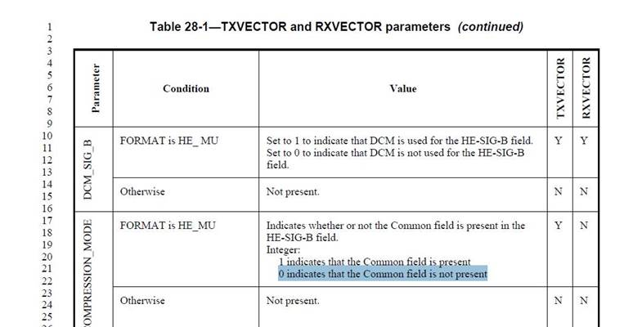

But in RU_Allocation definition in the TxVector, SIG_B_Compression_mode = 0 is used to indicate the presence of the common field (which is the opposite of previous definition)

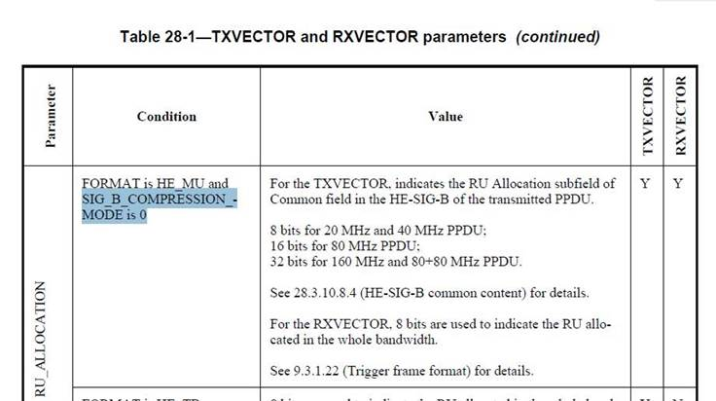

Finally, in SIGA definition for HE-MU PPDU, the SIG_B_Compression = 1 indicates that the Common field is not present.

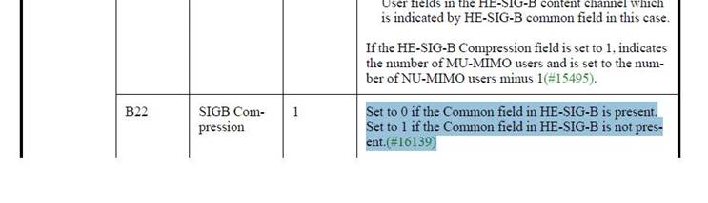

The proposal is to change the definition of SIG_B_COMPRESSION_MODE in TxVector to align it with its definition in SIG_A in the rest of the document.

**Resolution:**

*---------------------------Proposed Spec Text Modifications----------------------------------*

***TGax Editor: please modify the Table 28-1—TXVECTOR and RXVECTOR parameters as proposed below***

|  |  |  |  |  |
| --- | --- | --- | --- | --- |
| **Parameter** | **Condition** | **Value** | **TXVECTOR** | **RXVECTOR** |
| **…** | **…** | **…** | **…** | **…** |
| SIG_B_COMPRESSION_MODE | FORMAT is HE_MU | Indicates whether or not the Common field is present in the  HE-SIG-B field.  Integer:  ~~1~~0 indicates that the Common field is present  ~~0~~1 indicates that the Common field is not present | Y | N |
| Otherwise | Not present. | | |

--- ***End of proposed changes*** -----

**References:**

1. **IEEE P802.11axTM/D3.2, Oct 2018.**