IEEE P802.11
Wireless LANs
IEEE 802.11 Real Time Applications TIG Report
Date: 2018-11-11
Author:
Name | Affiliation | Address | Phone | email
Kate Meng | Tencent Technology (Shenzhen) Company Limited | C1, Hi-Tech Park, NanShan, Shenzhen, China | +86 166-7516-1765 | Katemeng@tencent.com
Allan Jones | Activision | 3100 Ocean Park Blvd, Santa Monica, CA 90405 | (310) 255-2000 | Allan.jones@activision.com
Dave Cavalcanti | Intel | 2111 NE 25th Ave, Hillsboro OR 97124, USA
Karthik Iyer | Activision | 3100 Ocean Park Blvd, Santa Monica, CA 90405 | (310) 255-2000 | Karthik.Iyer@activision.com
Chenhe Ji | HuaWei |  | +86-13813901984 | jichenhe@huawei.com
Abstract
This document contains report for 802.11 working group RTA TIG, which provides description of real-time application usage model, problem statement, technical requirements and potential features.

Table of contents
1.Definitions and abbreviations 3
2.Introductions 3
3.Proposes 3
4.Use case 4
4.1 Real-time mobile gaming 4
4.1.1 Challenges and problem highlight 4
4.1.2 Network architecture 6
4.1.3 Traffic characteristic 6
4.1.4 Traffic Model 7
4.1.5 Requirement metrics 10
4.2 Console gaming 12
4.2.1 Introduction 12
4.2.2 Network Architecture for an FPS game 12
4.2.3 Packet flow of an FPS console game 13
4.2.4 Traffic Modelling 14
4.2.5 Problem statement 16
4.3 Industrial automation 17
5.Functional requirements 17
5.1 Band capabilities 17
5.2 Throughput description 17
6.Potential technical features analysis 17
6.1 Dual link 17
6.2 Priority tagging 18
6.3 Time awareness network 18
7.Summary 18

Table of Figures

1.Definitions and abbreviations
Real-time mobile game: The mobile game can connect multiple players together in a single game session and transfer data messages between game server and connected players. Real-time means the feedback should present on screen as users operate in game. For good game experience, the latency from client to game servers plus game servers processing time should not be noticed by users as they play.
Gateway: Connect WLAN to WAN (Internet). Usually this entity refers to Wi-Fi router.
Lagging in game: lag is a noticeable delay between the action of players and the reaction of the server in a game. Usually, high latency cause lagging and lagging can be reflected as picture freeze or “fast-forward” or frame skipping in game.
In-game latency: round trip time between client and game server in datacenter. Real-time mobile game has a low threshold. Usually users would not encounter lagging (due to network) when the value is less than 100ms.
Jitter: Jitter reflects the fluctuation of latency over time. It can be evaluated by the time difference between two adjacent in-game ping values. In real-time mobile game, the jitter is calculated as standard deviation during a period time.
Disconnection: when latency is too high even causes packet loss, client will disconnect from game servers after several times of retry connection.
Dual link: dual link in this report refers to two independent bands which tranmit and receive data simultenously from one AP to one specific STA.

2.Introductions

As the fast development of wireless network, people have easy and ubiquitous access to the Internet via wireless network. However, due to the interference and congestions, the latency under wireless network is not guaranteed and causing problems for latency sensitive applications like real-time gaming, robotics and industrial automations due to random high latency.

This report consolidates key discussions of RTA TIG about some real-time scenarios, problems met under Wi-Fi and network requirements respectively.

3.Purpose
The purpose of this report is to provide detailed information of discussions and submissions that were presented within the group to help facilitate information sharing within the larger working group and also to provide feedback that could help to leverage work being done throughout the working group in order to facilitate potential solutions emerging from the activity being done within the various task groups.

4.Use Cases

4.1 Real-time mobile gaming

Real-time mobile gaming is a fast-developing application category. Different from traditional games, real time mobile gaming is very sensitive to network latency and stability.

The mobile game can connect multiple players together in a single game session and transfer data messages between game server and connected players. Real-time means the feedback should present on screen as users operate in game. For good game experience, the latency plus game servers processing time should not be noticed by users as they play the game.
The challenges that real-time mobile gaming encounter is the worst-case latency.

4.1.1 Challenges and problem highlight

Users connect to game under various environment, such as home, restaurants, subway, malls etc.
Around 60% users connect to game via Wi-Fi, with 20-30% possibilities that users encounter lagging in-game.
60-70% lagging because of problems between client and gateway. (around 10-15% are remain unknown which pending a validate process/ test plan to locate problem).
Comparison of lagging rate between 4G and Wi-Fi based on big data is as following table

Mode | Chance of lagging
Wi-Fi | 23%
4G | 15%

Below is lagging analysis per 2.4GHz and 5GHz Wi-Fi based on data from over millions pvp (player vs player) games.

Band | No lagging | Lagging
2.4GHz | 74.59% | 25.41%
5GHz | 86.87% | 13.13%

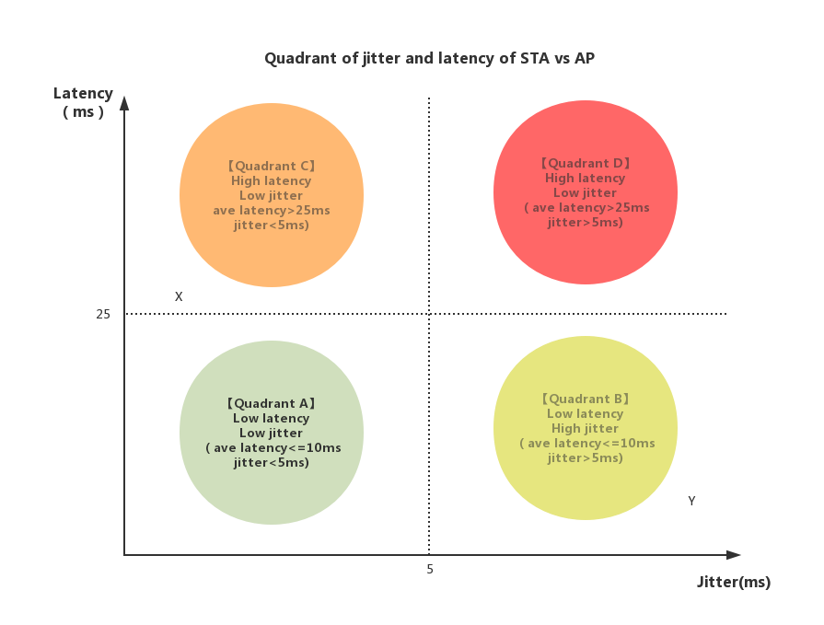
Description of the quadrant:
Latency is from STA to AP RTT. Jitter is standard deviation of latency.

Quadrant A: Network status between STA and AP is good. This is best scenario.
Quadrant B: Network status between STA and AP barely impact the game experience.
Quadrant C: Network status between STA and AP impact game experience.
Quadrant D: Network status between STA and AP impact game experience negatively.

Game experience of point X and Y shall be enhanced by the trade-off of latency and jitter.

4.1.2 Network architecture
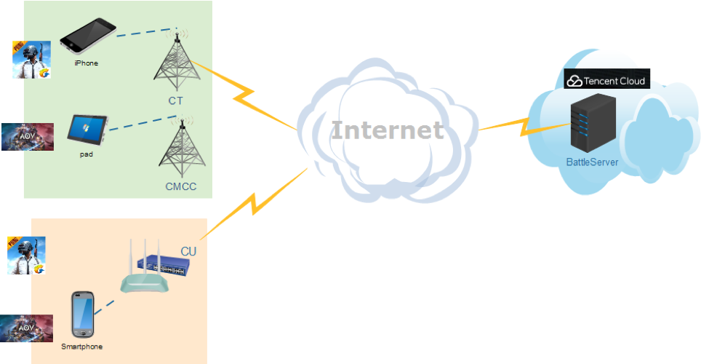
Users connect to game servers with mobile devices like mobile phone and tablets via celluar or wireless network and Internet.

4.1.3 Traffic characteristic

There are multiple functions running in game applications both chronologically and simutenously. Following characteristics refers to game traffic only.

Packet size: small packet with size of 30-500 Bytes (uplink and downlink), usually downlink packets are bigger than uplink.
Packet flow rate: Average every 30-60ms one packet (uplink and downlink), usually downlink packet interval is larger than uplink.
Bandwidth between client and AP: 0.1-1Mbps
Game data: Usually, the uplink packetscarry users’ instructions, while downlink packets carry calculation results or calculation instructions. So, both uplink and downlink packets are important and should be delivered as soon as possible.
Protocol: mostly UDP

4.1.4 Traffic Model
There are two popular mechanisms of synchronization between client and game server in real-time mobile games, one is frame lockstep sync, the other one is status sync.
There are three stages took into consideration in the analysis.
Initial stage: Selected users are in same battle room and ready to start gaming. Game map is yet to present to users.
Gaming stage: Users can operate in game.
Ending stage: Game over and present game results.

- Traffic model for status sync real-time mobile game
Component | Distribution |  | Parameters |  | PDF(probability density function)
 | L | UL | DL | UL
Initial packet size(Byte) | Uniform | Uniform | a=0,  b=20 | a=0,  b=20 | 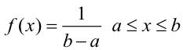
Packet arrival time (ms) | Largest Extreme Value | Largest Extreme Value | a=13,  b=3.7 | a=15,  b=5.7 | 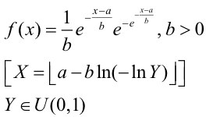
Packet size (Byte) | Largest Extreme Value | Largest Extreme Value | a=50,  b=11 | a=38,  b=3.7 | 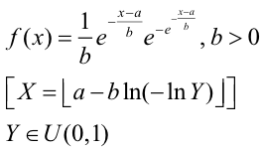
End packet  (Byte) | Uniform | Uniform | a=500,  b=600 | a=400,  b=550 | 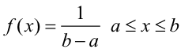
PDF for status sync DL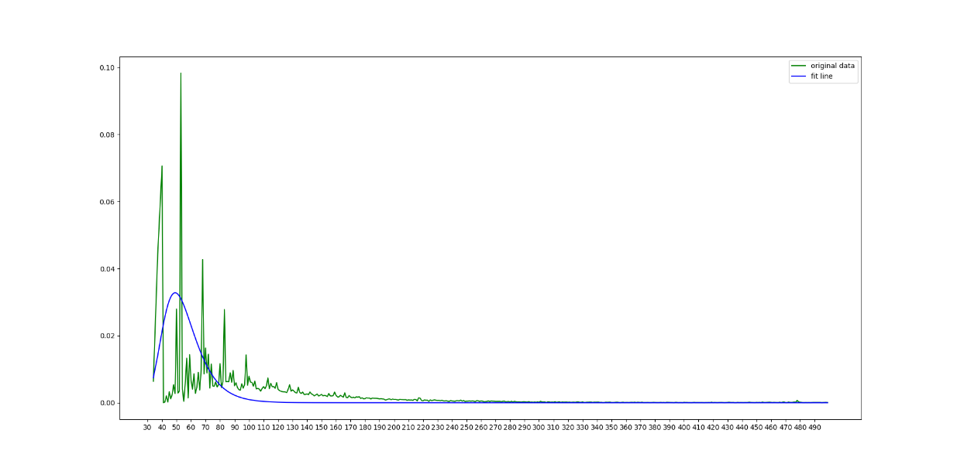
PDF for status sync UL
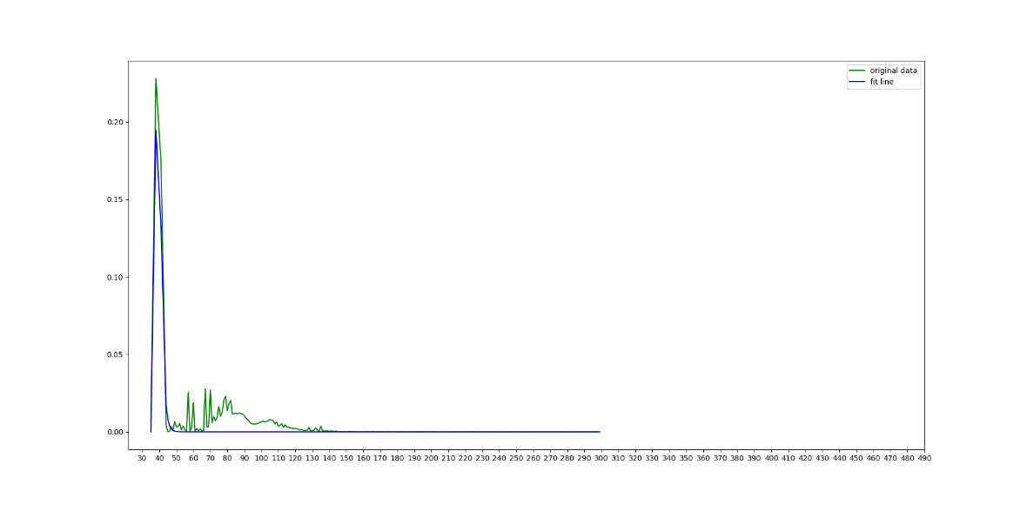

- Traffic model for frame lockstep sync real-time mobile game
Component | Distribution |  | Parameters |  | PDF
 | DL | UL | DL | UL
Initial packet size(Byte) | Uniform | Uniform | a=0,  b=80 | a=0,  b=80
Packet arrival time (ms) | Largest Extreme Value | Largest Extreme Value | a=28,  b=4.2 | a=22,  b=3.4
Packet size (Byte) | Largest Extreme Value | Largest Extreme Value | a=210,  b=35 | a=92,  b=38
End packet  (Byte) | Uniform | Uniform | a=1400,  b=1500 | a=500,  b=600

PDF for frame sync DL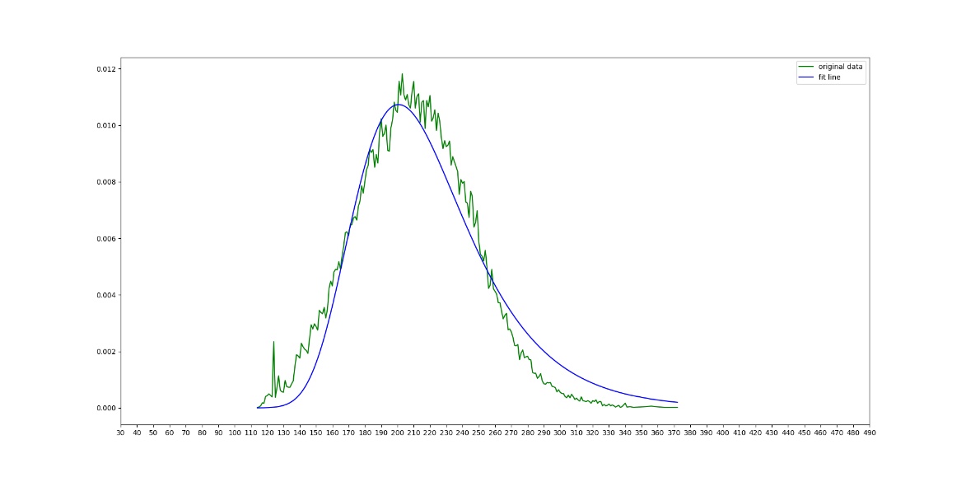
PDF for frame sync UL
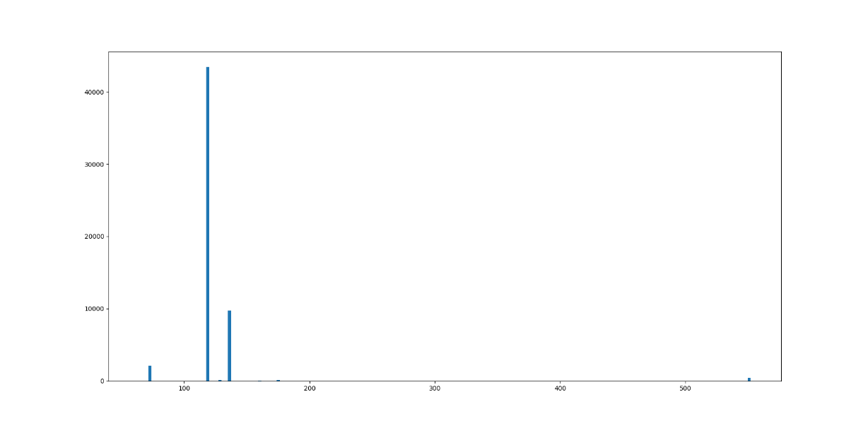

4.1.5 Requirement metrics
Real-time mobile game request instant feedback of in-game operation from multiple players who are in the same battle room, lagging will cause picture not fluent and impact user experience negatively.
Moreover, the time difference that users get the response will cause unfairness because the response is not synchronous.
A common observation is, during a period time, although average latency is low, worst case latency (spike) can be several times higher than the average. Jitter will cause spike in latency, when latency is too high which exceeds threshold and then cause packet loss, lagging is expected.
The relationship between game experience and latency is as below table.
The average latency from client to AP is 7ms, however user experience needs to be considered over the complete path from client to game server.
The latency breakdown from client to game server is as below.

Specifications from client to AP in below table (based on experience value)
Specification | Value
Latency | <10ms
Packet loss | <0.1%
Jitter | <5ms
High latency packet(>30ms) | <1%

To control worst case spike, the average latency can go up to 25ms for stability.

4.2 Wireless Console Gaming

4.2.1 Introduction

Console gaming involves various genres of games, but the main genre we are focusing on is latency sensitive online FPS (First Person Shooter) games. This is an interactive gaming experience with real-time feedback and response. A Synchronized game state is established among players in the same match to get best performance.

Wi-Fi has an especially bad reputation among the gaming community. According to a top selling online console game in the US up to 79% of FPS players are using Wi-Fi connected consoles.

4.2.2 Network Architecture for an FPS game

Dedicated Server:

In this model, many servers are in different geographical locations depending on the game traffic in the region. The main purpose of Dedicated server is to host the game and to perform matchmaking. Fig 4.1 is representation of Dedicated server architecture.
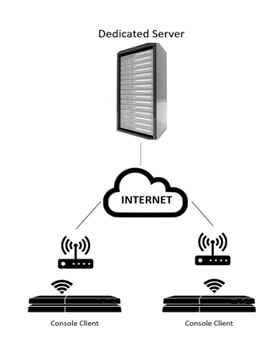
Figure 4.1

Local Server:

This architecture elects a gaming console to host the game which handles all the network traffic to the players connected. The game statistics are still managed by the centralized servers. This method helps to reduce the number of dedicated server infrastructure where there are not many players participating in the game. Fig, 4.2 is a representation if Local Server architecture.
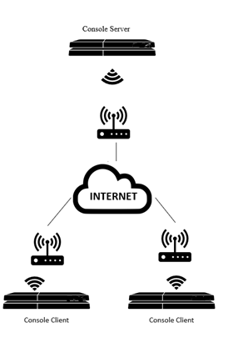
Figure 4.2

4.2.3 Packet flow of an FPS console game
Packet Protocol: Uses UDP Data packets for gameplay updates to and from the server and TCP for matchmaking
Packet Size: Frame size of 100-200 bytes depending on the size of data sent
Packet flow Rate: Flow rate will vary from game to game. In our testing we observed approximately 60 packets/sec from a console to server and 15 packets/sec from a server to console depending on the pace of gameplay
Bandwidth Between console and Server: 0.2 - 1 Mbps
Game Data: Carries users’ instructions during uplink and result of those instructions in a downlink.

4.2.4 Traffic Modelling
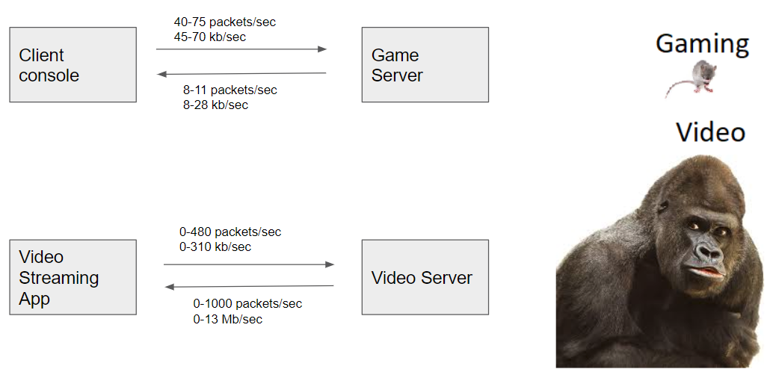
Figure 4.3
Comparing the traffic flow with a video streaming application, FPS games have less packets/sec and bandwidth occupied. Whereas video streaming chokes the whole network with packet blasts. When both are trying to compete, Video packets dominate mostly because of the packet size and bandwidth occupied. This leads to too many issues with other types of connection in the network.

Let us see the Network capture statistics of an FPS game alongside a Video streaming application in fig 4.4 and fig 4.5
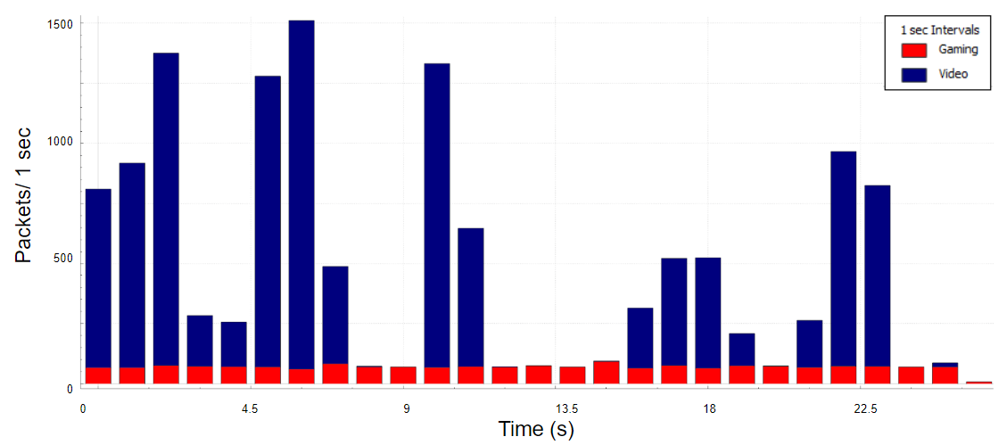
Figure 4.4

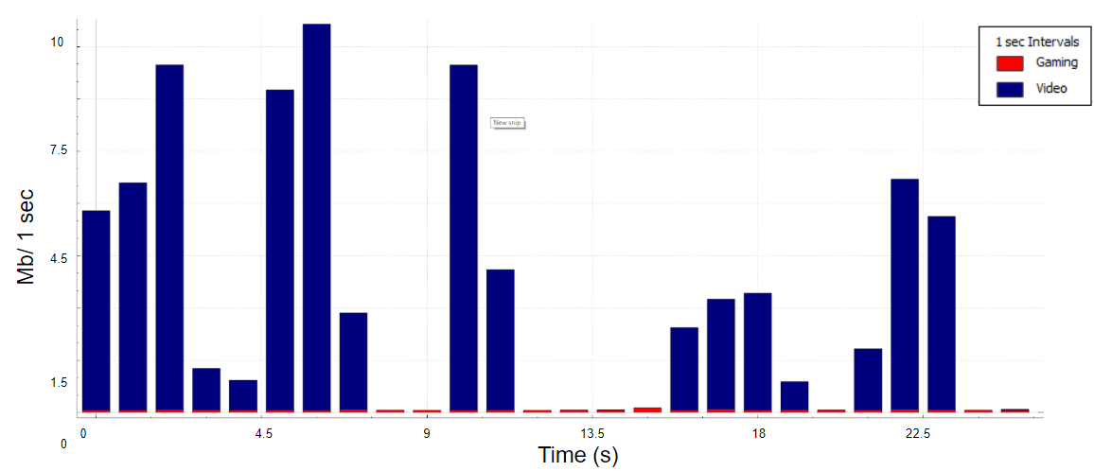
Figure 4.5

4.2.5 Problem statement

In regards to the Wi-fi problems that console games face, consoles have to contend with other devices with higher priority which also occupy more bandwidth. As number of video streams increase in a network, the contention also increases. To keep latency low, the total throughput of the Channel is decreased. Voice and Video streams have priority over data due to Enhanced Distributed Channel Access (EDCA). EDCA/WMM in attempt to contain the higher priority streams and offer protection to streams already in progress. These factors impact the smoothness of Best-effort UDP packet blasts during an intense gameplay.

Apart from these prioritization issues, gamers also face problems like:
- Lag spike during gameplay which can last for 1-3 seconds
- There is limited bandwidth availability due to high streaming devices
- Channel interference could be caused by other networks
- Packet loss is usually compensated by dead reckoning which can cause Rubber Banding
- One might get kicked out of the public match mostly due to high ping

In regards to gamers who face these problems, they are usually amateur gamers who play on Wi-fi as professional gamers who compete on eSports use best available wired connections to compete with the best players out there. As eSports is emerging as a major online worldwide online gaming competitions, people win a prize pools of up to $100 Million. Major sports networks have also started televising online competitions. Gamers who are bound to play on Wi-fi can never expect a good gameplay as they would have high ping issues. This does discourage new gamers from playing these competitions.

Game publishers have reported that upwards of 79% of their players use Wi-Fi.

4.3 Industrial Systems

Industrial systems include a wide range of applications: process monitoring, automation, control systems, human-machine-interfaces (MHI), Automated Guided Vehicles (AGVs), robotics and AR/VR. Recently, several standard organizations have published detailed description of industrial application and their requirements, such as:
- IEEE 802.1 NENDICA Report Wired/Wireless Use Cases and Communication Requirements for Flexible Factories IoT Bridged Network (802.1-18-0025-06-ICne);
- IEC/IEEE 60802 Use Cases for Industrial Automation (TSN-IA Profile for Industrial Automation);
- 3GPP TR 22.804 Technical Specification Group Services and System Aspects; Study on Communication for Automation in Vertical Domains.

The purpose of this document is not to repeat the detailed application descriptions, which can be found in above references. Instead, the focus is to summarize the challenges and requirements of real-time and time-senstive applications that most relevant to 802.11.

Many industrial applications can be considered delay-tolerant (e.g. process monitoring, industrial sensor networks, etc.) with latency requirements in the order of 100msec or more. Such applications may be served by existing wireless standards and are not considerd in this report. This report focuses only on time-sensitive and real-time applications.

4.3.1 Summary of Real-time Use Cases and Classes of Service

The table below summarizes use cases and requirements grouped in three classes of services. The latency bound is defined as the worst-case one-way latency measured at the application layer. The reliability is defined as the percentage of packets expected to be received within the latency bound.

Applications and Requirements | Class A | Class B | Class C
Applications | Interactive video, soft-real-time control, mobile robotics, Automated Guided Vehicles (AGV) | AR/VR, remote HMI, hard-real-time cyclic control, machine tools, production lines | Hard-real-time isochronous control, motion control, printing, packaging
Time synchronization | 10-1µs | ~1 µs | ~1 µs
Latency bound | 50 -10 ms | 10 – 1 ms | 1ms – 250 µs
Reliability | 99% - 99.9% | 99.9% - 99.99% | >99.999%

4.3.2 Traffic Profiles

The communication model of a closed loop control system, described in the figure below, is applicable to many industrial applications. Therefore, its traffic profile can be considered a repenstative model for many industrial systems.

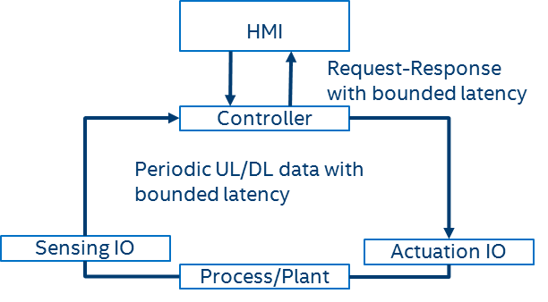

The main traffic patterns generated by a control system include:
- Periodic data: this is the typical pattern generated by remote IO (sensing and actuation) within a closed loop control system. Remote HMI devices can also operate as a remote IO device and generate peridic data. The data sizes are usually fixed and relatively small (e.g typicall from 30 to 300 bytes). The periodic data, which may be exchanged in uplink (sensor to controller) or downlink (controller to actuator) direction, is expected to be delivery within a give latency bound.
- Request/Response: these are asynchronous messages. The request is typically generated by the HMI device and response is generated by the controller device. This can also be seen as a control loop, but it is not a cyclic one as in the remote I/O (sensor, controller, and actuation) case. The bounded latency in this case applies to the round trip latency between the times when the request is generated and the response is received.

Real-time applications such as video streaming, AR, and VR are also used in industrial scenarios, but they have no industrial-specific requirement, therefore they are not described in this section.

4.3.3 Problem Statement

The bounded latency and reliability for periodic and resquest/response data used in the control cycle is the most challenging requirement for the communication links. The required values depend on the type of control system, but the target performance can be grouped in the classes of service described in the previous section.

It has been shown that average latency in 802.11 networks can be very low, but worst case latency and jitter can be very high, depending on the traffic and network congestion. Solutions to address congestion and reduce randomness in accessing the medium should be considered to enable more predictable/control of latency.

Providing high reliability has not been a focus for 802.11 networks. Operation in unlincesed bands and lack of coordination between BSSs are some of the factors that impacts reliability.

One important aspect to consider is that wireless networks within industrial environements are usually managed, which can help reduce interference from other (un-managed) networks. Futhermore, the traffic configurations and requirements are either pre-set or negotiated during the device association/network entry, and do not change during the system operation. Therefore, it is feasible to provision/configure the network to provide a predictable performance in terms of latency and reliability.

5.Functional requirements

5.1 Band capabilities

STA and AP mentioned in this report shall support frequency bands between 1GHz and 7.125GHz.

5.2 Throughput description

The throughput of applications mentioned are low throughput with less than !!!Mbps

6.Potential technical features analysis

Although current 802.11/Wi-Fi solutions can provide very low latency [REF] in uncongested environments, the worst-case latency can vary significantly, impacting the performance or limiting the usage of many real-time and time-sensitive applications over Wi-Fi.

There is a need to explore solutions to better control latency and jitter, and provide more stable/reliable performance. The next sections discuss potential capabilities that can be used to control congestion, which is a major cause of high/variable latency, and also improve reliability.

6.1 Time Sensitve Networking Extensions to 802.11
The IEEE 802.1 Time Sensitive Networking (TSN) Task Group has been developing standards for creating distributed, synchronized, real-time systems. Some of the TSN capabilities and standards include: stream reservation (802.1Qat), time synchronization (802.1AS), time-aware shaping (802.1Qbv), frame replication and elimiation (FRE defined in P802.1CB), and many others. Although many of the TSN capabilities have been designed assuming Ethernet as transmport media, some TSN capabilities have already been extended to 802.11, such as time synchronization (timing measurement capability in 802.11-2012), stream reservation (SRP over 802.11 for AV defined in 802.11aa), 802.11 links in an 802.1Q network (802.11ak). The 802.1 features defined so far over 802.11 do not address the worst-latency and reliability requirements. Additional extenstions, such as time-aware shaping and redundancy (FRE) can address the congestion and reliability problems identified earlier. Some of the existing capabilities and potential extensions are described in the following sections.

6.2 Priority tagging (Stream identification)
One basic requirement to provide better QoS for time-sensitive traffic is the capability to identify and differentiate time-sensitive packets from other (e.g. best-effort) traffic. The IEEE 802.1Q standard defines mechanisms used to identify and differentiate time-sensitive streams from other types of traffic. 802.1Q specifies a Virtual Local Area Network (VLAN) tag field, which is added to the header of the layer-2 Ethernet frames. Furthermore, 802.1Q defines traffic classes, and allows up to either traffic classes per Ethernet port, with each traffic class associated with a dedicated queue. The Priority Code Point (PCP) field of the VLAN Tag determines the traffic class for a given Ethernet frame. Specifically, bridges are configured to map PCP values to traffic classes, and as frames arrive, the bridge directs them to the appropriate queue based on the value of the frame’s PCP field and the configured PCP-to-traffic class mapping. The 802.1Q stream identification mechanisms have already been defined over Ethernet and 802.11.

Given that practical 802.11 MAC implementations are based on the EDCA, time-sensitive traffic has to be mapped to one of the four EDCA access categories, which can only provide probabilistic QoS guarantees, which is variable with the network traffic/congestion. Therefore, mechanisms that can not only identify time-sensitive frames at the 802.11 MAC, but also prioritize such frames in the channel access process could be useful to address the worst-case latency issues.

6.3 Time-aware shaping

The IEEE 802.1Qbv standard defines a Time-Aware Shaping capability consisiting of gates to control the opening/closing of queues that share a common egress port within an Ethernet switch. A scheduler defines the times when each queue opens or close, therefore eliminating congestion and ensuring that frames are delivered within the expected latency bounds. This solution can be extended to 802.11 to avoid congestion in a BSS and/or across managed BSSs.

In an 802.11 BSS, the queues at differnet contending STAs need to be controlled to avoid congestion as illustrated in the figure below. Once a time-sensitve queue is open, a transmission selection modules selects a data frame to send and delivers it to the MAC layer. One potential implementation is to use the time-division based scheduling to define service periods reserved for time-sensitive traffic, as shown below. The time-aware shaping capability is independent of the channel access mode and could be used with different options (e.g. EDCA, trigger-based access with 802.11ax, etc.). It is important to note that the more efficient and deterministic the access, the lower the latency bounds that could be supported by the network.

The extension of the Qbv traffic shaping concept over 802.11 would require modification in the 802.11 MAC layer to enable distribution of the Qbv schedule between managed stations (STAs) and also to ensure the 802.11 EDCA queues are controlled to meet the Qbv schedule.

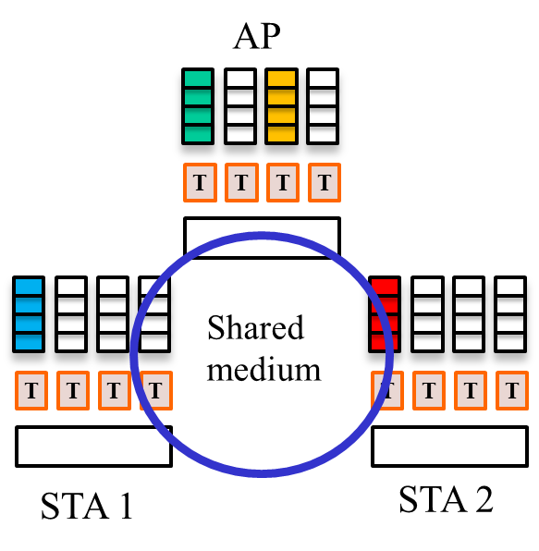

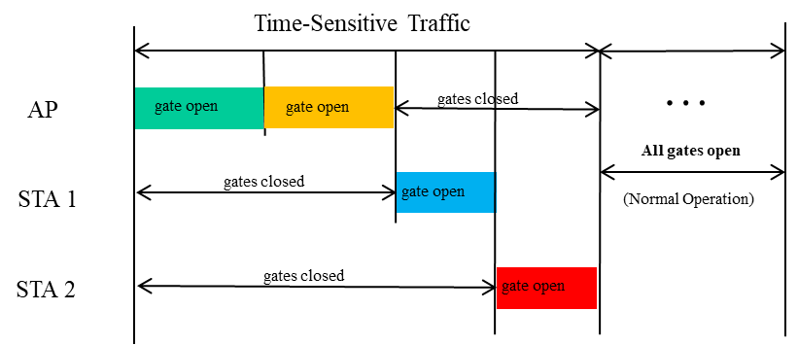

Example of time-Aware shaping capability to resolve contention between managed STAs.

6.4 Dual link (Frame Replication and Elimination)

Due to the competitions, interference are common and hardly in control under wireless network, in order to improve the latency stability, dual link proposal is brought up to address this issue. The dual link or FRE capability has also been defined for Ethernet by the 802.1CB standard and could be extended to 802.11. The dual link capability can be used in combination with other capabilities to control latency to improve the overall reliability of the system.

Dual link proposal applies to STA and AP which can work on at least two bands and can be enabled by user or specific API in APP for latency and stability sensitive applications.

The interaction process is demonstrated as following:
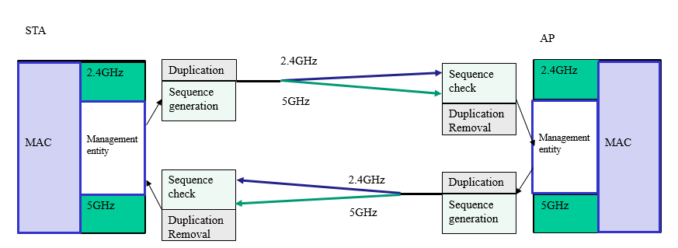

There are two implementation modes for dual link applications.
  - Duplicate Mode：When dual link feature is enabled, each packet in one certain traffic stream will be duplicated at one end and de-duplicated on the other end. The transmission side will tag duplicated packet with a unique sequence number which will be identified at the other end for de-duplication purposes. At the receiver side, the de-duplication will be done before packet is processed. Only first arrived packet will be accepted and trigger ACK and the second arrived packet will be dropped.
  - Cutting Mode：Different part of packet transmit in different stream of different links. The transmission side will tag part of packet with a unique sequence number which will be identified at the other end for combining purposes. If the combine processing time is short enough this mode will effectively reduce the latency.Monitoring the physical available bandwidth in the Wi-Fi link to determine which mode to be used for delivering the data.
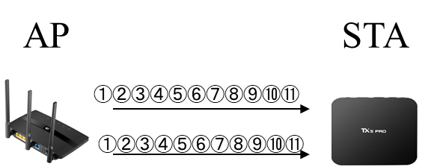
Diagram of Duplicate Mode
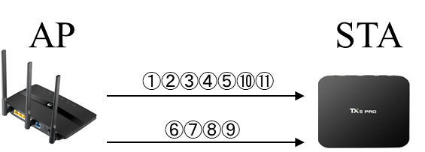
Diagram of Cutting Mode
Base on above modes, there are still many problems should be solved, like:
- Traffic load balance: Since the actual bandwidth of the Wi-Fi links are not stable enough, a proper mechanism should be considered to reasonably assign the proper amount of traffic dynamically according to the actual bandwidth status in the two bands: 5G and 2.4G.
- Packet align: Cutting mode will cause packets out of order. Out of order should be differentiated from losses in the MAC layer. (Losses will cause extra delay). Dealing with out of order packets requires extra buffer and capabilities.

6.5 Admission Control

Congestion is a major cause of high/variable latency and it is well known that if the traffic load exceeds the capability of the link, QoS will be degraded. QoS degradation maybe acceptable for many applications today, however emerging time-sensitive applications are highly succeptible to increased latency and jitter. In order to better control QoS, it is important to control access to the network resources. Admission control capabilities have already been defined in the 802.11 MAC. Admission control is also important to ensure that solution to control latency and reliability can be effective.

Admission control can be used within a BSS and across overlapping BSSs in a managed network. Obviously, there is always the possibility of non-managed overlapping BSSs due the unlicensed spectrum used by 802.11. However, there are many scenarios where the network can be managed and solutions to control latency/reliability can be very effective in combination with admission control policies. Furthermore, as new spectrum become available (e.g. 6 to 7 GHz), there will be opportunity to apply more efficient medium access techniques, such as 802.11ax and beyond, and avoid contention with legacy 802.11 systems.

7.Summary

8. References

The packet size range estimation is based on popular real-time mobile game data capture. Please refer to Traffic Model part.
The packet characteristics of UL and DL are different since these are using different transmission mechnisms.
The bandwidth is based on popular real-time game data capture. The main idea is that real-time mobile games are low throughput and the actual data usage is up to game duration.
In largest extreme value, a is location parameter and b is scale parameter.
The actual UL packets are fixed discrete value due to game application logic.

