IEEE P802.11
Wireless LANs
D3.0 Comment Resolution – Part 5
Date: 2018-11-14
Author(s):
Name | Affiliation | Address | Phone | email
Youhan Kim | Qualcomm |  |  | youhank@qti.qualcomm.com

Abstract
This submission proposes resolutions for the following comments from the letter ballot on P802.11ax D3.0:

15595, 15597, 16324, 16087, 16089, 16570, 15593, 15594, 16088, 15598

NOTE – Set the Track Changes Viewing Option in the MS Word to “All Markup” to clearly see the proposed text edits.

Revision History:

R0: Spin off CID 15597 from 11-18/1850r1. Also, include various CIDs which have been re-assigned.
R1: Update on CIDs 16087, 16089, 16570.

CID 15595, 15597

CID | Clause | Page.Line | Comment | Proposed Change
15595 | 17.3.9.10 | 249.17 | The 2 kHz requirement is only for -60 dBm. Does this mean that for a received power of -59 dBm, we can do much worse? Change the -60 dBm received power to a minimum value. | Replace "After compensation, the absolute value of residual CFO error with respect to the PPDU carrying the soliciting MU-RTS Trigger frame shall not exceed 2 kHz when measured at the 10% point of the complementary cumulative distribution function (CCDF) of CFO errors in AWGN at a received power of -60  dBm in the primary 20 MHz." wih "After compensation, the absolute value of residual CFO error with respect to the PPDU carrying  the soliciting MU-RTS Trigger frame shall not exceed 2 kHz when measured at the 10% point of the complementary  cumulative distribution function (CCDF) of CFO errors in AWGN at received powers greater than or equal to -60 dBm in the primary 20 MHz.".
15597 | 17.3.9.10 | 249.17 | The 350 Hz requirement is only for -60 dBm. Does this mean that for a received power of -59 dBm, we can do much worse? Change the -60 dBm received power to a minimum value. Also change "as the 10% point" to "at the 10% point". | Replace "After compensation, the absolute value of residual CFO error with respect to the PPDU carrying the soliciting Trigger frame shall not exceed 350 Hz for data subcarriers when measured at the 10% point of the complementary cumulative distribution function (CCDF) of CFO errors in AWGN at a received power of -60  dBm in the primary 20 MHz." wih "After compensation, the absolute value of residual CFO error with respect to the PPDU carrying  the soliciting Trigger frame shall not exceed 350 Hz for data subcarriers when measured at the 10% point of the complementary  cumulative distribution function (CCDF) of CFO errors in AWGN at received powers greater than or equal to -60 dBm in the primary 20 MHz.".

Background

D3.2 P259:
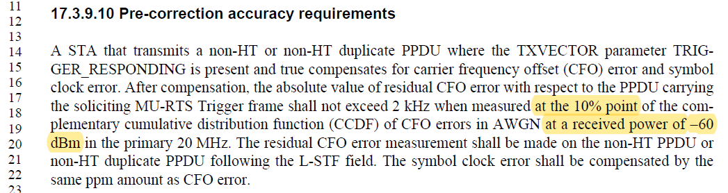

D3.2 P564:
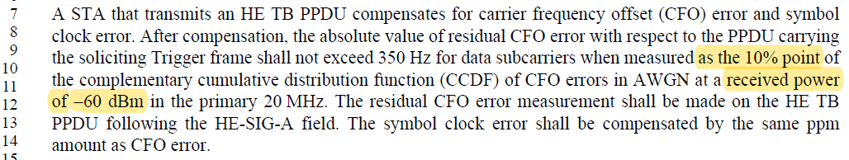

Proposed Resolution: CID 15595
Rejected.
The comment resolution group feels that checking at one point is sufficient for testing purposes.

Proposed Resolution: CID 15597
Revised.
The comment resolution group feels that checking at one point is sufficient for testing purposes. Agree with the typo fix.
Instruction to Editor: At D3.2 P564L9, change “as the 10% point” to “at the 10% point”.

CID 16324

CID | Clause | Page.Line | Comment | Proposed Change
16324 | 9.4.2.237.3 | 160.47 | PPE Thresholds Present field not required as can be determined unambiguously by length of element | Delete this field

Background

D3.2 P259:
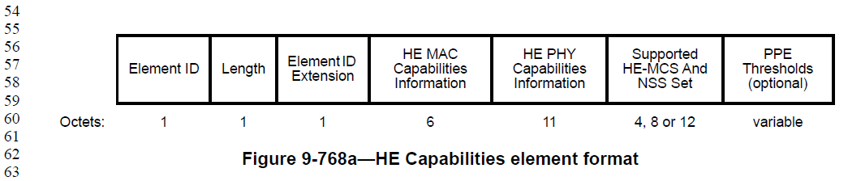

Proposed Resolution: CID 16324
Rejected.
While it is theoretically possible to compute the existence of the PPE Thresholds field based on the length and some other subfield parameters within the HE PHY Capabilities Information field, industry has adopted and is relying on the simpler method of using an explicit 1 bit signalling to indicate the existence of the PPE Thresholds field. There is no significant benefit at this point from deleting the PPE Thresholds Present field.

CID 16087, 16089, 16570

CID | Clause | Page.Line | Comment | Proposed Change
16087 | 17.3.9.10 | 249.14 | This is confusing as it first talks of "a non-HT or non-HT duplicate PPDU where the TXVECTOR parameter TRIGGER_RESPONDING is present and true" and then talks of "the PPDU carrying the soliciting MU-RTS Trigger frame" | In the referenced subclause at the referenced location change "a non-HT or non-HT duplicate PPDU where the TXVECTOR parameter TRIGGER_RESPONDING is present and true" to "a CTS frame in response to an MU-RTS Trigger frame"
16089 | 17.3.9.10 | 249.17 | What is "A STA that transmits a non-HT or non-HT duplicate PPDU where the TXVECTOR parameter TRIG-  GER_RESPONDING is true and that is a response to a PPDU containing a MU-RTS Trigger frame received  from an AP shall ensure that the arrival time of the non-HT or non-HT duplicate PPDU at the AP is" doing in a PHY clause? | Move to Clause 27
16570 |  | 545.00 | Without an actual measurement and feedback from the HE AP, the non-AP HE STA has no way of knowing that the HE TB PPDU it transmits arrives at the AP within +/-0.4 ╬╝s of TXTIME + aSIFSTime + RTD from the transmission start time of the triggering PPDU | On line 46 of this paragraph, change "shall ensure" to "should ensure"

Background

D3.2 P259:
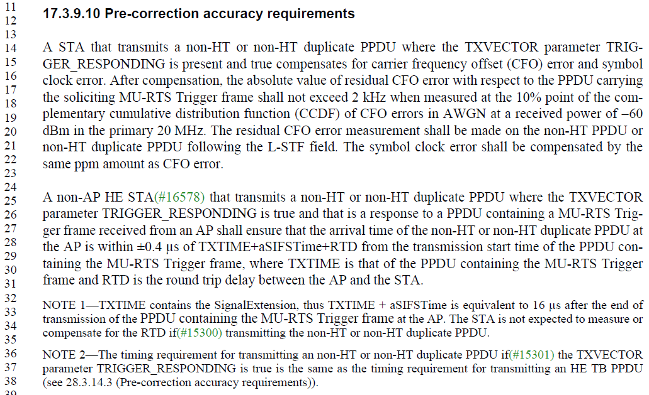

D3.2 P259:
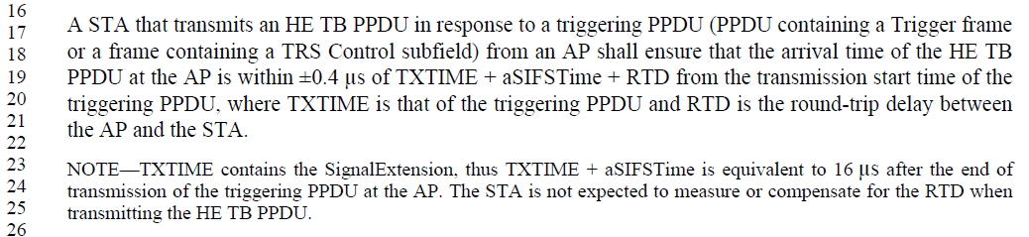

Proposed Resolution: CID 16087
Revised.
Proposed text in 11-18/1901r1 has cleaned up to language.
Instruction to Editor: Implement the proposed text changes in 11-18/1901r1 for CIDs 16087, 16089 and 16570.

Proposed Resolution: CID 16089
Revised.
This text belongs to a PHY clause as it deals with PHY level synchronization accuracy requirements. Proposed text in 11-18/1901r1 has cleaned up to language.
Instruction to Editor: Implement the proposed text changes in 11-18/1901r1 for CIDs 16087, 16089 and 16570.

Proposed Resolution: CID 16570
Revised.
Proposed text in 11-18/1901r1 provides additional clarification on the timing requirement of HE TB PPDU transmissions.
Instruction to Editor: Implement the proposed text changes in 11-18/1901r1 for CIDs 16087, 16089 and 16570.

Proposed Text Updates: CID 16087

TGax Editor: Add the following definitions at D3.2 P36L58.
Triggering frame: A Trigger frame or a frame carrying a TRS Control subfield.
Triggering phy layer (PHY) protocal data unit (PPDU): A PPDU carrying a Triggering frame.

TGax Editor: Update D3.2 P173L25 as shown below.

A non-AP HE STA that transmits a non-HT or non-HT duplicate PPDU with the TXVECTOR parameter TRIGGER_RESPONDING set to true compensates for carrier frequency offset (CFO) error and symbol clock error with respect to the corresponding triggering PPDU. After compensation, the absolute value of residual CFO error with respect to the triggering PPDU shall not exceed 2 kHz when measured at the 10% point of the complementary cumulative distribution function (CCDF) of CFO errors in AWGN at a received power of -60 dBm in the primary 20 MHz. The residual CFO error measurement shall be made on the non-HT or non-HT duplicate PPDU following the L-STF field. The symbol clock error shall be compensated by the same ppm amount as CFO error.

NOTE – The only triggering frame which solicits transmission of non-HT or non-HT duplicate PPDU, and not an HE TB PPDU, is the MU-RTS Trigger frame. And the subsequent non-HT or non-HT duplicate PPDU transmission in response to the MU-RTS Trigger frame carries a CTS frame.

A non-AP HE STA that transmits a non-HT or non-HT duplicate PPDU with the TXVECTOR parameter TRIGGER_RESPONDING set to true shall ensure that the arrival time of the non-HT or non-HT duplicate PPDU at the AP which has transmitted the corresponding triggering PPDU is within ±0.4 μs of TXTIME+aSIFSTime+RTD from the transmission start time of the triggering PPDU, or equivalently, ensure that the transmission start time of the non-HT or non-HT duplicate PPDU is within ±0.4 μs + 16 μs from the end of the triggering PPDU, where TXTIME is that of the triggering PPDU and RTD is the round trip delay between the AP and the STA.

NOTE 1—TXTIME contains the SignalExtension, thus TXTIME + aSIFSTime is equivalent to 16 μs after the end of transmission of the triggering PPDU. The STA is not expected to measure or compensate for the RTD when transmitting the non-HT or non-HT duplicate PPDU.

NOTE 2—The timing requirement for transmitting a non-HT or non-HT duplicate PPDU with the TXVECTOR parameter TRIGGER_RESPONDING set to true is the same as the timing requirement for transmitting an HE TB PPDU (see 28.3.14.3 (Pre-correction accuracy requirements)).

TGax Editor: Update D3.2 P564L17 as shown below.

A STA that transmits an HE TB PPDU in response to a triggering PPDU from an AP shall ensure that the arrival time of the HE TB PPDU at the AP is within ±0.4 μs of TXTIME + aSIFSTime + RTD from the transmission start time of the triggering PPDU, or equivalently, ensure that the transmission start time of the HE TB PPDU is within ±0.4 + 16 μs from the end of the triggering PPDU, where TXTIME is that of the triggering PPDU and RTD is the round-trip delay between the AP and the STA.

NOTE—TXTIME contains the SignalExtension, thus TXTIME + aSIFSTime is equivalent to 16 μs after the end of transmission of the triggering PPDU. The STA is not expected to measure or compensate for the RTD when transmitting the HE TB PPDU.

CID 15593

CID | Clause | Page.Line | Comment | Proposed Change
15593 | 17.3.9.10 | 249.17 | How the measurement is to be done in the following statement "After compensation, the absolute value of residual CFO error with respect to the PPDU carrying  the soliciting MU-RTS Trigger frame shall not exceed 2 kHz when measured at the 10% point of the complementary  cumulative distribution function (CCDF) of CFO errors in AWGN at a received power of -60  dBm in the primary 20 MHz." is not clear. Please clarify whether this measurement is done over a single antenna or over all antennas. | Please clarify how many antennas are used to make this measurement.

Background

D3.2 P259:
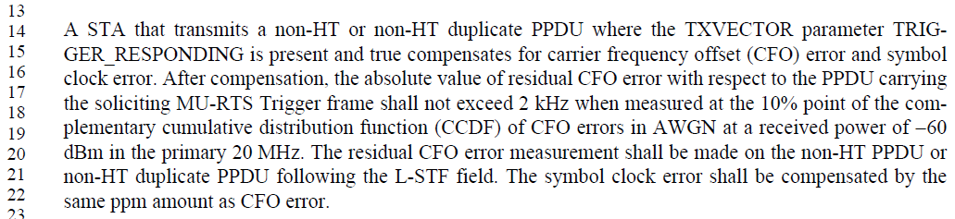

Proposed Resolution: CID 15593
Rejected.
It is not clear whether the commenter meant the number of antennas of the transmitter or receiver of the CTS frame. In case of the transmitter of the CTS frame, which is a non-AP STA, 28.3.16.3 clearly specifies that “transmit center frequency … for all transmit antennas … shall be derived from the same reference oscillator.” Hence, it does not matter which or how many transmit antennas are used to make the measurement. In case of the receiver of the CTS frame, it would be a test equipment which would be receiving the CTS frame when making such CFO compliance measurement. How many antennas/RF ports the test equipment uses for the measurement is outside the scope of the 11ax standard.

CID 15594

CID | Clause | Page.Line | Comment | Proposed Change
15594 | 17.3.9.10 | 249.17 | 2 kHz requirement corresponds to either 0.83 ppm (in 2.4 GHz) or 0.28 ppm (in 7.125 GHz). It is better to quantify residual CFO error in terms of ppm rather than an absolute number such as 2 kHz. | Please state the 2 kHz number in terms of ppm

Background

D3.2 P259:

Proposed Resolution: CID 15594
Rejected.
The primary impact of CFO is inter-carrier interference (ICI). And the amount of performance degradation (e.g. EVM degradation) due to ICI is a function of the ratio between the CFO and the subcarrier spacing. As the subcarrier spacing is the same for a non-HT PPDU in both 2.4 and 5 GHz (312.5 KHz), it is more appropriate to specify the CFO requirement in absolute frequency (e.g. Hz). If represented by ppm, then the standard unnecessarily must specify different ppm requirement for each channel (e.g. 11 20 MHz channels in 2.4 GHz, 25 20 MHz channels in 5 GHz, 59 20 MHz channels in 6 GHz, 12 40 MHz channels in 5 GHz, 29 40 MHz channels in 6 GHz, etc.)

CID 16088

CID | Clause | Page.Line | Comment | Proposed Change
16088 | 17.3.9.10 | 249.17 | The resolution to CID 12587 mostly aligned 17.3.9.10 and 28.3.14.3 but there's a "for data subcarriers" in the latter that is not in the former | After "2 kHz" in the referenced subclause add " for data subcarriers"

Background

D3.2 P259:
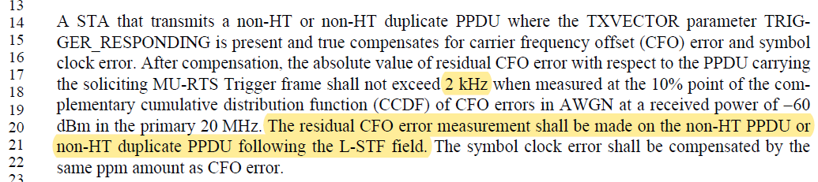

D3.2 P564:
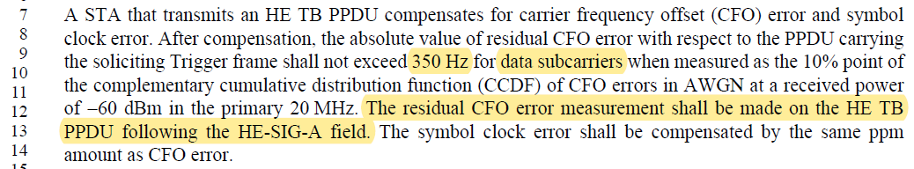

Proposed Resolution: CID 16088
Rejected.
28.3.14.3 measures the residual CFO after the HE-SIG-A, i.e., in the HE modulated fields, whereas 17.3.9.10 measures the residual CFO after L-STF, which is essentially the entire PPDU (minus the L-STF). Hence, there is no need to specifically call out “data subcarriers” in 17.3.9.10.

CID 15598

CID | Clause | Page.Line | Comment | Proposed Change
15598 | 17.3.9.10 | 249.34 | For STAs that do not compensate for the RTD, a distance greater than 60m between AP and STA causes the +-0.4us requirement in 17.3.9.10 to fail. We should add clarifying language to the spec that indicates this. | Replace the following sentence: "The STA is not expected to measure or compensate for the RTD when transmitting the non-HT or non-HT duplicate PPDU." with "For STAs that are less than or equal to 60 m apart from the AP, the STA is not expected to measure or compensate for the RTD when transmitting the non-HT or non-HT duplicate PPDU. For STAs that are more than 60 m apart from the AP, the STA is expected to measure and compensate for the RTD when transmitting the non-HT or non-HT duplicate PPDU."

Background

D3.2 P259:
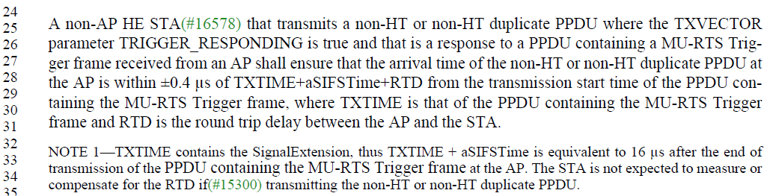

Proposed Resolution: CID 15598
Rejected.
CTS in response to MU-RTS is sent using the 6 Mbps rate. Furthermore, CTS in response to MU-RTS is not subject to transmit power control similar to that for HE TB PPDU. Hence, if some STAs have much smaller RTD compared to some other STAs, then it is likely that the CTS from the STA with smaller RTD would be received with higher power than the other STAs, further provide some relief to EVM degradation from STAs arriving with larger RTD.

[End of File]

