IEEE P802.11
Wireless LANs
CR on PHY Miscellaneous
Date: 2018-11-11
Author(s):
Name | Affiliation | Address | Phone | email
Yujin Noh | Newracom |  |  | yujin.noh at newracom.com
Abstract
This submission shows
- Resolution for a comment received from TGax comment collection (TGax Draft D3.0)
- The proposed changes are based on 11ax D3.2.

The submission provides resolutions to comments related to PHY Introduction.
- The submission provides resolutions to 20 CIDs:
16008, 15626, 16525, 16526, 16528, 16529, 16852, 16843, 16536, 16854,
16853, 16856, 16993, 16871, 15572, 16716, 15465, 16706, 16733 and 16717

Revisions:
- Rev 0: Initial version of the document.
- CID16733 and CID16856 updated based on PHY ad-hoc discussion

CID | P.L | Comment | Proposed Change | Resolution
16008 |  | "a" is a terrible name for the pre-fec padding factor! | Change all uses of "a" as the PFPF to "PFPF" | Rejected.  The commentor fails to identify what kinds of issues “a” as pre-FEC padding factor occur. In the current draft spec, “a” and “pre-FEC padding factor value” are used together and “a” is generally used to make the corresponding equations or indications simple. (e.g. equations in 28.3.11.2 (Pre-FEC padding process) or 28.3.11.5 (Coding)).  There is no harm to keep it this way.
15626 | 122.09 | DC is not in Acronym list | Add DC to acronym list, maybe defined as center frequency | Rejected.  Refering 3.2 (Definitions specific to IEEE 802.11) and proposed change, the commentor’s intention seems to add the definition of DC (not in Acronym list).  However, its definition is already shown in 28.3.9 (Mathematical description of signals) that the signal is transmitted with 0 being the center (DC) subcarrier.

CID | P.L | Comment | Proposed Change | Resolution
16525 | 410.54 | "The resource units (RUs) defined for DL and UL transmission are as follows" The acronym RU should be defined much earlier e.g. pg 410 line 2 ? | As in comment | Revised.  Agreed in priciple.  Given that RU is shown earlier than 28.3.2.2. (Resource unit, guard and DC subcarriers), the acronym RU needs to be defined before 28.3.2.2.  Now the definition of RU is shown in 28.3.1.2 (OFDMA).  TGax Editor: make changes according to this document 11-18-1790-01-00ax CR on PHY Miscellaneous on PHY Miscellaneous
To TGax editor: P428L01 replace the current text with the proposed changes below. (#16525)
------------- Begin Text Changes ---------------
Similar to OFDM, OFDMA employs multiple subcarriers, but the subcarriers are divided into several groups of subcarriers where each group is denoted as an resource unit (RU). With OFDMA, different transmit powers may be applied to different RUs.
------------- End Text Changes ---------------

To TGax editor: P428L54 replace the current text with the proposed changes below. (#16525)
------------- Begin Text Changes ---------------
28.3.2.2 Resource unit, guard and DC subcarriers
The resource units (RUs) defined for DL and UL transmission are as follows: 26-tone RU, 52-tone RU, 106- tone RU, 242-tone RU, 484-tone RU, 996-tone RU and 2$×$996-tone RU.
------------- End Text Changes ---------------

CID | P.L | Comment | Proposed Change | Resolution
16733 | 427.01 | It says "When the HE modulated fields are located in more than one 20 MHz channel, the pre-HE modulated fields are duplicated over the multiple 20 MHz channels, as shown in Figure 28-12", but Figure 28-12 doesn't show those fields, and neither the duplication. | Make a new figure to show the duplication of these fields | Rejected.  Figure 28-14 shows “When the HE modulated fields are located in more than one 20 MHz channel, the pre-HE modulated fields are duplicated over the multiple 20 MHz channels” with the texts on three kinds of RUs  - RUs located in one 20MHz channel (need 20 MHz pre-HE modulated fields)  - RUs located in two 20MHz channels (need 40 MHz duplicated pre-HE modulated fields)  - RUs located in four 20MHz channels (need 80 MHz duplicated pre-HE modulated fields)  Here, pre-HE modulated fields implicately means L-STF, L-LTF, L-SIG, RL-SIG and HE-SIG-A fields. We had a long discussion about this figure and decided this is the best way to explain the number of 20 MHz channels when transmitting the HE TB PPDUs.
Discussion
The original texts are below.
In the HE TB PPDU, the pre-HE modulated fields, which include L-STF, L-LTF, L-SIG, RL-SIG and HE-SIG-A fields, are sent only on the 20 MHz channels where the STA's HE modulated fields are located. If the HE modulated fields are located in more than one 20 MHz channel, the pre-HE modulated fields are duplicated over the multiple 20 MHz channels, as shown in Figure 28-14 (Number of 20 MHz channels occupied by the pre-HE modulated fields in an HE TB PPDU).
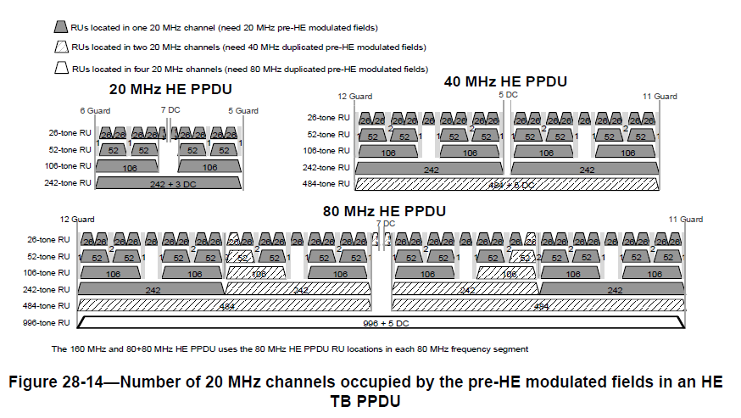

CID | P.L | Comment | Proposed Change | Resolution
15465 | 419.32 | "A full bandwidth MU-MIMO transmission using the HE MU PPDU format shall have a value of 1 for the SIGB Compression field in HE-SIG-A," should be "In a full bandwidth MU-MIMO transmission using the HE MU PPDU format, the SIBG Compression field in the HE-SIG-A shall be set to 1, | As in comment. | Rejected.  Given no grammar errors, I don’t see any big difference.
16706 | 421.50 | "An HE AP shall not allocate an RU in an 160 MHz or 80+80 MHz HE MU PPDU or HE TB PPDU to a 20 MHz operating non-AP HE STA with the 20 MHz In 160/80+80 MHz HE PPDU In 2.4 GHz Band subfield in the HE PHY Capabilities Information field in its HE Capabilities element equal to 0" | 160MHz not applicable in 2.4GHz band. Need to change band details. | Rejected.  Already fixed in D3.2 based on 11-18/1453r1
16526 | 410.58 | "The 26-tone RU, 52-tone RU, 106-tone RU and 242-tone RU are used in the 20 MHz, 40 MHz, 80 MHz,160 MHz and 80+80 MHz HE MU PPDU format. The 52-tone RU, 106-tone RU and 242-tone RU are usedin the 20 MHz, 40 MHz, 80 MHz, 160 MHz and 80+80 MHz HE TB PPDU format. The 26-tone RU is usedin the 20 MHz, 40 MHz, 80 MHz, 160 MHz and 80+80 MHz HE TB PPDU format, except when a STA isoperating in an operating class for which the behavior limits set listed in Annex E includes the DFS_50_100_Behavior (see 27.5.3.2.1 (General) and 27.5.3.3 (STA behavior for UL MU operation)). The106-tone RU is used in the HE ER SU PPDU format." Bullet points for easier reading ? | Make into bullet points | Rejected.  The current description is fully readable, so bullet points do not make any difference.
16528 | 417.36 | "The 20 MHz HE MU PPDU and HE TB PPDU with one or more RUs smaller than 242 tones has 7 DC subcarriers located at [-3: 3]. The 20 MHz HE SU PPDU, HE MU PPDU and HE TB PPDU with a 242-tone RU has 3 DC subcarriers located at [-1: 1]. The 40 MHz HE PPDU has 5 DC subcarriers located at [-2: 2]. An 80 MHz HE MU PPDU and HE TB PPDU with one or more RUs smaller than 996 tones has 7 DC subcarriers located at [-3: 3]. The 80 MHz HE SU PPDU, HE MU PPDU and HE TB PPDU with a 996-tone RU has 5 DC subcarriers located at [-2: 2]. The same structure as used in the 80 MHz HE PPDU is used for each 80 MHz frequency segment of the 160 MHz and 80+80 MHz HE PPDU. The DC tones are located on subcarriers [-11: 11]."; Place in table like Table 28-9 (Null subcarriers) | Have reference table | Rejected.  The current description corresponds to Figure 28-5 (RU locations in a 20 MHz HE PPDU), Figure 28-6 (RU locations in a 40 MHz HE PPDU) and Figure 28-7 (RU locations in an 80 MHz HE PPDU) especially for DC tones depending on the HE PPDU format and its bandwidth.  Given the three figures, having additional reference table does not make big difference when it comes to the readable aspect.
16529 | 417.47 | "The 20 MHz HE PPDU format has 11 guard subcarriers: the 6 lowest frequency subcarriers [-128: -123] and 5 highest frequency subcarriers [123: 127] as shown in Figure 28-5 (RU locations in a 20 MHz HE PPDU). The 40 MHz HE PPDU has 23 guard subcarriers: the 12 lowest frequency subcarriers [-256: -245] and the 11 highest frequency subcarriers [245: 255] as shown in Figure 28-6 (RU locations in a 40 MHz HE PPDU). The 80 MHz HE PPDU has 23 guard subcarriers: the 12 lowest frequency subcarriers [-512: -501] and the 11 highest frequency subcarriers [501: 511] as shown in Figure 28-7 (RU locations in an 80 MHz HE PPDU). For 160 MHz and 80+80 MHz HE PPDUs, the same number of lowest frequency and highest frequency guard subcarriers as 80 MHz are defined at each edge of the 160 MHz and 80+80 MHz.": Place in table like Table 28-9 (Null subcarriers) | Have reference table | Rejected  The current description corresponds to Figure 28-5 (RU locations in a 20 MHz HE PPDU), Figure 28-6 (RU locations in a 40 MHz HE PPDU) and Figure 28-7 (RU locations in an 80 MHz HE PPDU) especially for Guard tones depending on its bandwidth of HE PPDU.  Given the three figures, having additional reference table does not make big difference when it comes to the readable aspect.
16852 | 475.05 | The subclause title "Encoding and modulation" doesn't seem to be compatible to the content description. | Please update accordingly if agreed. | Rejected  Commentor fails to clarify why "Encoding and modulation" is not compatible to the content desciption. This subclause contains how HE-SIG-A1 and HE-SIG-A2 are BCC encoded and BPSK/QBPSK modulated in addition to the time domain waveforms for the HE-SIG-A field which need to be present in HE-SIG-A subclause.
16843 | 477.36 | The subclause title "Encoding and modulation" doesn't seem to be compatible to the content description. It seems to me that this subclause addresses frequency allocations for the users. | Update accordingly if confirmed. | Rejected.  It is true some part addresses freuquency allocation for users. However, it mostly corresponds to how to encode as shown an example of Figure 28-25 (HE-SIG-B field encoding structure in each 20 MHz) that each two users (only one user before Padding, if needed) are grouped and BCC encoded, and common bits are BCC encoded, respectively. Moreover, this subcluse contains how to modulate HE-SIG-B by a value in SIGB MCS field in HE-SIG-A.  More specific frequency allocation for User Specific field consisting of multiple User fields come up with 28.3.10.8.5 HE-SIG-B per user content.

CID | P.L | Comment | Proposed Change | Resolution
16536 | 486.43 | "When signaling RUs of size greater than 242 subcarriers, y2y1y0 = 000-111 indicates number of User fields inthe HE-SIG-B content channel that contains the corresponding 8-bit RU Allocation subfield. Otherwise, y2y1y0= 000-111 indicates number of STAs multiplexed in the 106-tone RU, 242-tone RU or the lower frequency 106-tone RU if there are two 106-tone RUs and one 26-tone RU is assigned between two 106-tone RUs. The binaryvector y2y1y0 indicates 22 ├ù y2 + 21 ├ù y1 + y0 + 1 STAs multiplexed the RU.z2z1z0 = 000-111 indicates number of STAs multiplexed in the higher frequency 106-tone RU if there are two106-tone RUs and one 26-tone RU is assigned between two 106-tone RUs. The binary vector z2z1z0 indicates22 ├ù z2 + 21 ├ù z1 + z0 + 1 STAs multiplexed in the RU." article "the" is missing before the word "number" three times in this paragraph | When signaling RUs of size greater than 242 subcarriers, y2y1y0 = 000-111 indicates THE number of User fields inthe HE-SIG-B content channel that contains the corresponding 8-bit RU Allocation subfield. Otherwise, y2y1y0= 000-111 indicatesTHE number of STAs multiplexed in the 106-tone RU, 242-tone RU or the lower frequency 106-tone RU if there are two 106-tone RUs and one 26-tone RU is assigned between two 106-tone RUs. The binaryvector y2y1y0 indicates 22 ├ù y2 + 21 ├ù y1 + y0 + 1 STAs multiplexed the RU.z2z1z0 = 000-111 indicatesT THE number of STAs multiplexed in the higher frequency 106-tone RU if there are two106-tone RUs and one 26-tone RU is assigned between two 106-tone RUs. The binary vector z2z1z0 indicates22 ├ù z2 + 21 ├ù z1 + z0 + 1 STAs multiplexed in the RU. | Revised.  Agreed in priciple.  TGax Editor: make changes according to this document 11-18-1790-01-00ax CR on PHY Miscellaneous
To TGax editor: P505L43 replace the current text with the proposed changes below. (#16536)
------------- Begin Text Changes ---------------
If signaling RUs of size greater than 242 subcarriers, y₂y₁y₀ = 000–111 indicates the number of User fields in the HE-SIG-B content channel that contains the corresponding 8-bit RU Allocation subfield. Otherwise, y₂y₁y₀ = 000–111 indicates the number of STAs multiplexed in the 106-tone RU, 242-tone RU or the lower frequency 106-tone RU if there are two 106-tone RUs and one 26-tone RU is assigned between two 106-tone RUs. The binary vector y₂y₁y₀ indicates 2² × y₂ + 2¹ × y₁ + y₀ + 1 STAs multiplexed the RU.
z₂z₁z₀ = 000–111 indicates the number of STAs multiplexed in the higher frequency 106-tone RU if there are two 106-tone RUs and one 26-tone RU is assigned between two 106-tone RUs. The binary vector z₂z₁z₀ indicates 2² × z₂ + 2¹ × z₁ + z₀ + 1 STAs multiplexed in the RU.
Similarly, y₁y₀ = 00–11 indicates the number of STAs multiplexed in the lower frequency 106-tone RU. The binary vector y₁y₀ indicates 2¹ × y₁ + y₀ + 1 STAs multiplexed in the RU.
------------- End Text Changes ---------------

CID | P.L | Comment | Proposed Change | Resolution
16854 | 496.06 | Does HE SU PPDU or HE ER SU PPDU incur one RU only? If so, r-th RU in the sentence is confusing. Suggest breaking it up to two sentences to cover SU PPDU and MU PPDU carrying N_STS and N_STS,r,total, respectively, as defined in table 28-15. | Please update accordingly if agreed. | Revised.  Looking at P466L20, there is Note that Nsts,r,total = Nsts for an HE SU PPDU. To be consistent, current text is modified.  In case of HE ER SU PPDU, only “upper frequency 106-tone RU” can be used such that to use Nsts is fine as well.  TGax Editor: make changes according to this document 11-18-1790-01-00ax CR on PHY Miscellaneous
To TGax editor: P515L37 replace the current text with the proposed changes below. (#16854)
------------- Begin Text Changes ---------------
28.3.10.10 HE-LTF
The HE-LTF field provides a means for the receiver to estimate the MIMO channel between the set of con-stellation mapper outputs (or, if STBC is applied, the STBC encoder outputs) and the receive chains. In an HE SU PPDU and HE ER SU PPDU, the transmitter provides training for N_{STS,} space-time streams (spatial mapper inputs) used for the transmission of the PSDU. In an HE SU PPDU, HE ER SU PPDU and HE MU PPDU, the transmitter provides training for N_{STS,r,total} space-time streams (spatial mapper inputs) used for the transmission of the PSDU(s) in the r-th RU.
------------- End Text Changes ---------------
CID | P.L | Comment | Proposed Change | Resolution
16853 | 496.11 | Not sure mentioning N_RX is intentional in a transmit centric paragraph. It seems no particular value. Can we delete the sentence or correct it if it is a typo or elaborate it if N_RX is intended? | Please update accordingly if agreed. | Rejected.  N_{RX} $×$ N_{STS,r,total} in the r-th RU is the general expression for the MIMO channel that can be estimated. It is intentional and has presented in VHT-LTF as well. N_{RX} is also used for the receive signal at beamformee later at 28.3.15 (SU-MIMO and DL MU-MIMO beamforming)

CID | P.L | Comment | Proposed Change | Resolution
16856 | 512.19 | The index u and r on the right hand side of eq. 28-59 are fixed numbers. Should they need to appear on the left hand side of the equation like i_Seg and i_Tx? | Please clarify. | Revised.  Agreed in principle.  The corresponding equations for HE-STF, HE-LTF and HE-data need to be updated.  TGax Editor: make changes according to this document 11-18-1790-01-00ax CR on PHY Miscellaneous
Discussion
Given Equation (28-4) in an HE-TB PPDU transmitted by user u in the r-th RU, each subfield is defined in the spec below.
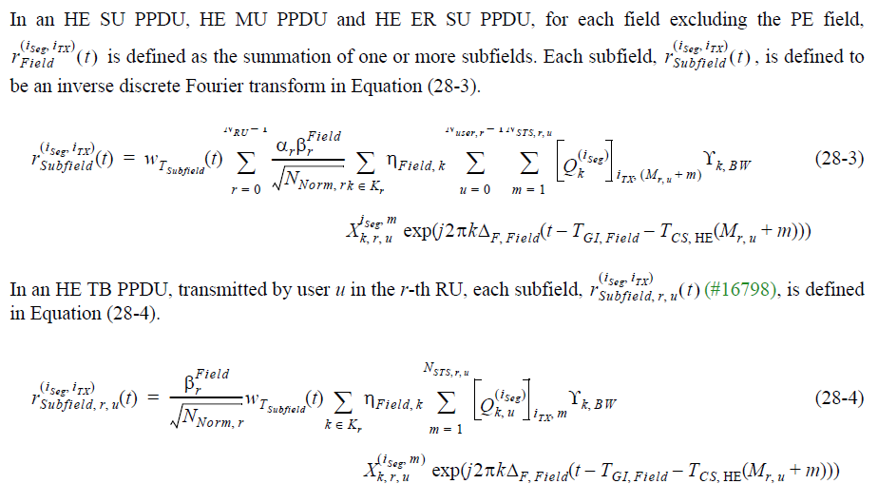
In current spec, corresponding equations in HE-STF, HE-LTF and HE-data are not present this way as commentor mentioned.
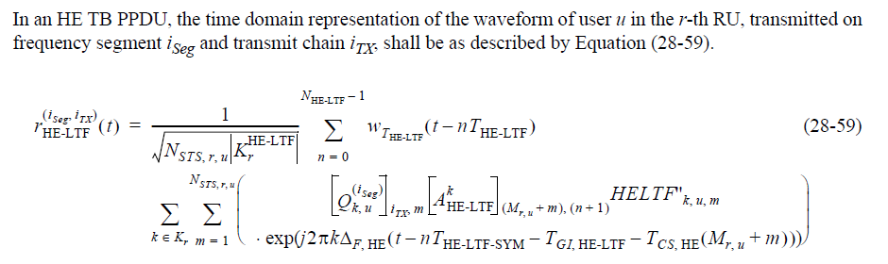
To TGax editor: P515L13 replace $r_{\text{HE-STF}}^{\left(i_{seg}, i_{tx}\right)}\left(t\right)$ with $r_{\text{HE-STF}\text{, r, u}}^{\left(i_{seg},i_{tx}\right)}\left(t\right)$ below. (#16856)
------------- Begin Text Changes ---------------
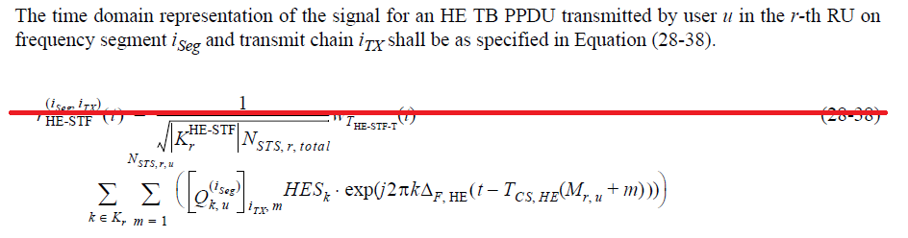
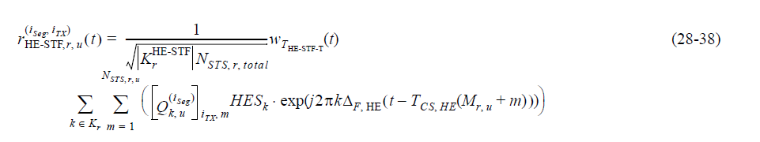
------------- End Text Changes ---------------
To TGax editor: P531L13 replace $r_{\text{HE-}\text{LTF}}^{\left(i_{seg}, i_{tx}\right)}\left(t\right)$ with $r_{\text{HE-}\text{LTF}\text{, r, u}}^{\left(i_{seg},i_{tx}\right)}\left(t\right)$ below. (#16856)
------------- Begin Text Changes ---------------
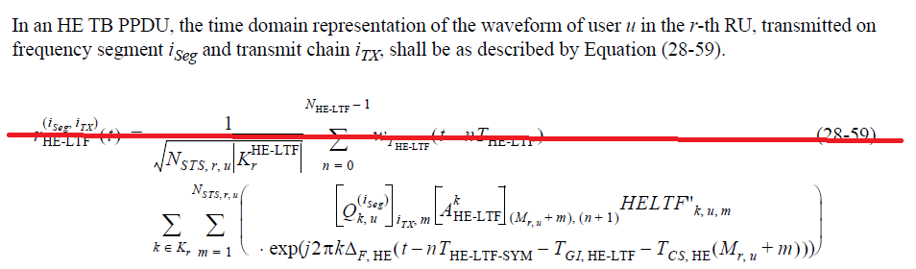
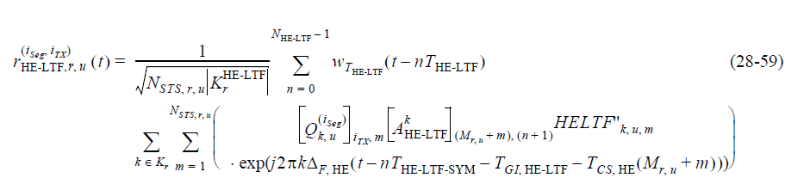
------------- End Text Changes ---------------
To TGax editor: P555L05 replace $r_{\text{HE-}\text{Data}}^{\left(i_{seg}, i_{tx}\right)}\left(t\right)$ with $r_{\text{HE-}\text{Data}\text{, r, u}}^{\left(i_{seg},i_{tx}\right)}\left(t\right)$ below. (#16856)
------------- Begin Text Changes ---------------
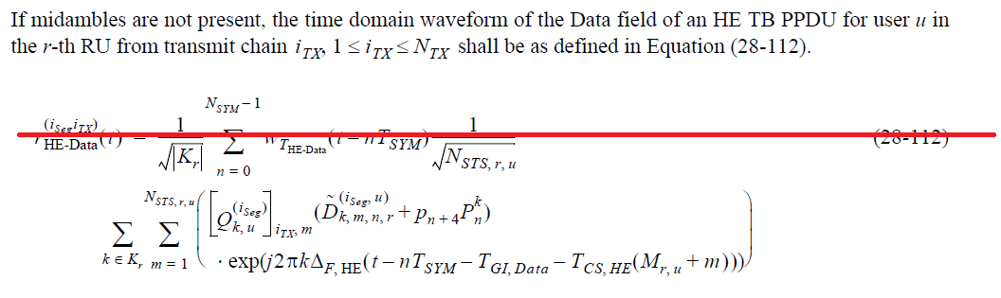
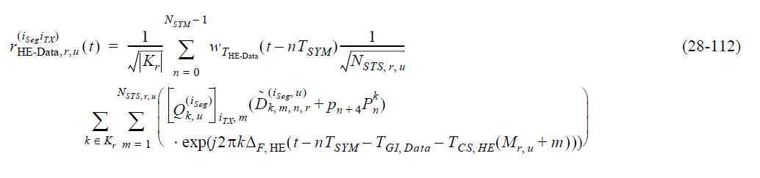
------------- End Text Changes ---------------
CID | P.L | Comment | Proposed Change | Resolution
16993 | 518.58 | "First compute initial pre-FEC padding factor value (ainit,u) for each user u using Equation (28-61), and the initial number of OFDM symbols (NSYM,init,u) for each user u using Equation (28-64) if user u is BCC encoded, or Equation (28-64) if user u is LDPC encoded." Remove "if user u is BCC encoded, or Equation (28-64) if user u is LDPC encoded". | as in comment | Rejected  It was already modified by the CID17096 and implemented well in D3.2.
16871 | 524.06 | Figures 28-36 through 28-39 use very tiny fonts and are difficult to read. | It would be useful to enlarge these figures to the edges of the page, and possibly increase the size of the font by 1 or 2 pts. | Rejected.  Those figures are the constellation bit mapping of 1024 QAM. The same comment (CID9012) was rejected in 11-17-0331r02 since if zoomed in, it can be readable.

CID | P.L | Comment | Proposed Change | Resolution
15572 | 537.33 | Can be rephased as "An HE STA shall not transmit an HE MU PPDU with midambles if there is MU-MIMO on any RU". | as in comment | Revised.  To make it clear, the current text updated.  TGax Editor: make changes according to this document 11-18-1790-01-00ax CR on PHY Miscellaneous
To TGax editor: P556L33 replace the current text with the proposed changes below. (#15572)
------------- Begin Text Changes ---------------
An HE STA shall not transmit an HE MU PPDU with midambles present and with MU-MIMO on an RU. An HE STA shall not transmit an HE MU PPDU with midambles if there is MU-MIMO on any RU.
------------- End Text Changes ---------------

CID | P.L | Comment | Proposed Change | Resolution
16716 | 537.55 | "When midamble is used in an HE SU PPDU, HE ER SU PPDU or HE MU PPDU, the number of space-timestreams in the PPDU shall not be greater more than that indicated by the maximum..." | Change "...PPDU shall not be greater more than that indicated..." to "...PPDU shall not be greater than that indicated.." | Revised.  TGax Editor: make changes according to this document 11-18-1790-01-00ax CR on PHY Miscellaneous
To TGax editor: P556L54 replace the current text with the proposed changes below. (#16716)
------------- Begin Text Changes ---------------
If midamble is used in an HE SU PPDU, HE ER SU PPDU or HE MU PPDU, the number of spacetime streams in the PPDU shall not be greater more than that indicated by the maximum of the values indicated by the Midamble Tx/Rx Max NSTS subfield in the PHY Capabilities Information field in the HE Capabilities element set by the recipient STA(s), as defined in 9.4.2.241.3 (HE PHY Capabilities Information field).An AP shall not trigger a non-AP STA to transmit an HE TB PPDU with midamble using number of space-time-streams higher than the values indicated by the non-AP STA's Midamble Tx/Rx Max NSTS subfield in the HE Capabilities elements.
------------- End Text Changes ---------------

CID | P.L | Comment | Proposed Change | Resolution
16717 | 548.37 | Edits to "N is the number of 20 MHz ppunctured channels. An example transmit spectral mask for Nx20..." to improve readability | Denote the number of 20 MHz punctured channels by N. An example transmit spectral mask for Nx20 MHz preamble punctured channel with transmission on both the upper and lower subchannels is shown in Figure 28-51, where the X axis in the plot is centered in the middle of the punctured subbands. Two examples are illustrated below in figures 28-51, 28-52 | Revised.  TGax Editor: make changes according to this document 11-18-1790-01-00ax CR on PHY Miscellaneous
Discussion
For your information, corresponding figure (Figure 28-52 ) is added below
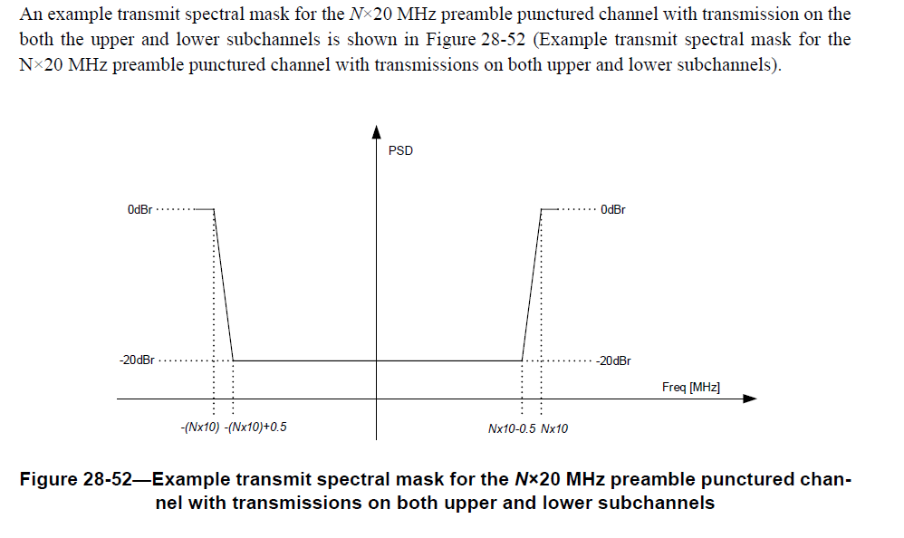
To TGax editor: P515L37 replace the current text with the proposed changes below. (#16717)
------------- Begin Text Changes ---------------
For preamble puncture, the signal leakage to the preamble punctured channel from the occupied subchannels shall be less than or equal to -20 dBr (dB relative to the maximum spectral density of the signal) starting 0.5 MHz from the boundary of the preamble punctured channel. N is the number of 20 MHz punctured channels. Denote the number of 20 MHz punctured channels by N.
An example transmit spectral mask for the N×20 MHz preamble punctured channel with transmission on the both the upper and lower subchannels is shown in Figure 28-52 (Example transmit spectral mask for the N×20 MHz preamble punctured channel with transmissions on both upper and lower subchannels), where the X axis in the plot is centered in the middle of the punctured subbands.
------------- End Text Changes ---------------

