IEEE P802.11
Wireless LANs
Resolution to CID 1272
Date: 2108-10-18
Author(s):
Name | Affiliation | Address | Phone | email
Christopher Hansen | Peraso |  |  | chris@covariantcorp.om
Abstract
Proposed resolution to CID 1272 in 802.11md LB232

CID | Page | Line | Clause | Comment | Proposed Change
1272 | 3393.61 | 61 | B.4.24.1 | Labeling beam tracking as mandatory in the PICS is inconsistent with text in other parts of the standard. There are DMG capability bits that signal Beam tracking is not supported. (See Table 9-245, p.9.4.2.127.4) Beam tracking is optional and the PICS should follow. Furthermore, following the normative text in Section 10.39.7, p.1869, line 50, that mandates that a response will not be provided if the bit is set to zero (which results in dot11BeamTrackingTimeLimit being set to zero). | Label Beam tracking as optional in the PICS.

Proposal: Accept

Discussion:

The PICS current specifies Beam Tracking from 10.39.7 as being mandatory. See:

However, this is inconsistent with other parts of the 802.11 standard, which allow a DMG STA to signal that Beam tracking is not supported.

Looking at D1.0 p.1210, Section 9.4.2.127.4, we that a DMG STA setting its Beam Tracking Time Limit to zero will create a condition where Beam Tracking is not supported no matter what it's peer STA has set for it's Beam Tracking Time Limit:

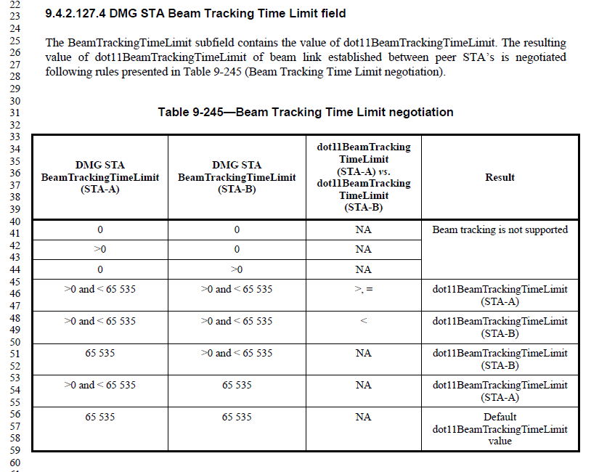

Zero is used to signal that Beam tracking is not supported.

The Beam Tracking TimeLimit subfield is contained in the DMG Capabilities element. (See 9.4.2.127 DMG Capabilities element on p.1205).

Futhermore, normative text in 10.39.7, p.1869, line 50 states that a DMG STA:

"shall not transmit a BRP frame with feedback to the beam tracking initiator if the time period between PHY-RXEND.indication primitive of the PPDU that contains the beam tracking request and of PHY-TXEND.confirm primitive of the response BRP frame is longer than dot11BeamTrackingTimeLimit."

Following the normative text as written, Beam Tracking feedback is only allowed when provided before the dot11BeamTrackingTimeLimit. When either STA signals zero for it's limit in it's DMG Capabilities, then the value of dot11BeamTrackingTimeLimit is null and Beam tracking feedback will not be provided.

Since the PICs is inconsistent with the normative text, the proper resolution is to change the PICS to match the normative text.

Resolution:

Instruct the Editor to change DMG-M9.8 Beam tracking to CFDMG:O.

