IEEE P802.11
Wireless LANs
LB234 Comment Resolutions – PHY and BF II
Date: 2018-10-23
Author(s):
Name | Affiliation | Address | Phone | email
Claudio da Silva | Intel |  |  | claudio.da.silva@intel.com
Abstract
This submission proposes resolutions to PHY and BF CIDs. The text used as reference is D2.0.

CID | Clause | Page | Comment | Proposed change
3007 | 10.43.6.3 | 241.15 | "chosen sectors" are discussed. There is no text on how the list is generated or how sectors are chosen. | Clarify as commented

Proposed resolution: Rejected

Discussion: The text referred to by the commenter is
“The EDMG responder shall then transmit through a list of chosen sectors during the TRN field of the transmitted PPDU.”
“Chosen sectors” appears multiple times in the MIDC subphase subclause (10.38.6.3 in 802.11-2016), including in the paragraph referred to by the commenter. In the General subclause (10.38.6.3.1) within the MIDC subphase sublause, which does not appear in 802.11ay D2.0, it is stated that sectors are “chosen by the receiver in an implementation dependent manner, that maximizes the probability of determining the RX AWVs that best match the chosen set of TX sectors.” Since the definition appears in the General subclause of the text pointed out by the commenter, to avoid duplication, we propose to not re-define “chosen” later on in the same sublause.

CID | Clause | Page | Comment | Proposed change
3216 | 29.9.2.2.4 | 531.21 | The relation between Nsymmin and aBRPminOFDMsym is unclear. If the length is specified at the Service interface, why is a new parameter needed? | Remove this paragraph or explain the relationship between the requirements - which one overrides
3461 | 29.9.2.2.4 | 531.14 | "currently the spec has multple mechanisms to dtermine min number of OFDM symbols in a OFDM BRP PPDU  1) Requested BRP OFDM symbols in Beamforming Capability subelement  2) an equation which derives min OFDM symbols based on min SC blocks in 29.9.2.2.4 in p531 L14  3) The requirement that uses the old aBRPminOFDMblocks parameter in p531 L21" | use either 1) or 2) but not both for EDMG STA to determine the min OFDM symbols of a BRP packet

Proposed resolution: Revised

Discussion: It is defined in 10.43.9.1 that

“If an EDMG STA transmits a BRP frame and at least one of the addressed receivers’ EDMG Capabilities element does not include the Beamforming Capability subelement, the TXVECTOR parameter EDMG_BRP_MIN_SC_BLOCKS shall be set to aBRPminSCBlocks that is specified in 20.11.4.”

and in 29.9.2.2.4 that

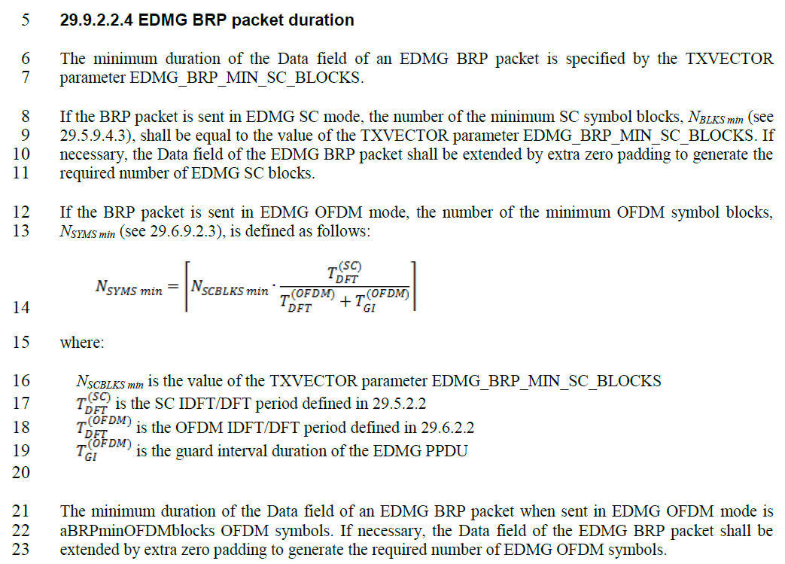

Therefore, for an EDMG OFDM PPDU, if EDMG_BRP_MIN_SC_BLOCKS is not defined, aBRPminSCBlocks will be used. Thus, there is no reason to define aBRPminOFDMblocks.

Modifications:
- Delete “Requested BRP OFDM Symbols” subfield from Figure 44.

- Delete lines 11-14 of page 107.

- Modify lines 21-23 of page 531 as follows
The minimum duration of the Data field of an EDMG BRP packet when sent in EDMG OFDM mode is aBRPminOFDMblocks OFDM symbols. If necessary, the Data field of the EDMG BRP packet shall be extended by extra zero padding to generate the required number of EDMG OFDM symbols.

- Delete last line of page 643 (Table 153 —EDMG PHY characteristics): aBRPminOFDMblocks 20

- In the dot11 Phy EDMG TABLE (page 664),
- Line 11: dot11RequestedBRPSCBlocks dot11RequestedBRPMinDataLength
- Line 12: dot11RequestedBRPOFDMBlocks Unsigned32,
- Line 23: dot11RequestedBRPSCBlocks dot11RequestedBRPMinDataLength
- Lines 31-33: This attribute indicates the minimum number of data SC blocks or OFDM symbols that the STA requests be included in a PPDU carrying a TRN field and transmitted to the STA.
- Delete lines 37-49 (definition of dot11RequestedBRPOFDMBlocks).

CID | Clause | Page | Comment | Proposed change
3226 | 10.43.4 | 234.15 | "An EDMG STA may set the TRN-LEN parameter of the TXVECTOR to a value greater than or equal to 0 if the PACKET-TYPE parameter of the TXVECTOR is set to TRN-R-PACKET and shall set the TRN LEN parameter of the TXVECTOR to 0 if the PACKET-TYPE parameter of the TXVECTOR is set to TRN-T-PACKET for a DMG Beacon frame." - why allow a TRN-T-PACKET in beacons? | replace quoted test by "An EDMG STA may set the TRN-LEN parameter of the TXVECTOR to a value greater than or equal to 0 if the PACKET-TYPE parameter of the TXVECTOR is set to TRN-R-PACKET. A beacon frame shall not have the PACK-TYPE parameter set to TRN-T-PACKET"

Proposed resolution: Revised

Modifications: Please modify lines 15-18 of page 234 as follows

An EDMG STA may set the TRN-LEN parameter of the TXVECTOR of a PPDU containing a DMG Beacon frame to a value greater than or equal to 0 if the PACKET-TYPE parameter of the TXVECTOR is set to TRN-R-PACKET and shall set the TRN-LEN parameter of the TXVECTOR to 0 if the PACKET-TYPE parameter of the TXVECTOR is set to TRN-T-PACKET for a DMG Beacon frame. The PACKET-TYPE parameter of the TXVECTOR of a PPDU containing a DMG Beacon frame shall not be set to TRN-T-PACKET.

CID | Clause | Page | Comment | Proposed change
3267 | 29.9.2.2.3 | 530.22 | The usage of M and N here does not seem to be consistent with how they are defined in Figure 198 and 199. This is confusing. | M and N are encoded in the L-Header with their values decremented by one, but in the draft text we should write them as the actual values, i.e. M=6, N=3 and M=8, N=1. This will make them consistent with Figures 198 and 199.

Proposed resolution: Revised

Discussion: P and N are defined by EDMG TRN-Unit P and EDMG TRN-Unit N, respectively, by non-linear relationships.
Labels in Figures 198 and 199 should be changed to reflect how the relationship between P/M/N and their corresponding header fields are defined in the text. For example:
- “For EDMG BRP-TX packets, the transmitter may change the AWV at the beginning of each set of N TRN subfields present in the last M TRN subfields of each TRN-Unit in the TRN field, where N is the value indicated by the EDMG TRN-Unit N field within the EDMG-Header-A.”
- “The P TRN subfields at the start of each TRN-Unit transmitted with the same AWV are not indexed, where P is the value indicated by the EDMG TRN-Unit P field in the EDMG-Header-A of the packet.”
The relationship between P/M/N and their corresponding header fields is defined in the paragraphs immediately before and after the figures.

Modifications: Replace figures 198 and 199 with the following ones:

CID | Clause | Page | Comment | Proposed change
3448 | 10.43.6.3.3 | 241.11 | "An EDMG responder, responding to an EDMG initiator, may choose to use a single PPDU for training during the MID phase by setting the TXVECTOR parameter EDMG_TRN_LEN to a value greater than zero and the parameter RX_TRN_PER_TX_TRN to a value equal to the value of the L-RX subfield transmitted during the last SLS phase or last BRP setup subphase'  for BRP setup, the parameter RX_TRN_PER_TX_TRN should be based on L-TX-RX of the EDMG request element" | as in comment

Proposed resolution: Rejected

Discussion: The case pointed out by the commenter is when the initiator requestes receive training and the responder, in an opportunistic manner, sends instead a BRP RX/TX packet to take the opportunity and also train its transmit settings. Similar procedure has also been defined for beam tracking – please refer to the text below. As a result, in this particular case, L-TX-RX is not defined in the BRP setup.

Beam tracking example (page 244, D2.0): “If BEAM_TRACKING_REQUEST parameter in the RXVECTOR is Beam Tracking Not Requested, EDMG_BEAM_TRACKING_REQUEST parameter in the RXVECTOR is Beam Tracking Requested, EDMG_BEAM_TRACKING_TYPE parameter in the RXVECTOR is Analog Beam Tracking, and EDMG_PACKET_TYPE parameter in the RXVECTOR is EDMG-TRN-R-PACKET, follow the rules described in 29.9.2.2 and the beam tracking responder shall respond with either an EDMG BRP-RX packet or an EDMG BRP-RX/TX packet to the initiator in the same allocation, with an MCS index greater than 0. If the responder sends an EDMG BRP-RX packet, the value of TXVECTOR parameter EDMG_TRN_LEN in the following packet from the responder to the initiator shall be equal to the value of the EDMG_TRN_LEN parameter in the RXVECTOR of the packet from the initiator. If the responder sends EDMG BRP-RX/TX packet, the value of TXVECTOR parameter RX_TRN_PER_TX_TRN in the following packet from the responder to the initiator shall be equal to the value of the EDMG_TRN_LEN parameter in the RXVECTOR of the packet from the initiator.”

CID | Clause | Page | Comment | Proposed change
3231 | 10.43.7 | 245.41 | "The BEAM_TRACKING_REQUEST parameter in the RXVECTOR is Beam Tracking Requested" - better define in what packet | as in comment

Proposed resolution: Revised

Modifications: Please modify lines 38-48 of page 245 as follows

If the responder has never received a BRP frame from the initiator with TX-TRN-REQ equal to 1, and if:
- If the The BEAM_TRACKING_REQUEST parameter in the RXVECTOR of the packet sent by the initiator requesting beam tracking is Beam Tracking Requested, the responder shall respond with all subfields of the FBCK-TYPE field equal to 0 and set the BS-FBCK field to the index of the TRN-T subfield that was received with the best quality.
- If, in the packet sent by the initiator requesting beam tracking, The BEAM_TRACKING_REQUEST parameter in the RXVECTOR is Beam Tracking Not Requested, EDMG_BEAM_TRACKING_REQUEST parameter in the RXVECTOR is Beam Tracking Requested, EDMG_BEAM_TRACKING_TYPE in the RXVECTOR is Analog Beam Tracking, and Packet Type is equal to TRN-T-PACKET, the responder shall respond with all subfields of the FBCK-TYPE field equal to 0 and set the BS-FBCK field to the AWV feedback ID corresponding to TRN subfields received with best quality.

CID | Clause | Page | Comment | Proposed change
3229 | 10.43.7 | 245.8 | "The feedback type shall be the same as the feedback type in the last BRP frame that was transmitted from the responder to the initiator with TX-TRN-REQ equal to 1. If the responder has never received a BRP frame 9 from the initiator with TX-TRN-REQ equal to 1," - the two sentences collide - the feedback type is defined by a reqeust from the respodner to the initiator (implicity indicating an initiator capability), and then then next sentence ask about a request from the initiator to the responder. | change second sentence to "If the initiator has never received a BRP frame fromt the respodner with TX-TRN-REQ equal to 1,"

Proposed resolution: Accepted

Discussion: For reference, paragraph referred to by the commenter is:
If a beam tracking responder sends an EDMG BRP-RX/TX packet in response to an analog receive beam tracking request, the beam tracking initiator may append the feedback to any packet to the responder. The feedback type shall be the same as the feedback type in the last BRP frame that was transmitted from the responder to the initiator with TX-TRN-REQ equal to 1. If the responder initiator has never received a BRP frame from the initiator responder with TX-TRN-REQ equal to 1, the initiator shall respond with all subfields of the FBCK-TYPE field equal to 0 and set the BS-FBCK field to the AWV feedback ID corresponding to TRN subfields received with best quality.

CID | Clause | Page | Comment | Proposed change
3719 | 11.33 | 328.21 | "In an EDMG BSS, when operating over multiple channels, the occupied bandwidth of a PPDU transmitted by a TXOP holder may be smaller than the occupied bandwidth of the last PPDU (10.40.11.2)." I read suclause 10.40.11.2 but the sentence is still not clear. Is the last PPDU in the same TXOP, which may be transmitted by a responder? Does it mean that the TXOP holder can first start with a wider bandwidth and in the middle, narrow it down, but the last PPDU should be the same bandwidth with the PPDU that acquired the TXOP??? | Clarify the sentence.

Proposed resolution: Revised

Modifications: Please modify lines 21-23 of page 328 as follows:

In an EDMG BSS, when operating over multiple channels, the occupied bandwidth of a PPDU transmitted by a TXOP holder may be smaller than the occupied bandwidth of the last PPDU (10.40.11.2) transmitted by the TXOP holder within the same TXOP (10.6.7.6).

CID | Clause | Page | Comment | Proposed change
3399 | 9.5.7 | 161.6 | TX-FBCK-REQ is not defined | remove this field

Proposed resolution: Accepted

Discussion: The EDMG BRP field has two subfields with similar name: TX-FBCK-REQ and TXSS-FBCK-REQ. While TXSS-FBCK-REQ appears/is used in various subclauses, as mentioned by the commenter, TX-FBCK-REQ is not and should be deleted.

CID | Clause | Page | Comment | Proposed change
3367 | 9.5.7 | 161.7 | The 1-bit Short SSW Packet Used field should be changed to 2-bit Sector Sweep Frame Type field as defined in 9.4.2.129 | as per comment

Proposed resolution: Accepted

Discussion: This modification mirrors a change (replacing “Short SSW Packet Used” with “Sector Sweep Frame Type”) made in the DMG Beam Refinement element (9.4.2.129).

CID | Clause | Page | Comment | Proposed change
3525 | 9.4.2.253 | 118.1 | Summary description of EDMG Sector ID Order is missing in the Meaning column EDMG channel measurement feedback element | Summary description of EDMG Sector ID Order should be in the Meaning column similar to the Sector ID Order field in the channel measurement feedback element

Proposed resolution: Revised

Discussion: Same definition used in the channel measurement feedback element (802.11-2016) is proposed.

Modifications: Please add the definitions given below, for k = 1… N_{meas}, in the appropriate “meaning” table fields for the “EDMG Sector ID Order” and “Additional EDMG Sector ID Order” fields
- Sector ID_{k}/CDOWN_{k}/AWV Feedback ID_{k} – Sector ID/CDOWN/AWV Feedback ID for SNR_{k} being obtained, or sector ID/CDOWN/AWV Feedback ID of the k^{th} detected beam.
- TX antenna ID_{k} – TX Antenna ID corresponding to Sector ID_{k}/CDOWN_{k}/AWV Feedback ID_{k}
- RX antenna ID_{k} – RX Antenna ID corresponding to Sector ID_{k}/CDOWN_{k}/AWV Feedback ID_{k}

CID | Clause | Page | Comment | Proposed change
3526 | 9.4.2.253 | 118.1 | Summary description of BRP CDOWN is missing in the Meaning column EDMG channel measurement feedback element | Summary description of BRP CDOWN should be in the Meaning column

Proposed resolution: Revised

Discussion: Description of BRP CDOWN field: “The EDMG Sector ID Order field and the BRP CDOWN field can be divided into Nmeas SISO ID subsets. Specifically, the i SISO ID subset (i = 1,2,…, Nmeas) comprises the values of the AWV feedback IDi, TX antenna IDi, RX antenna IDi and BRP CDOWNi subfields, where the AWV feedback IDi subfield indicates the AWV for a TX DMG antenna having its TX antenna ID equal to the TX antenna IDi value, which is used to transmit an EDMG BRP-RX/TX packet or EDMG BRP-TX packet with the BRP CDOWN field set to the BRP CDOWNi value.”

Modifications: Please add the definitions given below, for k = 1… N_{meas}, in the appropriate “meaning” table fields for the “BRP CDOWN” and “Additional BRP CDOWN” fields
- BRP CDOWN_{k}: BRP CDOWN corresponding to AWV Feedback ID_{k}

