IEEE P802.11
Wireless LANs
CR on PHY subcarriers and RU part 2
Date: 2018-11-11
Author(s):
Name | Affiliation | Address | Phone | email
Yujin Noh | Newracom |  |  | yujin.noh at newracom.com
Abstract
This submission shows
- Resolution for a comment received from TGax comment collection (TGax Draft D3.0)
- The proposed changes are based on 11ax D3.2.

The submission provides resolutions to comments related to PHY subcarriers and RU.
- The submission provides resolutions to 4 CIDs:
16632, 16692, 16693 and 16694

Revisions:
- Rev 0: Initial version of the document.
- Rev 1: modify resolution to CID16694 and add discussion based on the PHY ad-hoc meeting.

CID | P.L | Comment | Proposed Change | Resolution
16632 | 418.38 | Are there indeed cases where an HE-LTF would not have any pilot subcarriers? | Either a) Rewrite to "The location of pilot subcarrers ... shall be the same as ... the 4x HE-LTF except for pilot subcarriers that are deleted because they do not meet the following conditions: in a 1x HE-LTF, pilot subcarriers that are not a multiple of 4 are deleted, and in a 2x HE-LTF pilot subcarriers that are not a multiple of 2 are deleted" or b) add a note to explain how this field can be entirely bereft of pilot subcarriers | Revised.  TGax Editor: make changes according to this document 11-18-1734-01-00ax CR on PHY subcarriers and RU part 2
To TGax editor: P436L41 replace the current text with the proposed changes below. (#16632)
------------- Begin Text Changes ---------------
28.3.2.4 Pilot subcarriers
If pilot subcarriers are present in the HE-LTF field of an HE SU PPDU, HE MU PPDU, HE ER SU PPDU, or HE TB PPDU, the pilot subcarrier locations in the HE-LTF field and Data field shall be are the same for the 4x HE-LTF. In a 1x HE-LTF, the pilot subcarrier locations in the HE-LTF only consist of the pilot subcarri-ers for the Data field that are multiples of four. If pilot subcarriers are present in a 2x HE-LTF, then their locations shall be the same as those pilots in a 4x data symbol. All pilot subcarriers are at the even indices enumerated in Table 28-10 (Pilot subcarrier indices).
------------- End Text Changes ---------------

CID | P.L | Comment | Proposed Change | Resolution
16692 | 421.45 | This statement and the one in the next paragraph belong in the MAC clause. | Move to MAC clause | Revised  Each statement covering HE MU PPDU and HE TB PPDU is split into HE DL MU operation and UL MU operation, respectively.  TGax Editor: make changes according to this document 11-18-1734-01-00ax CR on PHY subcarriers and RU part 2
16693 | 421.55 | This whole subclause belongs in the MAC clause | Move to MAC clause | Revised  Since restricted RU assignment part needs to be moved in both HE DL MU operation and UL MU operation, most texts in this subclause would be repeated in 27.5.1 (HE DL MU operation) and 27.5.3 (UL MU operation). It remains as of now. Other parts are moved into corresponding MAC subclauses, respectively.  TGax Editor: make changes according to this document 11-18-1734-01-00ax CR on PHY subcarriers and RU part 2
16694 | 422.50 | The statements in this subclause belong in the MAC clause | Move to MAC clause | Rejected.  Once two statements in this subclause moves into to MAC, no contents are left.  Deleting the subclause of “28.3.2.9 80 (MHz operating non-AP HE STAs)” may cause readers not to catch a big picture of 11ax resource allocation.
Discussion
Subclauses (28.3.2.7, 28.3.2.8 and 28.3.2.9) the commentor mentioned are below. The basic guideline to modify the original text is to move some statements into corresponding MAC subclauses (e.g. 27.5.1 (HE DL MU operation) and 27.5.3 (UL MU operation)) as much as possible. However, given it is still important to provide readers a big picture of resource allocation in 11ax (e.g. 20 MHz operation non-AP HE STAs as well as and 80 MHz operating non-AP HE STAs), the group has decided to keep the last three subclauses in 28.3.2 (Subcarrier and resource allocation).
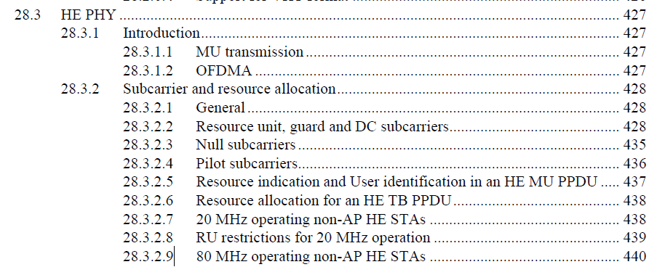
To TGax editor: P439L43 delete the current text below. (#16692)
------------- Begin Text Changes ---------------
An HE AP shall not allocate an RU in a 40 MHz HE MU PPDU or HE TB PPDU to a 20 MHz operating non-AP HE STA with the 20 MHz in 40 MHz HE PPDU In 2.4 GHz Band subfield in the HE PHY Capabilities Information field in its HE Capabilities element equal to 0.
An HE AP shall not allocate an RU in an 160 MHz or 80+80 MHz HE MU PPDU or HE TB PPDU to a 20 MHz operating non-AP HE STA with the 20 MHz In 160/80+80 MHz HE PPDU subfield in the HE PHY Capabilities Information field in its HE Capabilities element equal to 0.
------------- End Text Changes ---------------
To TGax editor: P440L29 delete the current text with the proposed changes below. (#16693)
------------- Begin Text Changes ---------------
The center 26-tone RU in any 20 MHz channel of a 40 MHz, 80 MHz, 160 MHz, or 80+80 MHz HE MU PPDU shall not be assigned to a 20 MHz operating non-AP STA.
An HE AP shall not allocate to a 20 MHz operating non-AP HE STA a 242-tone RU in a 40 MHz HE MU PPDU transmitted in the 2.4 GHz band unless the non-AP STA has B4 of the Channel Width Set subfield of the HE PHY Capabilities Information field equal to 1 in the HE Capabilities element it transmits.
An HE AP shall not allocate to a 20 MHz operating non-AP HE STA a 242-tone RU in a 40 MHz, 80 MHz, 160 MHz or 80+80 MHz HE MU PPDU transmitted in the 5 GHz band unless the non-AP HE STA has B5 of the Channel Width Set subfield of the HE PHY Capabilities Information field equal to 1 in the HE Capabilities element it transmits.
An HE AP shall not allocate to a 20 MHz operating non-AP HE STA a 242-tone RU for a 40 MHz, 80 MHz, 160 MHz, or 80+80 MHz HE TB PPDU transmission.
------------- End Text Changes ---------------
To TGax editor: P290L01 replace the current text with the proposed changes below.
------------- Begin Text Changes ---------------
27.5.1.3 RU allocation in an HE MU PPDU
An HE AP shall not allocate an RU in a 40 MHz HE MU PPDU to a 20 MHz operating non-AP HE STA with the 20 MHz in 40 MHz HE PPDU In 2.4 GHz Band subfield in the HE PHY Capabilities Information field in its HE Capabilities element equal to 0. (#16692)
An HE AP shall not allocate an RU in an 160 MHz or 80+80 MHz HE MU PPDU to a 20 MHz operating non-AP HE STA with the 20 MHz In 160/80+80 MHz HE PPDU subfield in the HE PHY Capabilities Information field in its HE Capabilities element equal to 0. (#16692)
The center 26-tone RU in any 20 MHz channel of a 40 MHz, 80 MHz, 160 MHz, or 80+80 MHz HE MU PPDU shall not be assigned to a 20 MHz operating non-AP STA. (#16693)
An HE AP shall not allocate to a 20 MHz operating non-AP HE STA a 242-tone RU in a 40 MHz HE MU PPDU transmitted in the 2.4 GHz band unless the non-AP STA has B4 of the Channel Width Set subfield of the HE PHY Capabilities Information field equal to 1 in the HE Capabilities element it transmits. (#16693)
An HE AP shall not allocate to a 20 MHz operating non-AP HE STA a 242-tone RU in a 40 MHz, 80 MHz, 160 MHz or 80+80 MHz HE MU PPDU transmitted in the 5 GHz band unless the non-AP HE STA has B5 of the Channel Width Set subfield of the HE PHY Capabilities Information field equal to 1 in the HE Capabilities element it transmits. (#16693)
An HE MU PPDU shall have a sufficient number of RUs allocated to users such that all of the following conditions are satisfied:
----------- End Text Changes ---------------

To TGax editor: P292L59 replace the current text with the proposed changes below. (#16692)
------------- Begin Text Changes ---------------
27.5.3.2 Rules for soliciting UL MU frames
27.5.3.2.1 General
An HE AP shall not allocate an RU in a 40 MHz HE TB PPDU to a 20 MHz operating non-AP HE STA with the 20 MHz in 40 MHz HE PPDU In 2.4 GHz Band subfield in the HE PHY Capabilities Information field in its HE Capabilities element equal to 0. (#16692)
An HE AP shall not allocate an RU in an 160 MHz or 80+80 MHz HE TB PPDU to a 20 MHz operating non-AP HE STA with the 20 MHz In 160/80+80 MHz HE PPDU in the HE PHY Capabilities Information field in its HE Capabilities element equal to 0. (#16692)
An HE AP shall not allocate to a 20 MHz operating non-AP HE STA a 242-tone RU for a 40 MHz, 80 MHz, 160 MHz, or 80+80 MHz HE TB PPDU transmission. (#16693)
(#15081)An AP shall not transmit a Trigger frame soliciting an HE TB PPDU that uses UL MU-MIMO within an RU that does not span the entire PPDU bandwidth to a non-AP STA(#16592) from which it has not received an HE Capabilities element with the Partial Bandwidth UL MU-MIMO subfield of the HE PHY Capabilities Information field equal to 1.
----------- End Text Changes ---------------

