IEEE P802.11
Wireless LANs
CID16364 on Packet Extension
Date: 2018-11-11
Author(s):
Name | Affiliation | Address | Phone | email
Yujin Noh | Newracom |  |  | yujin.noh at newracom.com
Abstract
This submission shows
- Resolution for a comment received from TGax comment collection (TGax Draft D3.0)
- The proposed changes are based on 11ax D3.1.

The submission provides resolutions to comments related to Packet Extension.
- The submission provides resolutions to 1 CIDs:
16364

Revisions:
- Rev 0: Initial version of the document.
- Rev 1: modification applied based on the comments

CID | P.L | Comment | Proposed Change | Resolution
16364 | 289.01 | "The DEFAULT_PE_DURATION parameter is set to the default PE duration value for UL MU response scheduling, which is indicated by the AP in the Default PE Duration subfield of the HE Operation element it transmits and the pre-FEC padding factor is set to 4 (see 28.3.12 (Packet extension))" -- the bit from "and the pre-FEC" onwards is broken. It's set where? How does this relate to the TXVECTOR parameters (which is what the list is about)? | Delete "and the pre-FEC padding factor is set to 4 (see 28.3.12)" from the cited text. The resolution to CID 12790 did not address the two specific issues identified ("It's set where? How does this relate to the TXVECTOR parameters (which is what the list is about)?") | Revised.  The pre-FEC padding factor is not related to setting TXVECTOR parameters when a STA transmits an HE TB PPDU in response to a frame containing a TRS Control subfield. This setting is moved in 28.3.11.5.5 (Encoding process for an HE TB PPDU).  TGax Editor: make changes according to this document 11-18-1733-01-00ax CID16364 on Packet Extension

Discussions

Given the feedback that better to add “the pre-FEC padding factor is set to 4” in more proper place such as 28.3.11.2 (Pre-FEC padding process) last meeting, motion of CID16364 was pushed back. It turned out that 28.3.11.2 (Pre-FEC padding process) describes the pre-FEC padding processing of an SU transmission, and its extension to MU transmission is described in 28.3.11.5.4 (Encoding process for an HE MU PPDU) and 28.3.11.5.5 (Encoding process for an HE TB PPDU).

Considering the comment is about a STA transmitting an HE TB PPDU in response to a frame containing a TRS Control subfield, modification is applied to 28.3.11.5.5 (Encoding process for an HE TB PPDU).

Three parts of the D3.1 modified below.
- Delete “the pre-FEC padding factor is set to 4” not related with TXVECTOR parameters in 27.5.3.3 (STA behavior for UL MU operation)
- Add subclause “28.3.11.5.5 (Encoding process for an HE TB PPDU)” as a reference to make sure the pre-FEC padding process of MU transmission is covered by both 28.3.11.5.4 (Encoding process for an HE MU PPDU) and 28.3.11.5.5 (Encoding process for an HE TB PPDU).
- In 28.3.11.5.5 (Encoding process for an HE TB PPDU) of the current draft spec, it only describes the pre-FEC padding process of HE TB PPDU in response to a Trigger frame. Add a transmitting HE TB PPDU in response to a frame containing a TRS Control subfield.
  - For LDPC, since the TXVECTOR parameter LDPC_EXTRA_SYMBOL is always set to 1 in the HE TB PPDU in response to a frame containing a TRS Control subfield, case assuming “the TXVECTOR parameter LDPC_EXTRA_SYMBOL is not present” deleted now in rev1
  - Reconstruct the paragraphs to make more readable
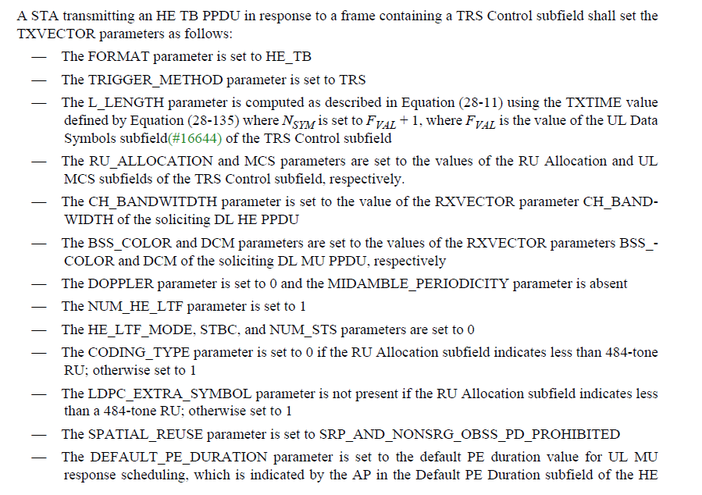
To TGax editor: P290L34 modify the current text with the proposed changes below. (#16364)
------------- Begin Text Changes ---------------
A STA transmitting an HE TB PPDU in response to a frame containing a TRS Control subfield shall set the TXVECTOR parameters as follows:
- The FORMAT parameter is set to HE_TB
…
- The DEFAULT_PE_DURATION parameter is set to the default PE duration value for UL MU response scheduling, which is indicated by the AP in the Default PE Duration subfield of the HE Operation element it transmits and the pre-FEC padding factor is set to 4 (see 28.3.12 (Packet extension))
------------- End Text Changes ---------------

To TGax editor: P518L28 modify the current text with the proposed changes below. (#16364)
------------- Begin Text Changes ---------------
The pre-FEC padding process is described in this subclause, and the encoding and post-FEC padding process are described in 28.3.11.5 (Coding). While this subclause describes the pre-FEC padding processing of an SU transmission, its extension to MU transmission is described in 28.3.11.5.4 (Encoding process for an HE MU PPDU) and 28.3.11.5.5 (Encoding process for an HE TB PPDU).
------------- End Text Changes ---------------

To TGax editor: P518L28 modify the current text with the proposed changes below. (#16364)
------------- Begin Text Changes ---------------
For an HE TB PPDU with BCC encoding, follow the HE SU PPDU padding and encoding process as introduced in 28.3.11.2 (Pre-FEC padding process), 28.3.11.5.1 (Binary convolutional coding and puncturing), and 28.3.11.5.3 (Post-FEC padding),.
- If transmitting an HE TB PPDU for which the TXVECTOR parameter TRIGGER_METHOD is TRIGGER_FRAME, with initial parameters setting to N_{SYM,init} = N_{SYM}, and a_{init} = a, where a is the pre-FEC padding factor indicated in the UL Packet Extension subfield of the Common Info field in the Trigger frame and N_{SYM} is the common number of data OFDM symbols derived from the UL Length, Number Of HE-LTF Symbols And Midamble Periodicity, and Doppler subfields of the Common Info field in the Trigger frame.
- If transmitting an HE TB PPDU for which the TXVECTOR parameter TRIGGER_METHOD is TRS, initial parameters set to N_{SYM,init} = N_{SYM,} and a_{init} = a, where a is the pre-FEC padding factor set to 4 and N_{SYM} is set to F_{VAL} + 1, where F_{VAL} is the value of the UL Data Symbols subfield of the TRS Control subfield.
For an HE TB PPDU with LDPC encoding, follow the HE SU PPDU padding and encoding process as introduced in 28.3.11.2 (Pre-FEC padding process), 28.3.11.5.2 (LDPC coding), and 28.3.11.5.3 (Post-FEC padding), with the following exceptions:
When transmitting an HE TB PPDU for which the TXVECTOR parameter TRIGGER_METHOD is TRIGGER_FRAME,
- If the LDPC Extra Symbol Segment field in the Trigger frame is 1, set the initial parameters following Equation (28-91).
where m_{STBC} is 2 if the Trigger frame indicates STBC and 1 otherwise. Then continue with the LDPC encoding process as in 19.3.11.7.5 (LDPC PPDU encoding process), during which in step d) of 19.3.11.7.5 (LDPC PPDU encoding process), always increment Navbits as in Equation (28-71), and always recompute Npunc as in Equation (19-40).
- If the LDPC Extra Symbol Segment field in the Trigger frame is 0, set initial parameters to N_{SYM,init} = N_{SYM}, and a_{init} = a. Then continue with the LDPC encoding process as in 19.3.11.7.5 (LDPC PPDU encoding process), during which in step d) of 19.3.11.7.5 (LDPC PPDU encoding process), Navbits and Npunc are not changed, and a = a_{init}.
When transmitting an HE TB PPDU for which the TXVECTOR parameter TRIGGER_METHOD is TRS,
- The TXVECTOR parameter LDPC_EXTRA_SYMBOL is always set to 1, and initial parameters set to N_{SYM,init} = N_{SYM,} and a_{init} = a – 1, where a is the pre-FEC padding factor set to 4 and N_{SYM} is set to F_{VAL} + 1, where F_{VAL} is the value of the UL Data Symbols subfield of the TRS Control subfield. Then continue with the LDPC encoding process as in 19.3.11.7.5 (LDPC PPDU encoding process), during which in step d) of 19.3.11.7.5 (LDPC PPDU encoding process), always increment Navbits as in Equation (28-71), and always recompute Npunc as in Equation (19-40).
------------- End Text Changes ---------------

