IEEE P802.11
Wireless LANs
CID 1002, 1003
Date: October 1, 2018
Author(s):
Name | Affiliation | Address | Phone | email
Menzo Wentink | Qualcomm | Utrecht, The Netherlands | +31-65-183-6231 | mwentink  @qualcomm.com

Abstract
This document proposes a resolution for CIDs 1002 and 1003.

Comments

1002 | Yoshio Urabe | 21.3.20 | 3000 | 38 | The start position of "Decoding delay" in the Figure 21-36 is not aligned to the start position of the received signal depicted below in the figure. | Align the start position of "Decoding delay" to the start of L-SIG in the received signal.
1003 | Yoshio Urabe | 23.3.19 | 3191 | 30 | The start position of "Decoding delay" in the Figure 23-31 is not aligned to the start position of the received signal depicted below in the figure. | Align the start position of "Decoding delay" to the start of SIG in the received signal.

Discussion

These are the cited figures:
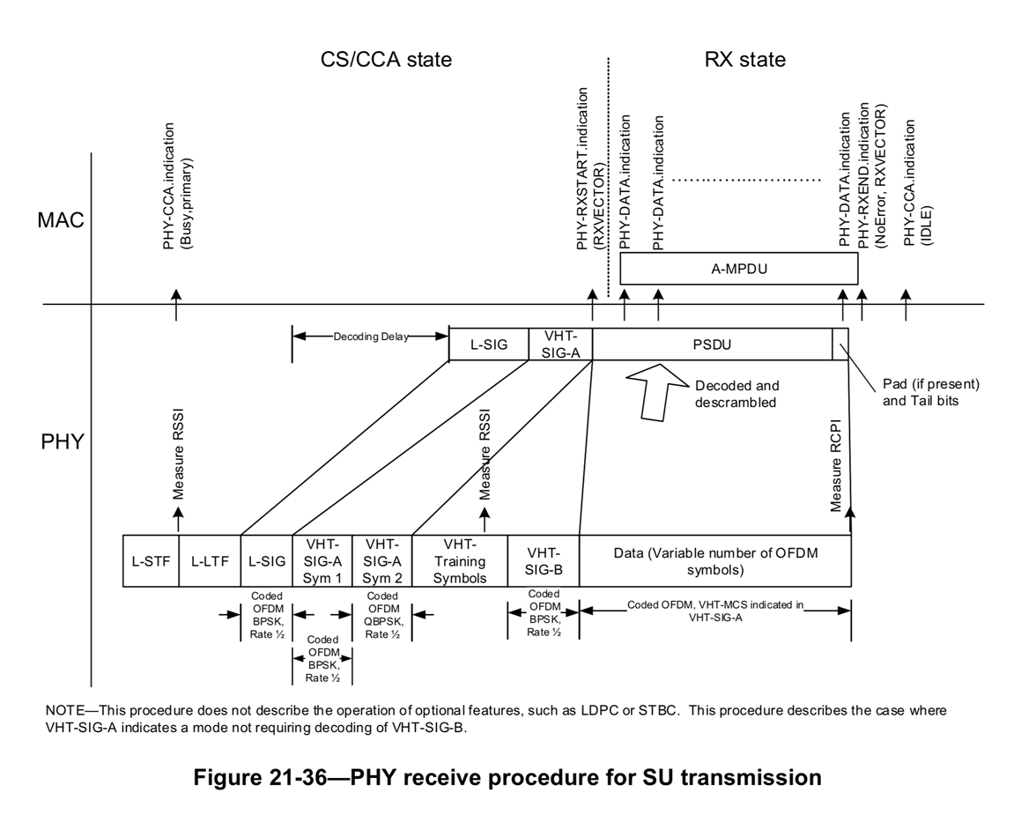

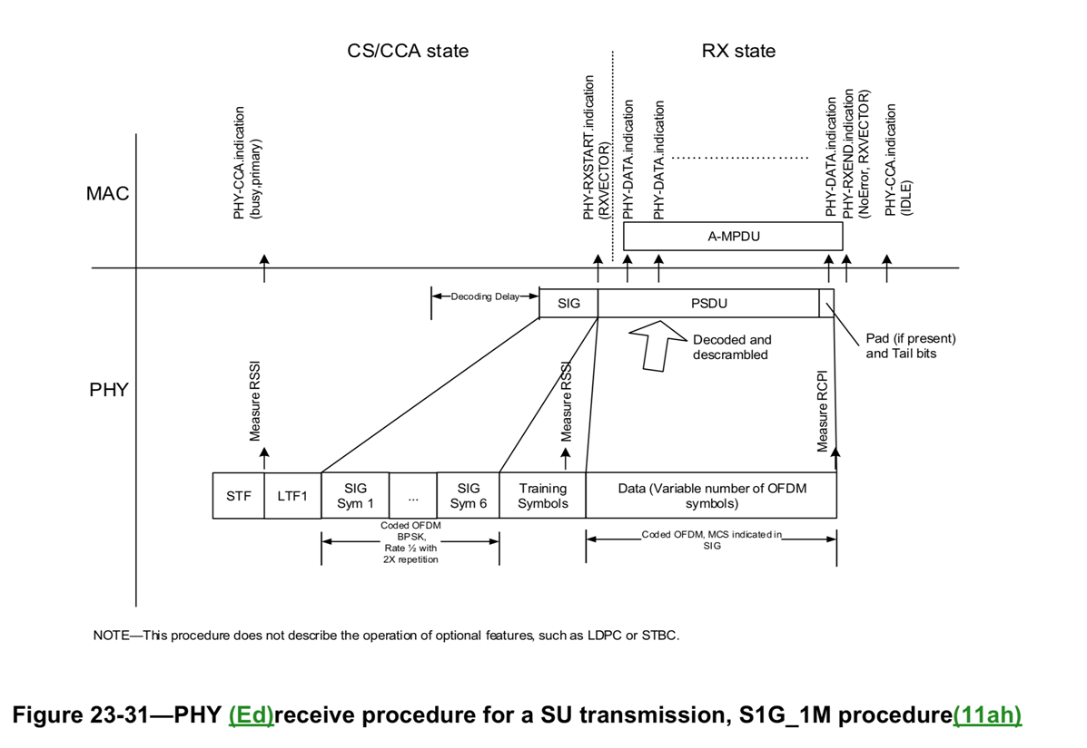

The decoding delay is indicative of an implementation specific delay that exists between the receipt of certain information in a packet and the moment at which it becomes available to the MAC. The decoding starts somewhere during or after the start of the receipt of the information, so the current location in the middle of the SIG is probably fine.

So one option to resolve the comments is to reject with the reason that the decoding delay is indicative and starts somewhere during or after the moment at which the information is received, as shown in the figure.

Another option is to revise and add "(indicative)" or "(implementation specific)" underneath "Decoding Delay".

Discussion:

Another option is to show no starting point at all.

There are a total of 7 figures affected.

Starting at the beginning of the SIG is fine but symbol reception time should then also be included.

Proposed resolution as discussed on the call (Mike has the right one in the comment spreadsheet):

Move the start of the "Decoding Delay" arrow to the beginning of the (L-)(HT-)SIG(NAL) field in the lower part and rename "Decoding Delay" to "Symbol reception and implementation specific decoding delay"

Affected figures (D1.5):

17-19
19-25 (only change to the name, arrow start point is correct)
19-26 (currently has no such arrow, should be added)
21-36
23-33
23-34
23-35

(7 figures total)

