IEEE P802.11  
Wireless LANs

|  |  |  |  |  |
| --- | --- | --- | --- | --- |
| Proposed FD-TIG report text on  Prototype of Full Duplex for 802.11 | | | | |
| Date: 2018-09-11 | | | | |
| Author(s): | | | | |
| Name | Affiliation | Address | Phone | email |
| James Gary Griffiths | Huawei Canada | 303 Terry Fox Drive, Suite 400  Kanata, Ontario Canada  K2K 3J1 |  | james.griffiths@huawei.com |
| Kwok Shum Au |  | edward.ks.au@huawei.com |
| Peiwei Wang |  | peiwei.wang@huawei.com |
| Philippe Wu |  | Philippe.Wu@huawei.com |
| Yan Xin |  | Yan.Xin@huawei.com |
| Baojian Zhou |  | zhoubaojian@huawei.com |
| Tho Le-Ngoc | McGill University | Room 633, McConnell Engineering Building 3480 University Street Montreal, Quebec, Canada H3A 0E9 |  | tho.le-ngoc@mcgill.ca |
| Robert Morawski |  | robert.morawski@mcgill.ca |
| Harry Lee |  | hakhyun.lee@mail.mcgill.ca |

Abstract

This document provides the proposed text on a prototype of full duplex for 802.11 to contribute to Sections 4.5 in the FD TIF report framework [1]. The proposed text is mainly based on the FD TIG presentation [2].

# FD Technical Feasibility

## Prototype of Full Duplex for 802.11

### Full Duplex (FD) – Potential Solution for Next Generation of 802.11

* **Successful Market** - WLANs are extensively deployed worldwide. According to Wi-Fi Alliance [1], the cumulative Wi-Fi device shipments will be over 20-billion units in 2018. Large quantities of Wi-Fi devices are used in dense environments demanding advanced technologies to improve the spectrum efficiency in WLANs. FD technology allows simultaneous transmission and reception of signals over the same bandwidth.
* **Various self-interference cancellation (SIC) techniques available** – Challenges in applications of FD have been discussed in [2]-[4]. Various techniques, such as shared (SISO) or separated (MIMO) antenna configurations, passive or active cancellations, RF or digital cancellations, have been proposed to reduce significant self-interference in FD.
* **Proposed Enabling Technique** - This contribution analyzes the components of SI and the requirements for a FD-capable receiver to cancel the SI, overviews several self-cancellation techniques potentially to be considered in FD for 802.11. In addition to digital cancellation, a cost-effective solution by using high Tx/Rx isolation MIMO antenna sub-system with SI cancellation capability to enable full duplex for 802.11 is proposed. Separating multiple antennas into Rx & Tx yields high isolation, however this may limit the MIMO capabilities.

### Prototype of SIC in 802.11 FD

In this prototype, 3 stages/levels of self-interference cancellation are introduced.

* Antenna isolation with the capability of 45-50dB
* Analogue SIC with the capability of 15-20dB, (See notes in Section 4.5.4.2).
* Digital SIC with the capability of 30-35dB

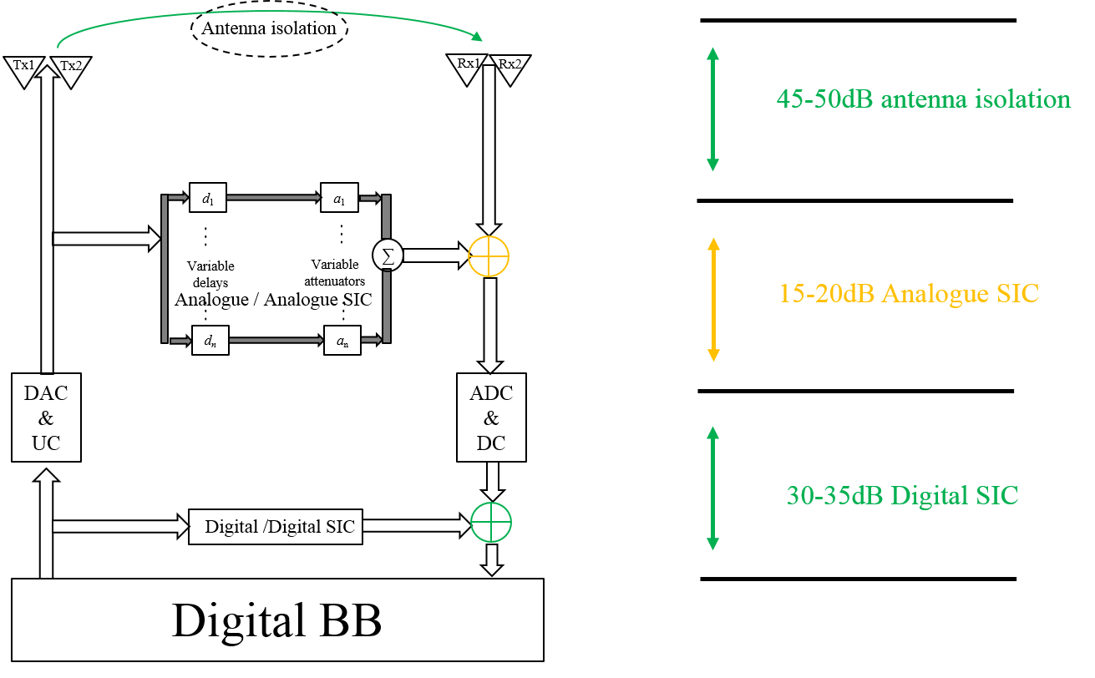

Figure 3: Prototype of SIC in 802.11 FD

#### Antenna Isolation and Analogue SIC in 802.11 FD

The 2x2 MIMO FD antenna is the state-of-art design. Theoretically, in simulation, the isolation can be achieved as high as 70dB. However, due to the impact to desired Rx MIMO signal, 45-50dB isolation is current achievable performance.

* 2x2 array with dual-polarized elements
* Use EBG (Electromagnetic Band Gap) technologies to reduce size and enhance inter-element isolation
* Multi-layer structures
* Wideband, high Tx/Rx isolations
* 45-50dB antenna isolation



Figure 4: Antenna Isolation against Measured Coupling S-Parameters



Figure 5: 2x2 MIMO FD Antenna Assembly

#### Analogue SI canceller Tuning

The analogue SI canceller’s performance is so tight-coupled with antenna to deal with the self-interferences in Tx-Rx antennas and the very near-end. The sophisticated tuning together with antenna is to deliver the desired cancellation performance.

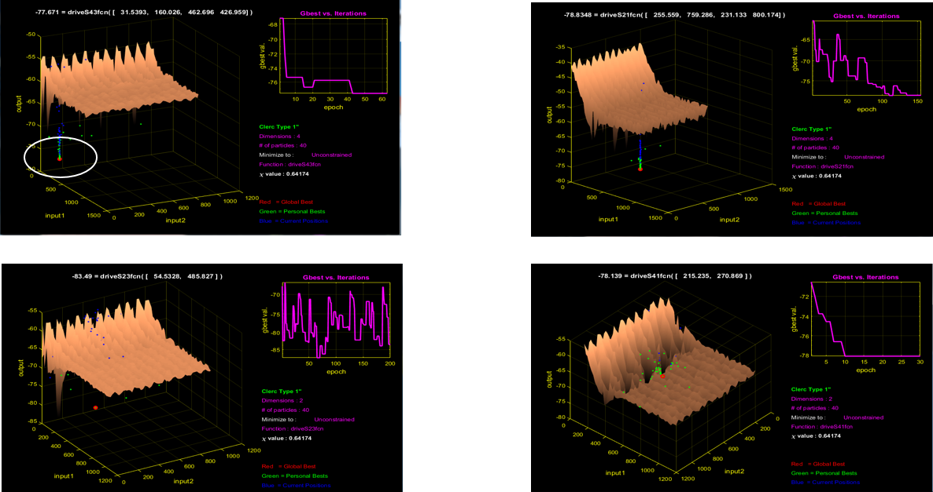

Figure 6: Analogue SIC tuning profile for Cancellation Paths

**Notes:**

* Typical Standalone Cancellation Surface for Analogue Canceller + High Isolation Antenna
* For 2x2 MIMO; 4 Cancellation Paths, S21, S43, S23, S41 ranging from -77 to -83 dB
* This is the work result from previous prototype. Re-banding is ongoing.

Together with antenna assembly, the analogue SIC assembly forms the high Tx/Rx isolation MIMO antenna sub-system with SI cancellation capability.

#### Prototype of Digital SIC in 802.11 FD

The digital SIC is done by accurate channel estimation through 802.11 preamble symbols and the re-generation of SI signal in digital.

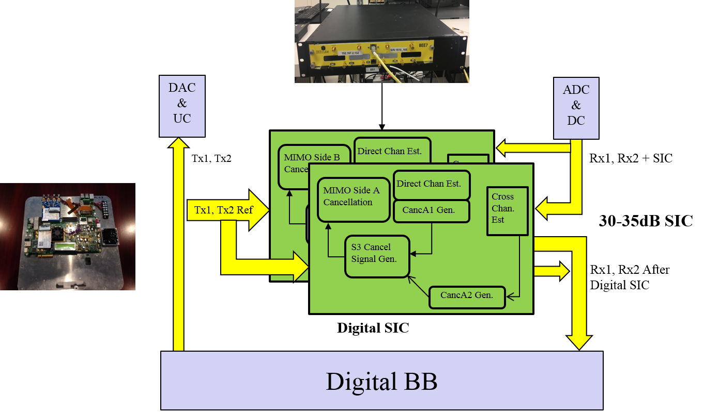

Figure 7: Prototype of Digital SIC in 802.11 FD

The prototype implements the symmetric FD operation mode with traffics on both DL and UL at same time in same frequency band.

The following figures show the digital cancellation in frequency domain against the signals in/out of digital canceller in time domain.

Case 1: DL SIC at AP without UL data traffic

Case 2: DL SIC at AP with UL data traffic

Case 3: UL SIC at STA with DL data traffic

Figure 8 and Figure 9 show the digital cancellation the signals in/out of digital canceller in frequency domain and time domain Figure 9 at AP.

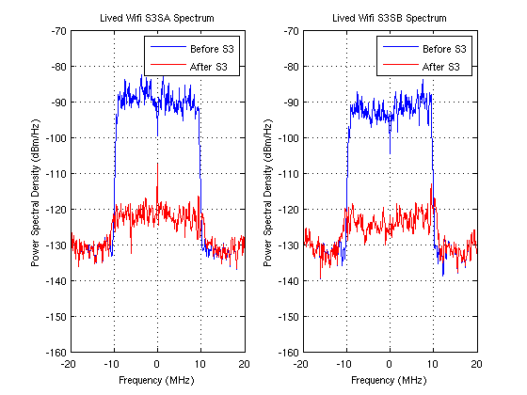

Figure 8: Case 1 - DL SIC at AP without UL Data Traffic in Frequency Domain

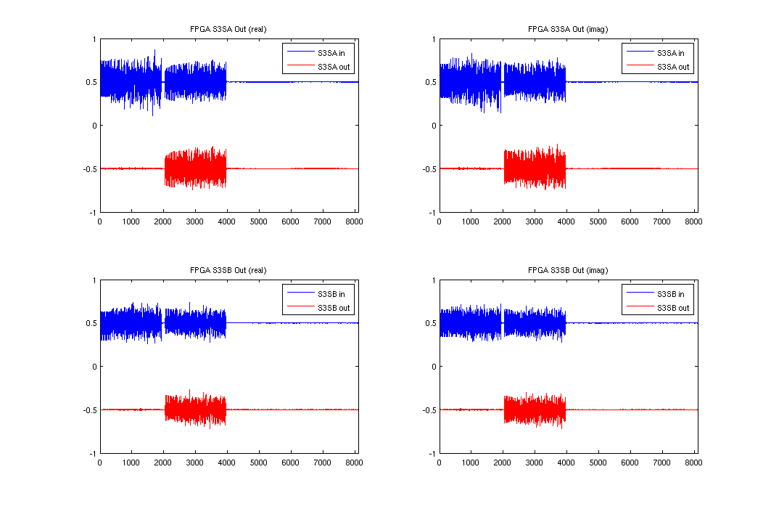

Figure 9: Case 1 - DL SIC at AP without UL Data Traffic in Time Domain

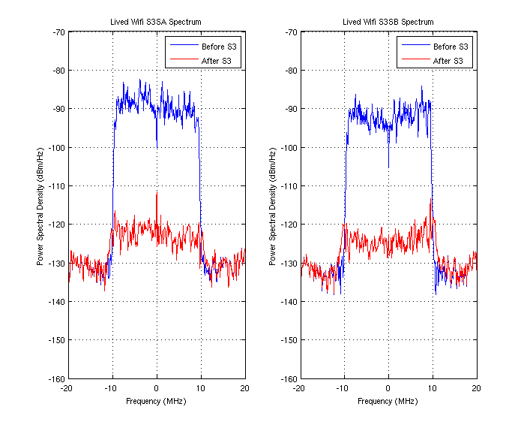

Figure 10: Case 2 - DL SIC at AP with UL Data Traffic in Frequency Domain

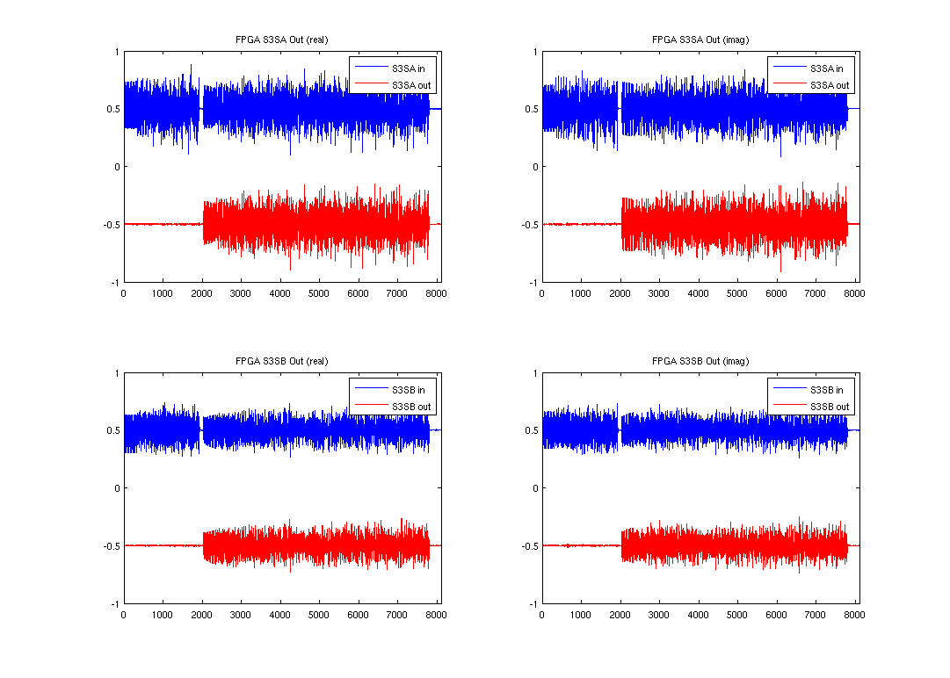

Figure 11: Case 2 - DL SIC at AP with UL Data Traffic in Time Domain

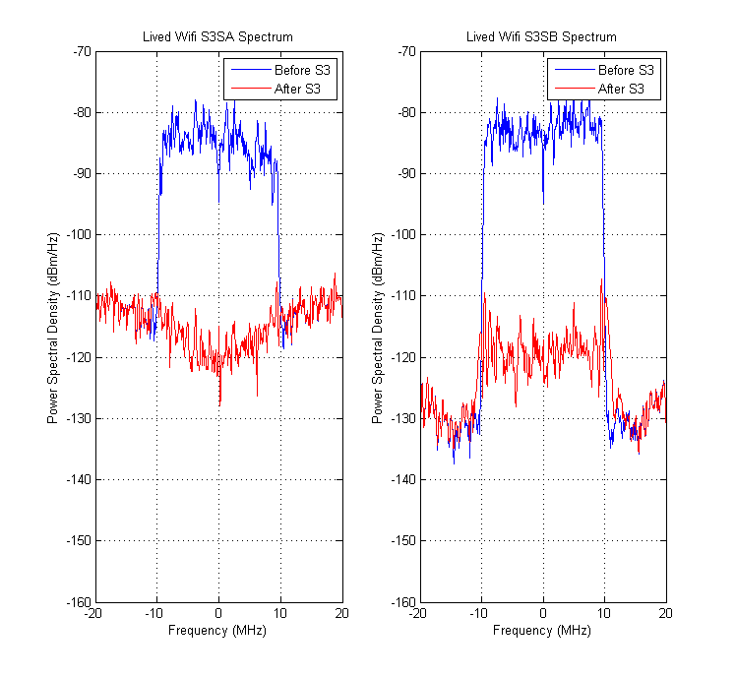

Figure 12: Case 3 - UL SIC at STA with DL Data Traffic in Frequency Domain

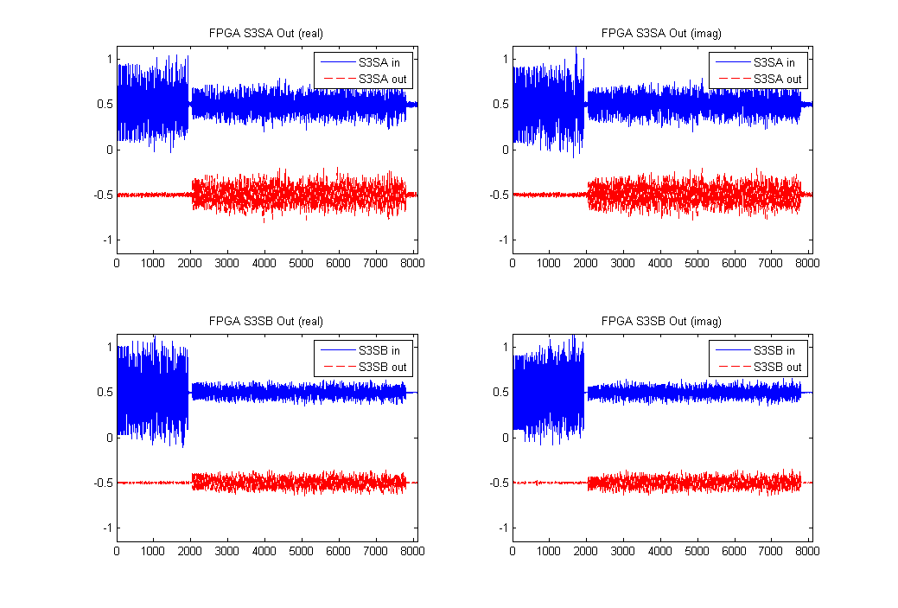

Figure 13: Case 2 - UL SIC at STA with DL Data Traffic in Time Domain

### Prototype Configuration Setup

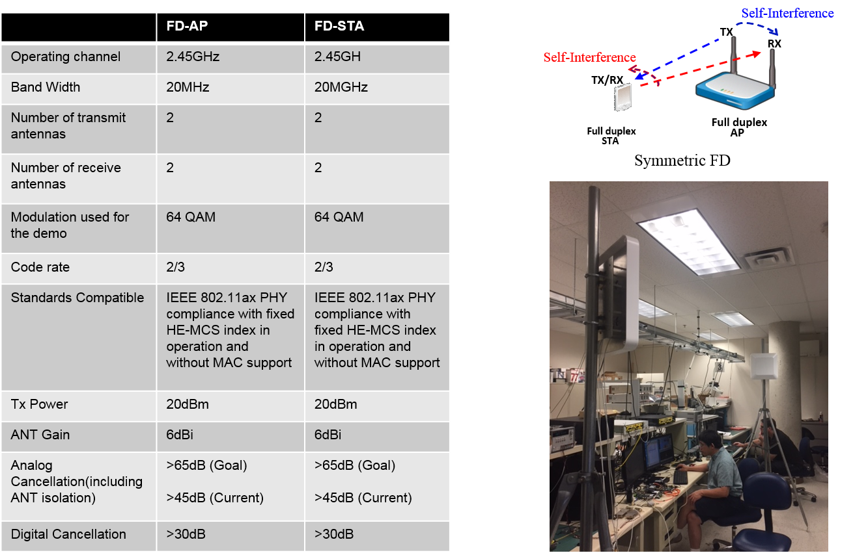

Figure 14: Prototype Configuration Setup

# References

[1] 11-18-0498-00-00fd-framework-fd-tig-report

[2] 11-18-0448-01-00fd-Prototype-of-Full-Duplex-for-802.11