IEEE P802.11
Wireless LANs
Full Duplex Wi-Fi Demonstration Description for Inclusion in the FD-TIG Report
Date: 2018-09-11
Author(s):
Name | Affiliation | Address | Phone | email
Allen D. Heberling | GenXcomm, Inc. | 1604 San Antonio St.  Austin, TX 78701 | 737-302-1423 | Allen.heberling@genxcomminc.com
Abstract
Text describing a full duplex Wi-Fi prototype along with photographs illustrating various performance metrics.

4 FD Technical Feasibility

4.1 Technical survey

4.1.4 Full Duplex Wi-Fi Demonstration
Figure 1 illustrates a prototype full duplex two node system in which the left-hand node is configured to operate as an Access Point (AP) and the right-hand node is configured to operate as a station (STA). The version of WiFi used in this demonstration is 802.11n. During this demonstration two different variable rate, video streams were simultaneously exchanged between the AP and the STA while operating on the same frequency channel.

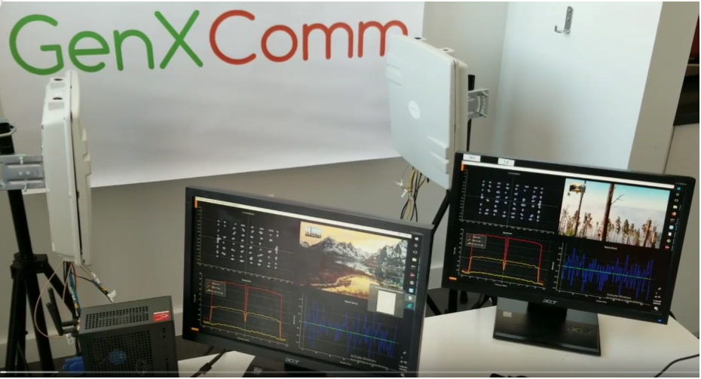
Figure 1: A two node, full duplex Wi-Fi prototype system

Table 1 summarizes the various operating parameters used during this Full Duplex Wi-Fi demonstration.

Table 1: Full Duplex Demonstration Operating Parameters
Attribute | Setting / Value
Environment | Indoor
Operating Channel | 2.45 GHz
Bandwidth | 20 MHz
Number of Tx Antennas | 1
Number of Rx Antennas | 1
Modulation Scheme | 64 QAM
Code Rate | 3/4
PHY Rate | 58.5 Mb/s
AP Tx power | 23 dBm EIRP (6dBi antenna)
STA Tx power | 18 dBm EIRP
Ranges | 1m, 10m, 20m, 40m
Transport Protocol | UDP/IP
MTU | 1244 Octets
MAC Protocol | 802.11 Promiscuous mode
ACK Policy | NO_ACK
Tx | Continuous transmission mode
Rx | Continuous reception mode

Figure 2 illustrates these key elements of the Full Duplex Wi-Fi demonstration:
- Left upper quadrant illustrates the STA’s received signal constellation map (64 QAM)
- Right upper quadrant illustrates the video received from the AP
- Left lower quadrant illustrates these frequency domain signal characteristics

Attribute | Measured Value
STA Tx power (EIRP) | 18 dBm
The red signal is the self interference signal as measured in the analog domain after antenna isolation | -15 dBm
The middle yellow signal is the self interference level remaining after analog domain SIC | -55 dBm
The bottom yellow signal is the residual self interference remaining after dynamic digital SIC | -91 dBm
Noise Floor (N_{Floor} ) | -98 dBm

- Right lower quadrant illustrates these time domain signal characteristics:
  - The varying amplitude dark blue time domain signal illustrates the behavior of the received signal prior to SIC.
  - The flat horizontal light blue-green signal illustrates the behavior of the received signal after SIC.

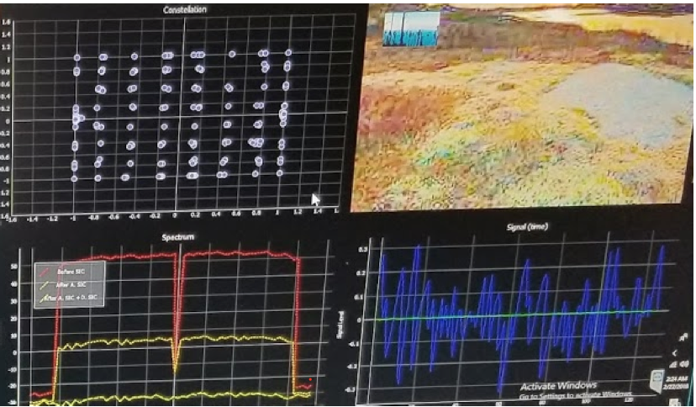
Figure 2: STA's Multi-Quadrant Information Display

The results of this early Full Duplex WiFi prototype provides evidence of how SIC techniques in both the analog and digital domains can be used to significantly reduce self interference signals to a level that enables the simultaneous transfer of two streaming videos between an AP and a STA. Future iterations of this system will include modifications to the 802.11 MAC protocol that will demonstrate the benefits of a full duplex MAC operating in a BSS populated with a) multiple half duplex (HD) STAs and one FD AP; b) multiple FD STAs and one FD AP; c) a mix of HD and FD STAs with a FD AP.

