IEEE P802.11
Wireless LANs
LB232 CID1544 – Proposed Comment Resolution
Date: 2018-09-12
Author(s):
Name | Affiliation | Address | Phone | email
Marc Emmelmann | SELF;  Koden-TI | Berlin, Germany |  | emmelmann@ieee.org
Hitoshi Morioka | SRC Software | 2-14-38 Tenjin, Chuo-ku, Fukuoka 810-001 JAPAN |  | hmorioka@src-soft.com
Abstract
Proposed comment resolution for CID 1544 (TGm LB232).

CID 1544

CID | Clause Number(C) | Page | Comment | Proposed Change
1544 | 11.45.1 | 2298.43 | As e.g. Tables 9-363, 9-365 and 9-366 show, FILS is also not supported in S1G BSSes | Change the sentence at the referenced location to read "FILS is only supported in a non-DMG non-S1G infrastructure BSS."

Discussion

Note: P2298.43 refers to D1.0 which is in D1.4 on page 2458.

Context D1.4 P2458

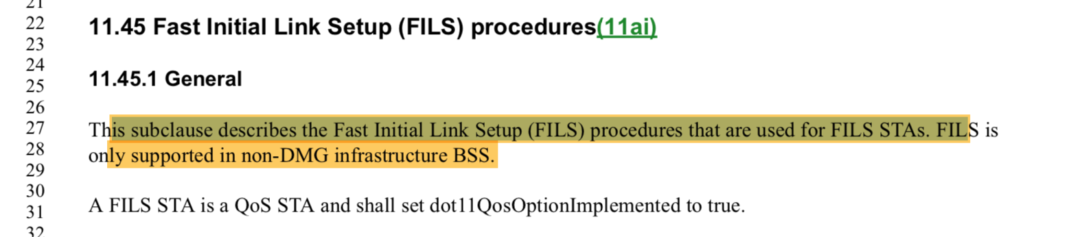

The comment is correct and identifies a missing part of the sentence.

Proposed Resolution:

Accept

.

