IEEE P802.11
Wireless LANs
LB232 CID1543 – Proposed Comment Resolution
Date: 2018-09-12
Author(s):
Name | Affiliation | Address | Phone | email
Marc Emmelmann | SELF;  Koden-TI | Berlin, Germany |  | emmelmann@ieee.org
Hitoshi Morioka | SRC Software | 2-14-38 Tenjin, Chuo-ku, Fukuoka 810-001 JAPAN |  | hmorioka@src-soft.com
Abstract
Proposed comment resolution for CID 1543 (TGm LB232).

Rev-1: changes based on commenter feedback

CID 1543

CID | Clause Number(C) | Page | Comment | Proposed Change
1543 | 9.4.2.182 | 1280.01 | "The AP verifies that the extracted source MAC address is equal to the source MAC address of  the (Re)Association frame. If these are different, the AP shall discard the FILS HLP Container  element;" -- so there's no point passing the source MAC address, since the transmitter will always ensure they are the same (why bother sending something you know the other end will discard?) | Delete step 2) at 2301.42 and the bullet at 2302.21. In Figure 9-634 delete the Source MAC Address and Destination MAC Address fields. In 9.4.2.182 delete the penultimate paragraph.

Discussion

Note: P1280.01 refers to D1.0 which is in D1.4 on page 1337.
Also, the clause number in D1.4 has changed from xxx.182 to xxx.183.

Context: D1.4 P1337

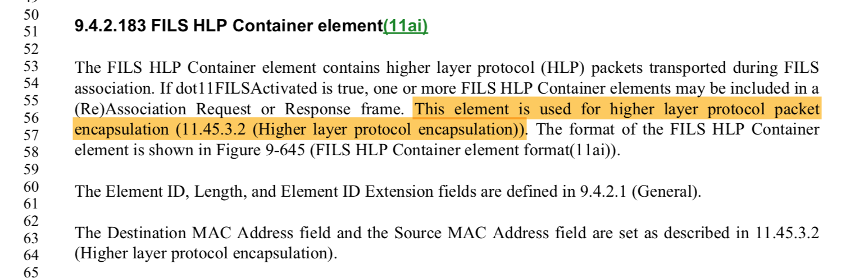

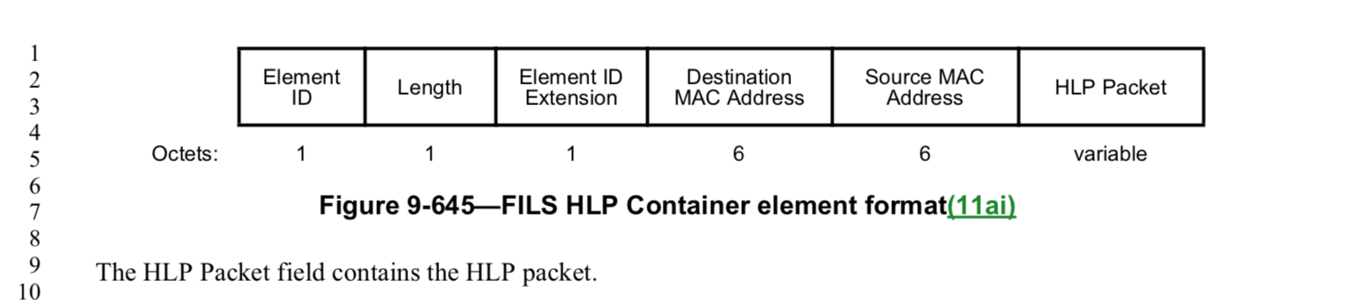

The cited text in the comment refers to the refrenced clause 11.45.3.2

Context D1.4 P2460ff
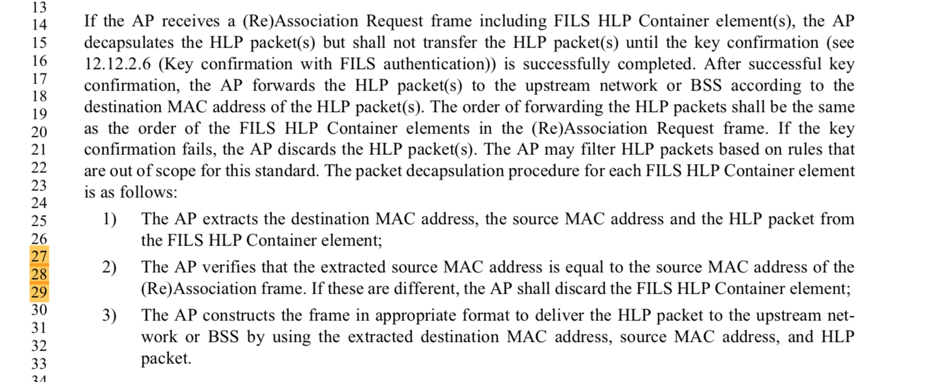

In the situation address in comment, the comment is correct: the source address fields are not required. Despite that fact, the FILS HLP Container element is reused in other situations, in which the source address field is required. Instead of defining another (new) element, the existing is reused.

The following exceprt from the draft highights an example where the Source MAC Address field of the element is used.

Contet D1.4 P2461:
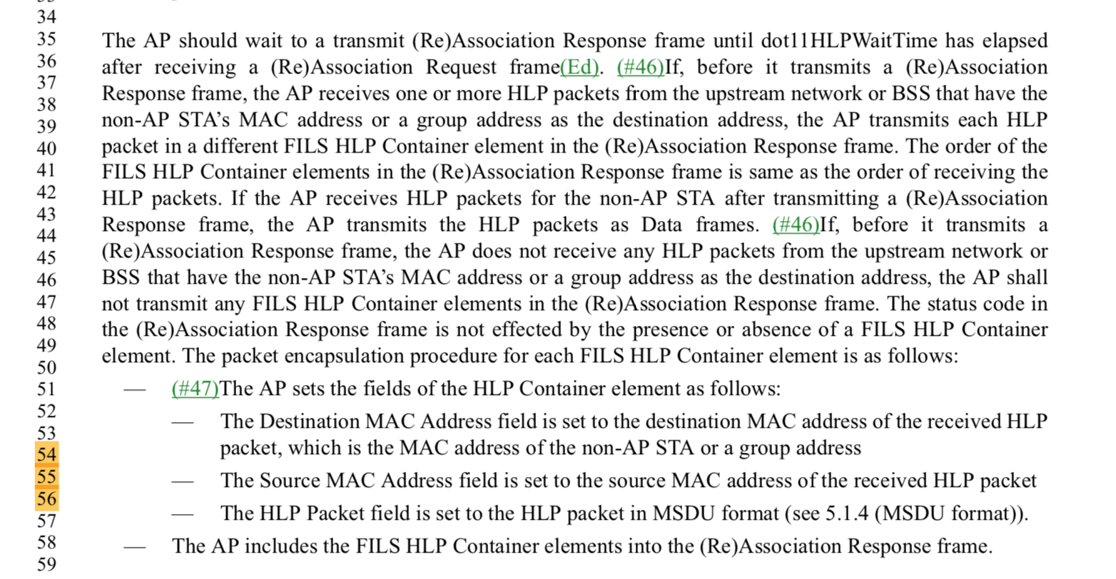

Proposed Resolution:

Reject.

The comment does highlight a valid case in which the source MAC address is not required. Though, the FILS HLP Container element is reused in other situations, in which the source address field is required. Instead of defining another (new) element, the existing is reused (e.g. see D1.4 P 2461 L55).

