IEEE P802.11
Wireless LANs
LB232 CID1542 – Proposed Comment Resolution
Date: 2018-09-12
Author(s):
Name | Affiliation | Address | Phone | email
Marc Emmelmann | SELF;  Koden-TI | Berlin, Germany |  | emmelmann@ieee.org
Hitoshi Morioka | SRC Software | 2-14-38 Tenjin, Chuo-ku, Fukuoka 810-001 JAPAN |  | hmorioka@src-soft.com
Abstract
Proposed comment resolution for CID 1542 (TGm LB232).

CID 1542

CID | Clause Number(C) | Page | Comment | Proposed Change
1542 | 9.4.2.183.3 | 1283.07 | The gateway address should be provided if the device address is | In Table 9-283 in the rightmost cell for B2 add at the end a sentence "IPv4 Gateway Address and IPv4 Gateway MAC Address subfields are included in the element if B1 is set to 1"

Discussion

Note: P1283.07 refers to D1.0 which is in D1.4 on page 1340.
The clause also changed from 9.4.2.183 to xxx.184

Context: D1.4 P1340
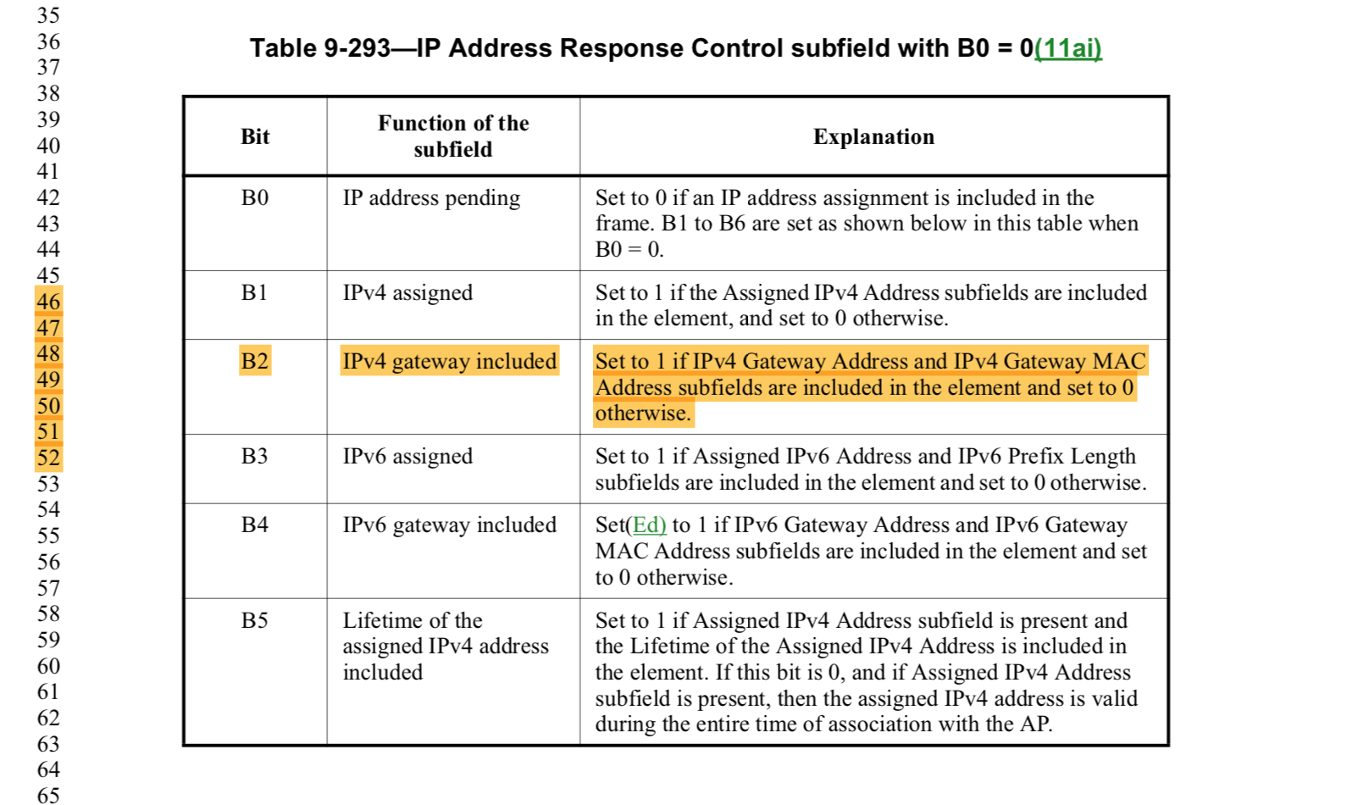

The comment aims at mandating to assign a gateway whenever a STA is assigned an IP address. This is conceptually not required. A STA, e.g. in a purely local network environment, may be assigned an IP address without requiring a gateway address. Such scenarios (local network only use cases) were discussed in TGai.

Proposed Resolution:

Reject.

The comment aims at mandating to assign a gateway whenever a STA is assigned an IP address. This is conceptually not required. A STA, e.g. in a purely local network environment, may be assigned an IP address without requiring a gateway address.

