IEEE P802.11
Wireless LANs
LB232 CID1337 – Proposed Comment Resolution
Date: 2018-09-12
Author(s):
Name | Affiliation | Address | Phone | email
Marc Emmelmann | SELF;  Koden-TI | Berlin, Germany |  | emmelmann@ieee.org
Hitoshi Morioka | SRC Software | 2-14-38 Tenjin, Chuo-ku, Fukuoka 810-001 JAPAN |  | hmorioka@src-soft.com
Abstract
Proposed comment resolution for CID 1337 (TGm LB232).

CID 1337

CID | Clause Number(C) | Page | Comment | Proposed Change
1337 | 11.45.5.3 | 2305.02 | "The Differentiated FILS Time field contains an unsigned integer that specifies the time duration for the  validity of fast initial link setup category (FILSC) Information priority condition" -- it is not clear what a FILSC Information priority condition is or what its duration means. It seems from 11.45.5.3 that it's a period after reception of a DILS element during which a STA that does not meet certain conditions does not setup a link (not sure whether that's the same as not associate). However, it means a STA can be permanently locked out, since every beacon/probe response can reset the timeout | At the referenced location change " Otherwise, the non-AP  STA shall postpone the link setup with the AP until the time specified in the last received Differentiated  FILS Time field elapses." to " Otherwise, the non-AP  STA shall not associate with the AP until the time specified in the first received Differentiated  FILS Time field elapses; when it has elapsed the STA may perform link setup with the AP."

Discussion

Note: P2304 refers to D1.0 which is in D1.4 on page 2464.

Context D1.4 2464
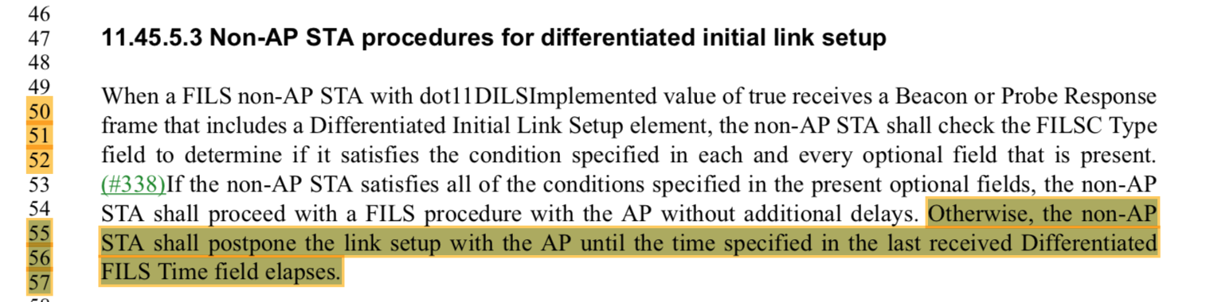

The DILS feature should allow to defer the association of a STA but is believed to not allow a permanent lock-out of a STA. Hence the suggested resolution is feasible.

Regarding the comment on the FILSC information priority condition, the commenter is referred to XXXX-1336-xxx which adds clarity on the conditons.

Proposed Resolution:

Accept.
.

