IEEE P802.11
Wireless LANs
LB232 CID1336 – Proposed Comment Resolution
Date: 2018-09-12
Author(s):
Name | Affiliation | Address | Phone | email
Marc Emmelmann | SELF;  Koden-TI | Berlin, Germany |  | emmelmann@ieee.org
Hitoshi Morioka | SRC Software | 2-14-38 Tenjin, Chuo-ku, Fukuoka 810-001 JAPAN |  | hmorioka@src-soft.com
Stephen McCann | Blackberry
Abstract
Proposed comment resolution for CID 1336 (TGm LB232).

Rev-1: changes based on commenter feedback

CID 1336

CID | Clause Number(C) | Page | Comment | Proposed Change
1336 | 9.4.2.185 | 1285.16 | "The Differentiated FILS Time field contains an unsigned integer that specifies the time duration for the  validity of fast initial link setup category (FILSC) Information priority condition" -- it is not clear what a FILSC Information priority condition is or what its duration means | Delete Subclauses 11.45.5 and 9.4.2.185

Discussion

Note: P1285.16 refers to D1.0 which is in D1.4 on page 1343.
The clause also changed from 9.4.2.185 to 9.4.2.186

Context D1.4 P1343:
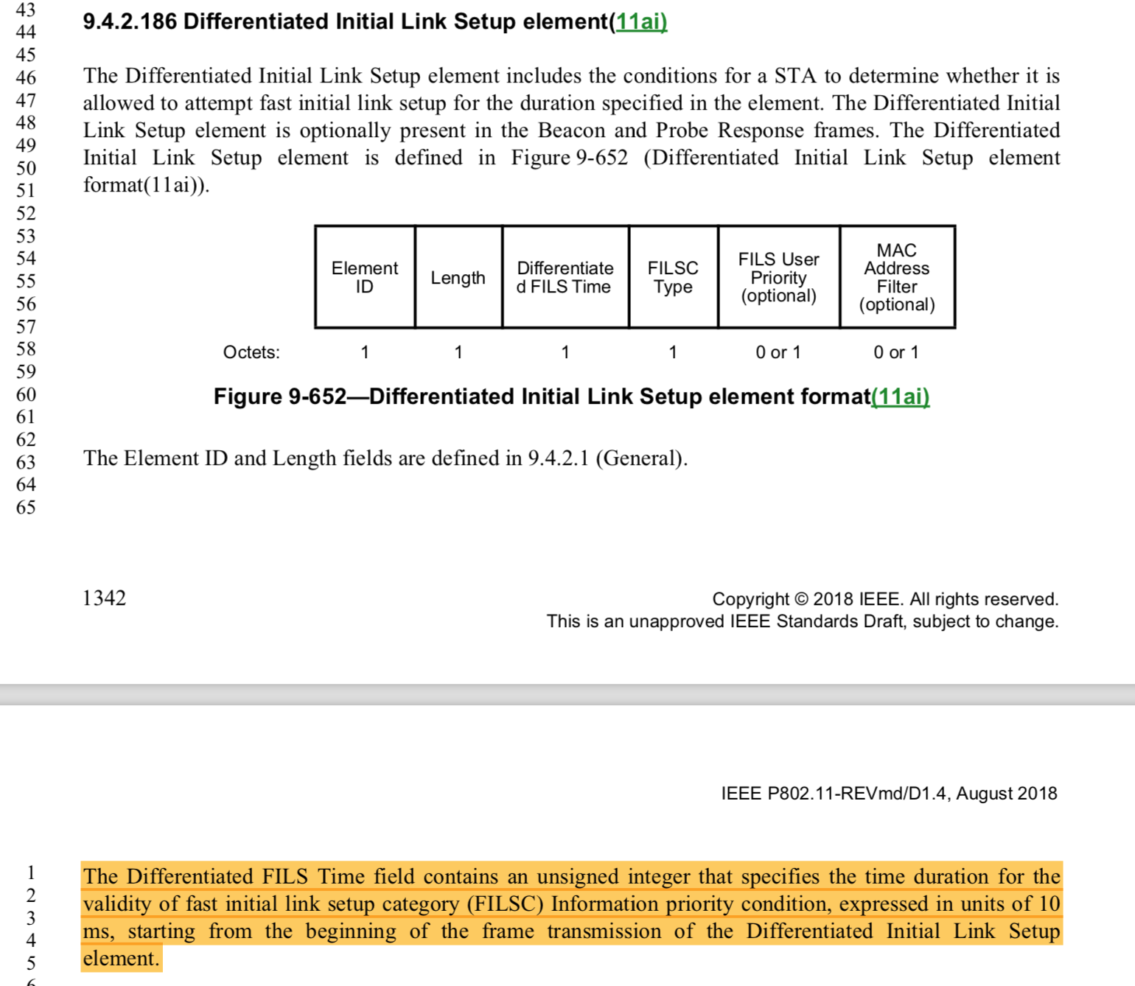
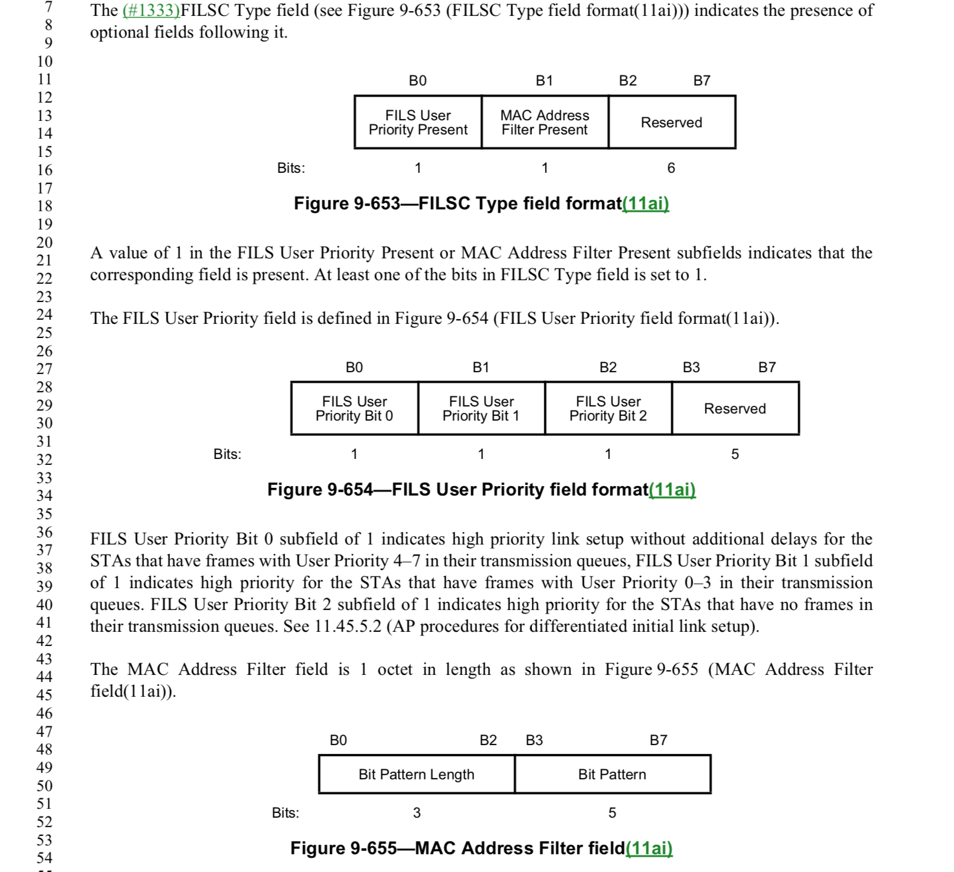
It looks as though the problem is that "fast initial link setup category (FILSC) Information priority condition" is indeed not defined anywhere and more importantly does not appear relate to either the MAC Address Filter (field) or the FILS User Priority (field). It's not obvious from the text, how either of these fields are also "FILSC information priority conditions".

The DILS element specified filters (priority contidions) which constrain STAs that are allowed to perform FILS. Those filters can be the MAC Address Filter (field) or the FILS User Priority (field). The term “information priority” in the cited text in the comment refers to either of those fields / priority contidions.

As a resolution, within the paragraph cited in the comment, the term “FILSC information priority conditions” can be replaced by directly refrencing the two fields it relates to. The resulting sentence would then read (replacement highlighted):

"The Differentiated FILS Time field contains an unsigned integer that specifies the time duration for the
validity of the MAC Address Filter field or the FILS User Priority field, expressed in units of 10
ms, starting from the beginning of the frame transmission of the Differentiated Initial Link Setup
element."

Proposed Resolution:

REVISED.

In the paragraph cited in the comment, at D1.4 P1343 L2:

Replace:
“Of fast initial link setup category (FILSC) Information priority condition”

With:
“the MAC Address Filter field or the FILS User Priority field”

