IEEE P802.11
Wireless LANs
LB232 CID1336 – Proposed Comment Resolution
Date: 2018-09-12
Author(s):
Name | Affiliation | Address | Phone | email
Marc Emmelmann | SELF;  Koden-TI | Berlin, Germany |  | emmelmann@ieee.org
Hitoshi Morioka | SRC Software | 2-14-38 Tenjin, Chuo-ku, Fukuoka 810-001 JAPAN |  | hmorioka@src-soft.com
Abstract
Proposed comment resolution for CID 1336 (TGm LB232).

CID 1336

CID | Clause Number(C) | Page | Comment | Proposed Change
1336 | 9.4.2.185 | 1285.16 | "The Differentiated FILS Time field contains an unsigned integer that specifies the time duration for the  validity of fast initial link setup category (FILSC) Information priority condition" -- it is not clear what a FILSC Information priority condition is or what its duration means | Delete Subclauses 11.45.5 and 9.4.2.185

Discussion

Note: P1285.16 refers to D1.0 which is in D1.4 on page 1343.
The clause also changed from 9.4.2.185 to xxx.186

Context D1.4 P1343:
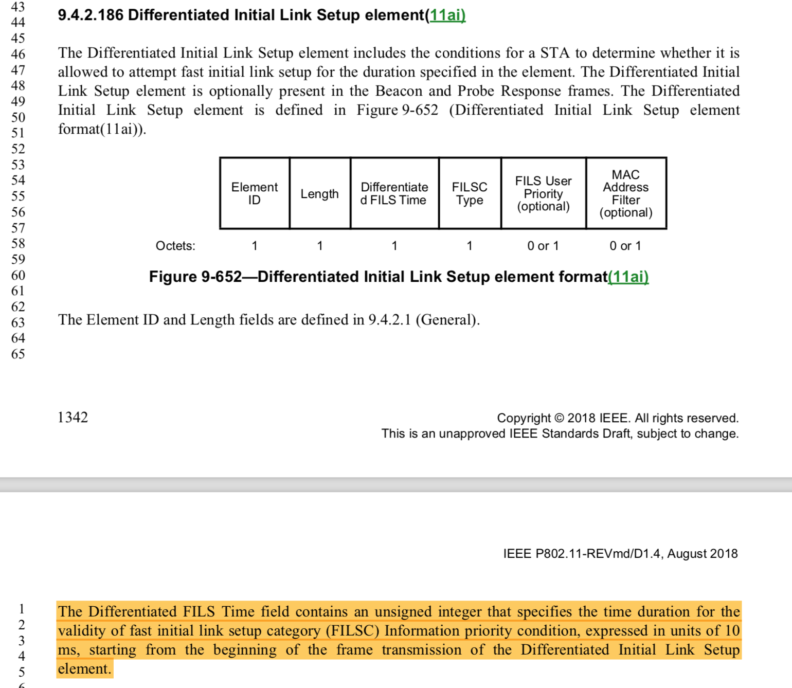
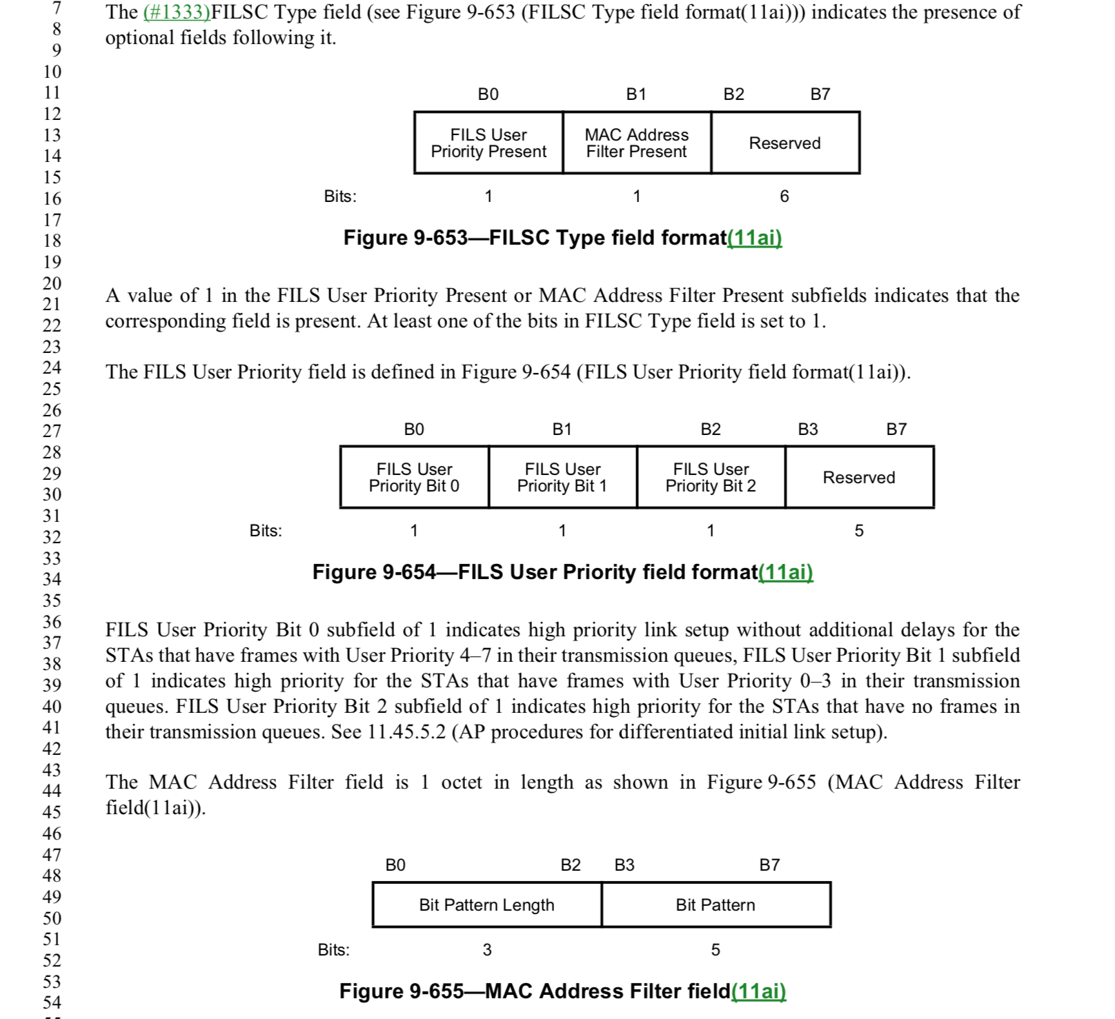
The DILS element specified filters (priority contidions) which constrain STAs that are allowed to perform FILS. Those filters can be the MAC Address Filter (field) or the FILS User Priority (field). The term “information priority” in the cited text in the comment refers to either of those fields / priority contidions.

Proposed resolution is to add a clarifying sentence in the first paragraph, stating what information priority conditions are currently supported:

Proposed Resolution:

REVISED.

Add after the following senctence:

The Differentiated Initial Link Setup element includes the conditions for a STA to determine whether it is allowed to attempt fast initial link setup for the duration specified in the element.

Ad P1342 L47 the following new sentence:

The element allows to specify two fast initial link setup category (FILSC) Information priority conditions as contained in the FILS User Priority field and MAC Address Filter field.

.

