IEEE P802.11
Wireless LANs
LB232 CIDs1334 and 1335 – Proposed Comment Resolution
Date: 2018-09-12
Author(s):
Name | Affiliation | Address | Phone | email
Marc Emmelmann | SELF;  Koden-TI | Berlin, Germany |  | emmelmann@ieee.org
Hitoshi Morioka | SRC Software | 2-14-38 Tenjin, Chuo-ku, Fukuoka 810-001 JAPAN |  | hmorioka@src-soft.com
Abstract
Proposed comment resolution for CID 1334 and 1335 (TGm LB232).

Rev-1: changes based on commenter feedback

CID 1334 & 1335

CID | Clause Number(C) | Page | Comment | Proposed Change
1334 | 11.45.5.3 | 2304.59 | " the non-AP STA shall check the FILSC Type  field to determine if it satisfies the condition specified in each and every optional field that is present" -- no specification is given of how optional fields encode a condition and how these conditions are deemed satisfied | Delete Subclauses 11.45.5 and 9.4.2.185
1335 | 11.45.5.3 | 2304.59 | " the non-AP STA shall check the FILSC Type  field to determine if it satisfies the condition specified in each and every optional field that is present" -- no specification is given of how optional fields encode a condition and how these conditions are deemed satisfied | Add text to describe what condition has to be met for each of the optional fields (and also state what happens if no optional fields are present)

Discussion

Note: P2304 refers to D1.0 which is in D1.4 on page 2464.

Context D1.4 2464

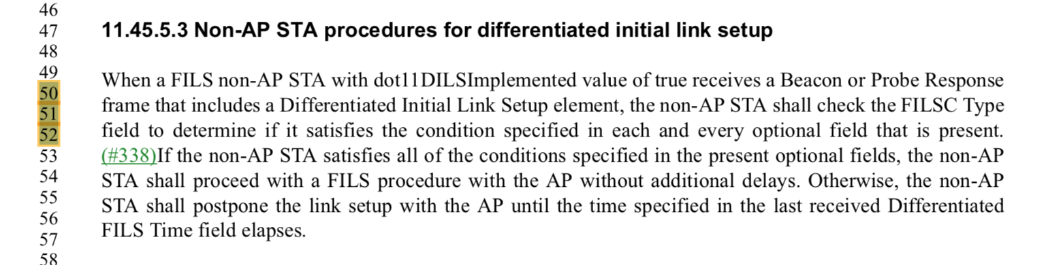

This indirectly refers back to the DILS element (D1.5 Cls. 9.4.2.186). This element contains two conditions referred to in the above paragraph.
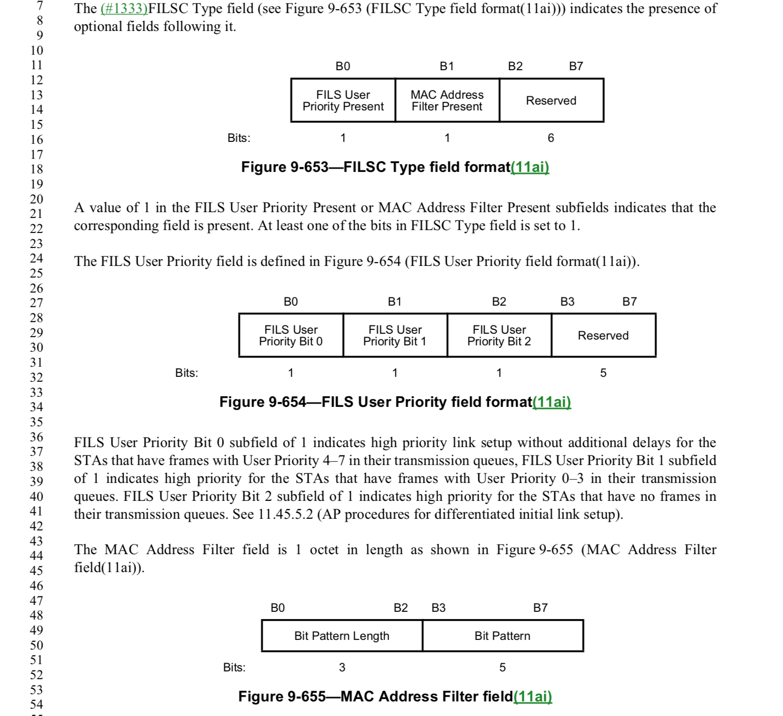

First, it as assured that at least one of the two optional elements specifying a condition, is present (see line 21).

Cls. 11.45.5.3 specifies the criteria in order to proceed with FILS, i.e. a non-AP STA has to satisfy each and every “condition”.

Those conditions are given as part of the DILS element referenced in Cls. 11.45.5.3. This element defines conditions via the FILS User Prioriy (field) and MAC Address Filter (field). The description of those fields explains how to interpret the conents of the fields and how to determine if the condition specified via the field is “true”.

Proposed Resolution:

REJECT

Cls. 11.45.5.3 specifies the criteria in order to proceed with FILS, i.e. a non-AP STA has to satisfy each and every “condition”.

Those conditions are given as part of the DILS element referenced in Cls. 11.45.5.3. This element defines conditions via the FILS User Prioriy (field) and MAC Address Filter (field). The description of those fields explains how to interpret the conents of the fields and how to determine if the condition specified via the field is “true”.

Please refer to https://mentor.ieee.org/802.11/documents?is_dcn=1611&is_year=2018 for a additional information.

.

