IEEE P802.11
Wireless LANs
LB232 CID1243 – Proposed Comment Resolution
Date: 2018-09-12
Author(s):
Name | Affiliation | Address | Phone | email
Marc Emmelmann | SELF;  Koden-TI | Berlin, Germany |  | emmelmann@ieee.org
Hitoshi Morioka | SRC Software | 2-14-38 Tenjin, Chuo-ku, Fukuoka 810-001 JAPAN |  | hmorioka@src-soft.com
Abstract
Proposed comment resolution for CID 1243 (TGm LB232).

CID 1243

CID | Clause Number(C) | Page | Comment | Proposed Change
1243 | 11.23.3.3.1 | 2207.37 | The use of the CAG (which is effectively ANQP response caching) in a STA can be used in any STA, not just a FILS STA. To some extent CAG is independent of FILS, even though it was introduced in the 11ai roll-up. In addition this clause is the ANQP behavior clause, which should have no dependancy on FILS. | Change the text "A FILS STA" to "A STA" at the start of the cited sentence

Discussion

Note: P2207.37 refers to D1.0 which is in D1.4 on page 2366

Context: D1.4 P2366

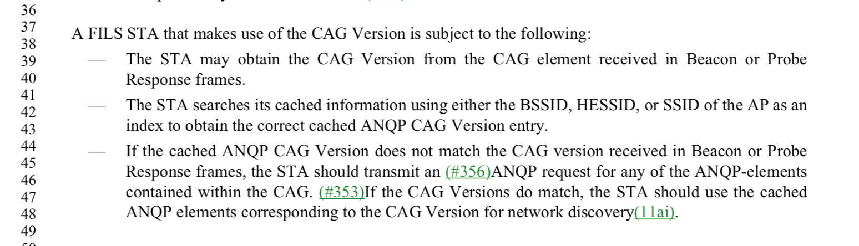

The comment correctly identifies that the cited clause does not only relate to FILS but to a STA in general.

Proposed Resolution:

Accept.

