IEEE P802.11
Wireless LANs
LB232 CID1309
Date: 2018-09-10
Author(s):
Name | Affiliation | Address | Phone | email
Youhan Kim | Qualcomm |  |  | youhank@qti.qualcomm.com

Abstract
This submission proposes resolutions for the following comments from the letter ballot on P802.11-REVmd D1.0:

1309

NOTE – Set the Track Changes Viewing Option in the MS Word to “All Markup” to clearly see the proposed text edits.

Revision History:

R0: Initial version.

CID 1309

CID | Clause | Page.Line | Comment | Proposed Change
1309 | 21.3.10.9.2 | 2972.49 | 160 MHz does not have 80 MHz 'segments'. | Check instances of 80 MHz 'segments' in the draft, which may need to be changed to 80 MHz 'portions'.

Discussion

Context: P1.4 P3147:

A VHT 160 MHz PPDU has one frequency segment, while a VHT 80+80 MHz PPDU has two frequency segments. However, in both VHT 160 MHz and 80+80 MHz PPDUs, the BCC interleaving or LDPC tone mapping is performed separately between the lower and upper 80 MHz ‘portions’. These ‘portions’ are referred to as frequency ‘subblocks’.

D1.4 P3138:
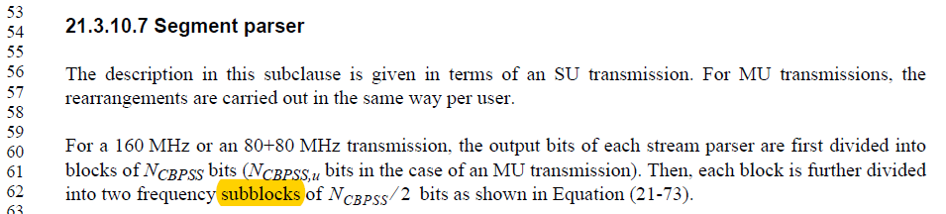

P3.1 P3140:

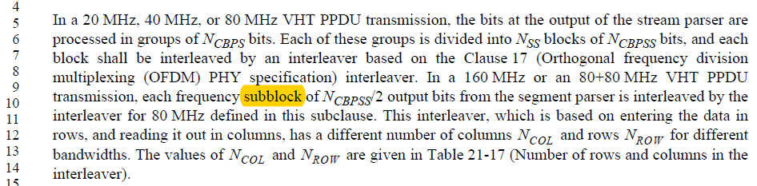

There are two instances of “80 MHz segment” in D1.4.

- P3147L49 should be updated as shown below
NOTE—LDPC tone mapping is performed separately for the upper and lower 80 MHz frequency subblocks of a 160 MHz or 80+80 MHz transmission as indicated by the frequency subblock index l in Equation (21-85) and Equation (21-86).

- P3161L1 is a valid use of the term “80 MHz segment” and should be left untouched
For an 80+80 MHz mask PPDU of non-HT duplicate or VHT format, the overall transmit spectral mask is
constructed in the following manner. First, the 80 MHz interim spectral mask is placed on each of the two
80 MHz segments.

Proposed Resolution: CID 1309
Revised. Agree with the commenter that “segement” is not the appropriate term. The correct terminology is “frequency subblock”.
Instruction to TGmd Editor: At D1.4 P3147L49, change “upper and lower 80 MHz segements of a 160 MHz of 80+80 MHz” to “upper and lower 80 MHz frequency subblocks of a 160 MHz or 80+80 MHz”. (Note the typo change of “of” to “or”.)

[End of File]

