IEEE P802.11
Wireless LANs
D3.0 Comment Resolution – Part 2
Date: 2018-09-11
Author(s):
Name | Affiliation | Address | Phone | email
Youhan Kim | Qualcomm |  |  | youhank@qti.qualcomm.com

Abstract
This submission proposes resolutions for the following comments from the letter ballot on P802.11ax D3.0:

16577, 16578, 15792, 16698, 16699, 16821, 16822, 15573, 15155

NOTE – Set the Track Changes Viewing Option in the MS Word to “All Markup” to clearly see the proposed text edits.

Revision History:

R0: Initial version.
R1: Added resolutions for CIDs 16577, 16578, 15792, 16698, 16699

CID 16577

CID | Clause | Page.Line | Comment | Proposed Change
16577 |  | 249.00 | Without an actual measurement and feedback from the HE AP, the non-AP HE STA has no way of knowing that the HE TB PPDU it transmits arrives at the AP within +/-0.4 ╬╝s of TXTIME + aSIFSTime + RTD from the transmission start time of the triggering PPDU | On line 27 of this paragraph, change "shall ensure" to "should ensure"

Background
D3.1 P251:
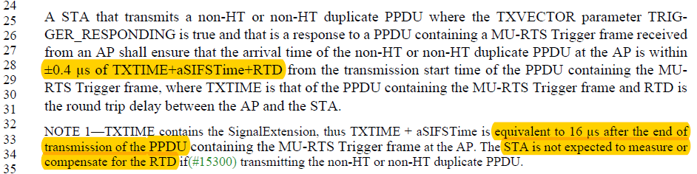

Proposed Resolution: CID 16577
Rejected. STA is expected to transmit the CTS frame 16 usec +- 0.4 usec after the end of the MU-RTS frame, which can be measured by an external equipment if necessary. The STA is not expected to measure or compensate for the RTD. See NOTE 1 at D3.1 P251L33.

CID 16578

CID | Clause | Page.Line | Comment | Proposed Change
16578 |  | 249.24 | Only non-AP HE STAs respond to MU-RTS | At the beginning of this paragraph, change "A STA" to "A non-AP HE STA"

Background
D3.1 P251:
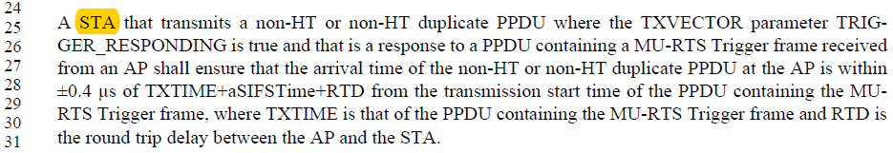

Proposed Resolution: CID 16578
Revised. Agree with the commenter.
Instruction to Editor: Change “STA” to “non-AP HE STA” at D3.1 P251L25.

CID 15792

CID | Clause | Page.Line | Comment | Proposed Change
15792 | 28.3.11.15 | 536.26 | The draft is severely bloated, and would be greatly improved by removing any modes that are only tangentially related to the main goals of the project. One of these is DCM, yet another (relatively) low-rate, longer-range mode: this has relatively little to do with high efficiency in dense deployments. The arguments that have been given in its support are unconvincing: (1) the argument that DCM gains 4dB or so depends on comparing a DCM mode with its counterpart that has the same modulation scheme and coding rate, i.e., that has double the data rate. The 'gain' of DCM is really one side of the same rate-range tradeoff that is a part of every clause in the entire standard. Doubling up again (DDCM?) would by the same token achieve some 'gain', probably the same 4dB or so; it does not follow that we should include such a mode; (2) the argument (from comment resolution on D2.0) that DCM is useful to combat narrowband interference caused by narrowband UL MU transmissions seems far-fetched: rather than a single narrow-band interferer we usually have interference across each channel bandwidth, but of varying strength, with overall interference low enough not to trigger CCA. This is a marginal justification for a marginal mode. The one argument in DCM's favor is that it is so tightly interwined throughout the draft that removing it would cause significant instability. That's a valid point, though in turn it demonstrates just how much clutter the mode brings to the project. Fortunately there is a simple way of removing DCM in effect, while not causing any short-term instability in the draft: we can require that all HE STAs signal that they do not support the option. At some later time, perhaps in TGm (md or me), we can complete the process of deleting it entirely. | Add at end of 28.3.11.15: "An HE STA shall set the DCM Max Constellation Rx subfield of the HE PHY Capabilities Information field to 0." Also at 378.65, delete "DCM (transmit and receive)".

Proposed Resolution: CID 15792
Rejected. The proposed resolution does not address the argument made by the commenter. An AP may still send a Trigger frame instructing the non-AP STA to transmit HE TB PPDU using DCM. Also, even if devices declare no support for DCM RX at this point, some devices may choose still implement DCM transmission with the anticipation that some future device may indicate support for DCM RX, with which DCM could be used.

CID 16698

CID | Clause | Page.Line | Comment | Proposed Change
16698 | 28.3.19.2 | 548.43 | The sentence "The test in ..." is not parsable. It is not possible to figure out whether a particular PPDU meets this condition. | Write the condition as a bulleted list: "The requirements in this subclause apply to PPDUs that meet all the following conditions: - STBC is not used; - 0.8 us GI is used; - If the PPDU bandwidth is 20 MHz, BCC is used; - If the PPDU bandwidth is greater than 20 MHz, LDPC is used; - The PPDU is an HE SU PPDU

Background
Page/Line seems to have a typo. Relevant sections are shown below.

D3.1 P564:
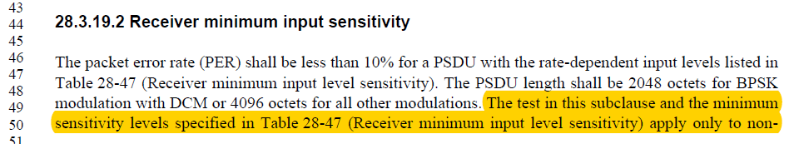

D3.1 P566:

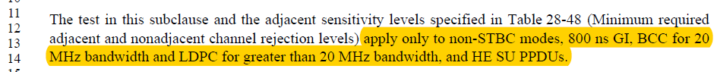

D3.1 P566:

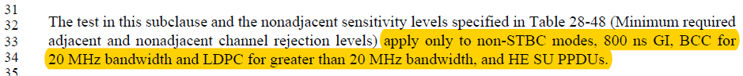

Proposed Resolution: CID 16698
Revised. Proposed text update implements the suggestion by the commenter in the general section (28.3.19.1).
Instruction to Editor: Implement the proposed text changes in 11-18/1591r1 for CID 16698.

Proposed Text Updates: CID 16698

      - General
TGax Editor: Update D3.1 P564L42 as shown below.
For tests in this subclause, the input levels are measured at the antenna connectors and are referenced as the average power per receive antenna. The number of spatial streams under test shall be equal to the number of utilized transmitting STA antenna (output) ports and also equal to the number of utilized Device Under Test input ports. Each output port of the transmitting STA shall be connected through a cable to one input port of the Device Under Test.
The requirements on receiver minimum input sensitivity (28.3.19.2), adjacent channel rejection (28.3.19.3) and nonadjacent channel rejection (28.3.19.4) apply to PPDUs that meet all the following conditions:
- STBC is not used
- 0.8 us GI is used
- If the PPDU bandwidth is 20 MHz, BCC is used
- If the PPDU bandwidth is greater than 20 MHz, LDPC is used
- The PPDU is an HE SU PPDU

      - Receiver minimum input sensitivity

TGax Editor: Update D3.1 P564L49 as shown below.

The packet error rate (PER) shall be less than 10% for a PSDU with the rate-dependent input levels listed in Table 28-47 (Receiver minimum input level sensitivity). The PSDU length shall be 2048 oc-tets for BPSK modulation with DCM or 4096 octets for all other modulations.

- Adjacent channel rejection
TGax Editor: Delete the paragraph at D3.1 P566L11 as shown below.

- Nonadjacent channel rejection
TGax Editor: Delete the paragraph at D3.1 P567L32 as shown below.

CID 16699

CID | Clause | Page.Line | Comment | Proposed Change
16699 | 28.3.19.6.2 | 552.11 | What is a BQR transmission? | Define BQR transmission

Background
D3.1 P557:

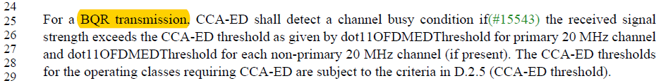

Proposed Resolution: CID 16699
Revised. BQR transmission should be changed to
Instruction to Editor: At D3.1 P557L25, change “BQR transmission” to
Implement the proposed text changes in 11-18/1591r1 for CID 16822 and 15573.

Proposed Text Updates: CID 16822, 15573

TGax Editor: Update D3.1 P557L28 as shown below.

An example transmit spectral mask for the N×20 MHz preamble punctured channel with transmission on the lower sub-channel is shown in Figure 28-52 (Example transmit spectral mask for the N×20 MHz preamble punctured channel with transmissions on the lower sub-channel)

CID 16821

CID | Clause | Page.Line | Comment | Proposed Change
16821 | 28.3.18.1 | 552.56 | "When preamble puncturing happens in an HE MU PPDU, the HE MU PPDU is still treated as an 80 MHz  PPDU if the Bandwidth field on HE-SIG-A field of the HE MU PPDU is set to 4 or 5 or a 160 MHz or  80+80 MHz PPDU if the Bandwidth field in HE-SIG-A field of the HE MU PPDU is set to 6 or 7, therefore  the spectral mask is the same as those defined for the total channel width." This requirement is already spelled out in the first paragraph of 28.3.18.1. | Delete lines 56-60.

Background
D3.1 P552:
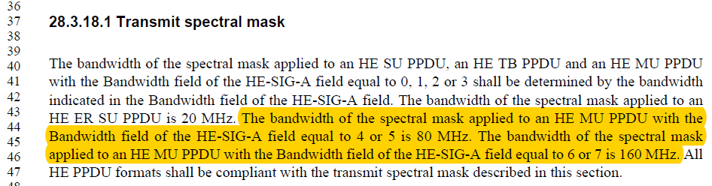

P3.1 P556:
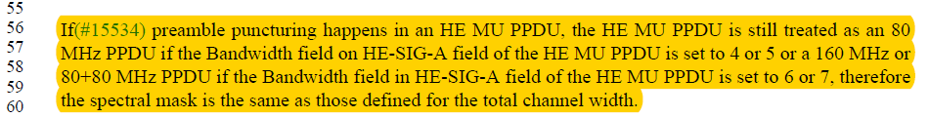

Proposed Resolution: CID 16821
Revised. Agree with the commenter that D3.1 P556L56-60 is redundant to D3.1 P552L43-46.
Instruction to Editor: Delete the paragraph at D3.1 P556L56-60.

CID 16822, 15573

CID | Clause | Page.Line | Comment | Proposed Change
16822 | 28.3.18.1 | 553.29 | "An example transmit spectral mask for the N├ù20 MHz preamble punctured channel with transmission on  both the upper and lower subchannels is shown in Figure 28-52". Wrong description of the figure. This figure describes a mask on the lower-subchannel. | Change "both the upper and lower subchannels" to "the lower sub-channel"
15573 | 28.3.18.1 | 553.30 | "on both the upper and lower subchannels is shown in Figure 28-52". Figure 28-52 shows the transmission only on the lower subchannel | as in comment

Background
D3.1 P557:
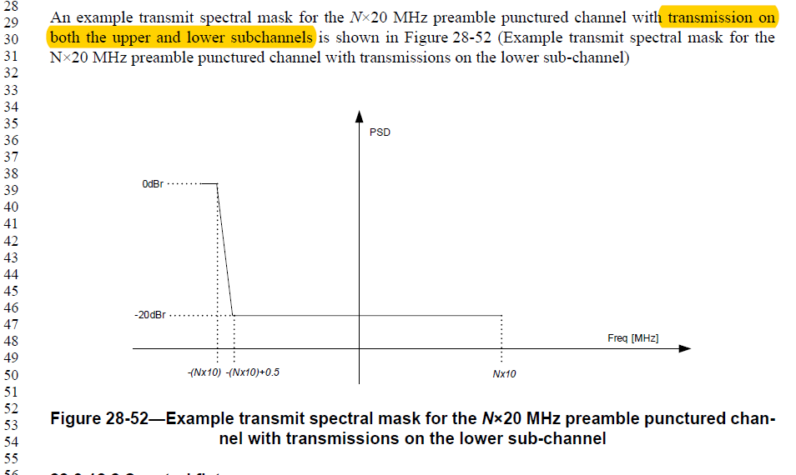

Proposed Resolution: CID 16822
Revised. Proposed text update implements the suggestion by the commenter on top of D3.1.
Instruction to Editor: Implement the proposed text changes in 11-18/1591r1 for CID 16822 and 15573.

Proposed Resolution: CID 15573
Revised. Proposed text update clarifies that Figure 28-52 is for the case of transmission on the lower sub-channel.
Instruction to Editor: Implement the proposed text changes in 11-18/1591r1 for CID 16822 and 15573.

Proposed Text Updates: CID 16822, 15573

TGax Editor: Update D3.1 P557L28 as shown below.

An example transmit spectral mask for the N×20 MHz preamble punctured channel with transmission on the lower sub-channel is shown in Figure 28-52 (Example transmit spectral mask for the N×20 MHz preamble punctured channel with transmissions on the lower sub-channel)

CID 15155

CID | Clause | Page.Line | Comment | Proposed Change
15155 | 28.3.18.3 | 555.06 | 802.11ax operates in the bands between 1 - 7.125 GHz . In clause 28.3.18.3 symbol clock frequency and transmit center frequency tolerance not specified for the 6 GHz band. | Change to "shall be +- 20 ppm in the 5 GHz and 6 GHz bands and +- 25 ppm in 2.4GHz bands.

Background
D3.1 P559:
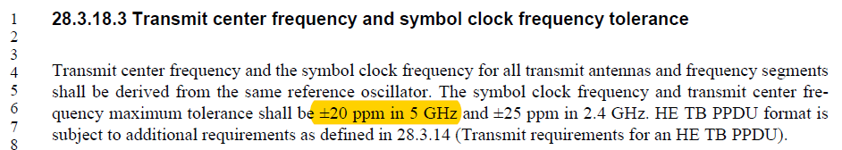

Proposed Resolution: CID 15155
Revised. Proposed text update clarifies that the +-20 ppm requirement applies for 5 GHz and above bands.
Instruction to Editor: Implement the proposed text changes in 11-18/1591r1 for CID 16822 and 15573.

Proposed Text Updates: CID 15155

TGax Editor: Update D3.1 P559L6 as shown below.

Transmit center frequency and the symbol clock frequency for all transmit antennas and frequency segments shall be derived from the same reference oscillator. The symbol clock frequency and transmit center frequency maximum tolerance shall be ±20 ppm in the 5 GHz and above bands, and ±25 ppm in the 2.4 GHz band. HE TB PPDU format is subject to additional requirements as defined in 28.3.14.

[End of File]

