IEEE P802.11
Wireless LANs
D3.0 Comment Resolution – Part 2
Date: 2018-09-09
Author(s):
Name | Affiliation | Address | Phone | email
Youhan Kim | Qualcomm |  |  | youhank@qti.qualcomm.com

Abstract
This submission proposes resolutions for the following comments from the letter ballot on P802.11ax D3.0:

16821, 16822, 15573, 15155

NOTE – Set the Track Changes Viewing Option in the MS Word to “All Markup” to clearly see the proposed text edits.

Revision History:

R0: Initial version.

CID 16821

CID | Clause | Page.Line | Comment | Proposed Change
16821 | 28.3.18.1 | 552.56 | "When preamble puncturing happens in an HE MU PPDU, the HE MU PPDU is still treated as an 80 MHz  PPDU if the Bandwidth field on HE-SIG-A field of the HE MU PPDU is set to 4 or 5 or a 160 MHz or  80+80 MHz PPDU if the Bandwidth field in HE-SIG-A field of the HE MU PPDU is set to 6 or 7, therefore  the spectral mask is the same as those defined for the total channel width." This requirement is already spelled out in the first paragraph of 28.3.18.1. | Delete lines 56-60.

Background
D3.1 P552:
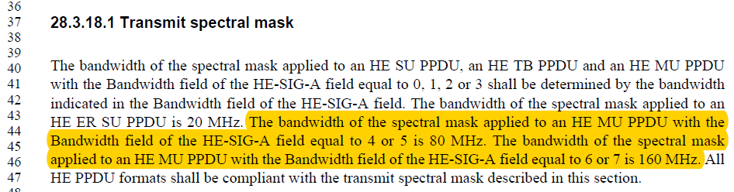

P3.1 P556:
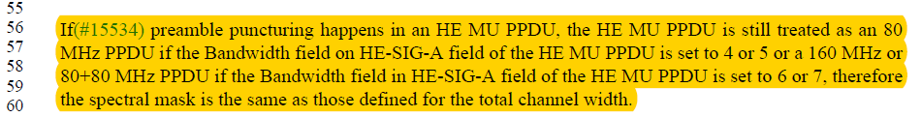

Proposed Resolution: CID 16821
Revised. Agree with the commenter that D3.1 P556L56-60 is redundant to D3.1 P552L43-46.
Instruction to Editor: Delete the paragraph at D3.1 P556L56-60.

CID 16822, 15573

CID | Clause | Page.Line | Comment | Proposed Change
16822 | 28.3.18.1 | 553.29 | "An example transmit spectral mask for the N├ù20 MHz preamble punctured channel with transmission on  both the upper and lower subchannels is shown in Figure 28-52". Wrong description of the figure. This figure describes a mask on the lower-subchannel. | Change "both the upper and lower subchannels" to "the lower sub-channel"
15573 | 28.3.18.1 | 553.30 | "on both the upper and lower subchannels is shown in Figure 28-52". Figure 28-52 shows the transmission only on the lower subchannel | as in comment

Background
D3.1 P557:
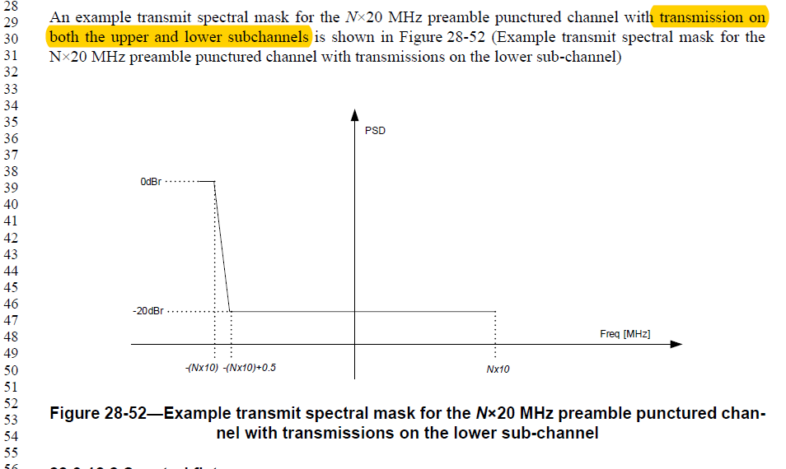

Proposed Resolution: CID 16822
Revised. Proposed text update implements the suggestion by the commenter on top of D3.1.
Instruction to Editor: Implement the proposed text changes in 11-18/1591r0 for CID 16822 and 15573.

Proposed Resolution: CID 15573
Revised. Proposed text update clarifies that Figure 28-52 is for the case of transmission on the lower sub-channel.
Instruction to Editor: Implement the proposed text changes in 11-18/1591r0 for CID 16822 and 15573.

Proposed Text Updates: CID 16822, 15573

TGax Editor: Update D3.1 P557L28 as shown below.

An example transmit spectral mask for the N×20 MHz preamble punctured channel with transmission on the lower sub-channel is shown in Figure 28-52 (Example transmit spectral mask for the N×20 MHz preamble punctured channel with transmissions on the lower sub-channel)

CID 15155

CID | Clause | Page.Line | Comment | Proposed Change
15155 | 28.3.18.3 | 555.06 | 802.11ax operates in the bands between 1 - 7.125 GHz . In clause 28.3.18.3 symbol clock frequency and transmit center frequency tolerance not specified for the 6 GHz band. | Change to "shall be +- 20 ppm in the 5 GHz and 6 GHz bands and +- 25 ppm in 2.4GHz bands.

Background
D3.1 P559:
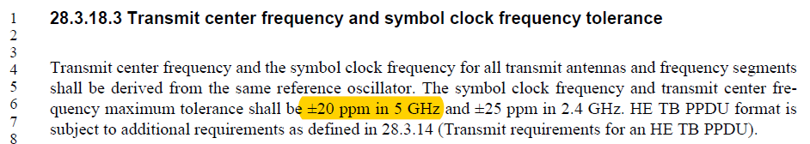

Proposed Resolution: CID 15155
Revised. Proposed text update clarifies that the +-20 ppm requirement applies for 5 GHz and above bands.
Instruction to Editor: Implement the proposed text changes in 11-18/1591r0 for CID 16822 and 15573.

Proposed Text Updates: CID 15155

TGax Editor: Update D3.1 P559L6 as shown below.

Transmit center frequency and the symbol clock frequency for all transmit antennas and frequency segments shall be derived from the same reference oscillator. The symbol clock frequency and transmit center frequency maximum tolerance shall be ±20 ppm in the 5 GHz and above bands, and ±25 ppm in the 2.4 GHz band. HE TB PPDU format is subject to additional requirements as defined in 28.3.14.

[End of File]

