IEEE P802.11
Wireless LANs
CR on PHY subcarriers and RU part 1
Date: 2018-09-08
Author(s):
Name | Affiliation | Address | Phone | email
Yujin Noh | Newracom |  |  | yujin.noh at newracom.com
Lochan Verma | Qualcomm |  |  | lverma@qti.qualcomm.com
Abstract
This submission shows
- Resolution for a comment received from TGax comment collection (TGax Draft D3.0)
- The proposed changes are based on 11ax D3.0.

The submission provides resolutions to comments related to PHY subcarriers and RU.
- The submission provides resolutions to 13 CIDs:
16485, 15974, 15977, 16836, 16632, 16790, 15645, 16691, 15467, 16439,
16973, 16988 and 16972

Revisions:
- Rev 0: Initial version of the document.

CID | P.L | Comment | Proposed Change | Resolution
16485 | 410.46 | An OFDM symbol is constructed of subcarriers, the number of which is a function of the  PPDU bandwidth. There are several subcarrier types, inlcuding Data subcarriers, Pilot subcarriers and Unused subcarriers. However, do the unused subcarriers contain Null subcarries? It seems Null subcarriers are resulted from tone plan in OFDMA. | Please correct it. | Rejected.  The comment fails to identify the specific issue when Null subcarrier is classified into the unused subcarriers and provide any appropriate resolution for changes.  In the spec at P410L46, the unused subcarrier is defined as the subcarriers which are not used for either data or pilot transmssion.
15974 | 414.23 | Delete the "Central 26-tone RU" text in Figure 28-5---RU locations in a 20 MHz HE PPDU, since this is confusing: it is not the magic bonus central 26-tone RU that you get for 80M+ PPDUs and that is signalled in the Center 26-tone RU subfield of the Common field of HE-SIG-B | As it says in the comment | Revised.  The “Central 26-tone RU” has not been defined except for showing Figs 28-5 and 28-7. To make it clear, “Central 26-tone RU” is replaced with “center 26-tone RU” which is defined at P414L12 with “The center 26-tone RU in the 20 MHz and 80 MHz HE MU PPDU or HE TB PPDU formats using OFDMA transmission (Figure 28-5 (RU locations  in a 20 MHz HE PPDU) and Figure 28-7 (RU locations in an 80 MHz HE PPDU)) is located on subcarriers [-16: -4, 4: 16].  TGax Editor: make changes according to this document 11-18-1453-00-00ax CR on PHY subcarriers and RU part 1
15977 | 416.03 | The "Central 26-tone RU" text in Figure 28-5---RU locations in a 20 MHz HE PPDU is confusing: it is not the magic bonus central 26-tone RU that you get for 80M+ PPDUs and that is signalled in the Center 26-tone RU subfield of the Common field of HE-SIG-B | Prepend "Additional" to "Central 26-tone RU" in Figure 28-7 | Revised.  Same reason to CID15974.

To TGax editor: P414L23 replace the current text with the proposed changes below.(# 15974, 15977 )
------------- Begin Text Changes ---------------
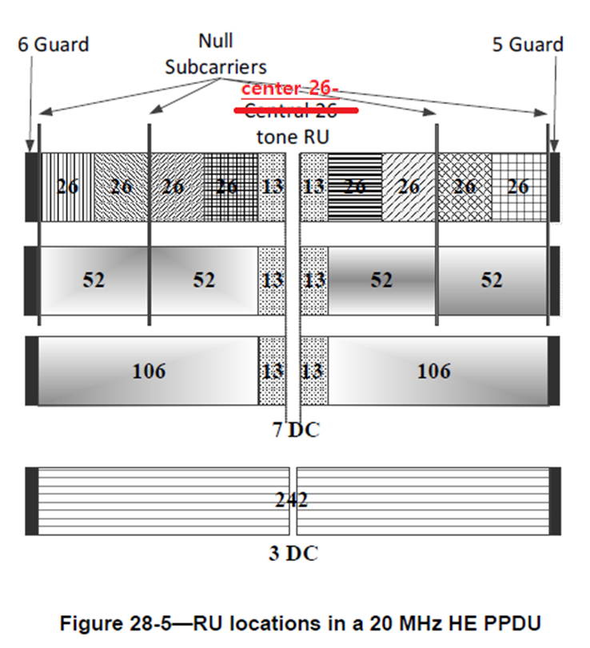
------------- End Text Changes ---------------
To TGax editor: P416L2 replace the current text with the proposed changes below.(# 15974, 15977 )
------------- Begin Text Changes ---------------
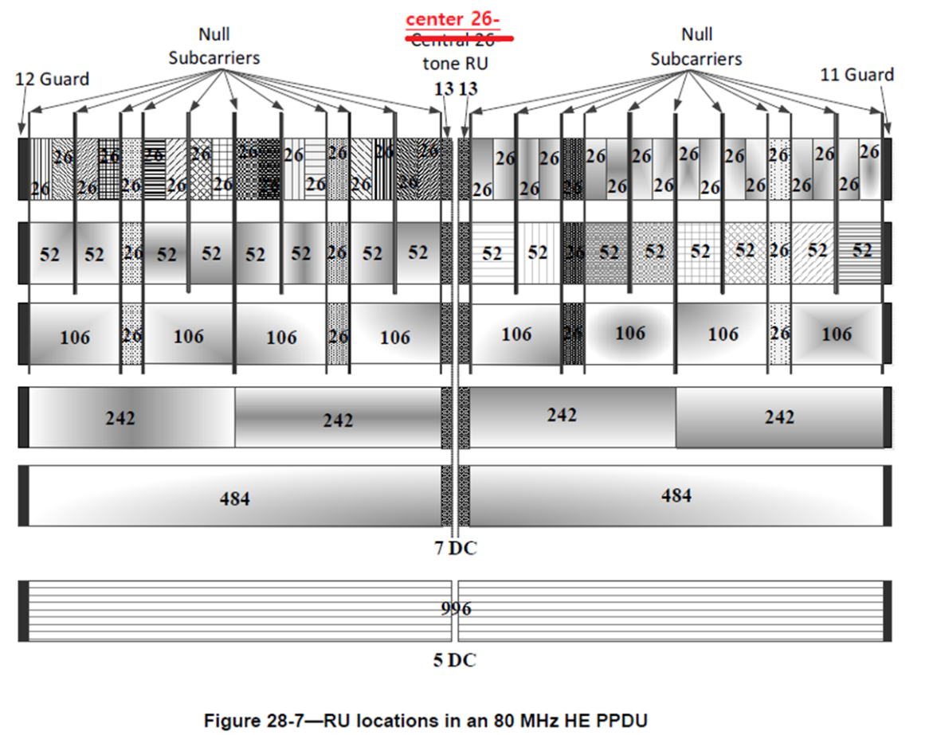
------------- End Text Changes ---------------

CID | P.L | Comment | Proposed Change | Resolution
16836 | 418.07 | Table 28-9: Add 160 MHz to the table for completion. Missing 160 MHz has probably resulted in another issue found next in Table 18-13. | Please update if agreed. | Revised.  Agreed in principle.  Table 28-9 is fixed for a 160MHz or 80+80 MHz HE PPDU.  As for Table 28-13, it shows the right figures for CBW160 even though it omits 10 unused subcarriers which are 5 DC tones per segment of 80MHz.  TGax Editor: make changes according to this document 11-18-1453-00-00ax CR on PHY subcarriers and RU part 1
To TGax editor: P418L6 replace the current text with the proposed changes below.(# 16836)
------------- Begin Text Changes ---------------
- Null subcarrier indices
Channel Width | RU Size | Null Subcarrier Indices
20 MHz | 26, 52 | ±69, ±122
 | 106 | none
 | 242 | none
40 MHz | 26, 52 | ±3, ±56, ±57, ±110, ±137, ±190, ±191, ±244
 | 106 | ±3, ±110, ±137, ±244
 | 242, 484 | none
80 MHz | 26, 52 | ±17, ±70, ±71, ±124, ±151, ±204, ±205, ±258, ±259, ±312, ±313, ±366, ±393, ±446, ±447, ±500
 | 106 | ±17, ±124, ±151, ±258, ±259, ±366, ±393, ±500
 | 242, 484 | none
 | 996 | none
160 MHz | 26, 52, 106 | {null subcarrier indices in 80 MHz - 512, null subcarrier indices  in 80 MHz +512}
 | 242, 484, 996,  2$×$996 | None

------------- End Text Changes ---------------

CID | P.L | Comment | Proposed Change | Resolution
16632 | 418.38 | Are there indeed cases where an HE-LTF would not have any pilot subcarriers? | Either a) Rewrite to "The location of pilot subcarrers ... shall be the same as ... the 4x HE-LTF except for pilot subcarriers that are deleted because they do not meet the following conditions: in a 1x HE-LTF, pilot subcarriers that are not a multiple of 4 are deleted, and in a 2x HE-LTF pilot subcarriers that are not a multiple of 2 are deleted" or b) add a note to explain how this field can be entirely bereft of pilot subcarriers | Rejected.  It fails to identify what is the critical issue without text changes. Without additional description, current text explains clearly which pilot subcarrers are present in 1x HE-LTF and 2x HE-LTF comparing to pilot subcarriers in 4x HE-LTF.
16790 | 420.35 | "The value of GI duration shall be the same for all users in an HE MU PPDU". This is a section on HE TB PPDUs. | Change "MU PPDU" to "TB PPDU" | Accepted.  TGax Editor: make changes according to this document 11-18-1453-00-00ax CR on PHY subcarriers and RU part 1
15645 | 420.39 | The spec reads "The Trigger frame indicates ... if a 1x LTF is used".  And in other places related to HE masked HE-LTF sequence mode, it has references to 1x LTF.  However, across the standard, there is only definition of term 1x HE-LTF, not 1x LTF.  I think the 1x LTF should be replaced with 1x HE-LTF to avoid confusion. | The spec reads "The Trigger frame indicates ... if a 1x HE-LTF is used" | Revised.  Throughout the current draft spec, as commenter mentioned, mixed terms with 1x LTF (as well as 2x LTF and 4x LTF) and 1x HE-LTF (as well as 2x HE-LTF and 4x HE-LTF) are in use to indicate 1x HE-LTF.  TGax Editor: do global search and replace 1x LTF, 2x LTF, and 4x LTF with 1x HE-LTF, 2x HE-LTF, and 4x HE-LTF, respectively
16691 | 420.46 | This statement belongs in the MAC clause since it has to do with sequencing and channel access. I'm not sure its necessary in any case. | Move to MAC clause or delete. | Revised.  STA's behavior for UL MU operation is described at P286L50 in 27.5.3.3. Better to delete the original text.  TGax Editor: make changes according to this document 11-18-1453-00-00ax CR on PHY subcarriers and RU part 1

To TGax editor: P420L36 replace the current text with the proposed changes below.(# 16790, #16691)
------------- Begin Text Changes ---------------
The value of GI duration shall be the same for all users in an HE MU TB PPDU.
The Trigger frame indicates whether the UL MU transmission following it uses HE single stream pilot HELTF mode or HE masked HE-LTF sequence mode or no pilots if a 1x LTF is used. When HE single stream pilot HE-LTF mode is used, no masking is applied to the HE-LTF. HE single stream pilot HE-LTF mode is used for any UL OFDMA transmission, including UL OFDMA with MU-MIMO transmissions. The appropriate MU-MIMO LTF mode indicated by the Trigger frame is used for full bandwidth UL MU-MIMO transmission except for 1x LTF.
If a STA finds that there is no User Info field in the Trigger frame carrying the STA’s AID in the AID12 subfield and there is no resource allocated for random access, then the STA shall not transmit an HE TB PPDU.
------------- End Text Changes ---------------

CID | P.L | Comment | Proposed Change | Resolution
15467 | 420.54 | There is something going on with the initial sentence of this paragraph. The 20MHz-only non-AP STA indicates that it "transmits, support for only 20Mhz"? Does it transmit support? | Change "When" to "if" | Revised.  Agreed in principle.  However, the proposed change fails to resolve it because there is no "When" in the sentence. It was rephrased to make it clear by deleting "," before "support"  TGax Editor: make changes according to this document 11-18-1453-00-00ax CR on PHY subcarriers and RU part 1
To TGax editor: P420L54 replace the current text with the proposed changes below. (# 15467)
------------- Begin Text Changes ---------------

A 20 MHz-only non-AP HE STA is a non-AP HE STA that indicates in the Channel Width Set subfield in the HE PHY Capabilities Information field of the HE Capabilities element that it transmits (see 9.4.2.237.3 (HE PHY Capabilities Information field)), support for only 20 MHz channel width for the frequency band in which it is operating.
------------- End Text Changes ---------------

CID | P.L | Comment | Proposed Change | Resolution
16439 | 421.52 | 160 MHz in 2.4 GHz? Sounds like a band grab! (That's a pun...) (https://en.wikipedia.org/wiki/Land_grabbing) | Delete "In 2.4 GHz band" | Accepted.  TGax Editor: make changes according to this document 11-18-1453-00-00ax CR on PHY subcarriers and RU part 1
16973 | 421.52 | An HE AP shall not allocate an RU in an 160 MHz or 80+80 MHz HE MU PPDU or HE TB PPDU to a  20 MHz operating non-AP HE STA with the 20 MHz In 160/80+80 MHz HE PPDU In 2.4 GHz Band subfield in the HE PHY Capabilities Information field in its HE Capabilities element equal to 0.  we don't have "20 MHz In 160/80+80 MHz HE PPDU In 2.4 GHz Band" subfield | should be 20 MHz In 160/80+80 MHz HE PPDU in 5 GHz Band | Revised.  Agreed in principle.  Same resolution to 16439  TGax Editor: make changes according to this document 11-18-1453-00-00ax CR on PHY subcarriers and RU part 1
16988 | 421.52 | An HE AP shall not allocate an RU in an 160 MHz or 80+80 MHz HE MU PPDU or HE TB PPDU to a 20 MHz operating non-AP HE STA with the 20 MHz In 160/80+80 MHz HE PPDU In 2.4 GHz Band subfield in the HE PHY Capabilities Information field in its HE Capabilities element equal to 0. It should be 5GHz Band instead of 2.4GHz Band. | as in comment | Revised.  Same resolution to 16439  TGax Editor: make changes according to this document 11-18-1453-00-00ax CR on PHY subcarriers and RU part 1
To TGax editor: P421L50 replace the current text with the proposed changes below. (# 16439, # 16973, # 16988)
------------- Begin Text Changes ---------------

An HE AP shall not allocate an RU in an 160 MHz or 80+80 MHz HE MU PPDU or HE TB PPDU to a 20 MHz operating non-AP HE STA with the 20 MHz In 160/80+80 MHz HE PPDU In 2.4 GHz Band subfield in the HE PHY Capabilities Information field in its HE Capabilities element equal to 0.
------------- End Text Changes ---------------

CID | P.L | Comment | Proposed Change | Resolution
16972 | 424.13 | HE masked HE-LTF sequence mode as defined in Equation (28-57).  Eq 28-57 doesn't specify the HE masked HE-LTF but 28-59 does. | Replace 28-57 with 28-59 | Accepted.  TGax Editor: make changes according to this document 11-18-1453-00-00ax CR on PHY subcarriers and RU part 1

Discussion
As shown in Equation (28-67) below, it does not specify the HE masked HE-LTF.
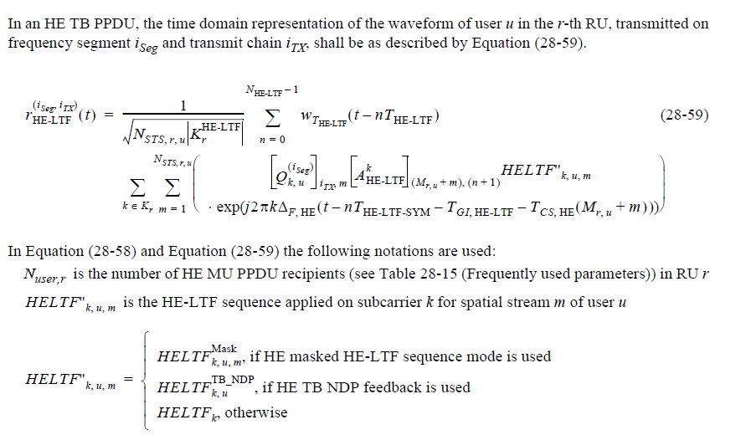
To TGax editor: P424L10 replace the current text with the proposed changes below. (#16972)
------------- Begin Text Changes ---------------
A non-AP STA that sets the Full Bandwidth UL MU-MIMO subfield of the HE PHY Capabilities Information field in the HE Capabilities element it transmits to 1 shall support HE single stream pilot HE-LTF mode and HE masked HE-LTF sequence mode as defined in Equation (28-59) (28-57) for the transmission of an HE TB PPDUs with one RU spanning the entire PPDU bandwidth, and the RU using MU-MIMO.
------------- End Text Changes ---------------

