IEEE P802.11  
Wireless LANs

|  |  |  |  |  |
| --- | --- | --- | --- | --- |
| CR on Packet Extension | | | | |
| Date: 2018-09-08 | | | | |
| Author(s): | | | | |
| Name | Affiliation | Address | Phone | email |
| Yujin Noh | Newracom |  |  | yujin.noh at newracom.com |
| Lochan Verma | Qualcomm |  |  | lverma@qti.qualcomm.com |

Abstract

This submission shows

* Resolution for a comment received from TGax comment collection (TGax Draft D3.0)
* The proposed changes are based on 11ax D3.0.

The submission provides resolutions to comments related to Packet Extension.

* The submission provides resolutions to 7 CIDs:   
  16636, 16111, 16358, 16261, 16364, 16820 and 16980

Revisions:

* Rev 0: Initial version of the document.

|  |  |  |  |  |
| --- | --- | --- | --- | --- |
| **CID** | **P.L** | **Comment** | **Proposed Change** | **Resolution** |
| 16636 | 538.59 | Packet is a vague term but the IEEE dictionary most closely associates it with a layer 3 entity so "Packet Extension" is a poor name | Replace "Packet Extension" by "PPDU Extension" here and thruout the spec. Ditto Nominal Packet Padding, NDP, etc. | Rejected.  “Packet” has been broadly used in not only 11ax draft 3.0 but also in other IEEE 802.11 amendments without any ambiguity. (e.g. IEEE P802.11-REVmd™/D1.3, August 2018). The comment fails to idenify a specific issue when term “packet” is used. |
| 16111 | 541.03 | " for the HE TB NDP feedback " is not clear | Change to " for an HE TB NDP feedback PPDU " | Revised  TGax Editor: make changes according to this document 11-18-1452-00-00ax CR on Packet Extension |
| 16358 | 541.17 | The equation for T_HE-PREAMBLE below E(28-115) duplicates that in E(28-122) | Under E(28-115) just say T_HE-PREAMBLE is defined in Equation (28-122) | Revised.  TGax Editor: make changes according to this document 11-18-1452-00-00ax CR on Packet Extension |

***Discussion***

For CID16358,   
as commentor mentioned, the same equation is given at both P541L18 and Equation (28-122) as below. *T*HE-PREAMBLE in Equation (28-115) can be referred from Equation (28-122).

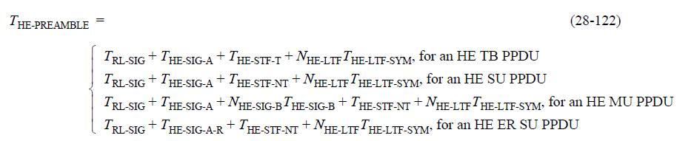

***To TGax editor:*** ***P541L01*** *replace the current text with the proposed changes below.* (#16111 and #16358)***------------- Begin Text Changes ---------------***

When transmitting an HE TB PPDU for which the TXVECTOR parameter TRIGGER_METHOD is TRIGGER_FRAME, each transmitter of an HE TB PPDU shall append a PE field with a duration *TPE* calculated using Equation (28-115) except for ~~the~~ an HE TB NDP feedback PPDU (see 28.3.17 (HE TB NDP feedback PPDU)) which has a *TPE* = 0(#12791).





where

*m* = 2 for an HE TB PPDU

LENGTH is the value indicated by UL Length subfield(#11372) of the Common Info field in the Trigger frame

*b*PE-Disambiguity is the value of the TXVECTOR parameter HE_TB_PE_DISAMBIGUITY

*T*HE-PREAMBLE is the value for an HE TB PPDU in Equation 28-122



*T*HE-STF-T, *T*HE-LTF-SYM, *T*RL-SIG and *T*HE-SIG-A are defined in **Error! Reference source not found.**

*NMA* is the number of midamble periods in the current PPDU.

***------------- End Text Changes ---------------***

|  |  |  |  |  |
| --- | --- | --- | --- | --- |
| **CID** | **P.L** | **Comment** | **Proposed Change** | **Resolution** |
| 16261 | 541.52 | There is no behaviour associated with PE_DURATION | After "When transmitting an HE TB PPDU for which the TXVECTOR parameter TRIGGER_METHOD is TRS,  each transmitter of the HE TB PPDU shall append a PE field with the duration TPE equal to the value specified in the TXVECTOR parameter DEFAULT_PE_DURATION." add "Otherwise, when transmitting an HE PPDU, a STA shall append a PE field with the duration TPE equal to the value specified in the TXVECTOR parameter PE_DURATION" | Rejected.  When it comes to a PE field of HE PPDU, spec shows the descrption - The duration of the PE field for an HE SU PPDU, HE ER SU PPDU or HE MU PPDU is determined by both the pre-FEC padding factor value in the last OFDM symbol(s) of the Data field, and the TXVECTOR parameter NOMINAL_PACKET_PADDING – at P539L1 which is enough. Since PE_DURATION parameter is not used in the spec, this entry is deleted.  Given that PE_DURATION TXVEXTOR parameter is not present, proposed change fails to resolve it correctly. |
| 16364 | 289.01 | "The DEFAULT_PE_DURATION parameter is set to the default PE duration value for UL MU response scheduling, which is indicated by the AP in the Default PE Duration subfield of the HE Operation element it transmits and the pre-FEC padding factor is set to 4 (see 28.3.12 (Packet extension))" -- the bit from "and the pre-FEC" onwards is broken. It's set where? How does this relate to the TXVECTOR parameters (which is what the list is about)? | Delete "and the pre-FEC padding factor is set to 4 (see 28.3.12)" from the cited text. The resolution to CID 12790 did not address the two specific issues identified ("It's set where? How does this relate to the TXVECTOR parameters (which is what the list is about)?") | Revised.  The pre-FEC padding factor is not related to setting TXVECTOR parametes when a STA transmitting an HE TB PPDU in response to a frame containing a TRS Control subfield. So this setting is moved in 28.3.12 Packet extension  TGax Editor: make changes according to this document 11-18-1452-00-00ax CR on Packet Extension |

***To TGax editor:*** ***P288L64*** *replace the current text with the proposed changes below.* (#16364)***------------- Begin Text Changes ---------------***

* The DEFAULT_PE_DURATION parameter is set to the default PE duration value for UL MU response scheduling, which is indicated by the AP in the Default PE Duration subfield of the HE Operation element it transmits ~~and the pre-FEC padding factor is set to 4 (see 28.3.12 (Packet extension))~~

***------------- End Text Changes ---------------***

***To TGax editor:*** ***P541L52*** *replace the current text with the proposed changes below.* (#16364)***------------- Begin Text Changes ---------------***

When transmitting an HE TB PPDU for which the TXVECTOR parameter TRIGGER_METHOD is TRS, each transmitter of the HE TB PPDU shall append a PE field with the duration *TPE* equal to the value spec-ified in the TXVECTOR parameter DEFAULT_PE_DURATION and set the pre-FEC factor to 4 in the last OFDM symbol(s) of the Data field.

***------------- End Text Changes ---------------***

***To TGax editor:*** ***P3981L11*** *replace the current text with the proposed changes below.* (#16364)***------------- Begin Text Changes ---------------***

|  |  |  |  |  |
| --- | --- | --- | --- | --- |
| DEFAULT_PE_DURATION | FORMAT is HE_TB(#12602) and TRIGGER_METHOD is TRS(#13136) | Duration of the PE field to be transmitted (see 27.5.3.3 (STA behavior for UL MU operation)).  Enumerated type:  PE0 for 0 µs  PE1 for 4 µs  PE2 for 8 µs  PE3 for 12 µs  PE4 for 16 µs(#12794, #Ed) | Y | N |
| Otherwise | Not present | N | N |
| ~~PE_DURATION~~ | ~~FORMAT is HE_SU, HE_MU, HE_ER_SU(#12602) or HE_TB(#12602).~~ | ~~The duration of the PE field in the received HE PPDU.(#Ed)~~  ~~Enumerated type:~~  ~~PE0 for 0 µs~~  ~~PE1 for 4 µs~~  ~~PE2 for 8 µs~~  ~~PE3 for 12 µs~~  ~~PE4 for 16 µs~~ | ~~N~~ | ~~O~~ |
| BEAM_CHANGE | FORMAT is HE_SU or HE_ER_SU(#12602) | Integer:  0 indicates that the spatial mapping of the pre-HE-STF portion of the PPDU is the same as the first symbol of HE-LTF on each tone.  1 indicates that the spatial mapping of the pre-HE-STF portion of the PPDU is different from the first symbol of HE-LTF.(#13426, #Ed) | Y | Y |
| Otherwise | Not present | N | N |

***------------- End Text Changes ---------------***

|  |  |  |  |  |
| --- | --- | --- | --- | --- |
| **CID** | **P.L** | **Comment** | **Proposed Change** | **Resolution** |
| 16820 | 542.21 | L_LENGTH in Equations (28-120) and (28-121) should be "LENGTH". See e.g. (28-115) and (28-116) | Change L_LENGTH to LENGTH | Revised  LENGTH in Equation (28-123) is replaced with L_LENGTH as same as ones in Equations (28-120) and (28-121).  TGax Editor: make changes according to this document 11-18-1452-00-00ax CR on Packet Extension |

***Discussion***

For CID16820

LENGTH in Equations (28-115) and (28-118) is the value indicated by UL Length subfield of the Common Info field in the Trigger frame as defined at P541L15. It is used for each transmitter to get *TPE* to append a PE field when transmitting an HE TB PPDU.

On the other hand, from P542L17 in the draft sepc it starts describing the procedure on how to compute *NSYM*, *TPE* and *NMA* using Equations (28-120), (28-121) and (28-123) respectively when receiving an HE PPDU. In those equations, L_LENGTH is the value indicated by LENGTH field of L-SIG field.

In order to remove the ambiguity, add the definition of L_LENGTH to be used when receiving the HE PPDU. And LENGTH in Equation (28-123) is replaced with L_LENGTH.

***To TGax editor:*** ***P542L17*** *replace the current text with the proposed changes below.* (#16820)***------------- Begin Text Changes ---------------***

The receiver computes *NSYM*, *TPE* and *NMA* using Equation (28-120), Equation (28-121) and Equation (28-123), respectively.

* 



where

L_LENGTH is the value indicated by LENGTH field of L-SIG field



*T*RL-SIG, *T*HE-STF-T, *T*HE-STF-NT, *T*HE-LTF-SYM, *T*HE-SIG-A, *T*HE-SIG-A-R, *T*HE-SIG-B are defined in Table 28-12 (Timing-related constants)

*N*HE-SIG-B, *N*HE-LTF are defined in Table 28-15 (Frequently used parameters)

*b*PE-Disambiguity is PE Disambiguity subfield of the HE-SIG-A field for an HE SU, HE ER SU or HE MU PPDU, and an indicated value of PE Disambiguity subfield in the UL Packet Extension subfield(#11372) of the Common Info field in the Trigger frame (see Table 9-25g (Subfields of the UL Packet Extension subfield)) for an HE TB PPDU.

*NMA* may be computed by multiple methods that get the same result(#11672), one example of which is given in Equation (28-123).



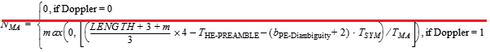

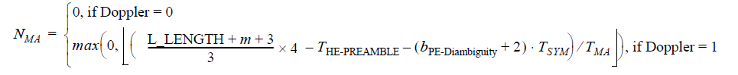

where

*TMA* is defined in Equation (28-117) except that *MMA* is the midamble periodicity indicated by the NSTS And Midamble Periodicity subfield(#11427) of the HE-SIG-A field in an HE SU PPDU and HE ER SU PPDU, or by the Number Of HE-LTF Symbols And Midamble Periodicity subfield of the HE-SIG-A field in an HE MU PPDU.

Doppler is indicated by the Doppler field of HE-SIG-A field.

***------------- End Text Changes ---------------***

|  |  |  |  |  |
| --- | --- | --- | --- | --- |
| **CID** | **P.L** | **Comment** | **Proposed Change** | **Resolution** |
| 16980 | 542.59 | The receiver computes NSYM, TPE and NMA using Equation (28-120), Equation (28-121) and Equation (28-  123), respectively.  these three equations are supposed to be used for all HE PPDU types. but 28-123 is for TB PPDU only and non-TB PPDU use 28-113. | make it clear how N_MA is calculated for different PPDU types | Revised.  There is no reason that Equation (28-123) belongs to only HE TB PPDU.  TGax Editor: make changes according to this document 11-18-1452-00-00ax CR on Packet Extension |

***Discussion***

For CID16980

Equation (28-113) provides the number of midamble periods (*NMA*) at TX side while Equation (28-123) is used to induce the *NMA* which is unknown in RX side for HE PPDUs. We cannot tell Equation (28-113) is used for non-TB PPDU for TX side.

For more specific, when transmitting a HE TB PPDU equipped with midambles and appended with a PE field, *TPE* is calculated by Equation (28-115) below.

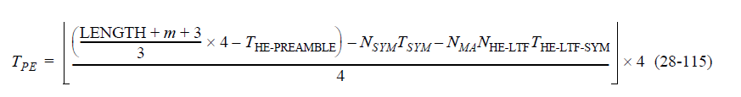

Where *NMA* and *NSYM* can be derived by Equations (28-113) and (28-116).

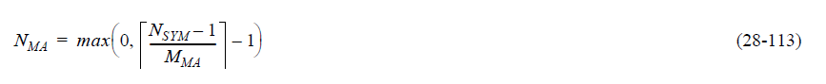

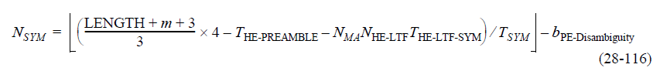

Given two equations contain two unknown variables, to make the calculation simple, the spec suggests one of the methods that *NMA* can be calculated easily with an alternative Equation (28-118) first (instead of using Equation (28-113)), then with *NMA* known, the transmiter can get *NSYM* in Equation (28-116). Spec shows this procedure from P541L40 below.

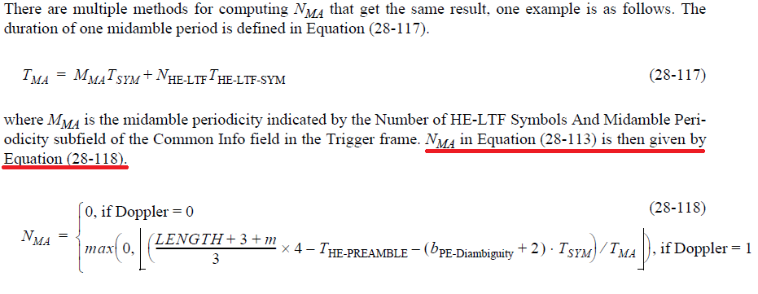

To make it clear how *NMA* can be calculated using different methods for an HE TB PPDU, the original text is updated.

***To TGax editor:*** ***P541L23*** *replace the current text with the proposed changes below.* (#16980)***------------- Begin Text Changes ---------------***

*NSYM* is derived from Equation (28-116)





There are multiple methods for computing *NMA* that get the same result for an HE TB PPDU(#11671), one example is as follows. The duration of one midamble period is defined in Equation (28-117).





where *MMA* is the midamble periodicity indicated by the Number of HE-LTF Symbols And Midamble Periodicity subfield of the Common Info field in the Trigger frame. *~~N~~~~MA~~* ~~in~~ Equation (28-113) for *NMA* ~~is then given~~ can be substituted by Equation (28-118).



where Doppler is indicated by the Doppler subfield of the Common Info field of the Trigger frame.

***------------- End Text Changes ---------------***