IEEE P802.11
Wireless LANs
TGbb Simulation Scenarios
Date: 2018-08-21
Author(s):
Name | Affiliation | Address | Phone | email
Oliver Pengfei Luo | Huawei | Q20 Huawei Building, No. 156 Beiqing Rd. Beijing, 100095, China | +861060612361 | oliver.luo@hisilicon.com
Jiamin Chen |  |  |  | jiamin.chen@mail01.huawei.com
John Qiang Li |  |  |  | john.liqiang@hisilicon.com
Nikola Serafimovski | pureLiFi |  |  | nikola.serafimovski@purelifi.com
Chong Han | pureLiFi |  |  | Chong.han@purelifi.com
Abstract
This document describes the simulation scenarios for IEEE802.11bb.

Introduction

This document defines simulation scenarios to be used for
- Evaluation of performance of features proposed in TGbb.
- Generation of results for simulators calibration purpose.

Each scenario is defined by specifying
- Topology: AP/STAs positions, P2P STAs pair positions, obstructions , layout, propagation model
- Traffic model
  - UL: STA - AP traffic
  - DL: AP – STA traffic
  - P2P traffic (tethering, Soft-APs, TDLS)
  - ‘Idle’ management (generating management traffic such as probes/beacons)
- List of PHY, MAC, Management parameters
  - We may want to fix the value of some parameters to limit the degrees of freedom, and for calibration

Per each of above items, the scenario description defines a detailed list of parameters and corresponding values.

Values not specified can be set to any value.
Values included in square brackets [] are default values to be used for calibration.
All other parameters values not included in [], are to be considered mandatory for performance evaluation.

Simulation results should be presented together with the specification of the value used per each of the parameters in the tables.

Scenarios summary

This document reports the initial agreement according to document 11-18/1422r0.

 | Scenario Name | Topology | Management | Channel Model | Traffic profile  [tentative]
1 | Industrial wireless | A - Industrial Robotic work cell  e.g. ~8m x 10m x 7m or ~5m x 5m x 3m size  ~10s of STAs/AP, P2P pairs | Managed | Indoor- Manufacturing Cell | Industrial
2 | Hospital ward | B - Dense small BSSs  e.g. ~6m x 6m x 3m size,  ~1-3m inter AP distance,  ~10s of STAs/AP, P2P pairs | Managed | Indoor- Office | Enterprise
3 | Enterprise | C - Dense small BSSs  e.g. ~14m x 14m x 3m size  ~1-3m inter AP distance  ~10s of STAs/AP, P2P pairs
 |  |  |  |  | Enterprise
4 | Residential | D - Apartment bldg.  e.g. ~6m x 6m x 3m size,  ~0.5-2 m inter AP distance  ~10s of STAs/AP, P2P pairs | Managed | Indoor-Home | Home

1-Industrial wireless

Topology (A)
Transmitters Receivers
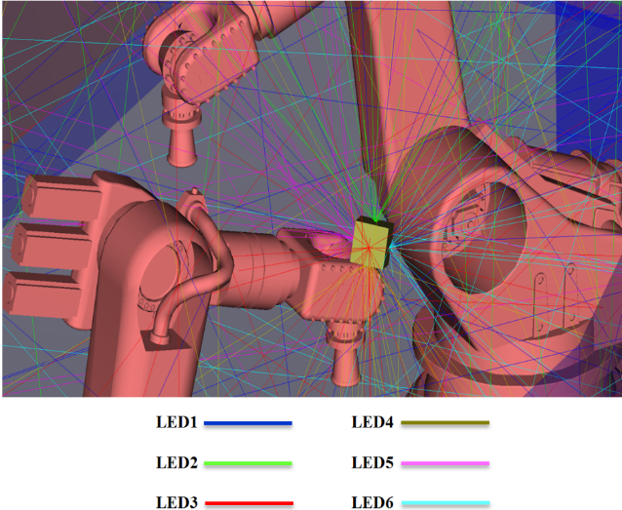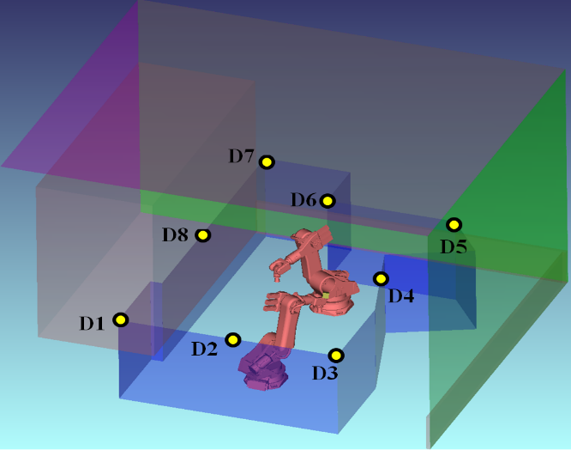
Parameter | Value
Environment description | 1 Industrial Robotic work cell  - Floors hight: 3 m, 7 m  - Work cell size:8m x 10m x 7m
APs location | 1 per work cell, installed at the head of the robot, with multiple transceivers facing different directions
STAs location | N per AP, located on the top of the work cell boundary looking in the direction of the robots
Channel Model | industrial, TBD
PHY paramters
BW: | [up to 250 MHz]
MCS: | [up to ] 64QAM ¾ - Target 1Gbps
Wavelength: | IR
GI: | 256ns
Data Premble: | TBD
STA TX power | [Xdbm/LED] 1 W optical / TX light source
AP TX Power | [Ydbm/LED] 1 W optical / TX light source
AP # of TX light sources
AP # of RX photoreceivers
TX beam angle of AP | 90 degrees
Photosensitive area | 20mm² [1 cm²]
Photodiode responsivitiy
RX FOV of AP | 90° FWHM for 2 m height
STA # of TX light sources
STA # of RX photoreceivers
TX beam angle of STA | 90 degrees
Photosensitive area | 20mm² [1 cm²]
Photodiode responsivitiy
RX FOV of STA | 90 degrees
Noise floor | -70dBm [-174 dBm/Hz]
MAC paramters
Acess protocol parameters: | [HCF?]
Aggregation: | [A-MPDU / A-MSDU?]
Max # of retries | [5]
RTS/CTS | [on/off?]
Rate adaptation method | [TBD in Evaluation Methodology]
Association | Each STA associated with the AP in same cell

Traffic model (Per each apartment) - TBD
# | Source/Sink | Name | Transport Protocol | Average rate [Mbps] | MSDU size [B] | Max. Delay [ms] | Max. PLR | PKT arrival distribution | AC
Dowlink
D0 | AP/STA1 | Local file transfer |  | max rate
D1 | AP/STA1 | 4k Video | …
D2 | AP/STA2 | Browsing | …
D3 | AP/STA3 | …
… | …
DN | AP/STAN
Uplink
U1 | STA1/AP
U2 | STA2/AP
U3 | STA3/AP
… | …
UN | STAN/AP
P2P
P1 | STA1/AP
P2 | STA2/AP
P3 | STA3/AP
… | …
PN | STAN/AP
Idle Management
M1 | AP1 | Beacon |  |  | X Bytes |  |  | 1/Xms
M2 | STA2 | Probe Req. |  |  | X Bytes |  |  | 1/Xs
M3 | STA3
… | …
MN | STAN

2 - Hospital ward

Topology (A)
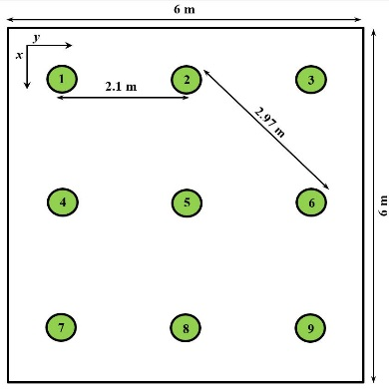
Arrangement of luminaries
Parameter | Value
Environment description | 1 hospital ward  - Floors height: 3 m  - Ward size:6m x 6m x 3m
APs location | 9 per ward, installed on the ceiling
STAs location | N per AP, installed on or near the hospital beds
Channel Model | hospital ward?,TBD
PHY paramters
BW: | [up to 300 MHz]
Spectral efficiency | Up to 10 bits/s/Hz
Frequency: | Visible light (DL) and IR (UL)
GI: | 256ns
Data Premble: | TBD
STA TX power | [Xdbm/LED] 200mW optical
AP TX Power | [Ydbm/LED] 15W optical
TX beam angle of AP | 90 degrees
AP RX photosensitive area | 20mm²
RX FOV of AP | 90 degrees
TX beam angle of STA | 90 degrees
STA RX photosensitive area | 20mm²
RX FOV of STA | 90 degrees
Noise Figure | -70 dBm
MAC paramters
Acess protocol parameters: | [HCF? / EDCA with default EDCA Parameters set / possible alternative proposals?]
Aggregation: | [A-MPDU]
Max # of retries | [up to 5]
RTS/CTS | [on]
Rate adaptation method | [TBD in Evaluation Methodology]
Association | Each STA associated with the AP in same cell

3 - Enterprise

Topology (A)
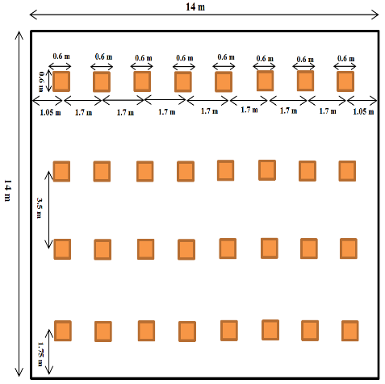
Arrangement of luminaries
Open office Office With Cubicles
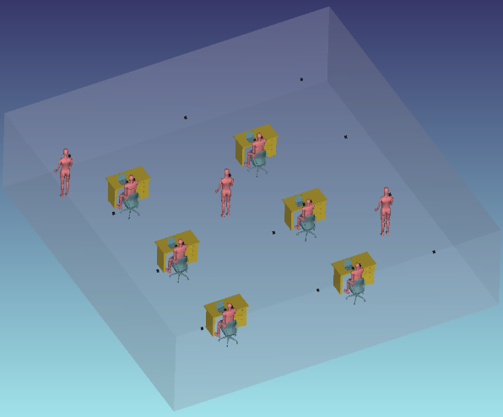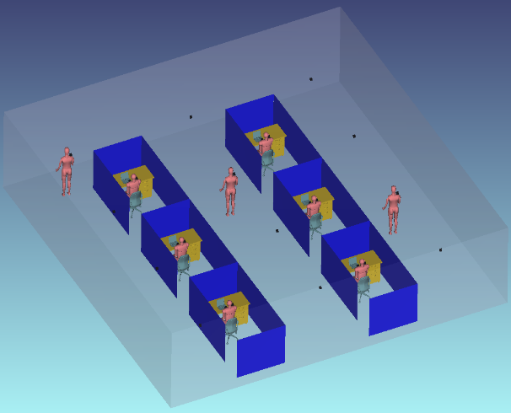
Arrangement of luminaries
Parameter | Value
Environment description | 1 office with/without cubicles  - Floors hight: 3 m  - Office size:14m x 14m x 3m
APs location | N per office, installed on the ceiling
STAs location | N per AP, place STAs in random xy-locations or in a cubicle (uniform distribution) at z = 1.5m above the floor
Channel Model | office
PHY paramters
BW: | [up to 300 MHz]
Spectral efficiency | Up to 10 bits/s/Hz
Frequency: | Visible light (DL) and IR (UL)
GI: | 256ns
Data Premble: | TBD
STA TX power | [Xdbm/LED] 200mW optical
AP TX Power | [Ydbm/LED] 15W optical
TX beam angle of AP | 90 degrees
AP RX photosensitive area | 20mm²
RX FOV of AP | 90 degrees
TX beam angle of STA | 90 degrees
STA RX photosensitive area | 20mm²
RX FOV of STA | 90 degrees
Noise Figure | -70 dBm
MAC paramters
Acess protocol parameters: | [HCF? / EDCA with default EDCA Parameters set / possible alternative proposals?]
Aggregation: | [A-MPDU]
Max # of retries | [up to 5]
RTS/CTS | [on]
Rate adaptation method | [TBD in Evaluation Methodology]
Association | Each STA associated with the AP in same cell

4 - Residential
Topology (A)
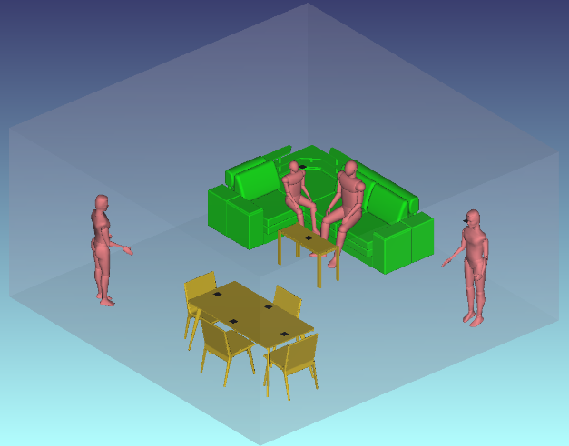
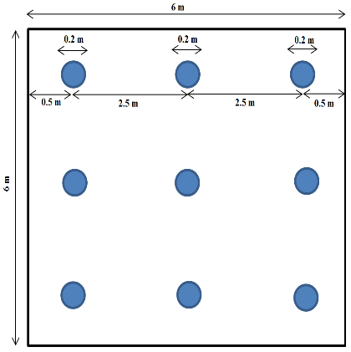
Arrangement of luminaries
Parameter | Value
Environment description | A living room with table, chairs, couch, coffee table and human bodies  - Floors hight: 3 m  - Room size:6m x 6m x 3m
APs location | TBD per room, installed on the ceiling
STAs location | TBD per AP, place STAs in random xy-locations at z = 1.5m above the floor
Channel Model | home
PHY paramters
BW: | [up to 1 GHz]
MCS: | [up to ] 64QAM ¾ - Target 4Gbps
Frequency: | Visible light (DL) and IR (UL)
GI: | 256ns
Data Premble: | TBD
STA TX power | [Xdbm/LED] 200mW optical
AP TX Power | [Ydbm/LED] 15W optical
TX beam angle of AP | 90 degrees
AP #of RX LEDs | 20mm² photosensitive area
RX FOV of AP | 90° FWHM for 2 m height
TX beam angle of STA | 90 degrees
STA #of RX LEDs | 20mm² photosensitive area
RX FOV of STA | 90 degrees
Noise Figure | -64 dBm
MAC paramters
Acess protocol parameters: | [EDCA with default EDCA Parameters set]
Aggregation: | [A-MPDU]
Max # of retries | [5]
RTS/CTS | [on]
Rate adaptation method | [TBD in Evaluation Methodology]
Association | Each STA associated with the AP in same cell

Annex 1 - Reference traffic profiles per scenario

Reference traffic profile for Scenario 1

Traffic Model # | Traffic model name | Description | Application traffic  (Forward / Backward) | Application Load (Mbps)  (Forward / Backward) | A-MPDU Size (B)  (Forward / Backward)
T1 | Local file transfer | FTP/TCP transfer of large file within local network | FTP file transfer  / FTP TCP ACK | Full buffer /  0.1 | Max A-MPDU / 64
T2 | Lightly compressed video
T3 | Internet streaming video/audio
T4 | 4k video streaming
T5 | Online game server
T6 | Management: Beacon
T7 | Management: Probe requests

Reference traffic profile for Scenario 2

Traffic Model # | Traffic model name | Description | Application traffic  (Forward / Backward) | Application Load (Mbps)  (Forward / Backward) | A-MPDU Size (B)  (Forward / Backward)
T1 | Local file transfer | FTP/TCP transfer of large file within local network | FTP file transfer  / FTP TCP ACK | Full buffer /  0.1 | Max A-MPDU / 64
T2 | Lightly compressed video
T3 | Internet streaming video/audio
T4 | 4k video streaming
T5 | Online game server
T6 | Management: Beacon
T7 | Management: Probe requests
T8 | Multicast Video Streaming | UDP/IP transfer of compressed video streaming | UDP packet transfer/Nothing | 3-6Mbps/Nothing

Reference traffic profile for Scenario 3

Traffic Model # | Traffic model name | Description | Application traffic  (Forward / Backward) | Application Load (Mbps)  (Forward / Backward) | A-MPDU Size (B)  (Forward / Backward)
T1 | Local file transfer | FTP/TCP transfer of large file within local network | FTP file transfer  / FTP TCP ACK | Full buffer /  0.1 | Max A-MPDU / 64
T2 | Lightly compressed video
T3 | Internet streaming video/audio
T4 | 4k video streaming
T5 | Online game server
T6 | Management: Beacon
T7 | Management: Probe requests

Reference traffic profile for Scenario 4

Traffic Model # | Traffic model name | Description | Application traffic  (Forward / Backward) | Application Load (Mbps)  (Forward / Backward) | A-MPDU Size (B)  (Forward / Backward)
T1 | Local file transfer | FTP/TCP transfer of large file within local network | FTP file transfer  / FTP TCP ACK | Full buffer /  0.1 | Max A-MPDU / 64
T2 | Lightly compressed video
T3 | Internet streaming video/audio
T4 | 4k video streaming
T5 | Online game server
T6 | Management: Beacon
T7 | Management: Probe requests

Annex 2 – Traffic model descriptions

Wireless Display (lightly compressed video) Traffic Model
Wireless display is a single-hop unidirectional (e.g., laptop to monitor) video application. The video slices (assuming a slice is a row of macro blocks) are generated at fixed slice interval. For example, for 1080p, the slice interval is 1/4080 seconds.

The video slices are typically packetized into MPEG-TS packets in wireless display application. But for LC simulation, we will ignore the MPEG-TS packetization process and assume video slices are delivered to MAC layer for transmission directly.

The traffic model for wireless display is modified from [TGad] with modifications below due to the fact that some parameters have dependency on video formats.

- Parameters
  - Set IAT, MaxSliceSize according to video format as Table xx.
  - Normal distribution parameters
    - µ = 15.798 Kbytes
    - σ = 1.350 Kbytes
    - b = 300 Mbps
- Algorithm for generating each video slice/packet
- Input: target bit rate in Mbps (p)
- Output: slice size in Kbytes (L): At each IAT, generate a slice size L with the following distribution: Normal(µ*(p/b), σ*(p/b))
    - If L > MaxSliceSize, set L= MaxSliceSize

Video format | Inter-arrival time (IAT) | MaxSliceSize | p
1080p60 | 1/4080 seconds | 92.160 Kbytes | 300
4K UHD (3840x2160) 60fps | 1/8100 seconds | 184.320 Kbytes | 600
8K UHD (7680x4320) 60fps | 1/16200 seconds | 368.640 Kbytes | 1200
1080p60 3D | 1/4080 seconds | 92.160 Kbytes | 450
Note: the data rate increase from 1080p to higher resolution is not linearly scaling as the uncompressed data rate due to higher redundancy in the images at higher resolution. Similar argument applies to 3D video. A 100% increase is assumed for 4K video as compared to 1080p, and 50% bit rate increase for 3D from 2D video.

Evaluation metric
- MAC throughput, latency

Buffered Video Steaming (e.g., YouTube, Netflix) Traffic Model
Unlike wireless display, video streaming is generated from a video server, and traverses multiple hops in the internet before arriving at AP for transmission to STA. It is a unidirectional traffic from the video server to the station.

Typically, Video streaming application runs over TCP/IP protocol, and video frames will be fragmented at TCP layer before leaving the video server. Since these TCP/IP packets experiences different processing and queuing delay at routers, the inter-arrival time between these TCP/IP packets are not a constant despite the fact that video frames are generated at constant interval at the video application layer.

STA Layering Model
STA layering model is shown in Figure xx. Both AP and STA generate video frames at application layer. The video traffic goes through TCP/IP layer and then to MAC layer. The TCP protocol used for video streaming simulation is the same as other traffic model described in section x.x. of this document.

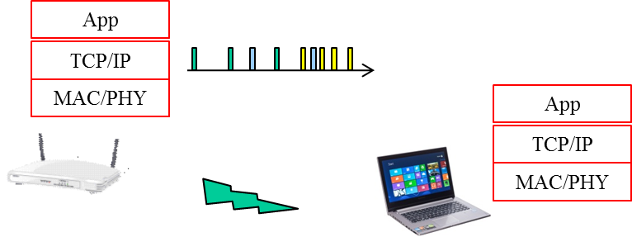

Figure xx Traffic layering model

Video traffic generation

The video traffic from AP to STA is generated as follows.
Step 1: At application layer, generate video frame size (bytes) according to Weibull distribution with the following PDF.
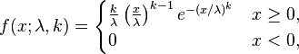

Depending on the video bit rate, the parameters to use are specified in Table 1.

Video bit rate | lambda | k
10Mbps | 34750 | 0.8099
8Mbps | 27800 | 0.8099
6Mbps | 20850 | 0.8099
4Mbps | 13900 | 0.8099
2Mbps | 695 | 368.640 Kbytes
Table 1 lambda and k parameter for video bit rate

Step 2: AT TCP layer, set TCP segment as 1500 bytes and fragment video packet into TCP segments.

Step 3: Add network latency to TCP/IP packets when these segments arrive at AP for transmission. The network latency is generated according to Gamma distribution whose PDF is shown below

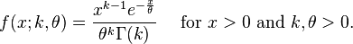

Where
  - k=0.2463
  - theta=55.928

The mean of the latency with the above parameters is 14.834ms. To simulate longer or shorter network latency, scale theta linearly since mean of Gamma distribution is K*theta

If network latency value is such that the packet arrives at MAC layer after the end of the simulation time, then re-generate another network latency value until the packet arrives at MAC within the simulation window.

Evaluation metrics
- MAC throughput, latency
- TCP throughput, latency

Video Conferencing (e.g., Lync) Traffic Model

Unlike video conferencing where video traffic is unidirectional, video conferencing is two-way video traffic. The video traffic is generated at each station, send to AP, transverse the internet and reach another AP and then send to the destination.

Station layer model

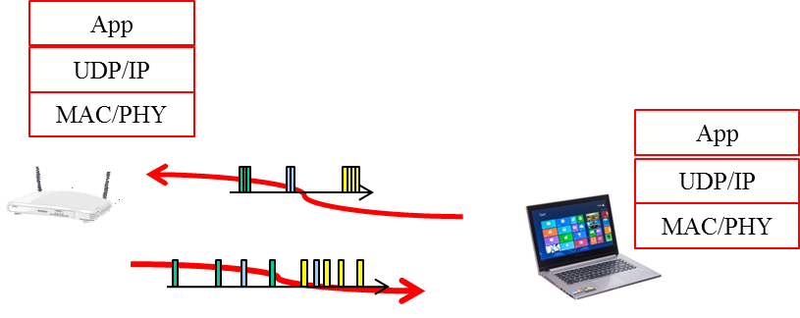

Because the traffic from AP to station has experienced network jitter, it can be modelled the same way as the traffic model of video streaming.

For the traffic sent from Station to AP, since the traffic has not experienced network jitter, it is a periodic traffic generation as the first two steps described in video streaming.

Video traffic generation

Traffic model from AP to station: use the same model as video streaming.
Traffic model from station to AP: use the first two steps in video streaming traffic model

Evaluation metrics
- MAC throughput, latency

Management traffic profiles

Unassociated clients probe all possible channels periodically until they associate to an AP. Even after association, while they are in sleep mode (e.g. the smartphone screen is off) they would wake up for a short time and probe the AP they are associated to (e.g. to check whether there are updates in the status of some applications, like whether an instant messaging server has a new message for the instant messaging client on the smartphone).

While probing may not generate significant management traffic per client, in high-density environments the probing traffic adds up and can consume a considerable percentage of the wireless medium. This becomes significant in use cases like stadiums, airports etc. This annex proposes management traffic models for associated and unassociated clients.

Management traffic model for unassociated clients:
- Probing period:
  - For 50% of the clients: [12.5 seconds]
  - For 50% of the clients:
    - [12 seconds]
    - If still unassociated after [5] times probing all the channels, then probe all the channels every with doubled Probing period, and maximum period of [400 seconds].
- Probing channels: Every supported channel [1,2,3,4..,36,40,..]
- Probe request SSID: Broadcast probe requests to wildcard SSID, plus [0-3] specified SSIDs
- Probe Request frame size: [80B, or 160B]

Management traffic model for associated clients:
- Probing period: [60 seconds]
- Probing channels: Same channel that the client is associated, unless the associated AP Beacon’s RSSI is below [TBD dBm] in which case probe every supported channel [1,2,3,4..,36,40,..]
- Probe Request frame size: [80B, or 160B]
Probe request SSID: Probe the associated AP/SSID if RSSI is not below [TBD dBm], otherwise broadcast probe requests to wildcard SSID

Annex 2.2 Application event models

Application event model is used to specify the patterns of the application events, i.e., when to start the applications and how long for each application in the simulation. Different use scenarios may choose different application event models in the simulation.
- Poisson model
Poisson model can be used for random application event pattern where there are many users, each generating a little bit of traffic and requesting network access randomly.
Parameters: TBD

- Hyper-exponential model
Hyper-exponential model can be used for peak event pattern where users requesting network access in big spikes from the mean.
Parameters: TBD

Multicast Video Streaming Traffic Model

Multicast Video Streaming is one-way video traffic from AP to STAs
The video traffic is generated from a video server, and traverses multiple hops in the internet before arriving at AP for transmission to STA.

Station layer model

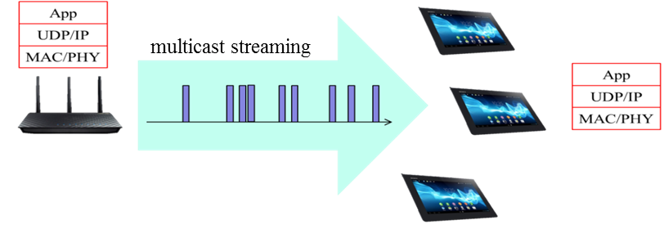

AP generates video frames at application layer.
Because the traffic from AP to station has experienced network jitter,
it can be modelled the same way as the traffic model of video streaming.
The video traffic goes through UDP/IP layer and then to MAC layer.

Video traffic generation
Traffic model from AP to station: use the same steps in video streaming traffic model
We assume bit rate for video streaming 6 Mbps (1080/30p AVC) and 3 Mbps (1080/30p HEVC)

Video bit rate | Lamda | K
6Mbps | 20850 | 0.8099
3Mbps | 10425 | 0.8099

Evaluation metrics
MAC throughput, latency

References for traffic models

- 11-13/486, “HEW video traffic modeling” Guoqing Li et al, (Intel) [1] 11-13-1162-01-hew-vide-categories-and-characteristics
- 11-13-1059-01-hew-video-performance-requirements-and-simulation-parameters
- 11-09-0296-16-00ad-evaluation-methodology.doc
- Rongduo Liu et al., “An Emperical Traffic Model of M2M Mobile Streaming Services ”, International conference C on Multimedia information networking and security, 2012
- JO. Rose, “ Statistical properties of MPEG video traffic and their impact on traffic modeling in ATM systems ”, Tech report, Institute of CS in University of Wurzburg
- Savery Tanwir., “A survey of VBR traffic models”, IEEE communication surveys and tutorials, Jan 2013
- Aggelos Lazaris et al., “A new model for video traffic originating from multiplexed MPEG-4 videoconferencing streams”, International journal on performance evaluation, 2007
- A. Golaup et al., “Modeling of MPEG4 traffic at GOP level using autoregressive process”, IEEE VTC, 2002
- K. Park et al., “Self-Similar network traffic and performance evaluation”, John Wiley&Son, 2000
- M Dai et al., “A unified traffic model for MPEG-4 and H.264 video traces”, IEEE Trans. on multimedia, issue 5 2009.
- L Rezo-Domninggues et al., “Jitter in IP network: A cauchy approach”, IEEE Comm. Letter, Feb 2010
- Hongli Zhang et al., “Modeling Internet link delay based on measurement”, International conference on electronic computer technology, 2009.

References
- https://mentor.ieee.org/802.11/dcn/18/11-18-1236-01-00bb-ieee-802-11bb-reference-channel-models-for-indoor-environments.pdf
- https://mentor.ieee.org/802.11/dcn/18/11-18-1109-05-00bb-lc-usage-model-document.pptx
- https://mentor.ieee.org/802.11/dcn/13/11-13-1000-02-0hew-simulation-scenarios.ppt
- https://mentor.ieee.org/802.11/dcn/13/11-13-1001-09-0hew-simulation-scenarios-document-template.docx

